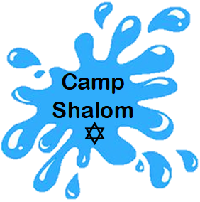

Summer 2026
Jewish Education Agency • 4050 S. Hulen Street • Fort Worth, Texas 76109 • (817) 737-9898
www.lilgoldmanschool.org

A beneficiary of the Dan Danciger/Fort Worth Hebrew Day School Supporting Foundation and the Jewish Federation of Tarrant County

Session Dates
Session I: June 1 – June 26
Session II: July 6 – July 31

Camp  Programs | Group or grade completed by May 31, 2026
Camp Shalom -Gan | Infants | Toddlers | Twos | Threes | PreK | K

Camp Closed June 19th

Interim Care Only June 29th – July 2nd

Camp Closed July 3rd

Camp Shalom- Gan: Summer Camp for Infants thru Kinder

Your child will enter the powerful world of STEAM this summer at Camp Shalom-Gan. Science, Technology, Engineering, Art, and Math will be the ongoing themes for the summer. From water, color, animals, climate, construction and more, each day will be filled with discovery. Campers enjoy these activities in addition to Jewish educational enhancement programs.
Our camp is staffed by professional early childhood certified instructors and assistants. Our indoor camp facilities provide lots of experiential and tactile learning opportunities, and our play areas encourage physical activity and exploration with natural elements included. There will be a great deal of natural materials for them to explore in connection to sand and water play.

Recurring Weekly Enhancement Programs Include:
Splash Pad Yoga Stars Music

Camp Goodies: Campers receive a complimentary T-shirt.
Security & Safety: Our facility has a staffed, monitored security entrance and strict visitor procedures, including required check-ins for all campers and visitors.
Lunch: Campers bring their own snacks, sack lunches, and beverages. Food items must be vegetarian or dairy. (Please see our office for a list of suggested foods.)
Camp Staff: All lead counselors have at least 5 years of experience in early childhood education. All camp staff participate in comprehensive staff training, health and safety training, are certified in CPR and First Aid, and pass a national criminal history background check.

Choose Your Experience:
Sign up for the weeks of your choice or the whole summer!

Session I: June 1 – June 26
Week 1 | June 1-5
Week 2 | June 8 - 12
Week 3 | June 15-19 (4 days)
Week 4 | June 22-26

Session II: July 6 – July 31
Week 5 | July 6-10
Week 6 | July 13-17
Week 7 | July 20-24
Week 8 | July 27-31

Create a schedule that works for you!

Monday thru Friday All Ages
Monday / Wednesday / Friday All Ages
Tuesday / Thursday All Ages

Camp Program 7:30 a.m. - 1:00 p.m.
Camp Plus 7:30 a.m. - 3:30 p.m.
Camp Extended 7:30 a.m. - 6:00 p.m.

Morning drop-off: any time after 7:30 and by 9:00am

2026 Camp Shalom – Gan Fees
Infants thru 3yrs | TTH | MWF | M - F
Camp 7:30am – 1:00pm | $131 | $158 | $231
Camp Plus: 7:30am – 3:30pm | $158 | $194 | $284
Camp Extended: 7:30am – 6:00pm | $194 | $242 | $378

PreK & Kinder | TTH | MWF | M - F
Camp 7:30am – 1:00pm | $121 | $147 | $200
Camp Plus: 7:30am – 3:30pm | $142 | $179 | $263
Camp Extended: 7:30am-6:00pm | $173 | $226 | $347
*Credit card payments will be charged a $5 fee per week.

Register & Pay in Full by
6:00 p.m. April 17, 2026
and receive a
10% discount.

Currently Enrolled registration fee: $50

Summer Camp Only Registration Fee: $75

Registration and Camp fee payments are
non-refundable

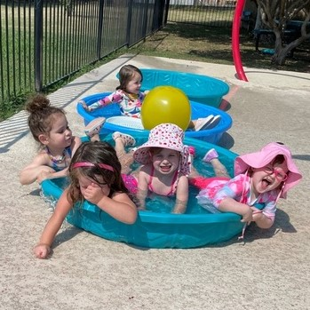
Splash pad fun!

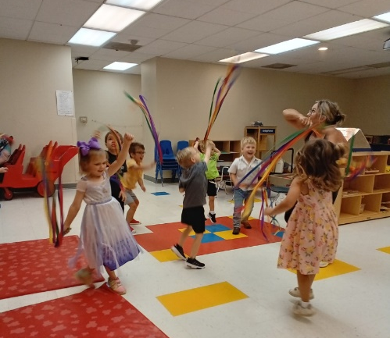
Music!

Stretch-n-Grow!

Weekly Special
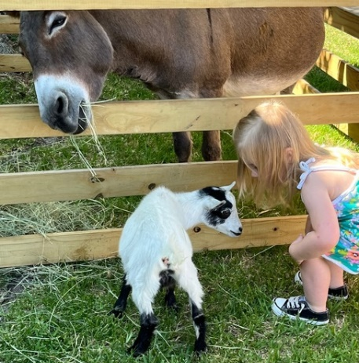
Activities and
Visitors!

