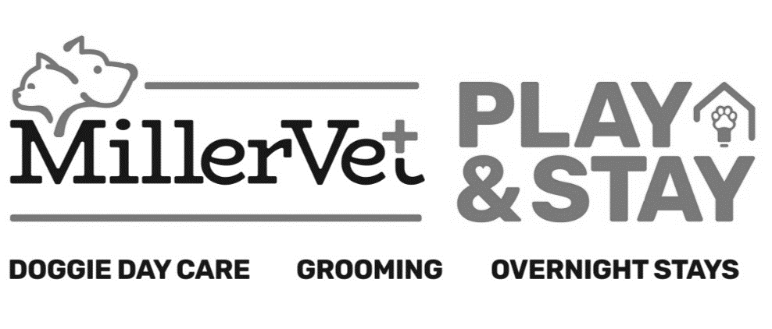

(470) - 363 - 8578
2242 Roswell Road Marietta, Georgia 30062
For multiple pets only: Would you like your dogs/cats to share a kennel? Please initial the following below and we will do our best to make sure your pets can share a kennel! Prices vary depending on size kennel needed to fit both dogs/cats. Ask a staff member for specific prices.
_____ My pets can eat in the same kennel and show no signs of food aggression when eating together at home.
_____ My pets show no aggression towards each other at home or when playing.
_____ I understand that if at any point a kennel assistant sees any aggression towards one other, my pets will put in separate kennels and I will be responsible for the separate kennel prices.

Boarding Form
Pet’s Name: _____________________________________
Check out time is 12:00pm noon Monday – Saturday and holidays. An additional charge will be added for late check-outs. Sunday hours are 5 to 6 p.m. only.

Drop off Date: ___________________________________
Pick Up Date: _________________________________
Estimated Pick-Up Time: ________________________

By signing below, you are acknowledging that all information below is correct, and you agree to the waiver and release you previously signed.
X_________________________________________________
Additional Services:
Please check any additional services you would like while your pet is boarding:
Senior Package  $10 per day  Includes absorbent non-slip mats for dogs with trouble standing, multiple extra potty breaks. | Exit Bath  Prices vary based on size.  Includes nail trim and ear cleaning. * | Nail Trim/Dremel  (electric nail grind for dogs,  nail clippers for cats)  $20.00 per dog & $30 per cat
Temperament Test for Doggie Day Care  $15 per pet but  FREE WITH BOARDING! | Doggie Day Care  Group play with other dogs!  + $12.00 a day per dog, only available Monday-Saturday.  *Must have passed their temperament test and be fixed if over 24 weeks of age. | Individual Play Time  30 minutes per day of one-on-one time  with a staff member!  + $8.00 a day per dog only available Monday-Saturday.
Feeding:
*** Allergies? *** Yes / No If yes, please list: ____________________________________________
Brought your own food? – Yes / No
*There is a fee for using our kennel food, this includes if you bring your own food, but it runs out before picking up. Fee ranges from $2-$6 per day depending how much we feed your pet.
Feed Daily: Once (AM) Once (PM) Twice (AM & PM) Three Times (AM, Lunch, & PM)
Amount: 2 cups 1 cup 1/2 cup 1/3 cup 1/4 cup
provided scoop: __________ individually bagged Other: _______________

Personal Items:
Please check any accessories brought in (and color) as well as any other personal items:
Please list all personal items you will be leaving for boarding as well as a description of items:
We no longer accept personal beds, blankets, or food bowls as we provide those items. We do accept slow feeders!

Leash: color:__________ Collar: color:__________ Harness: color:__________ Carrier: color:__________
Other items: ___________________________________________________________________________

Medication Information
Medication Name | Quantity  (how much/many) | Frequency  (please include AM, PM, or both) | How is it given?  (We have pill pockets & peanut butter we can provide)
Additional Medical Information:

