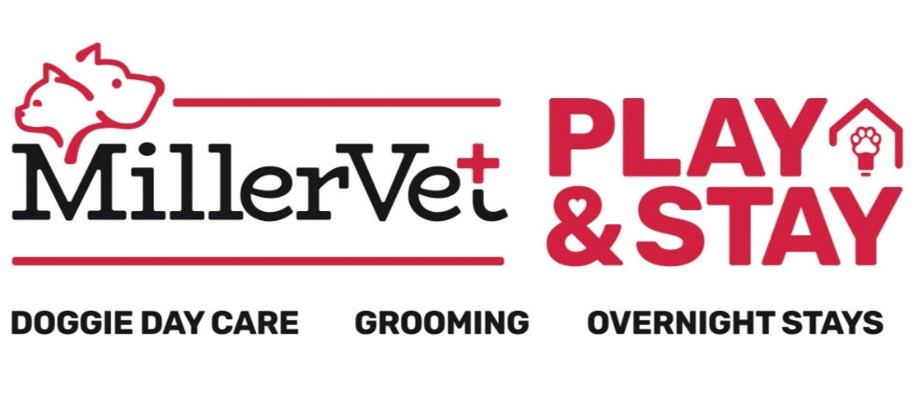

New Individual Doggie Play Form
Welcome to Miller Vet Doggie Day Care! Please fill out the below information for us to store into our system and please let one of our staff members know if you have any questions. Our number one priority at our facility is providing a safe and comfortable place for you to leave your furry family member.
Owner’s Name: _____________________________ Date: ________/_____/_____________
□ New Client or □ Existing Client of Miller Vet Services
Phone Number: _____________________________ Email: ______________________________________
Emergency Contact: ______________________________________________________________________
Who else is authorized to pick up your dog? ________________________________________________________
Your Pet
Name: ____________________________ Breed: ____________________ Birthday: _________________________
□ Male / □ Female Weight: _____________LB Color: _____________________________________
Is your pet fixed? □ yes / □ no
Does your dog growl or snap when food or toys are taken away? □ yes / □ no
Does your dog growl or snap for any other reason? □ yes / □ no; if yes, please explain: ___________________________
What commands does your dog know? ______________________________________________________________
Has your dog ever climbed or jumped a fence before? □ yes / □ no
Any behavioral information we should know about? ___________________________________________________
Any additional information? ______________________________________________________________________
If your dog is not a patient of one of the vets at Miller Vet Services, please provide regular vet information below.
Animal Hospital: ________________________________ Veterinarian: ____________________________________
Hospital Address: _______________________________________________________________________________
List of any known allergies: _______________________________________________________________________
Monthly Heartworm treatment: ______________________________________ Last Given: ___________________
Monthly Flea treatment: ____________________________________________ Last Given: ___________________
We require all dogs in doggie daycare to be up to date on the following vaccinations: Rabies, DHPP, Bordetella.
We will remove your dog from daycare and treat for fleas/ticks if any are seen on your pet without permission. You will be responsible for any cost that come with this treatment. Please ask if you have any questions about this.
Please make sure that our staff has an up to date copy of your dog’s records. We will not allow any dogs or cats to stay on the premises without these records in our system.

Rules, Regulations & Waiver
INJURIES & ILLNESS: Here at Miller Vet Play and Stay, we strive to provide your dog with excellent care and a fun experience during their stay. Although animals are supervised at all times, injuries can still occur while dogs are playing together such as scratches, cuts or sprained joints. Such injuries are rare, but they happen at all doggie daycares. In addition, while infrequent, dogs can get into fights, even under close supervision. Common areas for bites as a result of these fights are the snout, ears, tuft of the neck and paws. At Miller Vet Play and Stay, we have procedures to screen dogs for aggressive behavior and we do not allow aggressive dogs to play with other dogs. However, even the friendliest of dogs can get into fights with very little or no warning. In addition to injuries, it is possible for dogs to transfer illness such as upper respiratory infections and kennel cough, even with the required vaccinations and boosters. This is just like at a daycare for children where illness such as pink eye and the flu can be transferred from one child to another. Such illnesses do not occur often and all dogs must have the necessary vaccinations to check-in.
AGE & GENDER: Dogs of all ages are allowed at Miller Vet Play and Stay as long as they meet the facility’s criteria of vaccinations. All dogs participating in doggie daycare must be spayed or neutered if over 6 months of age.
ABANDONMENT OF ANIMALS: I understand if I do not pick up my dog by 5 days after the agreed upon pick up date, a certified letter will be sent regarding the animals abandonment. Should the animal not be removed within the specified time I, the client, hereby relinquish all claims to my animal, but shall not relieve me of my contractual liability of any treatment, boarding or care furnished.
PHOTOGRAPHS: I understand that photographs, video or digital recordings are taken of the facility, pets, customers and staff on a regular basis for, among other things, use in advertising by Miller Vet Play and Stay. I acknowledge that all such images, together with prints and copyrights, therein are the property of Miller Vet Play and Stay. I give Miller Vet Play and Stay my consent, permission, and authorization, without compensation to me, to use, reproduce, and alter the images, in print and electronic format (including the internet), either alone or in combination with other texts and graphics. I waive my right to approve the finished photograph, advertising copy, print material or electronic files that may be used in conjunction with the images.
1. I agree that Miller Vet Play and Stay will not be liable for any claims of injury, illness, damage or death to my dog during its stay and that under no circumstances will Miller Vet Play and Stay be liable for consequential damages.
2. I certify that I have informed Miller Vet Play and Stay of all dog and human aggression. I agree that I am responsible for any harm caused by my dog while in the care of Miller Vet Play and Stay. I shall indemnify Miller Vet Play and Stay against any claims made against it or for losses or damages suffered by Miller Vet Play and Stay as a result of my dog.
3. I understand that, in the event my dog appears to be ill or at significant risk of experiencing a medical problem, Miller Vet Play and Stay will attempt to contact me for instructions prior to seeking veterinary care. If I cannot be reached, I agree that Miller Vet Play and Stay may use its reasonable discretion in seeking veterinary care on my behalf and I will be responsible for all related expenses. I understand that Miller Vet Play and Stay will attempt to use my preferred veterinarian, but if my preferred veterinarian is unavailable or other circumstances mandate, I authorize Miller Vet Play and Stay to use the veterinarians of its choice. I agree that Miller Vet Play and Stay will not be liable for the actions and decisions of the veterinarian. I also agree to be responsible for any reasonable fees assessed by Miller Vet Play and Stay for emergency care and transportation.
4. I authorize my veterinarian to share the medical records of my dog with Miller Vet Play and Stay and other veterinarians. I assume full responsibility for payment of all veterinary services rendered, including, but not limited to, diagnosis, treatment, necessary grooming, medical supplies, transportation and boarding. I agree to make such payments directly to the attending veterinarian or reimburse Miller Vet Play and Stay if direct payment cannot be made.
This agreement and waiver is valid from the date below and grants permission for future veterinary care without the need for additional authorization each time Miller Vet Play and Stay cares for one or more of my dogs.
Signature:_________________________________ Print Name:_____________________________ Date:_____________

