GOLDY’S CLASSROOM MATH ANSWERS
FRACTION SERIES PART-1
ASSIGNMENT

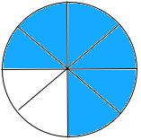
- Present each of the following fractions in the form of a diagram.
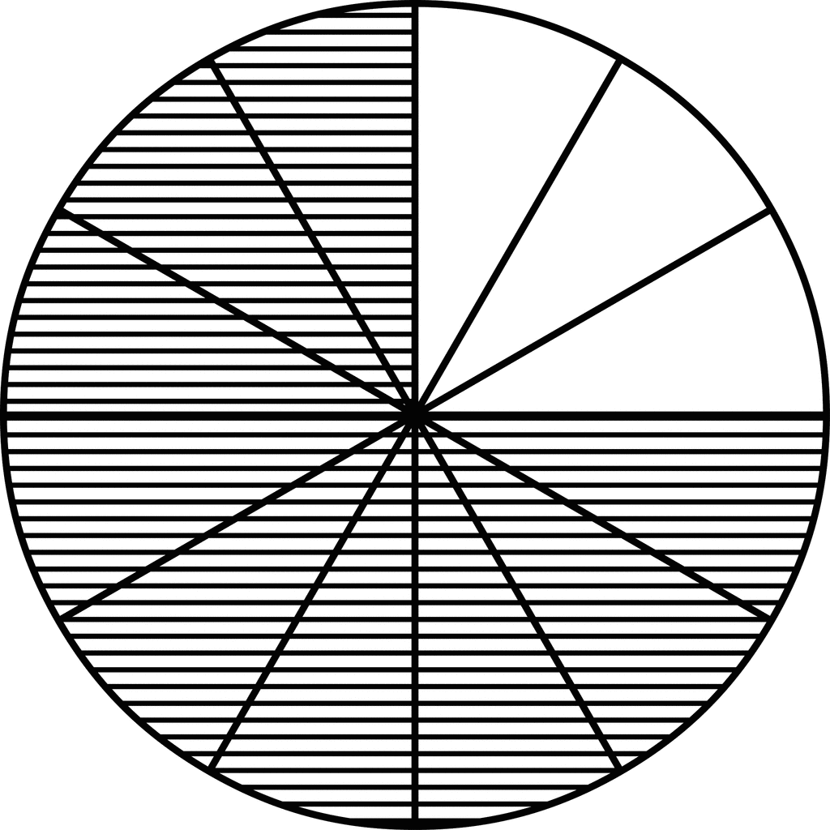
9
12
6
8
c.
a.
6
8
d.
3

6
8
3
d.
15
7
b.

- Draw diagrams to represent and differentiate between the following types of fractions:
Draw at least two different diagrams in each case.

5
9
10
14
  - Proper fraction

39
10
12
5
  - Improper fraction

3
7
3
4
5
1
  - Mixed fraction

3
7
3
15
7
  - Like fractions

6
8
5
9
  - Unlike fractions

4
6
  - Equivalent fractions

8
12

3
4

6
8

3. Sort out the following fractions and write them down in the correct column of the given table.

Proper Fractions | Improper Fractions | Mixed Fractions | Like Fractions | Unlike Fractions | Equivalent Fractions
9  12 | 15  7 | 300  1  8  18  11 | 9  11 | 21  18  21  24 | 16  100  4  25
6  8 | 250  240 | 1  2  5 | 66  57  63  57 | 8  10  4  5 | 8  10  4  5
35
46
2
97
 |  |  | 16  100 | 4  25

- Write down the fraction of each animal in the following group of animals.
7
18
- Fraction of horses:

5
18
- Fraction of elephants:

6
18
- Fraction of lions:

- Is there any LIKE FRACTION in your answers ‘a’, ‘b’ or ‘c’? ‘YES’ OR ‘NO’?
Give a mathematical reason for your answer.
Yes, all three fractions of answers a, b and c are ‘like fractions’. They all have the same denominator. This is because, these fractions represent the same group of animals, so their total is same.

- Is there any IMPROPER FRACTION in your answers ‘a’, ‘b’ or ‘c’? ‘YES’ OR ‘NO’?
Give a mathematical reason for your answer.
No there is no improper fraction in answers a, b and c. None of the fractions has a smaller numerator as compared to denominator. This is because, the fractions represent the number of animals in that whole group.

- Write down the fraction of each in the following pictures.
12
24
- Fraction of chocolate cones:

8
24
- Fraction of strawberry cones:

4
24
- Fraction of mango cones:

- Are the fractions of strawberry cones and mango cones equivalent fractions? ‘YES’ OR ‘NO’? Give a mathematical reason for your answer.
No, there are no equivalent fractions in these answers because all of them have same denominator whereas in equivalent fractions the numerator and denominator both must be different.

- Write down all the proper and improper fractions from your answers ‘a’, ‘b’ & ‘c’.
All the fractions in these answers are proper fractions as in all of them numerator is smaller than the denominator.

NO ASSIGNMENT FOR FRACTION SERIES PART-2

FRACTION SERIES PART-3

36
50
- The sum of two like simple fractions is , write down any 10 addition bonds for this answer.
14
50
22
50
+
25
50
11
50
+
18
50
18
50
+
16
50
20
50
+
30
50
6
50
+

10
50
26
50
+
9
50
27
50
+
32
50
4
50
+
24
50
12
50
+
19
50
17
50
+

9
15
- The difference of two like simple fractions is , write down any 10 subtraction bonds for this answer.

16
15
7
15
-
32
15
23
15
-
24
15
15
15
-
19
15
10
15
-
10
15
1
15
-
18
15
9
15
-
14
15
22
15
-
25
15
16
15
-
30
15
21
15
-

109
15
100
15
-

- Which of the above questions can have finite number of answers?
Q 2 can have infinite number of answers.

FRACTION SERIES PART-4

- What is an improper fraction? Give one example.
An improper fraction is a fraction in which the numerator is greater than or equal to the denominator. Example:
9
4

- Define a mixed number with an example.
1
3
2
A mixed number is a number that contains a whole number part and a fractional part. Example:

- State the steps to convert an improper fraction into a mixed number.
Step 1: Divide numerator by denominator till the end.
Step 2: Answer of the division which is called ‘quotient’ is the whole number of the mixed number
Step 3: Remainder is the numerator of the mixed number.
Step 4: Denominator remains the same.

- Why do we convert improper fractions into mixed numbers?
We convert improper fractions into mixed numbers to make the value clearer, easier to understand in real life and easy to do calculations. Example: = 2 ¼
9
4

- Explain with an example how to change a mixed number into an improper fraction.
To change a mixed number into an improper fraction: Multiply the whole number part by denominator, add numerator, keep denominator same. Example:
2
5
3

Step 1: Multiply whole number, ‘3’ with the denominator, ‘5’: 3 x 5 = 15
Step 2: Add the answer of multiplication i.e., ‘15’ to the numerator, ‘2’: 15 + 2 = 17. This is the new numerator for the improper fraction
Step 3: Denominator remains the same i.e., 5
17
15
Step 4: Write down the improper fraction:

17
5
- Show why is called an improper fraction.
17
5
is improper because numerator, ‘17’ is greater than denominator, ‘5’.

- Convert 9/4 into a mixed number.
9/4 = 2 ¼

- Write 22/7 in mixed form.
22
7
1
7
3
=

1
4
5
- Change to an improper fraction.
1
4
5
21
4
=

- Express 7 3/8 as an improper fraction.
59
8
3
8
7
=

- Compare 35/6 and its mixed number form. Which one is easier to use in a real-life situation? Why?
5
6
5
35
6
=

Mixed number is easier in daily life because it shows the whole part and a proper fraction clearly and separately.

- Analyze the process: What is common in converting improper → mixed and mixed → improper?
- Both conversions involve division, multiplication and addition of numerator, denominator and the whole number.
- They are reverse processes.
- In both, the denominator remains the same.

2
3
4
- Show the steps of converting into an improper fraction and explain each step.

Step 1: Multiply whole number, ‘4’ with the denominator, ‘3’: 4 x 3 = 12
Step 2: Add the answer of multiplication i.e., ‘12’ to the numerator, ‘2’: 12 + 2 = 14. This is the new numerator for the improper fraction
Step 3: Denominator remains the same i.e., 5
14
3
Step 4: Write down the improper fraction:

- Do you think mixed numbers are more useful in daily life than improper fractions? Give reasons with examples.
Mixed numbers are more useful because they show whole number and fraction part separately and clearly.
1
2
2
Example: km is easier to understand which means 2km and half km. Whereas when written in improper
5
2
fraction, km does not make it clear.

- Justify why converting 29/8 into a mixed number makes its meaning clearer.
When converted to mixed number, it shows the whole number and fraction part separately and clearly as shown below:
5
8
3
29
8
=

This helps in doing the calculations easily.

- A student converted 3 2/5 into 13/5. Evaluate if the answer is correct. If not, correct it.
Incorrect:
2
5
3
17
5
=

Multiply whole number with the denominator: 3 × 5 = 15
Add 15 to the numerator: 15 + 2 = 17
17
5
Improper fraction:

- Make a real-life word problem that involves converting an improper fraction into a mixed number.
A pizza has 8 slices. Ali and his friends ate 17 slices. How many whole pizzas and extra slices did they eat?
Solution:
As each pizza is divided into 8 pieces so 8 is the denominator. They have eaten 17 pieces, so numerator becomes 17.
17
8
Therefore, the fraction of pizza they have eaten becomes:
1
8
2
Converting it into mixed numbers it becomes:

Ali and his friends ate 2 complete pizzas and one piece from the third one.

- Create a recipe example where you must convert mixed numbers into improper fractions to multiply quantities.
3
4
23
A recipe needs cups of flour for one batch of cookies. How much floor will be needed for 3 batches?

Solution: We can get the answer by adding the number of cups 3 times. For this we first convert the mixed fraction of floor cups to improper fraction
3
4
2
11
4
=

11
4
+
11
4
=
33
4
11
4
+
Adding the number of cups three times:

1
4
8
=

1
4
8
For 3 batches he will need cups of flour

- Design a game or puzzle using mixed numbers and improper fractions.
A board game where players draw a mixed number card and convert it into an improper fraction to move ahead

- What does “simplest form of a fraction” mean?
Simplest form means numerator and denominator have no common factor other than 1.
2
3
Example:

- State the steps to reduce a fraction into simplest form.
Step 1: Find the common factor between numerator and denominator.
Step 2: Divide both numerator and denominator by that factor.
Step 3: If needed divide numerator and denominator again with a common factor.
Stop division when there is no common factor between numerator and denominator. That will be the simplest form.

- Give one example of a fraction already in simplest form.
3
5
Example: is already in simplest form.

- Why do we reduce fractions to simplest form?
We reduce fractions to simplest form to make them easier to understand and compare as large numbers are reduced to smaller numbers.
6
9
- Show why is not in simplest form.
6
9
is not in simplest form because its numerator and denominator have a common factor, both are divisible
2
3
by 3. Its simplest form is .

- Reduce to its simplest form.
9
12
9
12
÷ 3
÷ 3
=
3
4

18
24
- Simplify .
42
56
÷ 14
÷ 14
=
3
4

25
100
- Write in lowest terms.
25
100
÷ 25
÷ 25
=
1
4

42
56
- Reduce into simplest form.
42
56
÷ 14
÷ 14
=
3
4

10
15
- Compare and its reduced form. Which is easier to use? Why?
10
15
2
3
=

Reduced form is easier because numbers are smaller and easier to work with.
12
20
6
10
=
- A student says is in simplest form. Do you agree? Why or why not?
6
10
is not in simplest form, because both numerator and denominator can be divided by 2 again.
3
5
Simplest form is .

48
60
- Break down the process of simplifying step by step.

=
12
15
48
60
24
30
=
=
4
5
→ divide by 2 → divide by 2 → divide by 3

27
36
- Is in simplest form? Justify your answer.
27
36
is not in simplest form. Its numerator and denominator have a common factor and both can be
divided by 9.
3
4
Simplest form is

- A student reduced to . Check if the answer is correct.
10
16
50
80
50
80
÷ 10
÷ 10
=
5
8

10
16
The student’s answer can be simplified further, so it is not the final simplest form.

- Which method do you prefer to simplify fractions: dividing step by step or directly using the largest factor? Give reasons.
Directly using the biggest factor is better for the students who are proficient / expert in simplifying the fractions because it saves time.
Step by step helps the beginners as there is less chance of making mistake.

- Create a real-life problem where you would need to simplify a fraction.
10
16
A recipe needs cups of sugar. Simplify it so that it is understood by the user.

- Design a set of three fractions that all reduce to the same simplest form.
2
3
8
12
6
9
10
15
,
,
These fractions reduce to

FRACTION SERIES PART-5

- What is the meaning of unlike fractions?
Fractions that have different denominators, e.g., 1/2 and 1/3.

- List the steps involved in adding or subtracting unlike fractions with small denominator using Method-1 mentioned in this lesson.

- List the steps involved in adding or subtracting unlike fractions with small denominator using Method-2 mentioned in this lesson.

- List the steps involved in adding or subtracting unlike fractions with small denominator using Method-3 mentioned in this lesson.

- Explain why we need to convert unlike fractions into like fractions before adding or subtracting them.
Because we can only combine fractions when their denominators (units) are the same.

- Illustrate with an example: Why can’t we directly add 1/2 + 1/3 without finding a common denominator?
Because 1/2 means half and 1/3 means one-third, which are different-sized pieces. We must convert to like denominators first (1/2 = 3/6, 1/3 = 2/6, so 1/2 + 1/3 = 5/6).

- Add: 1/2 + 1/4
1/2 = 2/4, so 2/4 + 1/4 = 3/4.
- Subtract: 3/5 – 1/3
LCM of 5 and 3 = 15. 3/5 = 9/15, 1/3 = 5/15, so 9/15 – 5/15 = 4/15.

- Ali ate 1/2 of a cake and Sara ate 1/3. How much of the cake did they eat in total?
1/2 = 3/6, 1/3 = 2/6, total = 5/6 of the cake.

- Compare the steps of solving 1/3 + 1/6 and 2/3 – 1/4. What is common and what is different?
Both require finding LCM and making denominators same. The first involves addition, the second subtraction.

- Identify errors: A student solved 2/3 + 1/4 = 3/7. What mistake did the student make?
A: The student wrongly added denominators directly. Correct: LCM(3,4)=12 → 8/12 + 3/12 = 11/12.

- Check if this solution is correct: 1/2 + 2/3 = 7/6. If not, correct it.
Correct. LCM of 2 and 3 = 6 → 1/2 = 3/6, 2/3 = 4/6, total = 7/6.

- Which method is better for adding 3/4 + 2/5: Method-1, Method-2 or Method-3. Give a mathematical reason for your choice.

- Create a word problem involving subtraction of unlike fractions with denominators less than 6, then solve it.
Ayesha read 2/3 of a book, her brother read 1/4. How much more did Ayesha read? LCM(3,4)=12 → 8/12 – 3/12 = 5/12.

- Design a puzzle for your classmates where the missing number in a fraction must be found to make the addition correct.
Example: 1/3 + __ = 5/6
Solution: __ = 5/6 – 1/3 = 5/6 – 2/6 = 3/6 = 1/2.

FRACTION SERIES PART-6,7

- What is a mixed number?
A number that has a whole number and a fractional part (e.g., 2½).

- How do you convert a mixed number into an improper fraction?
Multiply the denominator by the whole number, add the numerator, and write the sum over the original denominator.
7
2
1
2
Example: 3 3×2 6+1 7 ​

- State the steps to add two mixed numbers with like denominators.
- Convert mixed numbers into improper fraction.
- Add the fractions.
- If needed simplify the fraction
- If the fraction part is improper, convert it to a mixed number.

- Explain why it is important to convert mixed numbers into improper fractions before adding or subtracting.
It makes calculation easier, especially when the denominators are different.

- Describe how you can check if your answer is reasonable after adding two mixed numbers.
Round each mixed number to the nearest whole number and estimate the result — your final answer should be close to the estimate.

- Why do we find the LCM of denominators when adding mixed numbers with unlike denominators?
To make the denominators the same, so fractions can be added or subtracted properly.
2
4
1
4
- Add 3 + 2
23
4
10
4
13
4
Convert to improper fractions: + =
3
4
Convert to mixed number: 5

1
6
2
3
- Subtract 7 − 4
25
6
23
3
1
6
2
3
7 − 4 = −

25
6
46
6
= −

21
6
=

7
2
21
6
÷ 3

÷ 3

Simplify: =

1
2
Mixed number: 3
3
4
1
2
- Ali ran 2 km in the morning and 3 km in the evening. How far did he run in total?
3
4
15
4
5
2
1
2
2 + 3 = +

15
4
10
4
= +

25
4
=

1
4
Mixed number: 6 Km

3
9
1
6
2
3
- Identify the error in this calculation: 4 + 3 = 7
Error: Denominators are not made same.
Correct:
1
6
19
6
14
3
2
3
4 + 3 = +

19
6
28
6
= +

47
6
=

5
6
Mixed number: 7

- Q2. Check whether this answer is correct: 635−245=3456\frac{3}{5} - 2\frac{4}{5} = 3\frac{4}{5}653​−254​=354​
A: Incorrect. Correct answer:
635−245=4−15=3456\frac{3}{5} - 2\frac{4}{5} = 4 - \frac{1}{5} = 3\frac{4}{5}653​−254​=4−51​=354​.
(Actually, it turns out to be correct, but verification was needed.)
- Q3. Which method do you find easier — converting to improper fractions or working directly with mixed numbers? Give reasons.
A: Answers will vary — but many prefer improper fractions for clarity in multi-step operations.

- Create a real-life problem involving addition of two mixed numbers and solve it.
A: Example: Sara spent 1341\frac{3}{4}143​ hours studying math and 2122\frac{1}{2}221​ hours on science.
Total = 4144\frac{1}{4}441​ hours.
- Q2. Design a story problem where you need to subtract one mixed number from another.
A: Example: A rope was 8138\frac{1}{3}831​ meters long. If 5½ meters were used, how much remains?
Answer: 2562\frac{5}{6}265​ meters.
- Q3. Make a short video or poster explaining “How to add and subtract mixed numbers easily.”
A: Students may use visuals, conversion steps, and examples in their project.

