GOLDY’S CLASSROOM MATH ANSWERS
FRACTION SERIES PART-1
ASSIGNMENT

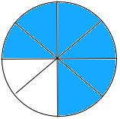
- Present each of the following fractions in the form of a diagram.
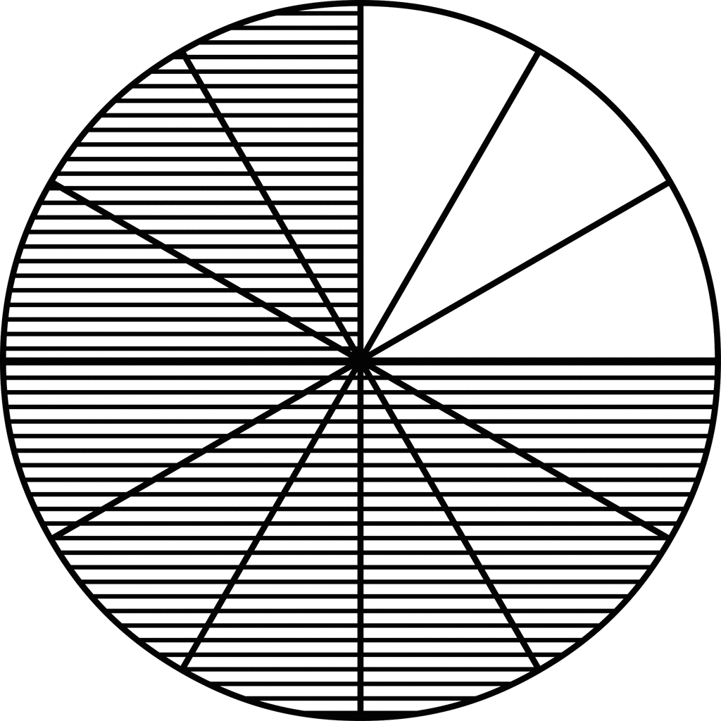
9
12
6
8
c.
a.
6
8
d.
3

6
8
3
d.
15
7
b.

- Draw diagrams to represent and differentiate between the following types of fractions:
Draw at least two different diagrams in each case.

5
9
10
14
  - Proper fraction

39
10
12
5
  - Improper fraction

3
7
3
4
5
1
  - Mixed fraction

3
7
3
15
7
  - Like fractions
18
11
6
8
5
9
  - Unlike fractions

4
6
  - Equivalent fractions

8
12

3
4

6
8

3. Sort out the following fractions and write them down in the correct column of the given table.

Proper Fractions | Improper Fractions | Mixed Fractions | Like Fractions | Unlike Fractions | Equivalent Fractions
9  12 | 15  7 | 300  1  8  18  11 | 9  11 | 21  18  21  24 | 16  100  4  25
6  8 | 250  240 | 1  2  5 | 66  57  63  57 | 8  10  4  5 | 8  10  4  5
35
46
2
97
 |  |  | 16  100 | 4  25

- Write down the fraction of each animal in the following group of animals.
7
18
- Fraction of horses:

5
18
- Fraction of elephants:

6
18
- Fraction of lions:

- Is there any LIKE FRACTION in your answers ‘a’, ‘b’ or ‘c’? ‘YES’ OR ‘NO’?
Give a mathematical reason for your answer.
Yes, all three fractions of answers a, b and c are ‘like fractions’. They all have the same denominator. This is because, these fractions represent the same group of animals, so their total is same.
- Is there any IMPROPER FRACTION in your answers ‘a’, ‘b’ or ‘c’? ‘YES’ OR ‘NO’?
Give a mathematical reason for your answer.
No there is no improper fraction in answers a, b and c. None of the fractions has a smaller numerator as compared to denominator. This is because, the fractions represent the number of animals in that whole group.
- Write down the fraction of each in the following pictures.
12
24
- Fraction of chocolate cones:

8
24
- Fraction of strawberry cones:

4
24
- Fraction of mango cones:

- Are the fractions of strawberry cones and mango cones equivalent fractions? ‘YES’ OR ‘NO’? Give a mathematical reason for your answer.
No, there are no equivalent fractions in these answers because all of them have same denominator whereas in equivalent fractions the numerator and denominator both must be different.
- Write down all the proper and improper fractions from your answers ‘a’, ‘b’ & ‘c’.
All the fractions in these answers are proper fractions as in all of them numerator is smaller than the denominator.

