GOLDY’S CLASSROOM MATH ANSWERS

GEOMETRY SERIES PART-1

- Find out objects in your home which have different 2-D & 3-D shapes. Write down the names of the shape and the object. You can also draw their pictures.
Students do it on their own

- Draw different 2-D shapes cut them out and make 3-D shapes from them.
Following are the links of YouTube videos. You can get help from them:
https://www.youtube.com/watch?v=88t0fESJnD0
https://www.youtube.com/watch?v=I_4SrkR5GpI
Using these 2-D and 3-D shapes create a real-life object. Label the shapes.
Students do it on their own

- Sort the following into two groups:
The shapes which have endpoints | The shapes which do not have endpoints
Point | Line
Line Segment | Curved Line
Ray (Has one endpoint)
Angle (One endpoint i.e. vertex)

- Draw the following, label them using correct notation and represent them mathematically.

X
Y
XY
  - Line

P
R
PR
  - Ray

C
D
PR
  - Line Segment

E
F
G
FEG
<
EFG
<
<EFG
  - Angle
EGF
<

- What is a point? Where is it used?
A point is an exact location or position. It has no length, width or thickness. In geometry, a point is usually represented by a small dot and is named with a capital letter, such as A or B.
Points are used to:
- Show the location of an object on a map.
- Mark the ends of a line segment or ray.
- Name the corners (vertices) of shapes.
- Plot locations on a coordinate plane.
- A marked spot on a graph or chart

- Why is a line different from a ray? Give mathematical reasons for your answer.
A line extends infinitely in both directions, while a ray extends infinitely in only one direction starting from a fixed point.
Mathematical Reason:
- Line has no endpoints – Ray has one fixed endpoint
- Line goes on forever in two opposite directions – Ray goes on forever in only one direction
- Line has no measurable length (because it is infinite) – Ray also has no fixed length, but it has a starting point, so its position is defined.

- Name the following diagram. Give a mathematical reason for your answer.
Curved Line
Line Segment

Ray
Line

- Is this angle labelled correctly? Support your answer with mathematical reason?
It is not labelled correctly
Mathematical Reason:
It is important that the label of the vertex should always come in the centre whereas in this labelling it’s not in the centre. The correct label is: <MLN OR <NLM
M
L
N

<LMN

- Draw a simple picture using:
1 line
1 ray
1 angle
1 curved line
Label all these
Students draw different pictures.
GOLDY’S CLASSROOM MATH ANSWERS

GEOMETRY SERIES PART-2

- Define a line, line segment and ray.
- A line extends endlessly in both directions.
- A line segment has two endpoints.
- A ray has one endpoint and extends endlessly in one direction.

- What is a curved line?
A curved line is a line that bends and is not straight.

- State the meaning of parallel, perpendicular and intersecting lines.
  - Parallel lines never meet and stay the same distance apart.
  - Perpendicular lines meet at a right angle (90°).
  - Intersecting lines cross each other at any angle.

- What is a transversal?
A transversal is a line that intersects two or more lines.

- Identify and mention the horizontal, vertical and oblique lines from your surroundings.
  - A horizontal line goes left to right.
  - A vertical line goes up and down.
  - An oblique line is slanted (neither horizontal nor vertical).

- Explain how a line is different from a line segment.
A line goes on forever; a line segment stops at two endpoints.

- Describe how a ray is different from a line.
A ray starts at one point and continues forever; a line continues forever in both directions.

- Explain why parallel lines never meet.
Parallel lines never meet because they run in the same direction and stay equally apart.

- Describe what happens when a transversal cuts two lines.
A transversal creates angles when it cuts across lines.

- Explain the difference between horizontal, vertical, and oblique lines.
  - Horizontal = flat
  - Vertical = upright
  - Oblique = slanted.

- Represent the following mathematically using correct notation:
- A line through points A and B ---------------- $\overset{↔}{AB}$
  - A line segment AB ---------------- $\overset{‾}{AB}$
  - A ray starting at A and passing through B ---------------- $\vec{AB}$
  - Line LM parallel to line OP ---------------- $\overset{↔}{LM}$ || $\overset{↔}{OP}$
  - Line WX perpendicular to line YZ ---------------- $\overset{↔}{WX}$ ⟂ $\overset{↔}{YZ}$

  - Line AB → $\overset{↔}{AB}$
  - Line segment AB → $\overset{‾}{AB}$
  - Ray AB → $\vec{AB}$
  - $\overset{↔}{LM}$ || $\overset{↔}{OP}$
  - $\overset{↔}{WX}$ ⟂ $\overset{↔}{YZ}$

- Compare a line segment and a ray based on endpoints and direction.
  - Segment: It has two endpoints and does not increase in any direction
  - Ray: It has one endpoint and one infinite direction

- How are intersecting and perpendicular lines similar and different?
  - In both the types, lines cross each other
  - Perpendicular lines cross at 90°, intersecting lines can cross at any angle

- Analyse how a transversal changes angle relationships when it intersects parallel vs non-parallel lines.
  - A transversal creates equal corresponding angles when cutting parallel lines, but not when cutting non-parallel lines.
  - Horizontal = left–right, vertical = up–down, oblique = slanted.

- How can you tell whether a given line is oblique, horizontal or vertical. Justify your answer with a mathematical reason.
  - Lines are parallel if they never meet and stay equidistant.
  - Lines are perpendicular if they form a right angle.
  - A line is oblique if it is neither horizontal nor vertical.
  - A line is a transversal if it intersects two or more lines.

- Design a figure where a transversal intersects two parallel lines and label all angles.
Students will make their own figure.

- Create a diagram that includes:
- one line
- one line segment
- one ray
- one curved line
- one pair of parallel lines
- one pair of perpendicular lines
- one transversal

Label all these lines using correct notation.
Students will make their own diagram.

- Draw a real-life scene (road, building, room, playground) and show at least five types of lines. Also label them
Students will make their own real-life scene.

- Create a geometric pattern using horizontal, vertical and oblique lines. Make this pattern colorful.
Students will make their own pattern.

GOLDY’S CLASSROOM MATH ANSWERS

GEOMETRY SERIES PART-3

- What is a polygon? List all its characteristics.
Polygons are 2-D shapes with straight sides that join to make a closed figure. Two sides of a polygon meet at a vertex.
Characteristics
- They are 2-D, flat shapes.
- They have straight sides that join end-to-end.
- Their sides meet only at their endpoints to form vertices (corners).
- There is no crossing over of sides.
- They have no curved sides.
- They have 3 or more sides.
- They form a closed shape with no openings.

- Compare a polygon and a non-polygon using a Venn diagram. Draw three polygons and three non-polygons.
Polygons
Non-Polygons
- Both include 2-D, flat, closed shapes.
- Both include flat, open 2-D shapes.
- They have straight sides that join end-to-end.
- Their sides meet only at their endpoints to form vertices (corners).
- There is no crossing over of sides.
- They have no curved sides.
- They have 3 or more sides.
- They have one or more curved sides.
- They have intersecting sides. Its sides cross over each other.
- They are not made entirely of straight-line segments.
- Their sides do not meet at their endpoints to form vertices (corners).

A
D
C
B

- Explain why this shape is not a polygon. Which rule does it break?
This shape has curved corners and straight edges and sharp vertices.

- A student says, "Every closed shape is a polygon.” Do you agree? Explain your answer.
No. The closed shapes that have curved surfaces are not polygons.

- Label the 2-D shapes shown in these diagrams.
Sort them into polygons and non-polygons.
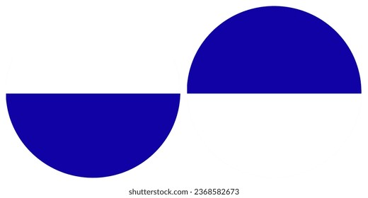
Circle
Triangle
Circle
Circle
Ovals
Lines
Triangles
Rectangles
Cylinder
Oval
Semi-circle

Cylinder
Triangle
Cylinder
Rectangles
Square
Rectangle
Rectangle
Rectangle
Cylinder
Circles
Circles
Triangle

Polygons | Non-Polygons
Triangle | Cylinder
Rectangle | Circle
Square | Semi-circle
 | Lines

- Explain why a circle is not a polygon.
Polygons do not have curved surface or edges whereas circle has a curved surface.

- State the basic properties of a triangle, rectangle, trapezium and hexagon.

2-D Shapes | No. of Sides | No. of Angles (Vertices) | Regular/Irregular
Rectangle  Trapezium  Hexagon  Triangle | 4 sides  2 sets of 2 equal sides | 4 angles  All equal 90º | Regular
 | 3 sides  All equal | 3 angles  All equal | Regular
 | 4 sides  At least 2 sides can be equal | 4 angles  Can be pairs of equal angles | Irregular
 | 6 sides  Can be equal or unequal | 6 angles  Can be equal or unequal | Can be  Regular  OR  Irregular

- What is a regular and an irregular polygon? Give examples.
A regular polygon is a 2-D shape where:
- All sides are equal in length
- All angles are equal in size
Example:
Equilateral Triangle
(3 equal sides, 3 equal angles)

An irregular polygon is a 2-D shape where:
- Sides are not all equal
- Angles are not all equal
(Often both are unequal)
Example:
Rectangle
(opposite sides are equal, but not all four sides are equal)

- Compare a square and a rhombus.

Square | Rectangle
4 sides  All equal | 4 sides  All equal
4 angles  All equal 90º | 4 angles  2 sets of 2 equal angles
Regular | Irregular

- Compare a rectangle and a parallelogram.

Rectangle | Parallelogram
4 sides  2 sets of 2 equal sides | 4 sides  2 sets of 2 equal sides
4 angles  All equal 90º | 4 angles  All equal 90º
Irregular | Irregular

- Explain what interior and exterior angles of a polygon are. Draw a labelled diagram to explain.
The interior angles of a polygon are the angles inside the shape at each corner made by two sides. Their measurement changes as the number of sides of the polygon changes.
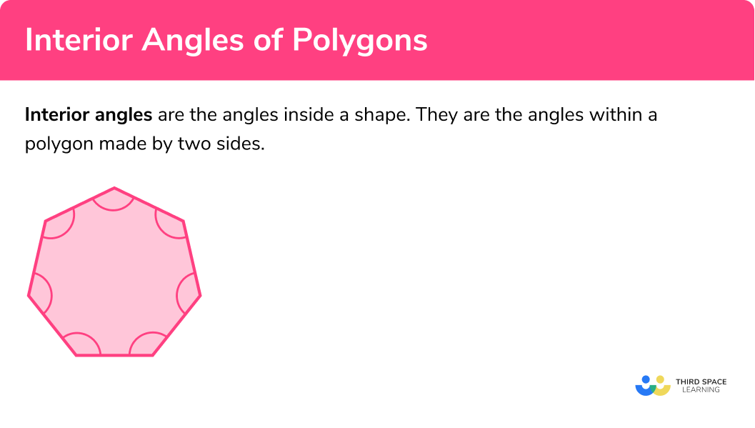
Internal Angles

An exterior angle of a polygon is the angle formed by extending one side outward from a vertex. Sum of exterior angles of all the polygons is always 360º.
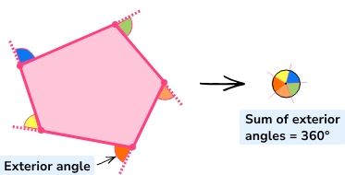

- Explain the relationship between an interior angle and its adjacent exterior angle. Explain:
Relationship:
The adjacent interior and exterior angles of a polygon are supplementary angles i.e., the sum of these angles is 180º.
  - how changing the interior angle affects the exterior angle.
As the interior angles increase the exterior angles decrease.
  - why does the sum of interior angles increase as the number of sides increases.
As the number of sides increases, the number of angles also increases, and the measurement of each angle also increases.
  - Compare the interior and exterior angles of a regular heptagon.
Each interior angle of a regular heptagon measures approximately 128.57°. And the measurement of each exterior angle is 51.43°. They both add up to 180º.

- Write down the formulas for calculating the following angles:
  - sum of interior angles of a polygon.
(n-2) x 180 --------- Where ‘n’ is the number of sides.
  - each interior angle of a regular polygon.
(n-2) x 180 --------- Where ‘n’ is the number of sides.
n
  - exterior angle of a regular polygon.
There are two methods:
- 360 ÷ n --------- Where ‘n’ is the number of sides.
- 180 – (adjacent interior angle)

- Find the measurement of the following angles:
  - the sum of interior angles of a pentagon.
(5-2) x 180 = 540º.
  - each interior angle of a regular nonagon.
(n-2) x 180
n
= (9-2) x 180
9
= 7 x 180
9
= 1260
9
= 140º

  - the exterior angle of a regular decagon.
Method 1
360 --------- Where ‘n’ is the number of sides.
n
= 360
10
= 36º

Method 2
Each interior angle of decagon = 144º
Each exterior angle of decagon = 180 – interior angle
= 180 – 144
= 36º

  - the interior angle of a regular 12-sided polygon (dodecagon)?
(n-2) x 180
n
= (12-2) x 180
12
= 10 x 180
12
= 1800
12
= 150º

- Calculate the following:
  - the adjacent exterior angle when the interior angle is 125°.
180 – interior angle
=180 – 125
= 55º

  - the interior angle when the exterior angle measures 70°.
180 – exterior angle
=180 – 70
= 110º

- A student says, "An interior angle and its adjacent exterior angle always add up to 360°." Explain why this is incorrect.
The interior and exterior angles always add up to 180º. Whereas the sum of all the exterior angles is always 360º.

- A student says, "All four-sided shapes are squares." Explain with examples why this statement is incorrect.
All four-sided shapes are called quadrilaterals, but they all are not squares as they do not fulfil the requirements of a square. A square has 4 equal sides and 4 equal angles. However, rectangle, parallelogram, rhombus and trapezium neither have all 4 equal sides nor all 4 equal angles.

- Which regular polygon has the larger interior angle—a hexagon or an octagon? Explain.
Hexagon has 6 sides and octagon has 8 sides. As the number of sides increase the measurement of interior angle increases. Therefore, octagon has larger interior angle.

- Can a shape have all sides equal but still be irregular? Explain with an example.
Yes a shape can have all sides equal but still be irregular. Rhombus has all the sides equal but all its angles are not equal.

- A polygon has an interior angle sum of 1,620°. How many sides does it have? Show your reasoning.
(n−2) × 180º = 1620º --------- Where ‘n’ is the number of sides.
(n−2) = 1620º
180º
n – 2 = 9
n = 9 + 2
n = 11

- Compare the properties of a regular decagon and an irregular decagon.
Differences:
Regular decagon has all the angles equal
Irregular decagon does not have all the angles equal
Regular decagon has all the sides equal
Irregular decagon does not have all the sides equal
Similarities:
The sum of exterior angles in both the regular and irregular decagon is 360º.

- Create an object (rocket, robot, flower, animal, house) using 2-D shapes and label them.
Students to design their own object.

- Which of the following statements is true? Support your answer with a mathematical reason.
  - All 2-D shapes are polygons.
  - All polygons are 2-D shapes.

- Statement ‘b’ i.e., “All polygons are 2-D shapes”, is the correct statement as polygons only comprise of 2-D shapes.
- Statement ‘a’ i.e., “All 2-D shapes are polygons”, is not a correct statement because the shapes with curved surfaces are 2-D shapes but they are not polygons. e.g., circle, oval etc.

