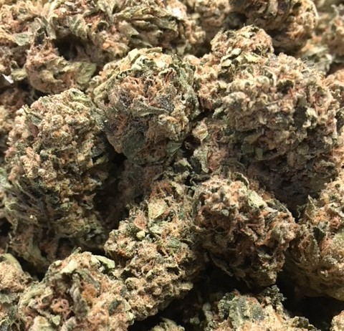 | BERRY BOMB ~ ID Hybrid  Berry Bomb is a hybrid cross between Blueberry and Bomb #1 that shows off its indica-leaning genetics through powerful sedation. A sweet blueberry and earthy pine flavor launches you into Berry Bomb’s potent full-body effects, which can easily help you transition into a restful night or an afternoon nap.  1/8 = $55; ¼ = $100; ½ = $190; 1oz = $300
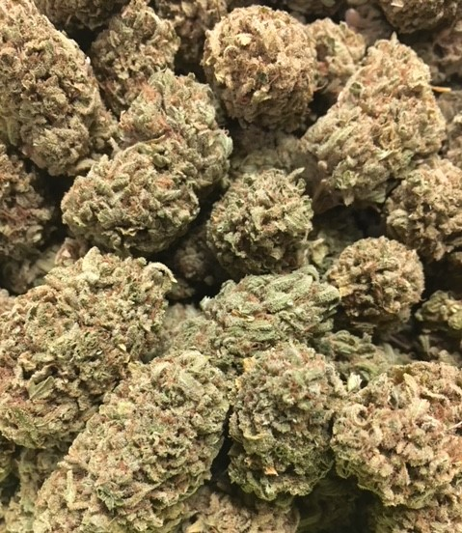 | FACE OFF OG ~ Indica  This 70/30 indica-dominant hybrid shares its name with the 1997 movie in which Nicolas Cage and John Travolta literally swap faces (“I want to take his face…off!”), and the experience this strain has to offer could be compared to losing your face. Dizzying euphoria goes straight to the head in an intensely psychoactive experience best reserved for veteran consumers. Its crushing full-body effects make this strain a great choice for resolving severe pain or for relaxing on a lazy weekend.  1/8 = $55; ¼ = $100; ½ = $190; 1oz = $300
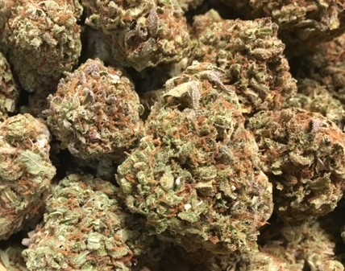 | STRAWBERRY OG ~ Hybrid  Strawberry OG (not to be confused with OG Strawberry) is the product of a search for stable strawberry flavor mixed against Bruce Banner’s exceptional structure and yield. This hybrid, clone-only strain blends the upbeat sedation of SFV OG with Bruce Banner’s OG Kush body and Strawberry Diesel mind to create a hybrid wonder of physical and mental effects. Anticipate a euphoric and relaxing aura that does deter physical activity, but unleashes the mind, offering a spacey, creative tint to everyday hobbies.  1/8 = $55; ¼ = $100; ½ = $190; 1oz = $300
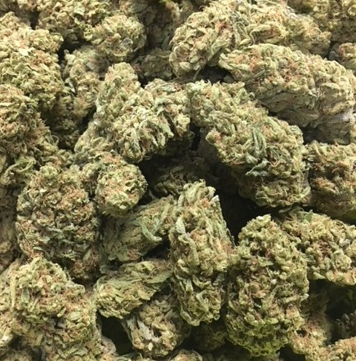 | TANGIE ~ Sativa  Tangie is another fantastic offering from DNA Genetics in Amsterdam that has quickly gained popularity in its home and is spreading elsewhere. This strain is a remake of sorts of the popular version of Tangerine Dream that was sought-after in the 1990s. The genetics on this strain are a cross of California Orange and a Skunk hybrid, and its citrus heritage is the most evident in its refreshing tangerine aroma.  1/8 = $55; ¼ = $100; ½ = $190; 1oz = $300
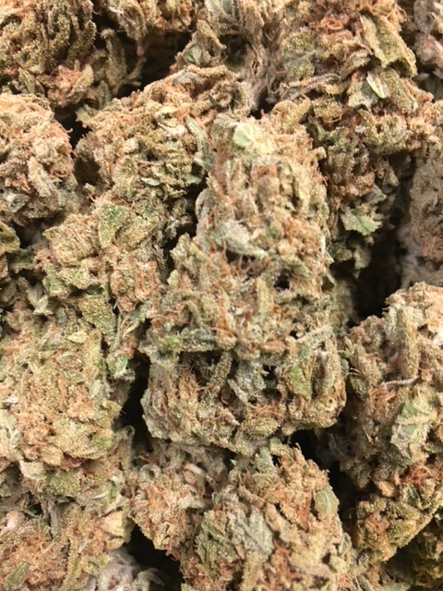 | 9 POUND HAMMER ~ Indica  9 Pound Hammer is an 80% indica strain created by JinxProof Gentics that crosses Gooberry, Hells OG, and Jack the Ripper. These dense buds are coated in resin, offering sweet grape and lime flavors. True to its indica dominance, effects are heavy and long-lasting, useful for pain and stress relief.  1/8 = $50; ¼ = $90; ½ = $140; 1oz = $240
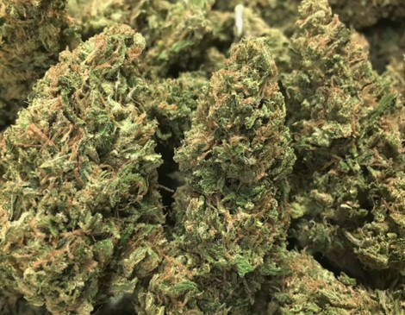 | GUAVA KUSH ~ Sativa  Guava Kush is reputed to be a sativa-dominant hybrid with a sativa/indica ratio of 65:35, delivering a true mix of physical and cerebral high: relaxing, creative, tingly, sociable, and occasionally sleepy. Chronic pain, insomnia, and anxiety may all be treated with this strain. The flavor is sweet, tropical, and fruity, while the aroma is similar. The nugs are a mix of dark and light green, together with amber hairs and a healthy layer of trichomes on the surface.  1/8 = $50; ¼ = $90; ½ = $140; 1oz = $240

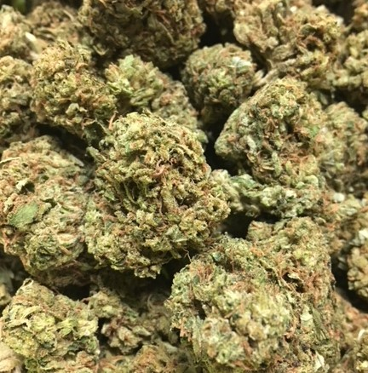 | SOUR DIESEL ~ Sativa  Sour Diesel, sometimes called Sour D, is an invigorating sativa-dominant strain named after its pungent, diesel-like aroma. This fast-acting strain delivers energizing, dreamy cerebral effects that have pushed Sour Diesel to its legendary status. Stress, pain, and depression fade away in long-lasting relief that makes Sour Diesel a top choice among medical patients. This strain took root in the early 90's, and it is believed to have descended from Chemdawg 91 and Super Skunk.  1/8 = $50; ¼ = $90; ½ = $140; 1oz = $240
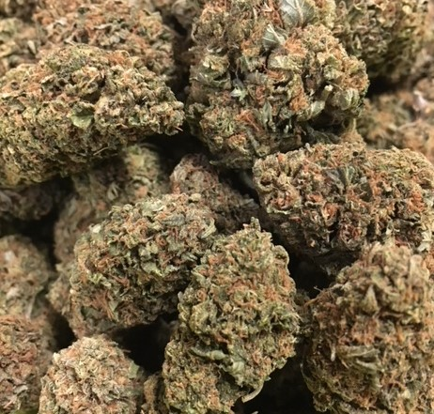 | BLUEBERRY COOKIES ~ ID Hybrid  Blueberry Cookies is an indica-dominant hybrid created by crossing Blueberry Tahoe and Thin Mint GSC. This strain’s unique flavor is a mixture of roasted nuts, mint, and fresh blueberries, while the bouquet provides an earthier, berry-forward aroma. Blueberry Cookies tends to hit the consumer in the body with mid-level sedative effects that are relaxing without being cumbersome. The mental state is often heady and creative, offering a distraction from stress. Blueberry Cookies is often recommended for consumers contending with chronic pain, inflammation, and depression.  1/8 = $45; ¼ = $75; ½ = $120; 1oz = $190
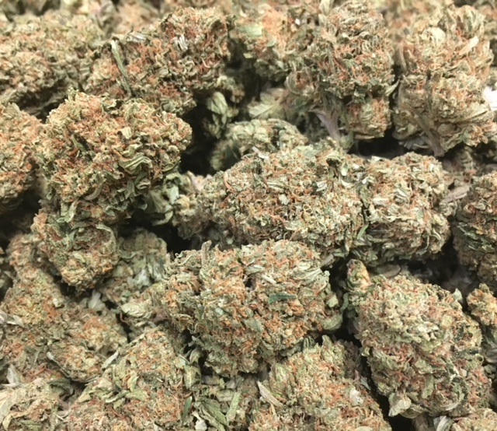 | CHEMDAWG ~ Sativa  Chemdawg has developed quite the name for itself over the years. The original source of powerhouse strains like Sour Diesel and OG Kush, Chemdawg is known for its distinct, diesel-like aroma. Pungent and sharp, you’ll be able to smell this hybrid from a mile away. Consumers can expect to have a very cerebral experience, coupled with a strong heavy-bodied feeling.  1/8 = $45; ¼ = $75; ½ = $120; 1oz = $190
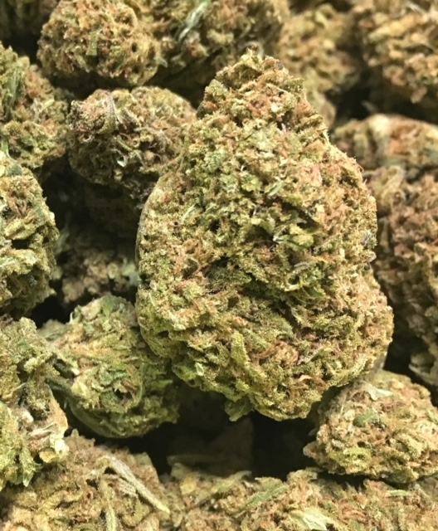 | MASTER KUSH ~ Indica  Master Kush is a popular indica cross created out of two landrace strains from different parts of the Hindu Kush region. This strain holds a superb balance of full-body relaxation without the mind-numbing effect that many indica strains produce. Instead, Master Kush offers a sharpened sensory awareness that can bring out the best of any activity.  1/8 = $45; ¼ = $75; ½ = $120; 1oz = $190
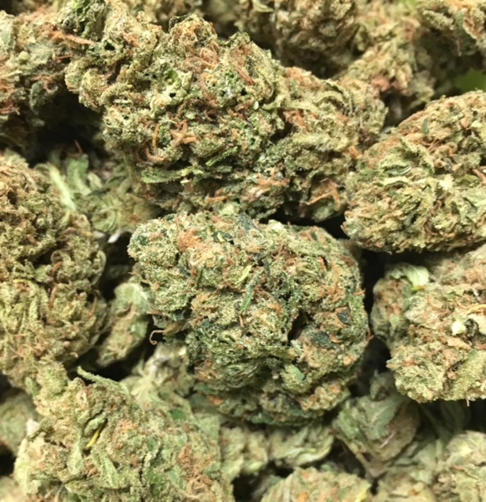 | HIPPIE CRIPPLER ~ SD Hybrid  Don’t worry, Hippie Crippler isn’t some strange affliction you may get from hanging around with flower children, it’s an uplifting sativa-dominant hybrid. Patients love this cross of AK-47 and Blue Satellite for its sweet smell and taste. Take this Hippie home and you’ll be glad you did. While this strain is popular for daytime, it may leave some patients bleary-eyed and a little spacey depending on tolerance and dosage.  1/8 = $40; ¼ = $60; ½ = $100; 1oz = $150
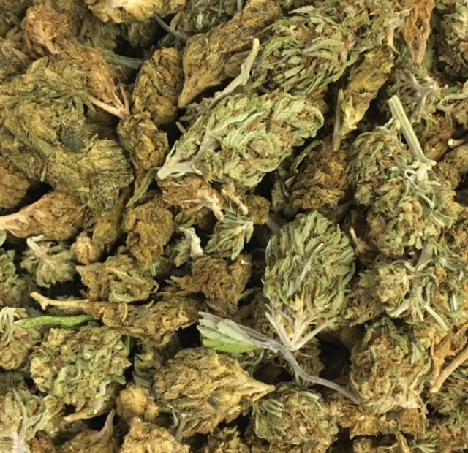 | HOUSE BLEND ~ Variety  A variety mix of flowers recently taken off the menu.  1/8 = $40; ¼ = $60; ½ = $100; 1oz = $150

