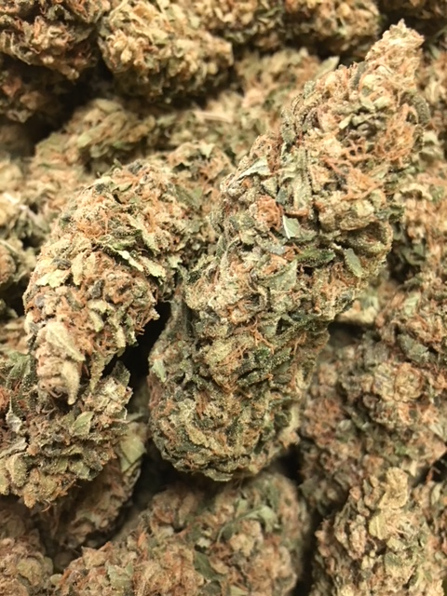 | JET FUEL ~ Sativa  Jet Fuel, also known as G6, from 303 Seeds is the ultimate cross of some of the most renowned Diesel strains. By combining Aspen OG with High Country Diesel, we are left with a sativa-driven hybrid that stays true to the influence of SFV OG Kush and East Coast Sour Diesel in its lineage. The name Jet Fuel isn’t purely devoted to the sweet, pungent aroma of diesel fumes that this strain exudes, but also the high-energy jolt of uplifting sativa effects that eventually level off to provide a dream-like state of relaxation.  1/8 = $55; ¼ = $100; ½ = $190; 1oz = $300
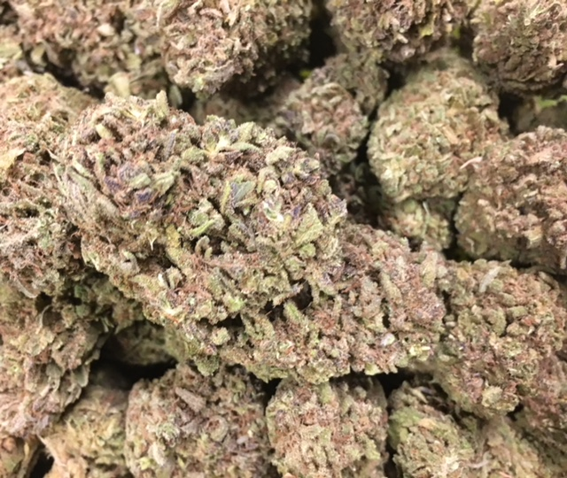 | MASTER YODA ~ ID Hybrid  With lab-tested THC levels that reach over 20%, strong medicine, Master Yoda is. This strain, however, is not about brute “Force,” as the original Master Yoda would know, and the sativa side of this mostly indica buzz has just enough of an uplifting balance to please just about anyone. Master Yoda clinched 1st Place at High Times Los Angeles Cannabis Cup in 2012, where the OG Kush and Master Kush cross was already a local favorite.  1/8 = $55; ¼ = $100; ½ = $190; 1oz = $300
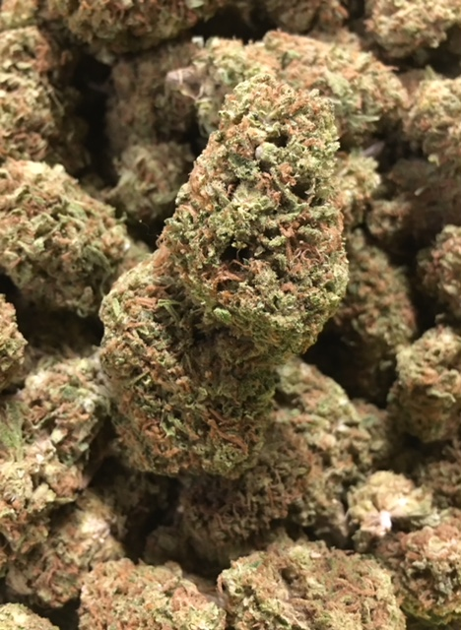 | STRAWBERRY BANANA ~ ID Hybrid  Strawberry Banana is a 70/30 indica-dominant cannabis strain developed by DNA Genetics in collaboration with Serious Seeds. A genetic cross between Crockett’s Banana Kush and the “Strawberry” phenotype of Bubble Gum, Strawberry Banana inherits a sweet fruity flavor that earned this hybrid her name. Known for its heavy resin production and high THC content, Strawberry Banana produces happy, peaceful effects that sharpen creativity and sensory awareness.  1/8 = $55; ¼ = $100; ½ = $190; 1oz = $300
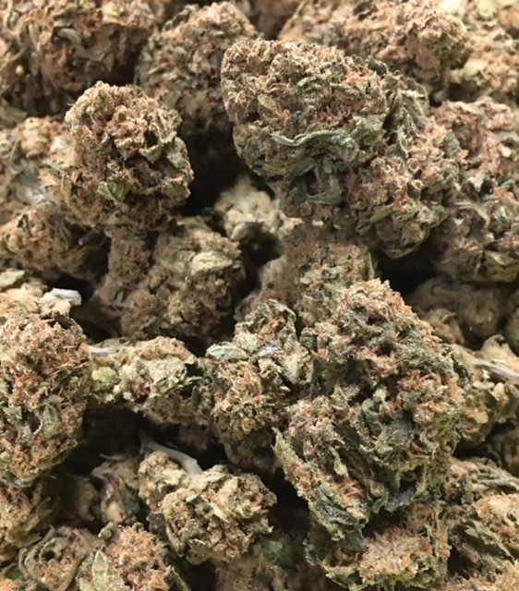 | THC BOMB ~ ID Hybrid  THC Bomb is the signature hybrid strain from Bomb Seeds, and as its name indicates, it was developed to have very high THC levels—upwards of 20%! This bomb won’t completely knock you off your feet, though, thanks to its well-rounded hybrid mix.  1/8 = $55; ¼ = $100; ½ = $190; 1oz = $300
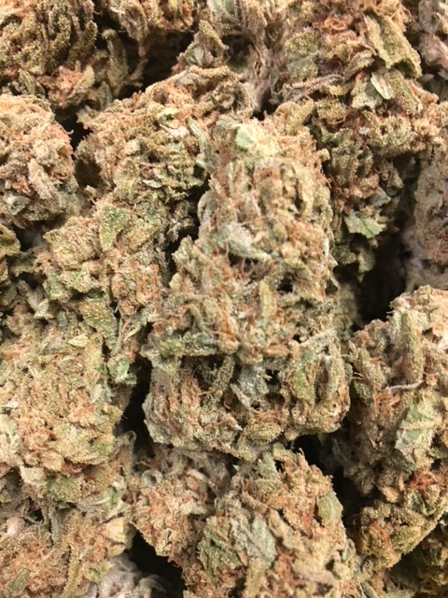 | 9 POUND HAMMER ~ Indica  9 Pound Hammer is an 80% indica strain created by JinxProof Gentics that crosses Gooberry, Hells OG, and Jack the Ripper. These dense buds are coated in resin, offering sweet grape and lime flavors. True to its indica dominance, effects are heavy and long-lasting, useful for pain and stress relief.  1/8 = $50; ¼ = $90; ½ = $140; 1oz = $240
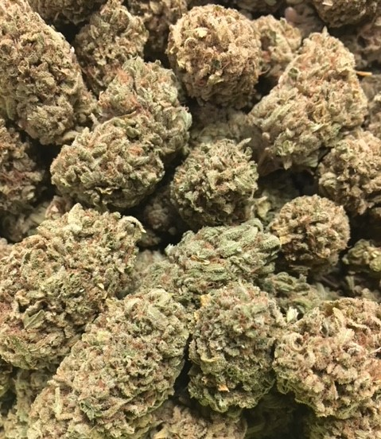 | FACE OFF OG ~ Indica  This 70/30 indica-dominant hybrid shares its name with the 1997 movie in which Nicolas Cage and John Travolta literally swap faces (“I want to take his face…off!”), and the experience this strain has to offer could be compared to losing your face. Dizzying euphoria goes straight to the head in an intensely psychoactive experience best reserved for veteran consumers. Its crushing full-body effects make this strain a great choice for resolving severe pain or for relaxing on a lazy weekend.  1/8 = $50; ¼ = $90; ½ = $140; 1oz = $240

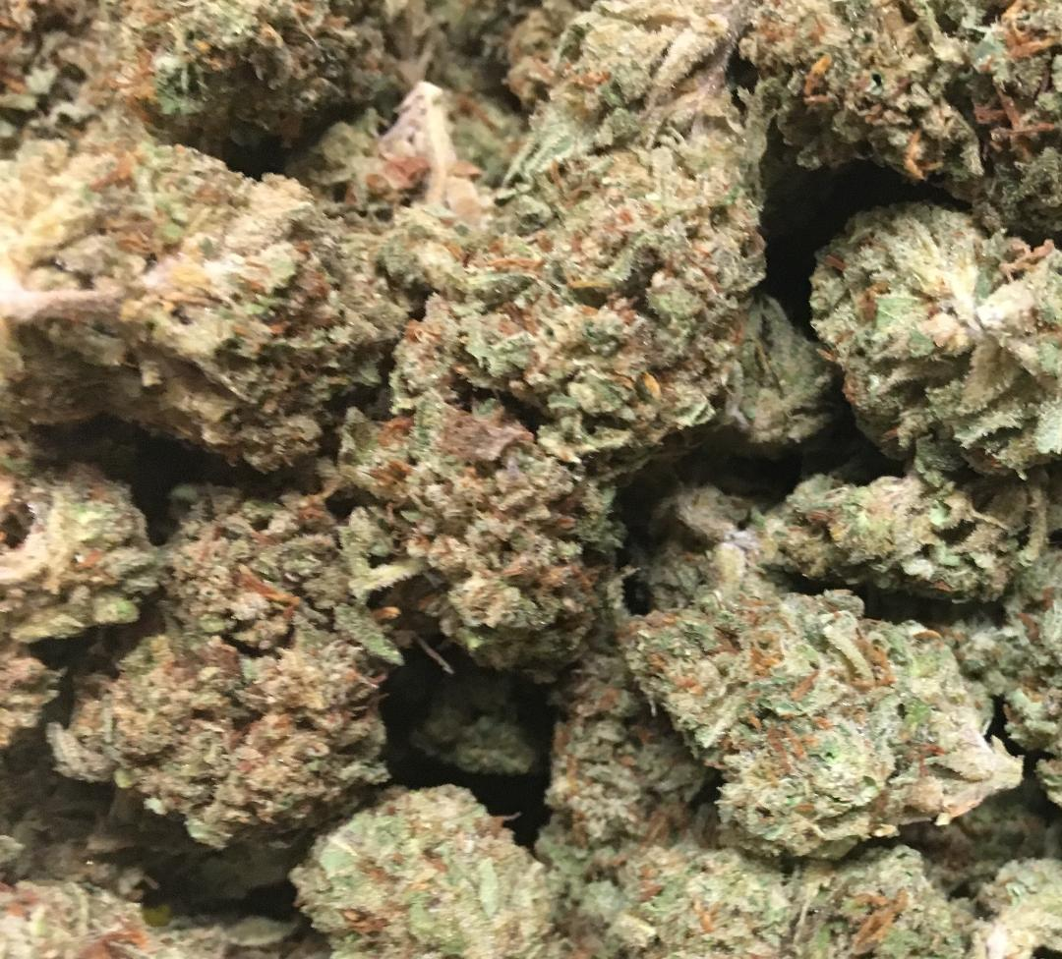 | SHAPE SHIFTER ~ ID Hybrid  Like John Carpenter’s the Thing Shape Shifter seems to be an attempt to absorb the qualities of nearly everything to create a perfect chimera. A cross of Old Man’s Purple, Malawi, Northern Lights Haze, and Memory Loss, this powerful indica strain delivers dreamy, sleepy euphoria giving your eyelids some heaviness at night while giving your mood a burst of energy.  1/8 = $50; ¼ = $90; ½ = $140; 1oz = $240
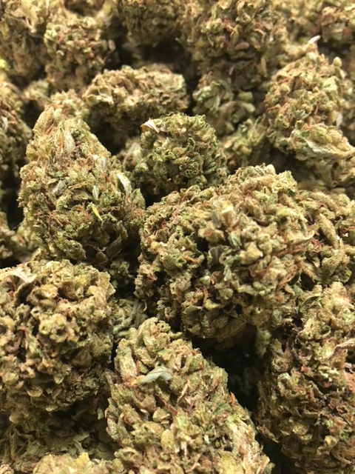 | 3 KINGS ~ SD Hybrid  The 3 Kings marijuana strain, a holy trinity of Headband, Sour Diesel, and OG Kush, is a sativa-dominant hybrid and genetic masterpiece. Sour tanginess reek from the sage green buds, and its frosty coat gives you a fair warning of the 3 Kings’ potency. Medical patients will appreciate the versatility of this strain’s medicinal effects as it relieves pain, stress, and nausea without heavy sedation.  1/8 = $45; ¼ = $75; ½ = $120; 1oz = $190
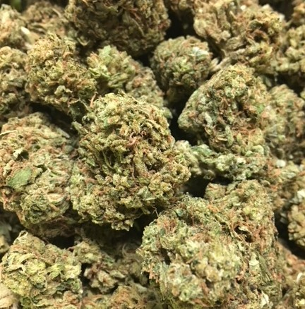 | SOUR DIESEL ~ Sativa  Sour Diesel, sometimes called Sour D, is an invigorating sativa-dominant strain named after its pungent, diesel-like aroma. This fast-acting strain delivers energizing, dreamy cerebral effects that have pushed Sour Diesel to its legendary status. Stress, pain, and depression fade away in long-lasting relief that makes Sour Diesel a top choice among medical patients. This strain took root in the early 90's, and it is believed to have descended from Chemdawg 91 and Super Skunk.  1/8 = $45; ¼ = $75; ½ = $120; 1oz = $190
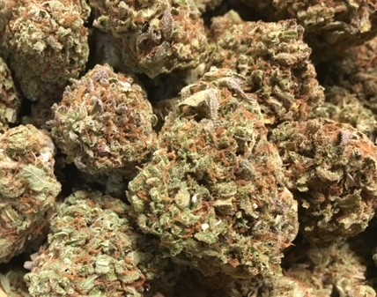 | STRAWBERRY OG ~ Hybrid  Strawberry OG (not to be confused with OG Strawberry) is the product of a search for stable strawberry flavor mixed against Bruce Banner’s exceptional structure and yield. This hybrid, clone-only strain blends the upbeat sedation of SFV OG with Bruce Banner’s OG Kush body and Strawberry Diesel mind to create a hybrid wonder of physical and mental effects. Anticipate a euphoric and relaxing aura that does deter physical activity, but unleashes the mind, offering a spacey, creative tint to everyday hobbies.  1/8 = $45; ¼ = $75; ½ = $120; 1oz = $190
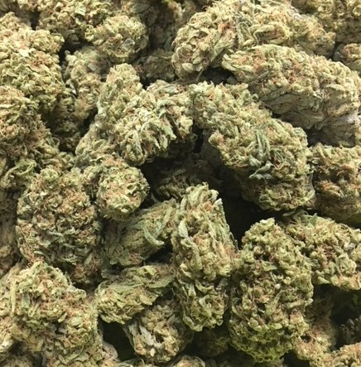 | TANGIE ~ Sativa  Tangie is another fantastic offering from DNA Genetics in Amsterdam that has quickly gained popularity in its home and is spreading elsewhere. This strain is a remake of sorts of the popular version of Tangerine Dream that was sought-after in the 1990s. The genetics on this strain are a cross of California Orange and a Skunk hybrid, and its citrus heritage is the most evident in its refreshing tangerine aroma.  1/8 = $40; ¼ = $60; ½ = $100; 1oz = $150
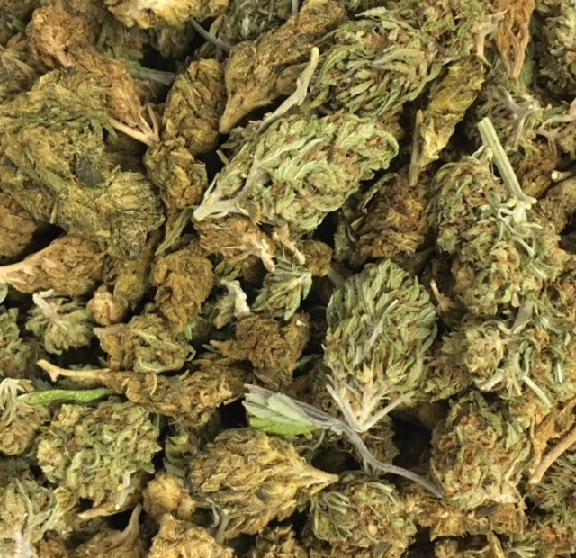 | HOUSE BLEND ~ Variety  A variety mix of flowers recently taken off the menu.  1/8 = $40; ¼ = $60; ½ = $100; 1oz = $150

