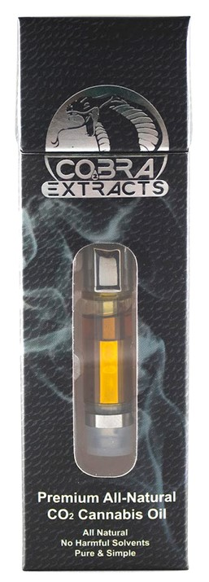 | Cobra Extracts Oil Cartridge 1g (1,000mg)  Cobra Extracts Vape Cartridges offer a convenient means of medicating, just attach our cartridge to any standard vape pen and smoke it. Since it is concentrated (typical ranges are 60-70% THC) much less is needed to produce the desired affect.  Unlike some other companies, we never add any additives or "cut" our vape cartridges with anything. Because of our unique process our vape cartridge oil maintains a flowing consistency, so you never have to deal with wasted medicine that won't wick in the cartridge. Our process ensures that every cartridge is 100% cannabis oil. Pure and Simple.  $60/each

Cobra Extracts Award winning Distillate! 2018 High Times Cannabis Cup Winner!

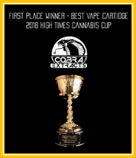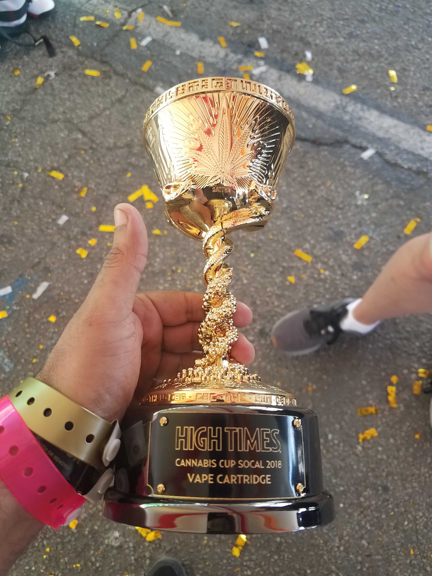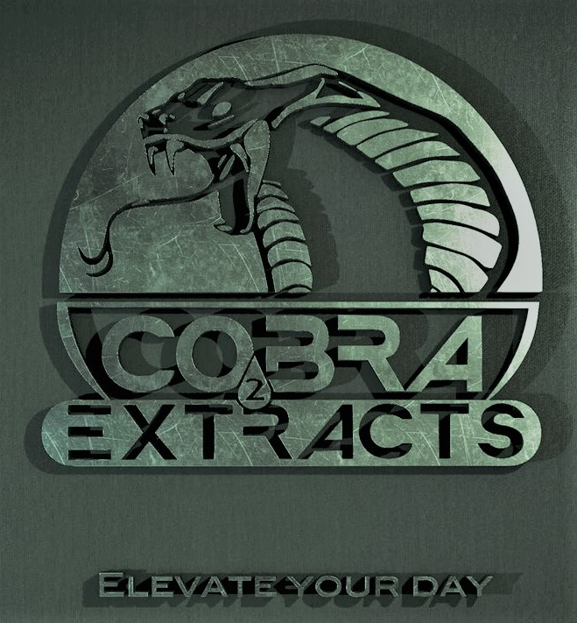
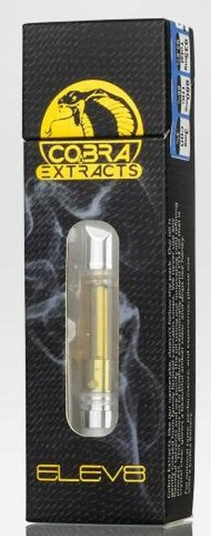 | Cobra ELEV8 Distillate Cartridge 1g (1,000mg)  Cobra Extracts Award winning Distillate! 2018 High Times Cannabis Cup Winner!  Available in Blue Berry Haze (Award winning flavor) and Venom OG  This is a new CCell cartridge that requires a strong battery, don’t forget to buy a Cobra Extracts Switch Blade Style Battery for optimum results! (Discount when purchased as a Battery/Cartridge Bundle!)  $75/each
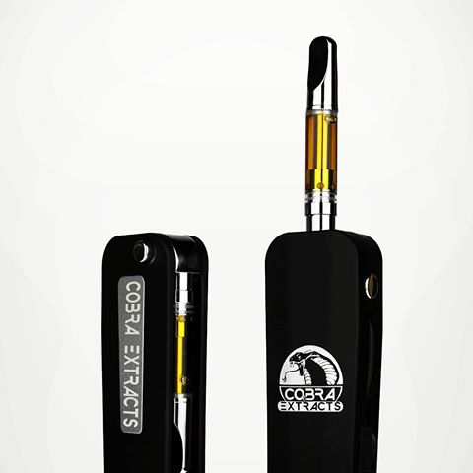 | Cobra Extracts Switch Blade Style Battery  Cobra Extracts has created a battery that elegantly combines both form and function, offering a convenient switch blade style push button retracting cartridge, preventing breaking cartridges while you store them in your pockets or a bag. The battery also has a built in USB charger so you never need to search for yours! Finally, because it looks so much like a FOB key, we added a keychain loop so you can always carry it with you and enjoy a vape whenever the mood strikes you.  $30/EACH
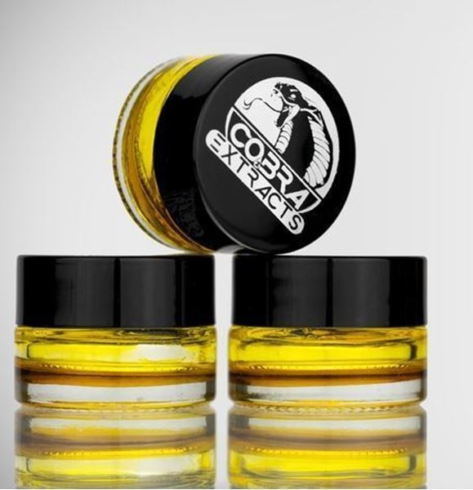 | Cobra Extracts SAP 1g (1,000mg)  Our dabs offer traditional dabbers the option to enjoy the benefits of CO2 extraction.  Produced all naturally with no solvents, our unique process allows us to extract high potency without sacrificing critical terpenes. We take pure CO2 oil and naturally purge excess water, leaving only a beautiful cannabis oil. Because the oil is not further refined, it maintains a less oily consistency than our other products. It can be pulled like any other dab, but unlike other dabs it's produced without any hard solvents. Taste the difference!  $45/EACH
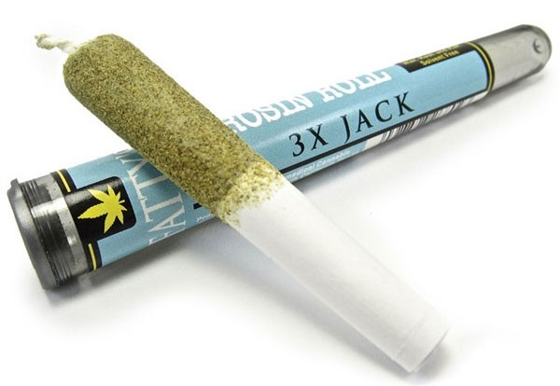 | Fatty’s Rosin Roll  Made for the professional smoker, Fatty's "The Rosin Roll" is a limited edition product because of the care and effort that is required to make this superior pre-roll. Using only 100% pure bud, each one is infused with the same strain of naturally extracted rosin wax, hash and kief. It is three layers of extremely high quality products so that you can enjoy a pure taste if its the strain you choose.  $20/EACH
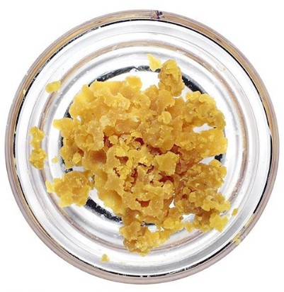 | Crumble 1g  Beautiful, golden crumble, 100% solvent free.  $30/EACH

