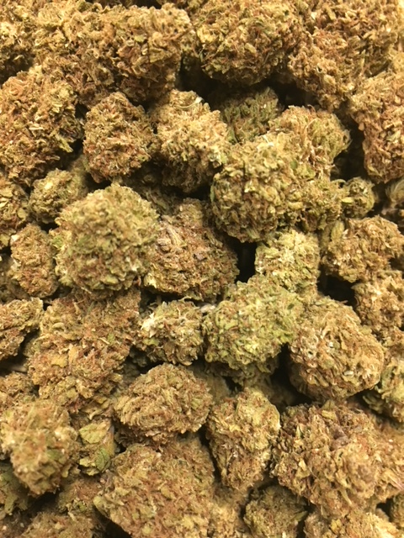 | BLUE SUGAR ~ Hybrid  Blue Sugar is a Sativa-dominant hybrid strain that is genetically linked to Blue Dream and Sugar Kush. Blue Sugar seems to provide a look and smell like Cannabis Sativa. However, if you aren’t careful with the Blue Sugar strain, it can have some intense couch-lock capability. This is great for full body pain relief, especially when medicating in large quantities. This heavy effect stems from the Indica lineage of Sugar Kush. The Sugar Kush strain was chosen for its ability to increase the yield, add a bit more stoniness to the equation, and improve the show quality of the bud structure.  1/8 = $55; ¼ = $100; ½ = $190; 1oz = $300
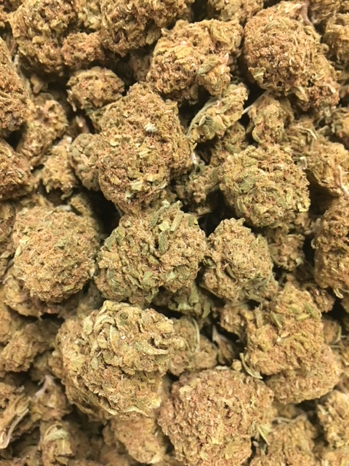 | JEDI KUSH ~ Indica  Cali Connection’s Jedi Kush brings together the forces of Death Star and SFV OG Kush, an indica alliance that will awaken both mind and body. Jedi Kush’s timid aroma isn’t fully realized until a bud is cracked open, releasing a complex fusion of sour skunk and tangy diesel. Dreamy euphoria blankets the mind, a sensation that builds over time into bolting cerebral energy that’s unexpected from our indicas. This lethargy-free strain is a great way for patients to get a powerful dose of cannabinoids during the day while treating ailments like pain, PTSD, depression, stress, headaches, and appetite loss.  1/8 = $55; ¼ = $100; ½ = $190; 1oz = $300
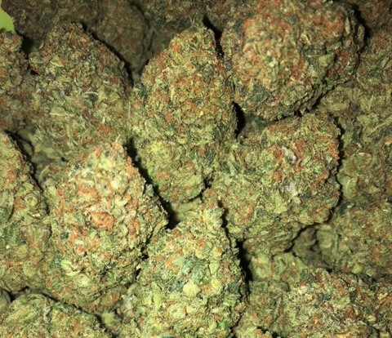 | SFV OG ~ SD Hybrid  SFV OG by Cali Connection is a sativa-dominant hybrid that is great for patients who need strong pain relief but don’t want to be stuck on the couch. As the name indicates, this OG Kush relative originates from California’s San Fernando Valley. Although their names are barely distinguishable, SFV OG Kush is actually the Afghani-crossed child to SFV OG. Its indica body effects take a little longer to feel than the initial head haziness, but once they do, everything will feel fine.  1/8 = $55; ¼ = $100; ½ = $190; 1oz = $300
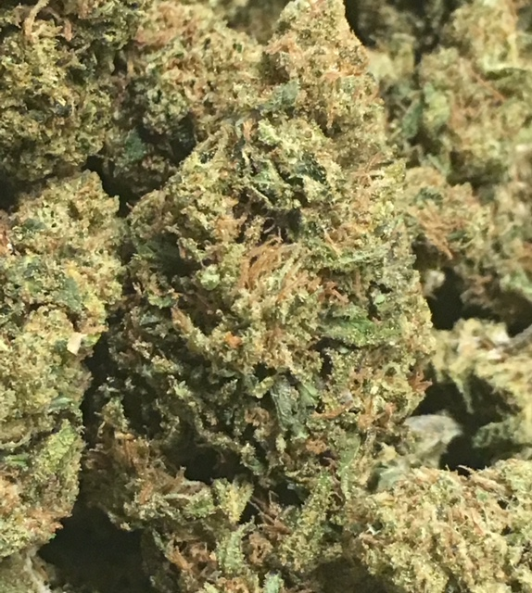 | DAWGFATHER OG ~ ID Hybrid  Dawgfather OG, or simply “The Dawgfather,” is an indica-dominant hybrid created by AlphaKronik Genes capable of massive plant production and a healthier-than-average yield. With potency floating above 20%, this strain contends well with chronic pain, insomnia, Crohn's, and anxiety. Expect traditional notes of gas/chemicals, Kush, and some funkiness. Dawgfather OG offers a strong buzz with nuance worth exploring.  1/8 = $50; ¼ = $90; ½ = $140; 1oz = $240
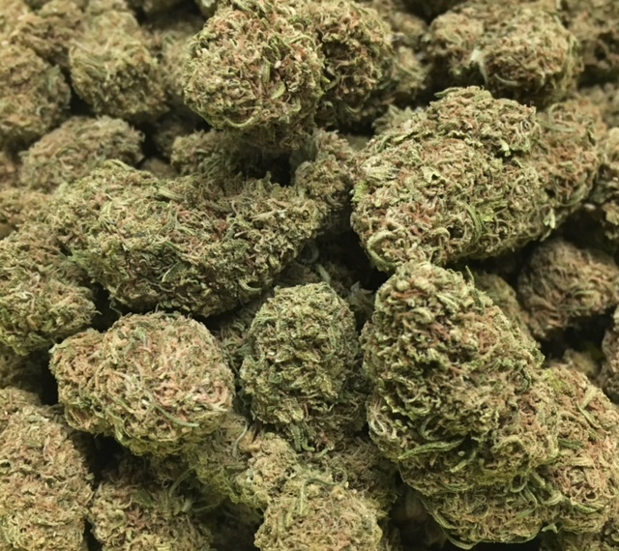 | LEMON SKUNK ~ SD Hybrid  Lemon Skunk was conceived from two separate Skunk phenotypes that displayed exceptionally zesty lemon traits. The skunky, citrus flavor draws you in immediately, and the happy, energetic buzz will shake you out of any funk. DNA Genetics has developed Lemon Skunk as great strain for combating depression and stress.  1/8 = $50; ¼ = $90; ½ = $140; 1oz = $240
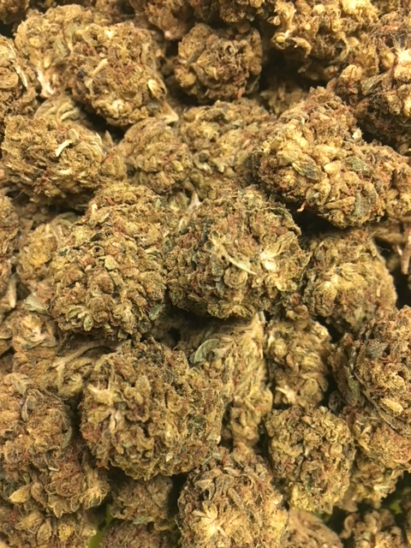 | SOUR PATCH KISS ~ SD Hybrid  Sour Patch Kiss by Elev8 Seeds was designed as a heavy-yielding trichome producer. This was achieved by crossing Kimbo Kush’s sweet, doughy aroma with Sour Kush’s pungent odor and generous production. Sour Patch Kiss stands as a 60/40 sativa-dominant hybrid but represents its Kush lineage in effects. Offering a heady rush at the onset due to its high-THC percentage, Sour Patch Kiss offers a melting euphoria that settles in the limbs as low-level sedation, curbing stress while honing focus.  1/8 = $50; ¼ = $90; ½ = $140; 1oz = $240
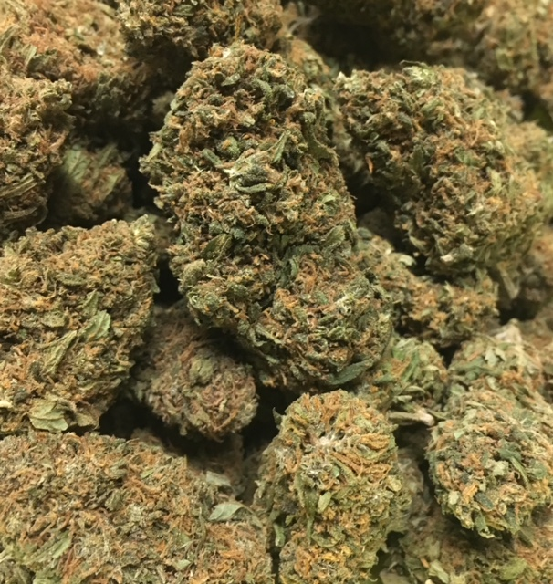 | TRAINWRECK ~ SD Hybrid  Trainwreck is a mind-bending hybrid with potent sativa effects that hit like a freight train. Trainwreck begins its speedy hurtle through the mind with a surge of euphoria, awakening creativity and happiness. Migraines, pain, and arthritis are mowed down by Trainwreck’s high THC content, and many patients also use it for relief of anxiety, ADD/ADHD, and PTSD.  1/8 = $50; ¼ = $90; ½ = $140; 1oz = $240
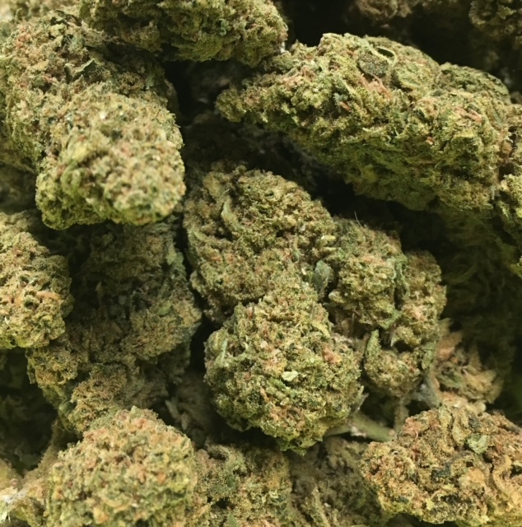 | 9LB HAMMER ~ Indica  9 Pound Hammer is an 80% indica strain created by JinxProof Gentics that crosses Gooberry, Hells OG, and Jack the Ripper. These dense buds are coated in resin, offering sweet grape and lime flavors. True to its indica dominance, effects are heavy and long-lasting, useful for pain and stress relief.  1/8 = $45; ¼ = $75; ½ = $120; 1oz = $190
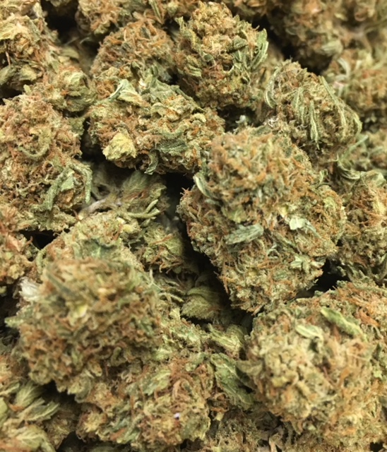 | ORANGE CREAMSICLE ~ SD Hybrid  Taking the best attributes of parent strains Orange Crush and Juicy Fruit, Orange Creamsicle’s tall structure, heavy colas, and pungent flavor will be sure to keep you coming back for more. This hybrid strain, as the name suggests, has a strong citrus flavor and is used to treat nausea and anxiety.  1/8 = $45; ¼ = $75; ½ = $120; 1oz = $190
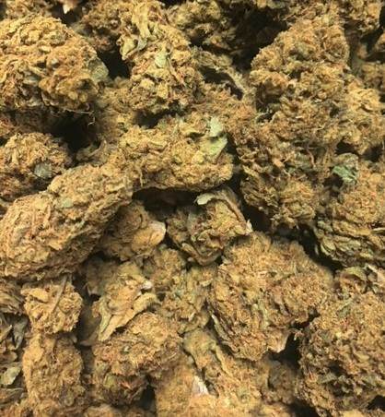 | PHANTOM COOKIES ~ SD Hybrid  Phantom Cookies is a sativa-dominant hybrid from Northern California that crosses a flavorful Cherry Pie with the resin-heavy Granddaddy Purple. Its aroma is an intricate blend of earthiness and roasted nuts, accented by sweeter notes of grape and berry. Next comes this hybrid’s crushing euphoria which shakes the mind awake with creativity and happiness. Increase the dose and the brain and body will be overcome with a relaxing haze that dulls nausea, stress, and pain while sharpening the appetite.  1/8 = $45; ¼ = $75; ½ = $120; 1oz = $190
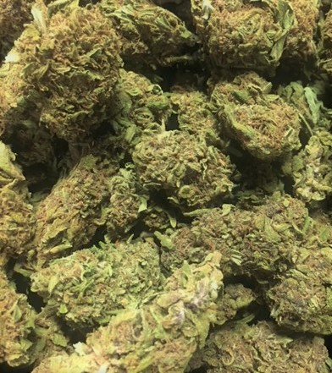 | HINDU SKUNK ~ Indica  Also known as Skunk Kush, Hindu Skunk is a cross of Hindu Kush and Skunk #1. The taste of the smoke is smooth and provides a strong and very mellow high.  1/8 = $40; ¼ = $60; ½ = $100; 1oz = $150
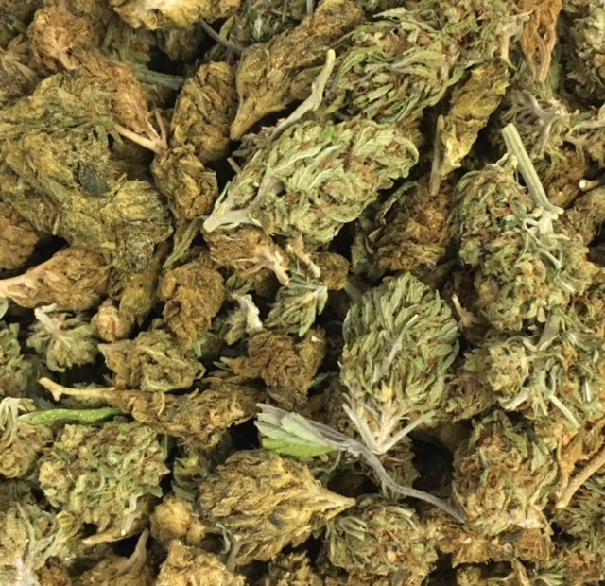 | HOUSE BLEND ~ Variety  A variety mix of flowers recently taken off the menu.  1/8 = $40; ¼ = $60; ½ = $100; 1oz = $150

