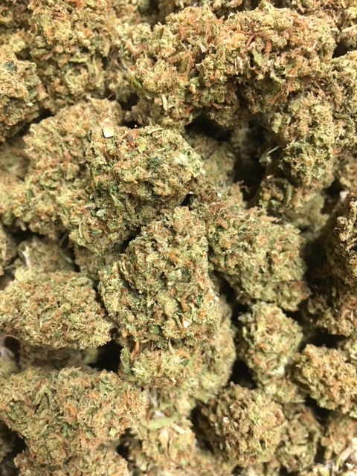 | BIRTHDAY CAKE ~ ID Hybrid  Birthday Cake Kush, also known as Wedding Cake or just Birthday Cake, is an indica-dominant hybrid with strong body effects and sweet cake-like flavor. As decadent as its Girl Scout Cookies and Cherry Pie parent strains, Birthday Cake Kush buds bloom with a crystalline icing of THC-rich resin. Like any dessert, Birthday Cake Kush is the perfect way to end your day, with deeply relaxing effects that soothe the body without sedating the mind. This indica is preferred by patients treating pain, anxiety, appetite loss, inflammation, and headaches.  1/8 = $55; ¼ = $100; ½ = $190; 1oz = $300
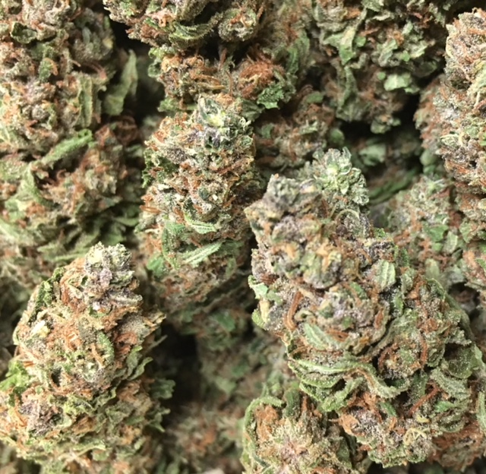 | FORBIDDEN FRUIT ~ Indica  Forbidden Fruit is the mouthwatering cross of Cherry Pie x Tangie. The terpene profile is a perfect mixture of Cherry Pie’s musky, sweet cherry undertones and Tangie’s loud tropical flavors. There are also notes of pine, mango, and passionfruit candy. The effects hit hard between the eyes and lay into the body with each hit. Forbidden Fruit’s deep physical relaxation and mental stoniness make it perfect for dulling minor physical discomfort and discarding stress.  1/8 = $55; ¼ = $100; ½ = $190; 1oz = $300
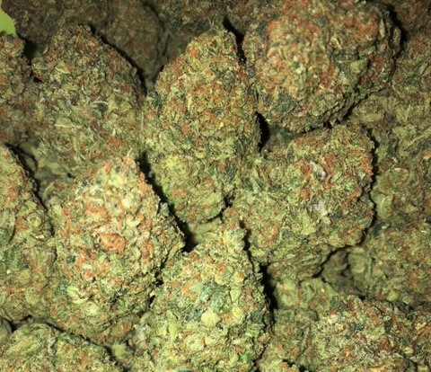 | SFV OG ~ SD Hybrid  SFV OG by Cali Connection is a sativa-dominant hybrid that is great for patients who need strong pain relief but don’t want to be stuck on the couch. As the name indicates, this OG Kush relative originates from California’s San Fernando Valley. Although their names are barely distinguishable, SFV OG Kush is actually the Afghani-crossed child to SFV OG. Its indica body effects take a little longer to feel than the initial head haziness, but once they do, everything will feel fine.  1/8 = $55; ¼ = $100; ½ = $190; 1oz = $300
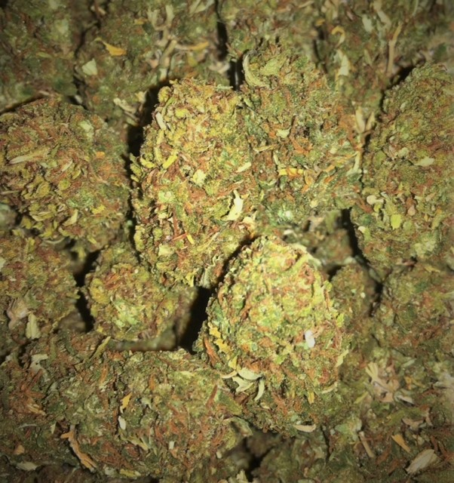 | AFGHAN SKUNK ~ Indica  This popular classic strain was originally developed in the United States to cross the pure indica genetics of an Afghani strain with the durable genes of Skunk plants. Afghan Skunk quickly spread to Amsterdam and beyond and is now considered one of the “classics".  1/8 = $50; ¼ = $90; ½ = $140; 1oz = $240
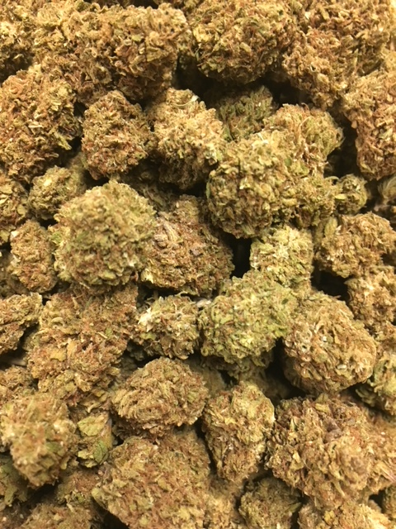 | BLUE SUGAR ~ Hybrid  Blue Sugar is a Sativa-dominant hybrid strain that is genetically linked to Blue Dream and Sugar Kush. Blue Sugar seems to provide a look and smell like Cannabis Sativa. However, if you aren’t careful with the Blue Sugar strain, it can have some intense couch-lock capability. This is great for full body pain relief, especially when medicating in large quantities. This heavy effect stems from the Indica lineage of Sugar Kush. The Sugar Kush strain was chosen for its ability to increase the yield, add a bit more stoniness to the equation, and improve the show quality of the bud structure.  1/8 = $50; ¼ = $90; ½ = $140; 1oz = $240
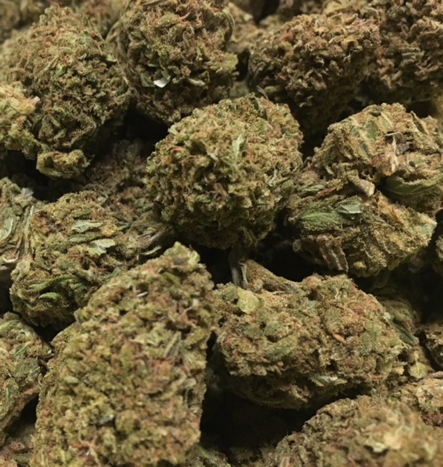 | MASTER BUBBA ~ Indica  Master Bubba is the perfect strain for those looking for true indica effects. Bred from Master Kush and Bubba Kush, it’s popular for the treatment of pain, stress and insomnia thanks to the strong body sedation it provides. Master Bubba plants flower at 8 to 9 weeks with smaller, dense buds that can have a fruity, musky aroma. Kush earthiness is the main note in its smooth flavor. This strain can be very potent, making it best in the evening or as a nightcap.  1/8 = $50; ¼ = $90; ½ = $140; 1oz = $240
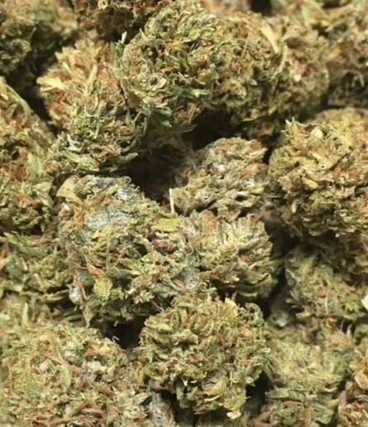 | SKYWALKER OG ~ ID Hybrid  Skywalker OG is an indica dominant hybrid that’s a potent cross between the hugely popular Skywalker X OG Kush strains, with an aroma of spicy herbal jet fuel and a taste of spicy diesel with an herby aftertaste. Skywalker OG is an ideal strain for treating patients suffering from conditions such as chronic stress, pain due to injury or illness, and mild to moderate cases of depression.  1/8 = $50; ¼ = $90; ½ = $140; 1oz = $240
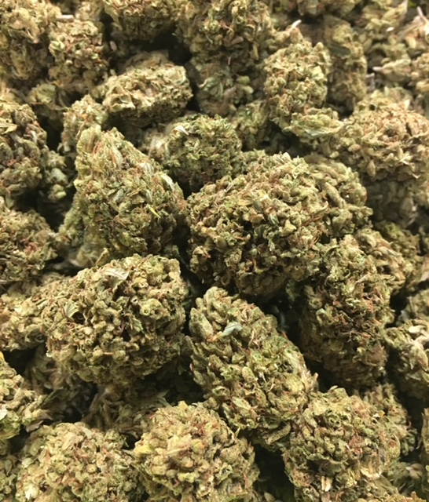 | 3 KINGS ~ SD Hybrid  The 3 Kings marijuana strain, a holy trinity of Headband, Sour Diesel, and OG Kush, is a sativa-dominant hybrid and genetic masterpiece. Sour tanginess reek from the sage green buds, and its frosty coat gives you a fair warning of the 3 Kings’ potency. Medical patients will appreciate the versatility of this strain’s medicinal effects as it relieves pain, stress, and nausea without heavy sedation.  1/8 = $45; ¼ = $75; ½ = $120; 1oz = $190
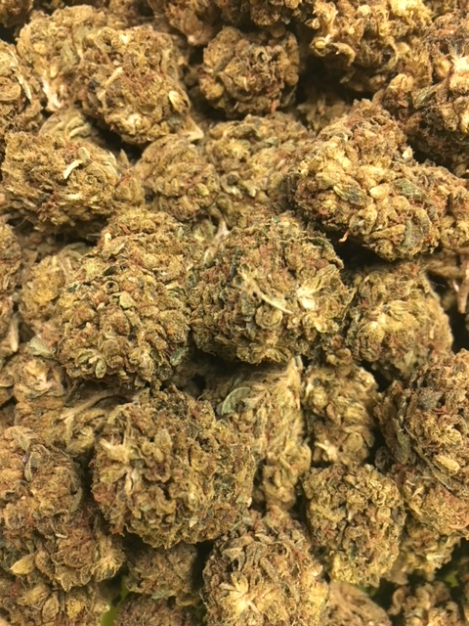 | SOUR PATCH KISS ~ SD Hybrid  Sour Patch Kiss by Elev8 Seeds was designed as a heavy-yielding trichome producer. This was achieved by crossing Kimbo Kush’s sweet, doughy aroma with Sour Kush’s pungent odor and generous production. Sour Patch Kiss stands as a 60/40 sativa-dominant hybrid but represents its Kush lineage in effects. Offering a heady rush at the onset due to its high-THC percentage, Sour Patch Kiss offers a melting euphoria that settles in the limbs as low-level sedation, curbing stress while honing focus.  1/8 = $45; ¼ = $75; ½ = $120; 1oz = $190
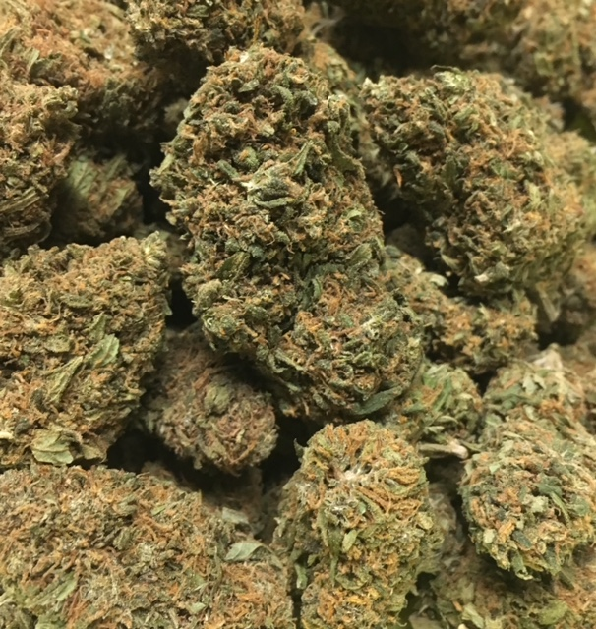 | TRAINWRECK ~ SD Hybrid  Trainwreck is a mind-bending hybrid with potent sativa effects that hit like a freight train. Trainwreck begins its speedy hurtle through the mind with a surge of euphoria, awakening creativity and happiness. Migraines, pain, and arthritis are mowed down by Trainwreck’s high THC content, and many patients also use it for relief of anxiety, ADD/ADHD, and PTSD.  1/8 = $45; ¼ = $75; ½ = $120; 1oz = $190
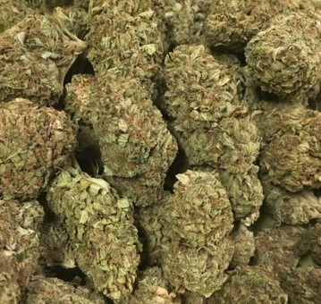 | OREGON PINEAPPLE ~ ID Hybrid  Oregon Pineapple is an indica dominant hybrid cross of the classic OG Kush X Pineapple strains. Much like its name suggests, Oregon Pineapple has an aroma of sweet earthy pineapple with a dash of haze and tastes much the same, with a delicious pineapple flavor accented by a hint of hazy citrus. The Oregon Pineapple high hits you hard with an almost immediate effect that jolts through your head with an uplifted and stoney effect. This heavy hitter slowly ebbs into a mellow and relaxing body buzz that leaves you sleepy and euphoric with an almost overpowering feeling of couch-lock and laziness.  1/8 = $40; ¼ = $60; ½ = $100; 1oz = $150
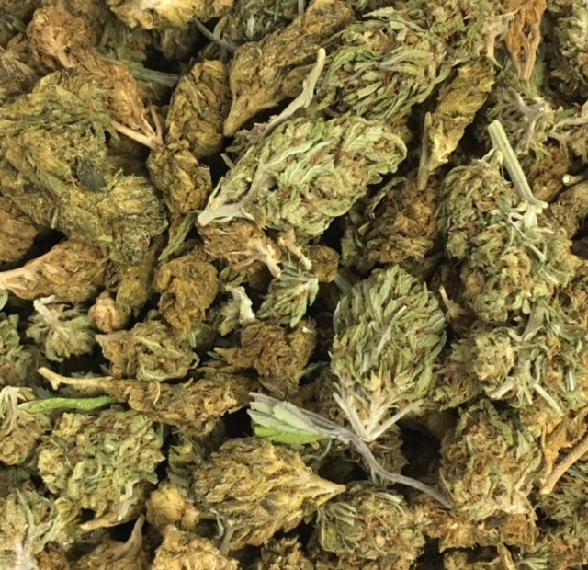 | HOUSE BLEND ~ Variety  A variety mix of flowers recently taken off the menu.  1/8 = $40; ¼ = $60; ½ = $100; 1oz = $150

