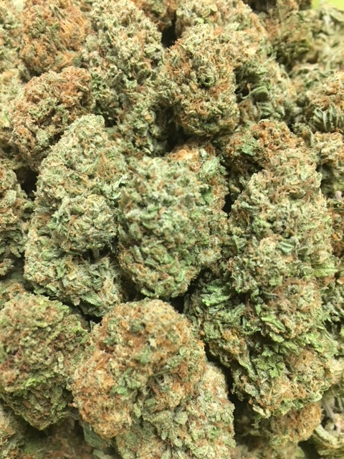 | CHERRY COOKIES ~ Hybrid  Cherry Cookies is one of the most popular Girl Scout Cookie crosses to date, ranking next to Pink Cookies and Thin Mint Girl Scout Cookies. With similar genetic parentage, Cherry Cookies derives from the blending of Cherry Pie (aka Cherry Kush) and Cookies F2. This cross preserves the tight, slightly purple buds and deep orange pistils while accentuating the cherry tang and tartness on the nose and exhale. This strain behaves like a GSC, offering a medical-grade sedation on the body with an alert mental state.  1/8 = $55; ¼ = $100; ½ = $190; 1oz = $300
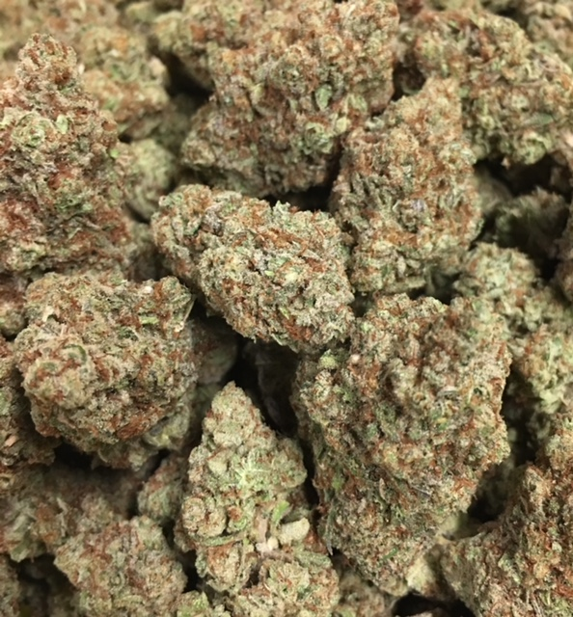 | PURPLE PUNCH ~ Hybrid  Purple Punch is the sweet and sedating union of two indica-dominant classics. By breeding Larry OG with Granddaddy Purple, the astonishing trichome laden Purple Punch was born, smelling of grape candy, blueberry muffins, and tart Kool-Aid. The potency of this strain gives the consumer a one-two punch to the head and body, initially landing between the eyes and settling down into the limbs. Its effects may help with managing nausea, stress, minor body aches, and sleeplessness.  1/8 = $55; ¼ = $100; ½ = $190; 1oz = $300
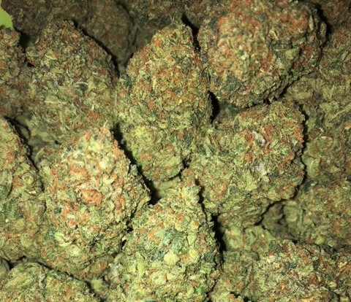 | SFV OG ~ SD Hybrid  SFV OG by Cali Connection is a sativa-dominant hybrid that is great for patients who need strong pain relief but don’t want to be stuck on the couch. As the name indicates, this OG Kush relative originates from California’s San Fernando Valley. Although their names are barely distinguishable, SFV OG Kush is actually the Afghani-crossed child to SFV OG. Its indica body effects take a little longer to feel than the initial head haziness, but once they do, everything will feel fine.  1/8 = $55; ¼ = $100; ½ = $190; 1oz = $300
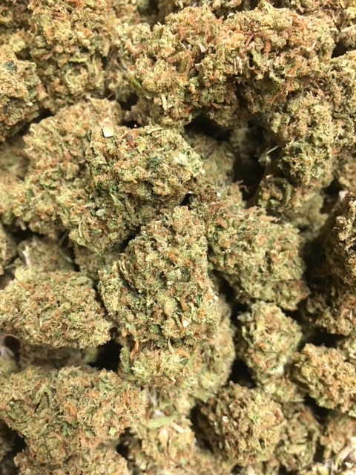 | BIRTHDAY CAKE ~ ID Hybrid  Birthday Cake Kush, also known as Wedding Cake or just Birthday Cake, is an indica-dominant hybrid with strong body effects and sweet cake-like flavor. As decadent as its Girl Scout Cookies and Cherry Pie parent strains, Birthday Cake Kush buds bloom with a crystalline icing of THC-rich resin. Like any dessert, Birthday Cake Kush is the perfect way to end your day, with deeply relaxing effects that soothe the body without sedating the mind. This indica is preferred by patients treating pain, anxiety, appetite loss, inflammation, and headaches.  1/8 = $50; ¼ = $90; ½ = $140; 1oz = $240
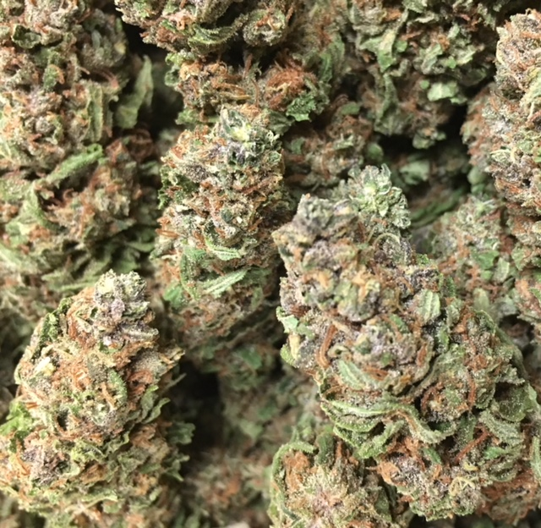 | FORBIDDEN FRUIT ~ Indica  Forbidden Fruit is the mouthwatering cross of Cherry Pie x Tangie. The terpene profile is a perfect mixture of Cherry Pie’s musky, sweet cherry undertones and Tangie’s loud tropical flavors. There are also notes of pine, mango, and passionfruit candy. The effects hit hard between the eyes and lay into the body with each hit. Forbidden Fruit’s deep physical relaxation and mental stoniness make it perfect for dulling minor physical discomfort and discarding stress.  1/8 = $50; ¼ = $90; ½ = $140; 1oz = $240
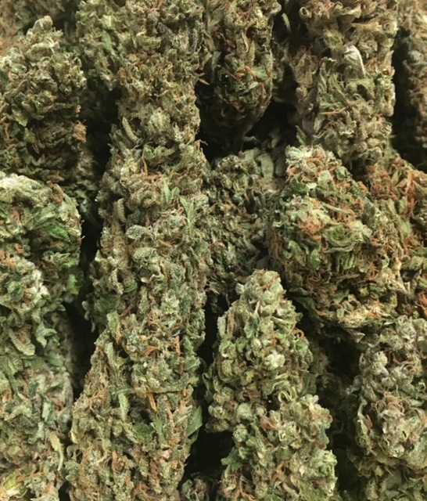 | GOD’S GIFT ~ Indica  A strain that became popular in California dispensaries in 2005, God's Gift contains flavors of grape, citrus, and hash. Its parents are Granddaddy Purple and OG Kush. No matter what your belief system, this strain is a "gift" with its strong THC content of 18-22%.  1/8 = $50; ¼ = $90; ½ = $140; 1oz = $240
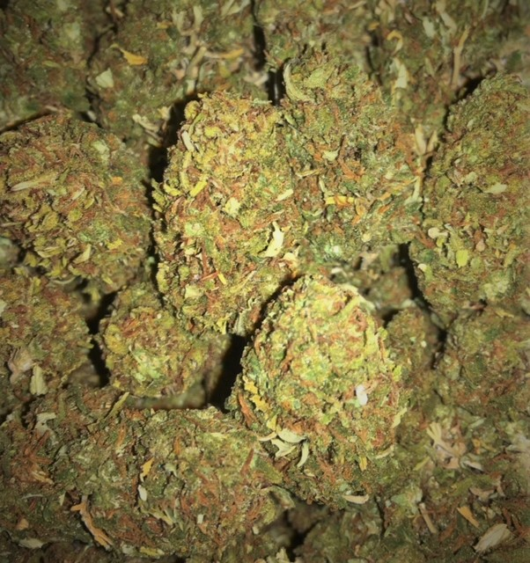 | AFGHAN SKUNK ~ Indica  This popular classic strain was originally developed in the United States to cross the pure indica genetics of an Afghani strain with the durable genes of Skunk plants. Afghan Skunk quickly spread to Amsterdam and beyond and is now considered one of the “classics".  1/8 = $45; ¼ = $75; ½ = $120; 1oz = $190
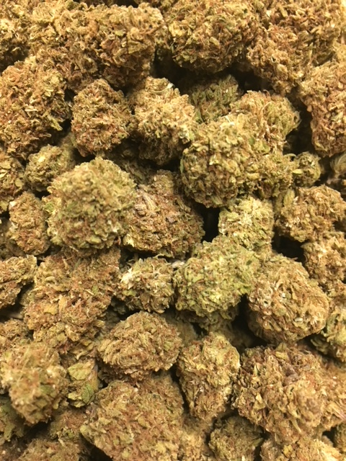 | BLUE SUGAR ~ Hybrid  Blue Sugar is a Sativa-dominant hybrid strain that is genetically linked to Blue Dream and Sugar Kush. Blue Sugar seems to provide a look and smell like Cannabis Sativa. However, if you aren’t careful with the Blue Sugar strain, it can have some intense couch-lock capability. This is great for full body pain relief, especially when medicating in large quantities. This heavy effect stems from the Indica lineage of Sugar Kush. The Sugar Kush strain was chosen for its ability to increase the yield, add a bit more stoniness to the equation, and improve the show quality of the bud structure.  1/8 = $45; ¼ = $75; ½ = $120; 1oz = $190
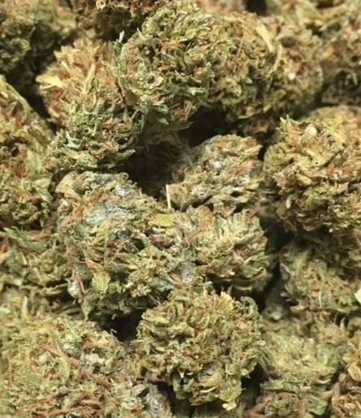 | SKYWALKER OG ~ ID Hybrid  Skywalker OG is an indica dominant hybrid that’s a potent cross between the hugely popular Skywalker X OG Kush strains, with an aroma of spicy herbal jet fuel and a taste of spicy diesel with an herby aftertaste. Skywalker OG is an ideal strain for treating patients suffering from conditions such as chronic stress, pain due to injury or illness, and mild to moderate cases of depression.  1/8 = $45; ¼ = $75; ½ = $120; 1oz = $190
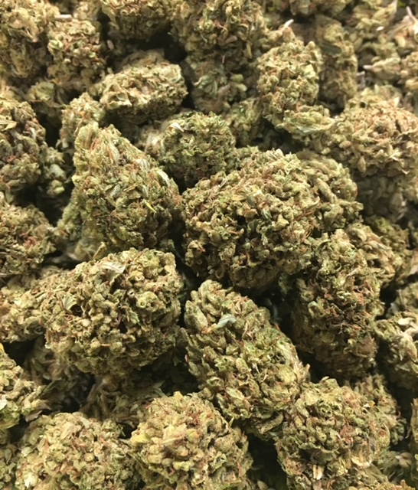 | 3 KINGS ~ SD Hybrid  The 3 Kings marijuana strain, a holy trinity of Headband, Sour Diesel, and OG Kush, is a sativa-dominant hybrid and genetic masterpiece. Sour tanginess reek from the sage green buds, and its frosty coat gives you a fair warning of the 3 Kings’ potency. Medical patients will appreciate the versatility of this strain’s medicinal effects as it relieves pain, stress, and nausea without heavy sedation.  1/8 = $40; ¼ = $60; ½ = $100; 1oz = $150
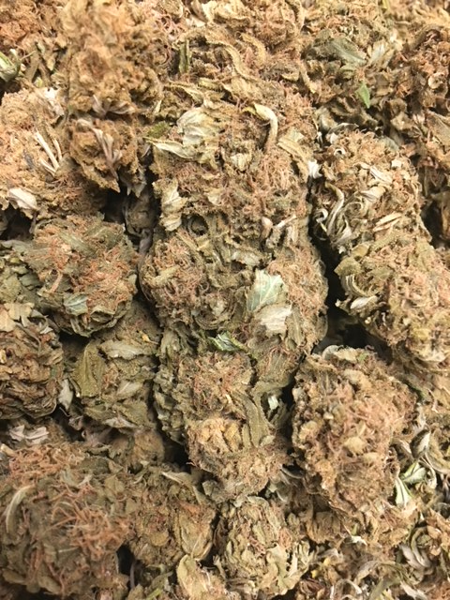 | YO MAMA! ~ ID Hybrid  Big, bold, and beautiful... just like your mama...Crossing Afgooey with Appalachia, this strain smells of apple spice, skittles, caramel, and lemon balm. Deep warm zonking body high bear hug with a happy heavy head...  1/8 = $40; ¼ = $60; ½ = $100; 1oz = $150
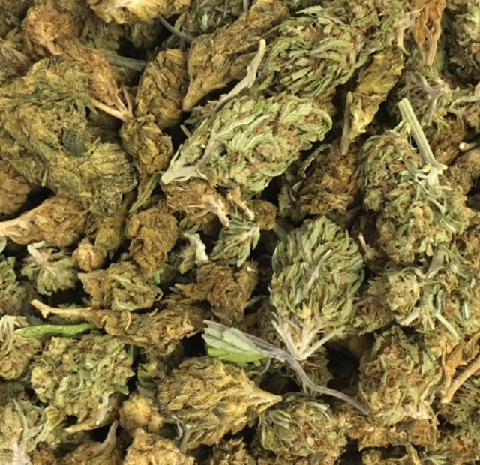 | HOUSE BLEND ~ Variety  A variety mix of flowers recently taken off the menu.  1/8 = $40; ¼ = $60; ½ = $100; 1oz = $150

