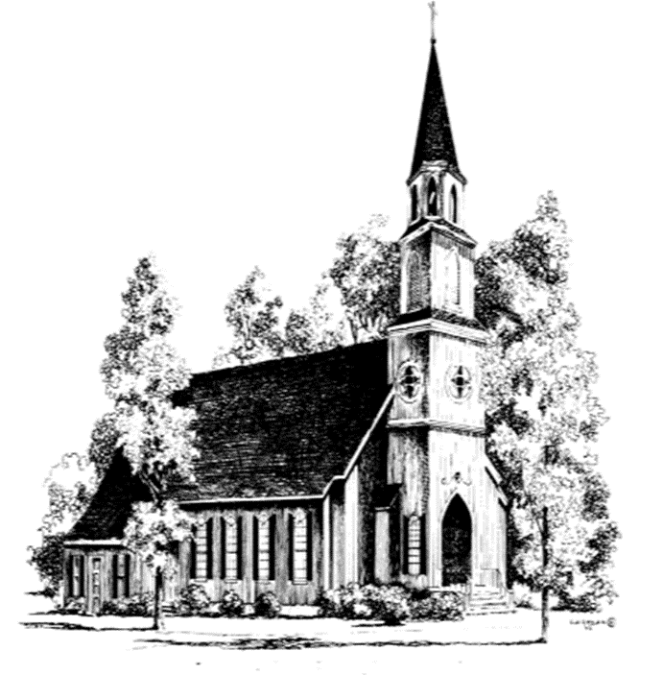
The Sixth Sunday
of Easter
May 10, 2026
10:00 AM

A warm welcome to all who come to worship at St. John’s this beautiful day. If you are visiting with us, we would like to get to know you better, so please fill out a visitor’s card found in the pew and place in the offering plate.
There is no wrong way to worship. The people’s responses are in bold and instructions for sitting, standing, and kneeling are in italics. We invite you to participate in the way that feels most comfortable and authentic to you.

Prelude “Voluntary on Stephanos”

The Word of God

Hymn 400, verses 1,4,5 & 7
All creatures of our God and King Sung by all. Lasst uni erfreuen

Celebrant Alleluia! Christ is Risen.
People The Lord is risen indeed. Alleluia.
Celebrant Almighty God, to you all hearts are open, all desires known, and from you no secrets are hid: Cleanse the thoughts of our hearts by the inspiration of your Holy Spirit, that we may
perfectly love you, and worthily magnify your holy Name; through Christ our Lord. Amen.

Hymn S280
Gloria (next page) Sung by all. Powell

Collect of the Day
Celebrant The Lord be with you.
People And also with you. Celebrant Let us pray. O God, you have prepared for those who love you such good things as surpass our
understanding: Pour into our hearts such love towards you, that we, loving you in all things and above all things, may obtain your promises, which exceed all that we can desire; through Jesus Christ our Lord, who lives and reigns with you and the Holy Spirit, one God, for ever and ever. Amen.

Hymn S280
Gloria Sung by all. Powell
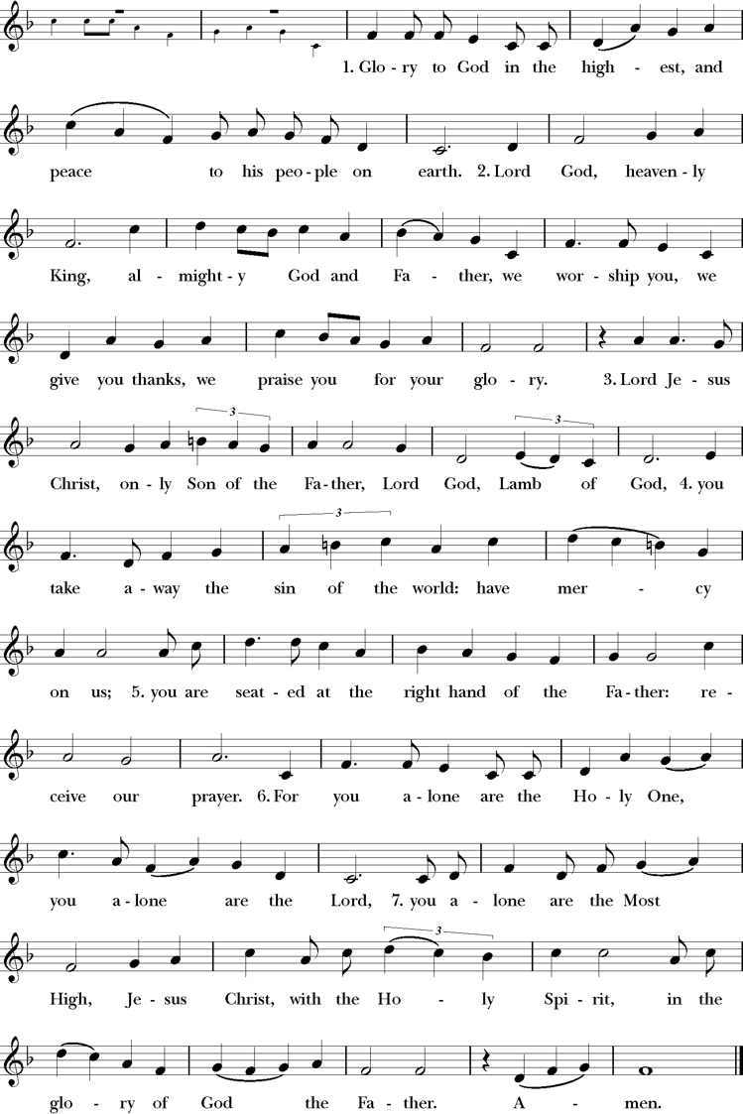

The people are seated.

The First Lesson Acts 17:22-31
²²Paul stood in front of the Areopagus and said, “Athenians, I see how extremely religious you are in every way. ²³For as I went through the city and looked carefully at the objects of your worship, I found among them an altar with the inscription, ‘To an unknown god.’ What therefore you worship as unknown, this I proclaim to you. ²⁴The God who made the world and everything in it, he who is Lord of heaven and earth, does not live in shrines made by human hands, ²⁵nor is he served by human hands, as though he needed anything, since he himself gives to all mortals life and breath and all things. ²⁶From one ancestor he made all nations to inhabit the whole earth, and he allotted the times of their existence and the boundaries of the places where they would live, ²⁷so that they would search for God and perhaps grope for him and find him—though indeed he is not far from each one of us. ²⁸For ‘In him we live and move and have our being’; as even some of your own poets have said,
‘For we too are his offspring.’
²⁹Since we are God’s offspring, we ought not to think that the deity is like gold, or silver, or stone, an image formed by the art and imagination of mortals. ³⁰While God has overlooked the times of human ignorance, now he commands all people everywhere to repent, ³¹because he has fixed a day on which he will have the world judged in righteousness by a man whom he has appointed, and of this he has given assurance to all by raising him from the dead.”
Lector The Word of the Lord.
People Thanks be to God.

Psalm 66:7-18 Antiphon sung by all.
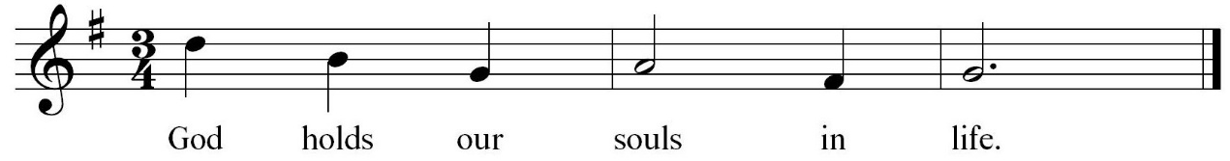

⁷Bless our God, you peoples; *
make the voice of his praise to be heard,
⁸Who holds our souls in life, *
and will not allow our feet to slip. Antiphon
⁹For you, O God, have proved us; *
you have tried us just as silver is tried.
¹⁰You brought us into the snare; *
you laid heavy burdens upon our backs.
¹¹You let enemies ride over our heads;
we went through fire and water; *
but you brought us out into a place of refreshment. Antiphon
¹²I will enter your house with burnt-offerings
and will pay you my vows, *
which I promised with my lips
and spoke with my mouth when I was in trouble.
¹³I will offer you sacrifices of fat beasts
with the smoke of rams; *
I will give you oxen and goats. Antiphon
¹⁴Come and listen, all you who fear God, *
and I will tell you what he has done for me.
¹⁵I called out to him with my mouth, *
and his praise was on my tongue.
¹⁶If I had found evil in my heart, *
the Lord would not have heard me;
¹⁷But in truth God has heard me; *
he has attended to the voice of my prayer.
¹⁸Blessed be God, who has not rejected my prayer, *
nor withheld his love from me. Antiphon

The Second Lesson 1 Peter 3:13-22
¹³Now who will harm you if you are eager to do what is good? ¹⁴But even if you do suffer for doing what is right, you are blessed. Do not fear what they fear, and do not be intimidated, ¹⁵but in your hearts sanctify Christ as Lord. Always be ready to make your defense to anyone who demands from you an accounting for the hope that is in you; ¹⁶yet do it with gentleness and reverence. Keep your conscience clear, so that, when you are maligned, those who abuse you for your good conduct in Christ may be put to shame. ¹⁷For it is better to suffer for doing good, if suffering should be God’s will, than to suffer for doing evil. ¹⁸For Christ also suffered for sins once for all, the righteous for the unrighteous, in order to bring you to God. He was put to death in the flesh, but made alive in the spirit, ¹⁹in which also he went and made a proclamation to the spirits in prison, ²⁰who in former times did not obey, when God waited patiently in the days of Noah, during the building of the ark, in which a few, that is, eight persons, were saved through water. ²¹And baptism, which this prefigured, now saves you—not as a removal of dirt from the body, but as an appeal to God for a good conscience, through the resurrection of Jesus Christ, ²²who has gone into heaven and is at the right hand of God, with angels, authorities, and powers made subject to him.
Lector The Word of the Lord.
People Thanks be to God.

The people stand as able.

Sequence Hymn 516, verses 1 & 2
Come down O love devine Sung by all. Down Ampney

The Gospel John 14:15-21
Celebrant The Holy Gospel of our Lord Jesus Christ according to John.
People Glory to you, Lord Christ.
Jesus said, ¹⁵“If you love me, you will keep my commandments. ¹⁶And I will ask the Father, and he will give you another Advocate, to be with you forever. ¹⁷This is the Spirit of truth, whom the world cannot receive, because it neither sees him nor knows him. You know him, because he abides with you, and he will be in you.
¹⁸“I will not leave you orphaned; I am coming to you. ¹⁹In a little while the world will no longer see me, but you will see me; because I live, you also will live. ²⁰On that day you will know that I am in my Father, and you in me, and I in you. ²¹They who have my commandments and keep them are those who love me; and those who love me will be loved by my Father, and I will love them and reveal myself to them.”
Celebrant The Gospel of the Lord.
People Praise to you, Lord Christ.

Sequence Hymn 516 verse 3
Come down O love devine Sung by all. Down Ampney

The Sermon

The people stand as able.

The Nicene Creed
We believe in one God, the Father, the Almighty, maker of heaven and earth, of all that is, seen
and unseen.
We believe in one Lord, Jesus Christ, the only Son of God, eternally begotten of the Father, God from God, Light from Light, true God from true God, begotten, not made, of one, Being with the Father. Through him all things were made. For us and for our salvation he came down from heaven: by the power of the Holy Spirit he became incarnate from the Virgin Mary, and was made man. For our sake he was crucified under Pontius Pilate; he suffered death and was buried. On the third day he rose again in accordance with the Scriptures; he ascended into heaven and is seated at the right hand of the Father. He will come again in glory to judge the living and the dead, and his kingdom will have no end.
We believe in the Holy Spirit, the Lord, the giver of life, who proceeds from the Father and the Son. With the Father and the Son he is worshiped and glorified. He has spoken through the Prophets. We believe in one holy catholic and apostolic Church. We acknowledge one baptism for the forgiveness of sins. We look for the resurrection of the dead, and the life of the world to come. Amen.

The Prayers of the People
Celebrant Bless our God, you peoples; make the voice of God’s praise to be heard, saying, “We call out to you with our mouths; your praise is on our tongues.”
Lector Lord Christ, you have not left us orphaned, but have given your Church an Advocate. May that same Holy Spirit teach us to keep your commandments and comfort us with divine love. Silence. We call out to you with our mouths;
People Your praise is on our tongues.
Lector Loving God, bless the suffering. May those who suffer for doing good find a friend in Christ Jesus. May those who suffer from disasters beyond their control find you attentive to the voice of their prayers. May those who suffer for doing wrong find redemption and grace. Silence. We call out to you with our mouths;
People Your praise is on our tongues.
Lector Lord of heaven and earth, you made the world and everything in it. You give to all mortals life and breath and all things. May we be faithful stewards of all you have created. We thank you for the many blessings of this life, including those things which we name silently or aloud. Pause. We call out to you with our mouths;
People Your praise is on our tongues.
Lector Creator God, on this Mother’s Day, we pray for all mothers and those who have mothered in abundant and varying ways. Bless their love, their nurture, and their strength. May all those who struggle with this day find comfort in your goodness. Give to all children someone to mother them in the way that you mother us. Silence. We call out to you with our mouths;
People Your praise is on our tongues.
Lector Merciful Lord, bless the people of this city with a spirit of gentleness and reverence. May we be set free from fear to live, instead, in hope. Silence.
We call out to you with our mouths;
People Your praise is on our tongues.
Lector God, you are not far from each one of us. You love us as your children. Reveal your love, especially this day, to the sick and sorrowful. We pray for those on our parish prayer list and those we name silently or aloud. Pause. We call out to you with our mouths;
People Your praise is on our tongues.
Lector Heavenly Father, you hold our souls in life. You have saved us in baptism. Because your Son Jesus lives so do we rejoice in the hope of unending life in you. Silence. We call out to you with our mouths;
People Your praise is on our tongues.

The celebrant adds a concluding collect.

The Peace
Celebrant The peace of the Lord be always with you.
People And also with you.

The people greet each other with a sign of God’s peace and are seated.

Announcements

The Holy Communion
The Offertory
Having listened to the Word of God, affirmed our faith, and shared in the peace, we now prepare ourselves for the gift of the Holy Communion. At the offertory, we gratefully offer back to God some of what God has given us, both in the bread and wine, and in the money we give. Here at St. John’s, it is tradition that people stand as the elements are brought forward and are seated once the bread and wine are on the altar.

Offertory Anthem “Prayer of St. Richard of Chichester” by Malcom Archer
Doxology
Hymn 380 (verse 3) Sung by all. Old 100th

Praise God from whom all blessings flow, Praise Him all creatures, here below.
Praise Him above ye heavenly host. Praise Father, Son and Holy Ghost.

The Great Thanksgiving
Celebrant The Lord be with you.
People And also with you.
Celebrant Lift up your hearts.
People We lift them to the Lord.
Celebrant Let us give thanks to the Lord our God.
People It is right to give him thanks and praise.
Celebrant It is right, and a good and joyful thing, always and everywhere to give thanks to you, Father Almighty, Creator of heaven and earth. But chiefly are we bound in praise you for glorious resurrection of your Son Jesus Christ our Lord; for he is the true Paschal Lamb, who was sacrificed for us, and has taken away the sin of the world. By his death he has destroyed death, and by his rising to life again he has won for us everlasting life. Therefore we praise you, joining our voices with Angels and Archangels and with all the company of heaven, who for ever sing this hymn to proclaim the glory of your Name:

Together
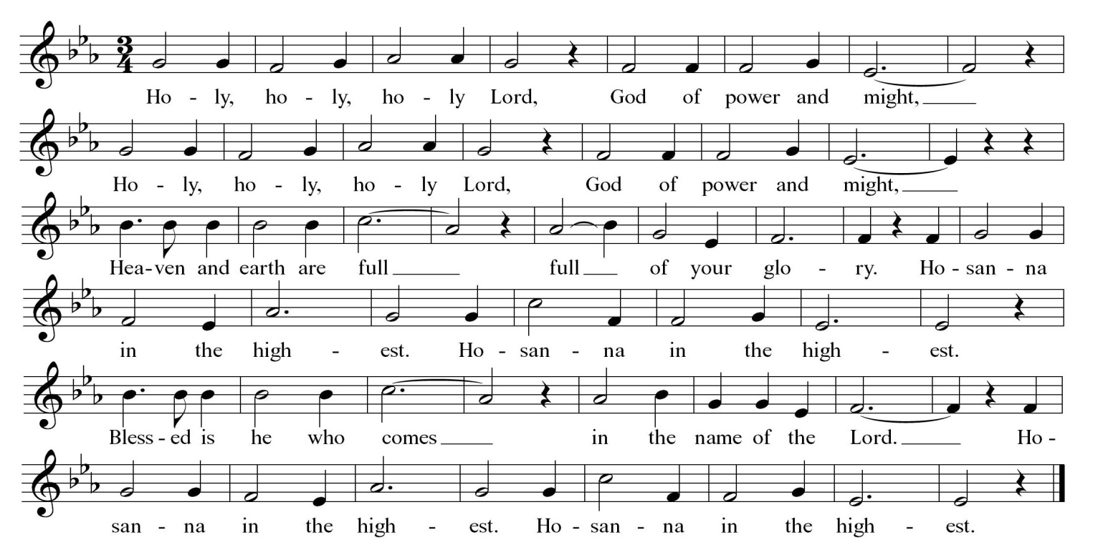
Sanctus Schubert
The people kneel or stand as able.
Celebrant Holy and gracious Father: In your infinite love you made us for yourself; and, when we had fallen into sin and become subject to evil and death, you, in your mercy, sent Jesus Christ, your only and eternal Son, to share our human nature, to live and die as one of us, to reconcile us to you, the God and Father of all. He stretched out his arms upon the cross, and offered himself, in obedience to your will, a perfect sacrifice for the whole world.
On the night he was handed over to suffering and death, our Lord Jesus Christ took bread; and when he had given thanks to you, he broke it, and gave it to his disciples, and said, “Take, eat: This is my Body, which is given for you. Do this for the remembrance of me.”
After supper he took the cup of wine; and when he had given thanks, he gave it to them, and said, “Drink this, all of you: This is my Blood of the new Covenant, which is shed for you and for many for the forgiveness of sins. Whenever you drink it, do this for the remembrance of me.” Therefore we proclaim the mystery of faith:
Together Christ has died, Christ is risen, Christ will come again.
Celebrant We celebrate the memorial of our redemption, O Father, in this sacrifice of praise and thanksgiving. Recalling his death, resurrection, and ascension, we offer you these gifts.
Sanctify them by your Holy Spirit to be for your people the Body and Blood of your Son, the holy food and drink of new and unending life in him. Sanctify us also that we may faithfully receive this holy Sacrament, and serve you in unity, constancy, and peace; and at the last day bring us with all our saints into the joy of your eternal kingdom.
All this we ask through your Son Jesus Christ. By him, and with him, and in him, in the unity of the Holy Spirit all honor and glory is yours, Almighty Father, now and forever. Amen.

The Lord’s Prayer
Celebrant And now, as our Savior Christ has taught us, we are bold to say,
People Our Father, who art in heaven, hallowed be thy Name, thy kingdom come, thy will be done, on earth as it is in heaven. Give us this day our daily bread. And forgive us our trespasses, as we forgive those who trespass against us. And lead us not into temptation, but deliver us from evil. For thine is the kingdom, and the power, and the glory, for ever and ever. Amen.

The Fraction Anthem
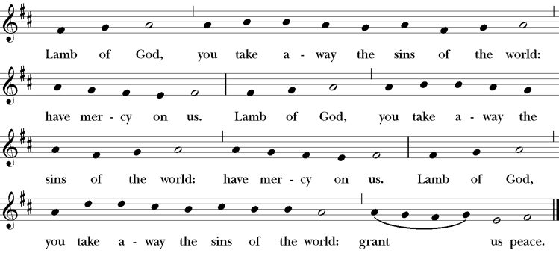

Invitation to Communion
The people are seated.
All who seek God and a deeper life in Christ are welcome to receive Holy Communion. While we believe that it is most meaningful when done as a baptized Christian, no one will ever be turned away from God’s table.
Please move at the direction of the ushers. You may receive the bread in open and outstretched hands. Gluten-free wafers are available; please make your need known to the priest. Receiving the bread only is full participation in the Eucharist. Wine is also available. If you prefer to receive a blessing instead, please indicate your choice by crossing your hands across your chest. Those who wish to have Holy Communion brought to them at their seat should notify an usher.

Post Communion Prayer

Celebrant Let us pray.

People Eternal God, heavenly Father, you have graciously accepted us as living members of your Son our Savior Jesus Christ, and you have fed us with spiritual food in the Sacrament of his Body and Blood. Send us now into the world in peace, and grant us strength and courage to love and serve you with gladness and singleness of heart; through Christ our Lord. Amen.

The people stand as able.

The Blessing

Closing Hymn 344 verses 1, 3-5

Lord dismiss us with thy blessing Sung by all. Sicilian Mariners

The Dismissal

Celebrant Let us go forth in the name of Christ; Alleluia, alleluia!
People Thanks be to God; Alleluia, alleluia!

The Postlude

All liturgical materials printed in this bulletin are printed under
license from either Rite Planning or CCLI #1994456.

St. John’s Episcopal Church
12201 Richmond Street
Chester, Virginia 23831
(804) 748-2182 | stjohnschester.com

