The Fifth Sunday after Pentecost

July 13, 2025

10:00 AM

*A warm welcome to all who come to worship at St. John’s this beautiful day. If you are visiting with us, we would like to get to know you better, so please fill out a visitor’s card found in the pew and place in the offering plate.*

*There is no wrong way to worship. The people’s responses are in bold and instructions for sitting, standing, and kneeling are in italics. We invite you to participate in the way that feels most comfortable and authentic to you.*

**Prelude**

**The Word of God**

**Hymn 304**

*I come with joy to meet my Lord Sung by all. Land of Rest*

Celebrant Blessed be God: Father, Son, and Holy Spirit.

**People And blessed be his kingdom, now and for ever. Amen.**

Celebrant Almighty God, to you all hearts are open, all desires known, and from you no secrets are hid: Cleanse the thoughts of our hearts by the inspiration of your Holy Spirit, that we mayperfectly love you, and worthily magnify your holy Name; through Christ our Lord. **Amen***.*

**Hymn S280**

*Gloria* *Sung by all.*   *Powell*

**The Collect of the Day**

Celebrant The Lord be with you.

**People And also with you.**

Celebrant Let us pray. O Lord, mercifully receive the prayers of your people who call upon you, and grant that they may know and understand what things they ought to do, and also may have grace and power faithfully to accomplish them; through Jesus Christ our Lord, who lives and reigns with you and the Holy Spirit, one God, now and for ever **Amen**.

*The people are seated.*

**The First Lesson** *Amos 7:7-17*

7This is what he showed me: the Lord was standing beside a wall built with a plumb line, with a plumb line in his hand. 8And the Lord said to me, “Amos, what do you see?” And I said, “A plumb line.” Then the Lord said,  
 “See, I am setting a plumb line  
  in the midst of my people Israel;  
  I will never again pass them by;  
 9the high places of Isaac shall be made desolate,  
  and the sanctuaries of Israel shall be laid waste,  
  and I will rise against the house of Jeroboam with the sword.”  
  10Then Amaziah, the priest of Bethel, sent to King Jeroboam of Israel, saying, “Amos has conspired against you in the very center of the house of Israel; the land is not able to bear all his words. 11For thus Amos has said,  
 ‘Jeroboam shall die by the sword, and Israel must go into exile  
  away from his land.’ ”  
12And Amaziah said to Amos, “O seer, go, flee away to the land of Judah, earn your bread there, and prophesy there; 13but never again prophesy at Bethel, for it is the king’s sanctuary, and it is a temple of the kingdom.”  
  14Then Amos answered Amaziah, “I am no prophet, nor a prophet’s son; but I am a herdsman, and a dresser of sycamore trees, 15and the Lord took me from following the flock, and the Lord said to me, ‘Go, prophesy to my people Israel.’  
 16“Now therefore hear the word of the Lord.  
 You say, ‘Do not prophesy against Israel,  
  and do not preach against the house of Isaac.’  
 17Therefore thus says the Lord:  
 ‘Your wife shall become a prostitute in the city,  
  and your sons and your daughters shall fall by the sword,  
  and your land shall be parceled out by line;  
 you yourself shall die in an unclean land,  
  and Israel shall surely go into exile away from its land.’ ”

Lector The Word of the Lord.

**People Thanks be to God.**

**Psalm 82:1-8** *Said responsively by whole verse.*

1God takes his stand in the council of heaven; *  
  he gives judgment in the midst of the gods:  
**2“How long will you judge unjustly, *  
  and show favor to the wicked?** 3Save the weak and the orphan; *  
  defend the humble and needy;  
**4Rescue the weak and the poor; *  
  deliver them from the power of the wicked.** 5They do not know, neither do they understand;  
 they go about in darkness; *  
  all the foundations of the earth are shaken.  
**6Now I say to you, ‘You are gods, \***

**and all of you children of the Most High;**

7Nevertheless, you shall die like mortals, *  
 and fall like any prince.’ ”  
**8Arise, O God, and rule the earth, *  
  for you shall take all nations for your own.**

**The Second Lesson**   *Colossians 1:1-14*

1Paul, an apostle of Christ Jesus by the will of God, and Timothy our brother,  
  2To the saints and faithful brothers and sisters in Christ in Colossae:  
  Grace to you and peace from God our Father.  
  3In our prayers for you we always thank God, the Father of our Lord Jesus Christ, 4for we have heard of your faith in Christ Jesus and of the love that you have for all the saints, 5because of the hope laid up for you in heaven. You have heard of this hope before in the word of the truth, the gospel 6that has come to you. Just as it is bearing fruit and growing in the whole world, so it has been bearing fruit among yourselves from the day you heard it and truly comprehended the grace of God. 7This you learned from Epaphras, our beloved fellow servant. He is a faithful minister of Christ on your behalf, 8and he has made known to us your love in the Spirit.  
  9For this reason, since the day we heard it, we have not ceased praying for you and asking that you may be filled with the knowledge of God’s will in all spiritual wisdom and understanding, 10so that you may lead lives worthy of the Lord, fully pleasing to him, as you bear fruit in every good work and as you grow in the knowledge of God. 11May you be made strong with all the strength that comes from his glorious power, and may you be prepared to endure everything with patience, while joyfully 12giving thanks to the Father, who has enabled you to share in the inheritance of the saints in the light. 13He has rescued us from the power of darkness and transferred us into the kingdom of his beloved Son, 14in whom we have redemption, the forgiveness of sins.

Lector The Word of the Lord.

**People Thanks be to God**.

*The people stand as able.*

**Sequence Hymn 660, verses 1 & 2**

*O Master let me walk with thee Sung by all. Maryton*

**The Gospel**  *Luke 10:25-37*

Celebrant The Holy Gospel of our Lord Jesus Christ according toLuke.

**People Glory to you, Lord Christ.**

25Just then a lawyer stood up to test Jesus. “Teacher,” he said, “what must I do to inherit eternal life?” 26He said to him, “What is written in the law? What do you read there?” 27He answered, “You shall love the Lord your God with all your heart, and with all your soul, and with all your strength, and with all your mind; and your neighbor as yourself.” 28And he said to him, “You have given the right answer; do this, and you will live.”  
  29But wanting to justify himself, he asked Jesus, “And who is my neighbor?” 30Jesus replied, “A man was going down from Jerusalem to Jericho, and fell into the hands of robbers, who stripped him, beat him, and went away, leaving him half dead. 31Now by chance a priest was going down that road; and when he saw him, he passed by on the other side. 32So likewise a Levite, when he came to the place and saw him, passed by on the other side. 33But a Samaritan while traveling came near him; and when he saw him, he was moved with pity. 34He went to him and bandaged his wounds, having poured oil and wine on them. Then he put him on his own animal, brought him to an inn, and took care of him. 35The next day he took out two denarii, gave them to the innkeeper, and said, ‘Take care of him; and when I come back, I will repay you whatever more you spend.’ 36Which of these three, do you think, was a neighbor to the man who

fell into the hands of the robbers?” 37He said, “The one who showed him mercy.” Jesus said to him, “Go and do likewise.”

Celebrant The Gospel of the Lord.

**People Praise to you, Lord Christ.**

**Sequence Hymn 660, verses 3 & 4**

*O Master let me walk with thee Sung by all. Maryton*

**The Sermon**

*The people stand as able.*

**The Nicene Creed**

**We believe in one God, the Father, the Almighty, maker of heaven and earth, of all that is, seen and unseen.**

**We believe in one Lord, Jesus Christ, the only Son of God, eternally begotten of the Father, God from God, Light from Light, true God from true God, begotten, not made, of one, Being with the Father. Through him all things were made. For us and for our salvation he came down from heaven: by the power of the Holy Spirit he became incarnate from the Virgin Mary, and was made man. For our sake he was crucified under Pontius Pilate; he suffered death and was buried. On the third day he rose again in accordance with the Scriptures; he ascended into heaven and is seated at the right hand of the Father. He will come again in glory to judge the living and the dead, and his kingdom will have no end.**

**We believe in the Holy Spirit, the Lord, the giver of life, who proceeds from the Father and the Son. With the Father and the Son he is worshiped and glorified. He has spoken through the Prophets. We believe in one holy catholic and apostolic Church. We acknowledge one baptism for the forgiveness of sins. We look for the resurrection of the dead, and the life of the world to come. Amen.**

**The Prayers of the People**

CelebrantCommanded to love our neighbor as ourselves, let us offer prayers for all peoples in every place.

Lector For this holy gathering and for those God loves in every place.

**People Christ, have mercy.**

Lector For all nations, peoples, tribes, clans, and families.

**People Christ, have mercy.**

Lector For mercy, justice, and peace in the world.

**People Christ, have mercy.**

Lector: For farmers and a good harvest, for those on vacation, and for safety from violent storms. We pray this day especially for those in the Texas Hill Country: those who have died; those still missing; for families who feel the grief of loss and the anxiety of not knowing. Keep all first responders safe and those who will assist their communities in the months to come ever vigil.

**People             Christ, have mercy.**

Lector For those who travel roads of danger, for the sick, the poor, and the oppressed, and for all in peril and great need.

**People Christ, have mercy.**

Lector For those who rest in Christ and for all the dead.

**People Christ, have mercy.**

Lector For ourselves, our families and companions, especially those on our prayer list and those we now name silently or aloud. *Pause*. And all those we love,

**People Christ, have mercy.**

Lector Lifting our voices with all creation, let us offer ourselves and one another to the living God through Christ.

**People To you, O Gracious God.**

CelebrantGod of mercy and kindness, who gave us the great commandment of love, hear the prayers we offer this day and write your word in our mouth and in our heart; through Jesus Christ our Lord. **Amen.**

**Confession of Sin and Absolution**

Celebrant Let us confess our sins against God and our neighbor.

*The people kneel as able. Silence is kept for reflection.*

**Together** **Most merciful God, we confess that we have sinned against you in thought, word, and deed, by what we have done, and by what we have left undone. We have not loved you with our whole heart; we have not loved our neighbors as ourselves. We are truly sorry and we humbly repent. For the sake of your Son Jesus Christ, have mercy on us and forgive us; that we may delight in your will, and walk in your ways, to the glory of your Name. Amen.**

Celebrant Almighty God have mercy on you, forgive you all your sins through our Lord Jesus Christ, strengthen you in all goodness, and by the power of the Holy Spirit keep you in eternal life. **Amen**.

**The Peace**

Celebrant The peace of the Lord be always with you.

**People And also with you.**

*The people greet each other with a sign of God’s peace and are seated.*

**The Holy Communion**

**The Offertory**

*Having listened to the Word of God, affirmed our faith, and shared in the peace, we now prepare ourselves for the gift of the Holy Communion. At the offertory, we gratefully offer back to God some of what God has given us, both in the bread and wine, and in the money we give. Here at St. John’s, it is tradition that people stand as the elements are brought forward and are seated once the bread and wine are on the altar.*

**Offertory Anthem**

**Doxology**

*Hymn 380 (verse 3)*  *Sung by all.* *Old 100th*

**Praise God from whom all blessings flow, Praise Him all creatures, here below.**

**Praise Him above ye heavenly host. Praise Father, Son and Holy Ghost.**

**The Great Thanksgiving**

Celebrant The Lord be with you.

**People And also with you.**

Celebrant Lift up your hearts.

**People We lift them to the Lord.**

Celebrant Let us give thanks to the Lord our God.

**People It is right to give our thanks and praise.**

Celebrant God of all power, Source and Sustainer of the Universe, you are worthy of glory and praise.

**People Glory to you for ever and ever.**

Celebrant At your command all things came to be: shining light and enfolding dark; the vast expanse of interstellar space, galaxies, suns, the planets in their courses, and this fragile earth, our island home.

**People By your will they were created and have their being.**

Celebrant From the primal elements you brought forth the human race, and blessed us with the capacity for memory, reason, and skill. You made us the stewards of creation. But we turned against you, and betrayed your trust; and we turned against one another.

**People Have mercy, Lord, for we are sinners in your sight.**

Celebrant Again and again, you called us to return. Through prophets and sages you revealed your righteous Law. And in the fullness of time you sent your eternal Word, born of your servant Mary, to fulfill your Law, opening for us the way of freedom and peace.

**People By his blood, he reconciled us.**

**By his wounds, we are healed.**

Celebrant And therefore we praise you, joining with the heavenly chorus, with prophets, apostles, and martyrs, and with all those in every generation who have looked at you in hope, to proclaim with them your glory, in their unending hymn:

**Together**

*Sanctus Schubert*

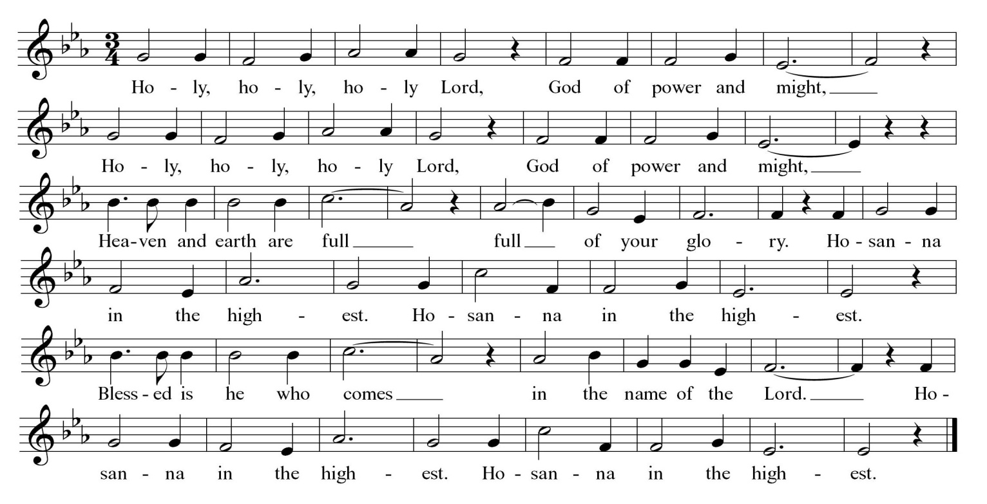

*The people kneel or stand as able.*

Celebrant Blessed are you, Lord our God, for sending us Jesus, the Christ, who on the night he was handed over to suffering and death, took bread, said the blessing, broke the bread, and gave it to his friends, and said, “Take, eat: This is my Body, which is given for you. Do this for the remembrance of me.”

After supper, Jesus took the cup of wine, gave thanks, and said, “Drink this, all of you: This is my Blood of the new Covenant, which is shed for you and for all for the forgiveness of sins. Whenever you drink it, do this for the remembrance of me.” Remembering now his work of redemption, and offering to you this sacrifice of thanksgiving,

**People We celebrate Christ’s death and resurrection, as we await the day of his coming.**

Celebrant Therefore, O God, we who have been redeemed by Jesus Christ, and made a new people by water and the Spirit, now bring before you these gifts. Sanctify them by your Holy Spirit to be the Body and Blood of Jesus Christ our Savior. Sanctify us also, and let the grace of this Holy Communion make us one body, one spirit in Christ, that we may worthily serve the world in his name.

**People Risen Lord, be known to us in the breaking of the Bread.**

Celebrant God of our ancestors; Redeemer and Mother of Israel; God and Father of our Lord Jesus Christ: Open our eyes to see your hand at work in the world about us. Deliver us from the presumption of coming to this Table for solace only and not for strength; for pardon only and not for renewal. Accept these prayers and praises, Almighty God, through Jesus Christ our great High Priest, to whom, with you and the Holy Spirit, your Church gives honor, glory, and worship, from generation to generation.

**People AMEN.**

**The Lord’s Prayer**

Celebrant And now, as our Savior Christ has taught us, we are bold to say,

**People Our Father, who art in heaven, hallowed be thy Name, thy kingdom come, thy will be done, on earth as it is in heaven. Give us this day our daily bread. And forgive us our trespasses, as we forgive those who trespass against us. And lead us not into temptation, but deliver us from evil. For thine is the kingdom, and the power, and the glory, for ever and ever. Amen.**

**The Fraction Anthem** Lindsey

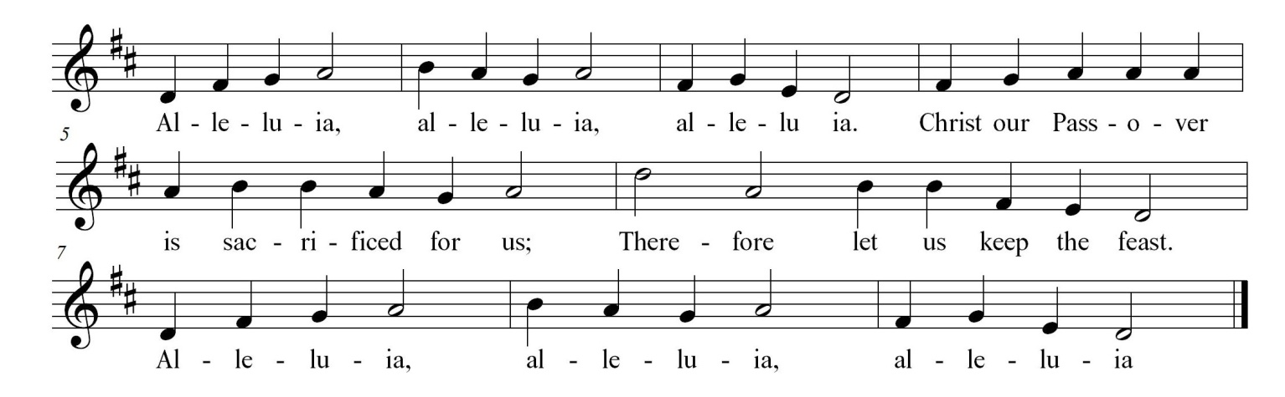

**Invitation to Communion**

*The people are seated.*

*All who seek God and a deeper life in Christ are welcome to receive Holy Communion. While we believe that it is most meaningful when done as a baptized Christian, no one will ever be turned away from God’s table.*

*Please move at the direction of the ushers. You may receive the bread in open and outstretched hands. Gluten-free wafers are available; please make your need known to the priest. Receiving the bread only is full participation in the Eucharist. Wine is also available. If you prefer to receive a blessing instead, please indicate your choice by crossing your hands across your chest. Those who wish to have Holy Communion brought to them at their seat should notify an usher.*

**Post Communion Prayer**

Celebrant Let us pray.

**People**  **Eternal God, heavenly Father, you have graciously accepted us as living members of your Son our Savior Jesus Christ, and you have fed us with spiritual food in the Sacrament of his Body and Blood. Send us now into the world in peace, and grant us strength and courage to love and serve you with gladness and singleness of heart; through Christ our Lord. Amen.**

*The people stand as able.*

**The Blessing**

**Closing Hymn 344**

*Lord dismiss us with thy blessing Sung by all.*  *Sicilian Mariners*

**The Dismissal**

Celebrant Let us go forth into the world rejoicing in the power of the Spirit; Alleluia, alleluia!

**People** **Thanks be to God; Alleluia, alleluia!**

**The Postlude**

*All liturgical materials printed in this bulletin are printed*

*under license from either Rite Planning or CCLI #1994456.*

*St. John’s Episcopal Church*

*12201 Richmond Street*

*(804)748-2182 | Chester, VA 23831*

*stjohnschester.com*