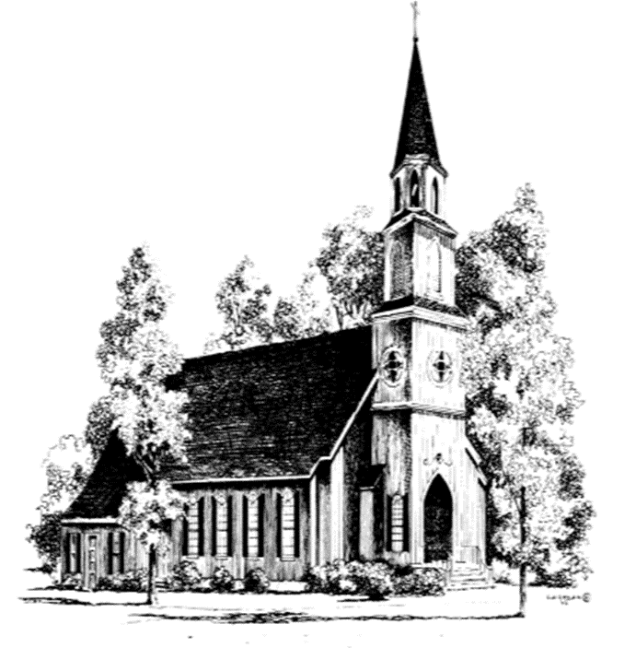
The Twenty-Third
Sunday after Pentecost
November 16, 2025
10:00 AM
A warm welcome to all who come to worship at St. John’s this beautiful day. If you are visiting with us, we would like to get to know you better, so please fill out a visitor’s card found in the pew and place in the offering plate.
There is no wrong way to worship. The people’s responses are in bold and instructions for sitting, standing, and kneeling are in italics. We invite you to participate in the way that feels most comfortable and authentic to you.

Prelude Air Carl Reinecke

The Word of God

Hymn 522
Glorious things of thee are spoken Sung by all. Austria
Celebrant Blessed be God: Father, Son, and Holy Spirit.

People And blessed be his kingdom, now and for ever. Amen.

Celebrant Almighty God, to you all hearts are open, all desires known, and from you no secrets are hid: Cleanse the thoughts of our hearts by the inspiration of your Holy Spirit, that we may perfectly love you, and worthily magnify your holy Name; through Christ our Lord. Amen.

Gloria (next page) Sung by all. Powell

The Collects
Celebrant The Lord be with you.
People And also with you.
Celebrant Let us pray. Blessed Lord, who caused all holy Scriptures to be written for our learning: Grant us so to hear them, read, mark, learn, and inwardly digest them, that we may embrace and ever hold fast the blessed hope of everlasting life, which you have given us in our Savior Jesus Christ; who lives and reigns with you and the Holy Spirit, one God, for ever and ever. Amen.

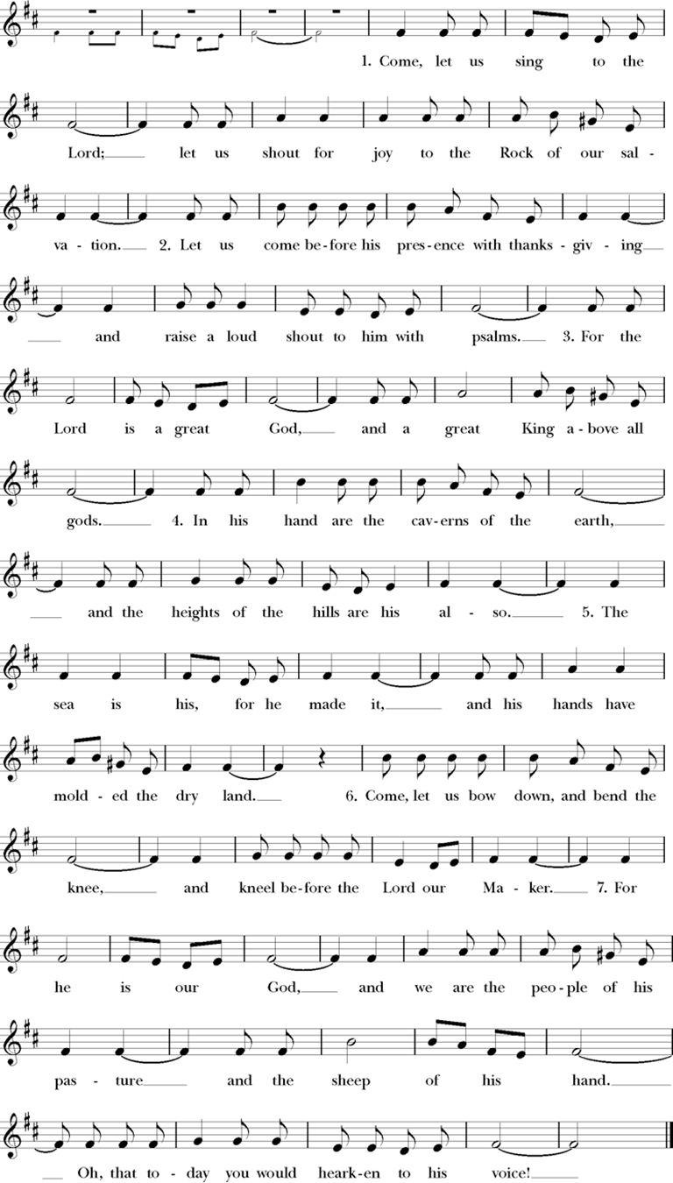

The people are seated.

The First Lesson Isaiah 65:17-25
₁₇I am about to create new heavens
and a new earth;
the former things shall not be remembered
or come to mind.
₁₈But be glad and rejoice forever
in what I am creating;
for I am about to create Jerusalem as a joy,
and its people as a delight.
₁₉I will rejoice in Jerusalem,
and delight in my people;
no more shall the sound of weeping be heard in it,
or the cry of distress.
₂₀No more shall there be in it
an infant that lives but a few days,
or an old person who does not live out a lifetime;
for one who dies at a hundred years will be considered a youth,
and one who falls short of a hundred will be considered accursed.
₂₁They shall build houses and inhabit them;
they shall plant vineyards and eat their fruit.
₂₂They shall not build and another inhabit;
they shall not plant and another eat;
for like the days of a tree shall the days of my people be,
and my chosen shall long enjoy the work of their hands.
₂₃They shall not labor in vain,
or bear children for calamity;
for they shall be offspring blessed by the Lord—
and their descendants as well.
₂₄Before they call I will answer,
while they are yet speaking I will hear.
₂₅The wolf and the lamb shall feed together,
the lion shall eat straw like the ox;
but the serpent—its food shall be dust!
They shall not hurt or destroy
on all my holy mountain,
Lector The Word of the Lord. People Thanks be to God.

Psalm 98 Antiphon sung by all.
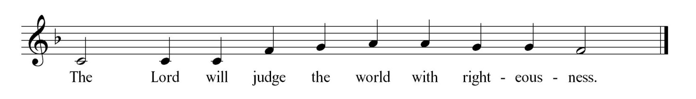

₁Sing to the Lord a new song, *
for he has done marvelous things.
²With his right hand and his holy arm *
has he won for himself the victory. Antiphon
³The Lord has made known his victory; *
his righteousness has he openly shown in the sight of the nations.
⁴He remembers his mercy and faithfulness to the house of Israel, *
and all the ends of the earth have seen the victory of our God. Antiphon
⁵Shout with joy to the Lord, all you lands; *
lift up your voice, rejoice, and sing.
⁶Sing to the Lord with the harp, *
with the harp and the voice of song. Antiphon
⁷With trumpets and the sound of the horn *
shout with joy before the king, the Lord.
⁸Let the sea make a noise and all that is in it, *
the lands and those who dwell therein. Antiphon
⁹Let the rivers clap their hands, *
and let the hills ring out with joy before the Lord,
when he comes to judge the earth.
¹⁰In righteousness shall he judge the world *
and the peoples with equity. Antiphon

The Second Lesson 2 Thessalonians 3:6-13
⁶Now we command you, beloved, in the name of our Lord Jesus Christ, to keep away from believers who are living in idleness and not according to the tradition that they received from us. ⁷For you yourselves know how you ought to imitate us; we were not idle when we were with you, ⁸and we did not eat anyone’s bread without paying for it; but with toil and labor we worked night and day, so that we might not burden any of you. ⁹This was not because we do not have that right, but in order to give you an example to imitate. ¹⁰For even when we were with you, we gave you this command: Anyone unwilling to work should not eat. ¹¹For we hear that some of you are living in idleness, mere busybodies, not doing any work. ¹²Now such persons we command and exhort in the Lord Jesus Christ to do their work quietly and to earn their own living. ¹³Brothers and sisters, do not be weary in doing what is right.
Lector The Word of the Lord.
People Thanks be to God.

The people stand as able.

Sequence Hymn 635, verse 1
If thou best trust in God to guide thee Sung by all. Wer nur den lieben

The Gospel Luke 21:5-19
Celebrant The Holy Gospel of our Lord Jesus Christ according to Luke.
People Glory to you, Lord Christ.
5When some were speaking about the temple, how it was adorned with beautiful stones and gifts dedicated to God, Jesus said, 6“As for these things that you see, the days will come when not one stone will be left
upon another; all will be thrown down.”
⁷They asked him, “Teacher, when will this be, and what will be the sign that this is about to take place?” ⁸And he said, “Beware that you are not led astray; for many will come in my name and say, ‘I am
he!’ and, ‘The time is near!’ Do not go after them.
⁹“When you hear of wars and insurrections, do not be terrified; for these things must take place first, but the end will not follow immediately.” ¹⁰Then he said to them, “Nation will rise against nation, and kingdom against kingdom; ¹¹there will be great earthquakes, and in various places famines and plagues; and there
will be dreadful portents and great signs from heaven.
¹²“But before all this occurs, they will arrest you and persecute you; they will hand you over to synagogues and prisons, and you will be brought before kings and governors because of my name. ¹³This will give you an opportunity to testify. ¹⁴So make up your minds not to prepare your defense in advance; ¹⁵for I will give you words and a wisdom that none of your opponents will be able to withstand or contradict. ₁⁶You will be betrayed even by parents and brothers, by relatives and friends; and they will put some of you to death. ¹⁷You will be hated by all because of my name. ¹⁸But not a hair of your head will perish. ¹⁹By your endurance you will gain your souls.”

Celebrant The Gospel of the Lord.
People Praise to you, Lord Christ.

Sequence Hymn 635, verse 2
If thou best trust in God to guide thee Sung by all. Wer nur den lieben
The Sermon

The people stand as able

The Nicene Creed
We believe in one God, the Father, the Almighty, maker of heaven and earth, of all that is, seen and unseen.
We believe in one Lord, Jesus Christ, the only Son of God, eternally begotten of the Father, God from God, Light from Light, true God from true God, begotten, not made, of one, Being with the Father. Through him all things were made. For us and for our salvation he came down
from heaven: by the power of the Holy Spirit he became incarnate from the Virgin Mary and was made man. For our sake he was crucified under Pontius Pilate; he suffered death and was buried. On the third day he rose again in accordance with the Scriptures; he ascended into
heaven and is seated at the right hand of the Father. He will come again in glory to judge the living and the dead, and his kingdom will have no end.
We believe in the Holy Spirit, the Lord, the giver of life, who proceeds from the Father and the Son. With the Father and the Son he is worshipped and glorified. He has spoken through the Prophets. We believe in one holy catholic and apostolic Church. We acknowledge one baptism for the forgiveness of sins. We look for the resurrection of the dead, and the life of the world to come. Amen.

The Prayers of the People
Celebrant Believers, do not be weary in doing what is right. It is right to give God thanks and praise; therefore, let us say, “Sing to the Lord a new song: O God, you have done marvelous things!”
Lector O God, remember your mercy and faithfulness to your Church. Give us your words and your wisdom. May we have the strength to bear the name of Jesus in all circumstances.
Sing to the Lord a new song:
People O God, you have done marvelous things!
Lector O God, remember your mercy and faithfulness to this nation. Save us from arrogance and self-reliance. Grant us to be a nation that favors peace over war, life rather than death.
Sing to the Lord a new song:
People O God, you have done marvelous things!
Lector O God, remember your mercy and faithfulness to all of creation. May the seas and their creatures noisily praise you; may the rivers clap their hands and the hills ring out with joy before you, their Creator. Sing to the Lord a new song:
People O God, you have done marvelous things!
Lector O God, remember your mercy and faithfulness to our city. We pray that there may be work enough for all our citizens, that they might be able to earn a living that promotes dignity and health. Sing to the Lord a new song:
People O God, you have done marvelous things!
Lector O God, remember your mercy and faithfulness to all your children, especially those who are sick and suffering. Come to them, Lover of Souls, with healing in your wings. We pray especially for those on our prayer list, and those we name silently or aloud. Pause.
Sing to the Lord a new song:
People O God, you have done marvelous things!
Lector O God, remember your mercy and faithfulness to all who have died, especially Thomas Gardner. Bless them for their endurance. May they forever rest in that land where the sound of weeping is heard no more. Sing to the Lord a new song:
People O God, you have done marvelous things!

The Celebrant adds a concluding collect.

Confession and Absolution

Celebrant Let us confess our sins against God and our neighbor.

The people kneel as able. Silence is kept for reflection.

Together Most merciful God, we confess that we have sinned against you in thought, word, and deed, by what we have done, and by what we have left undone. We have not loved you with our whole heart; we have not loved our neighbors as ourselves. We are truly sorry and we humbly repent. For the sake of your Son Jesus Christ, have mercy on us and forgive us; that we may delight in your will, and walk in your ways, to the glory of your Name. Amen.

Celebrant Almighty God have mercy on you, forgive you all your sins through our Lord Jesus Christ, strengthen you in all goodness, and by the power of the Holy Spirit keep you in eternal life. Amen.

The Peace
Celebrant The peace of the Lord be always with you.
People And also with you.
The people greet each other with a sign of God’s peace and are seated.
The Holy Communion

The Offertory
Having listened to the Word of God, affirmed our faith, confessed our sins, and shared in the peace, we now prepare ourselves for the gift of the Holy Communion. At the offertory, we gratefully offer back to God some of what God has given us, both in the bread and wine, and in the money we give. Here at St. John’s, it is tradition that people stand as the elements are brought forward and are seated once the bread and wine are on the altar.

Offertory Anthem Consider the Lilies arr. Al Lyons

Doxology
Hymn 380 (verse 3) Sung by all. Old 100th

Praise God from whom all blessings flow,
Praise Him all creatures, here below.
Praise Him above ye heavenly host.
Praise Father, Son and Holy Ghost.

The Great Thanksgiving
Celebrant The Lord be with you.
People And also with you.
Celebrant Lift up your hearts.
People We lift them to the Lord.
Celebrant Let us give thanks to the Lord our God.
People It is right to give our thanks and praise.
Celebrant It is right, and a good and joyful thing, always and everywhere to give thanks to you, Father Almighty, Creator of heaven and earth through Jesus Christ our Lord; who on the first day of the week overcame death and the grave, and by his glorious resurrection opened to us the way of everlasting life. Therefore we praise you, joining our voices with Angels and Archangels and with all the company of heaven, who for ever sing this hymn to proclaim the glory of your Name:
Together
Sanctus Schubert
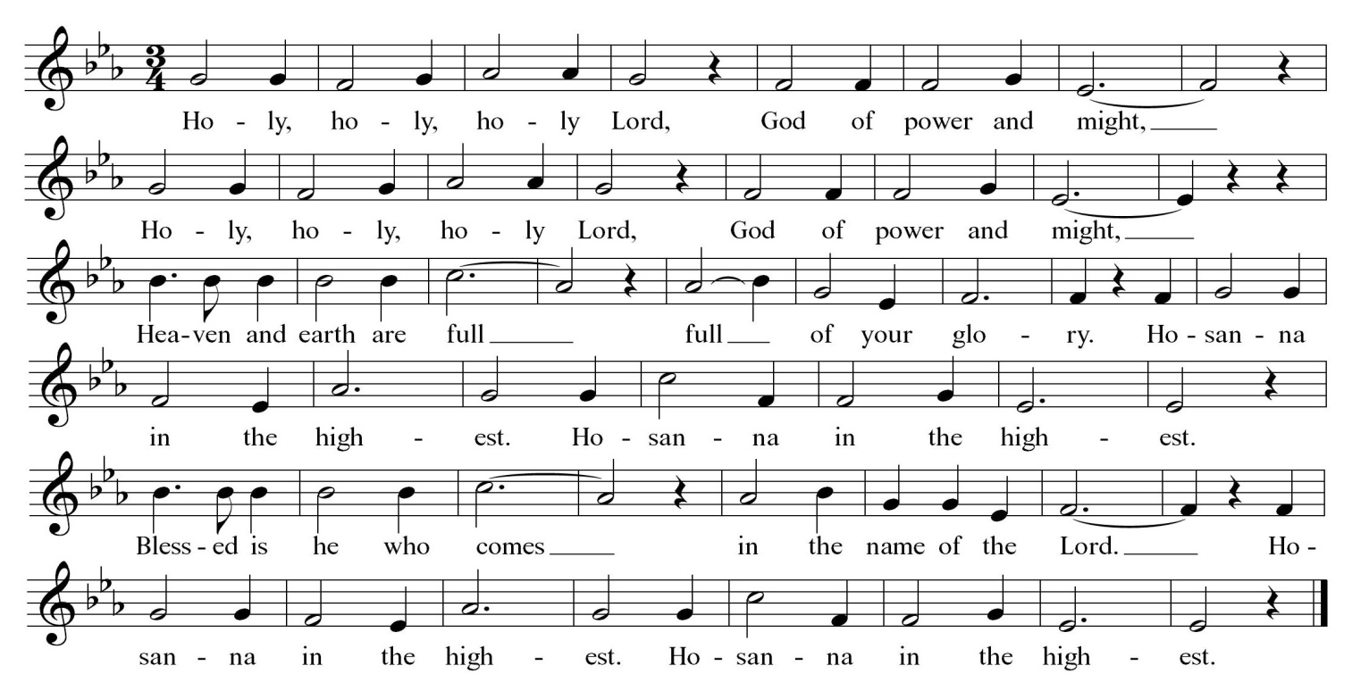

The people kneel or stand as able.

Celebrant We give thanks to you, O God, for the goodness and love which you have made known to us in creation; in the calling of Israel to be your people; in your Word spoken through the prophets; and above all in the Word made flesh, Jesus, your Son. For in these last days you sent him to be incarnate from the Virgin Mary, to be the Savior and Redeemer of the world. In him, you have delivered us from evil, and made us worthy to stand before you. In him, you have brought us out of error into truth, out of sin into righteousness, out of death into life. On the night before he died for us, our Lord Jesus Christ took bread; and when he had given thanks to you, he broke it, and give it to his disciples, and said, “Take, eat: This is my Body, which is given for you. Do this for the remembrance of me.” After
supper he took the cup of wine; and when he had given thanks, he gave it to them, and said “Drink this, all of you: This is my Blood for the new Covenant, which is shed for you and for many for the forgiveness of sins. Whenever you drink it, do this for the remembrance of me.” Therefore, according to his command, O Father,
Together We remember his death,
We proclaim his resurrection
We await his coming in glory;
Celebrant And we offer our sacrifice of praise and thanksgiving to you, O Lord of all; presenting to you, from your creation, this bread and this wine. We pray you, gracious God, to send your Holy Spirit upon these gifts that they may be the Sacrament of the Body of Christ and his Blood of the new Covenant.
Unite us to your Son in his sacrifice, that we may be acceptable through him, being sanctified by the Holy Spirit. In the fullness of time, put all things in subjection under your Christ, and bring us to that heavenly country where, with all your saints, we may enter the everlasting heritage of your sons and daughters; through Jesus Christ our Lord, the firstborn of all creation, the head of the Church, and the author of our salvation. By him, and with him, and in him, in the unity of the Holy Spirit all honor and glory is yours, Almighty Father, now and for ever.
People AMEN.

The Lord’s Prayer
Celebrant And now, as our Savior Christ has taught us, we are bold to say,
People Our Father, who art in heaven, hallowed be thy Name, thy kingdom come, thy will be done, on earth as it is in heaven. Give us this day our daily bread. And forgive us our trespasses, as we forgive those who trespass against us. And lead us not into temptation, but deliver us from evil. For thine is the kingdom, and the power, and the glory, for ever and ever. Amen.

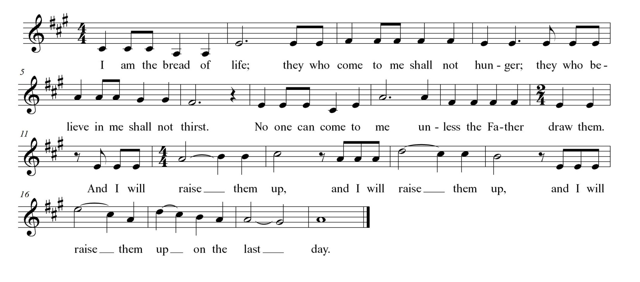
The Fraction Anthem

Invitation to Communion

The people are seated.

All who seek God and a deeper life in Christ are welcome to receive Holy Communion. While we believe that it is most meaningful when done as a baptized Christian, no one will ever be turned away from God’s table.

Please move at the direction of the ushers. You may receive the bread in open and outstretched hands. Gluten-free wafers are available; please make your need known to the priest. Receiving the bread only is full participation in the Eucharist. Wine is also available.

If you prefer to receive a blessing instead, please indicate your choice by crossing your hands across your chest. Those who wish to have Holy Communion brought to them at their seat should notify an usher.

Post Communion Prayer

Celebrant Let us pray.

People Eternal God, heavenly Father, you have graciously accepted us as living members of your Son our Savior Jesus Christ, and you have fed us with spiritual food in the Sacrament of his Body and Blood. Send us now into the world in peace, and grant us strength and courage to love and serve you with gladness and singleness of heart; through Christ our Lord. Amen.

The Blessing

Closing Hymn 596

Judge eternal throned in splendor Sung by all. Komn

The Dismissal

The Celebrant dismisses the people.
People Thanks be to God; Alleluia, alleluia!

The Postlude

All liturgical materials printed in this bulletin are printed
under license from either Rite Planning or CCLI #1994456.

St. John’s Episcopal Church
12201 Richmond Street | Chester, Virginia 23831
stjohnschester.com | 804-748-2182

