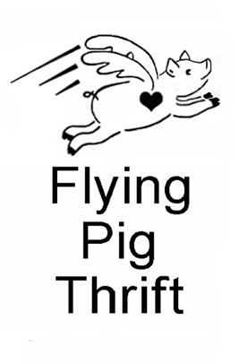
My name _____________________________ Phone _______________________________

I am a volunteer for Flying Pig Thrift. I’d like to come back during the final hours of your Sale to ask whether you will donate any of the following to the Store:

New or gently used adult clothing Kitchen items (dishes, pots/pans, utensils, etc.)
Books (youth and adult) Jewelry
Games (puzzles, board games, etc.) Small Furniture (chairs, end tables, etc.)
CDs, DVDs, records Artwork, household décor
Sporting goods Musical instruments
General household items Brown paper bags (grocery bags)

Not accepted: anything past its expiration date; moldy/wet items; garden chemicals; holiday decorations; hangers; video games/controllers; old remotes; old landline phones; computers; printers; chemicals; household hazardous waste items; dictionaries; encyclopedias; religious materials.

Donations accepted until 5 pm (Tuesday-Saturday). Call in advance to arrange large donations.

***********
Flying Pig Thrift is a nonprofit thrift store located at 722 Snelling Avenue North, St. Paul, MN 55104, on the corner of Snelling and Minnehaha. The shop opened in 2019 in honor of the founder’s sister who was an dedicated thrifter. The store donates to other nonprofits working towards social justice and non-violence, eco/“green” projects, and the like.

We are always looking for volunteers; please email or call the Store for information.

Store hours: Tuesday – Saturday from 11 am – 6 pm
Phone: 651-646-9697
Email: flyingpigthrift@gmail.com
Website: www.TheFlyingPigThrift.org

