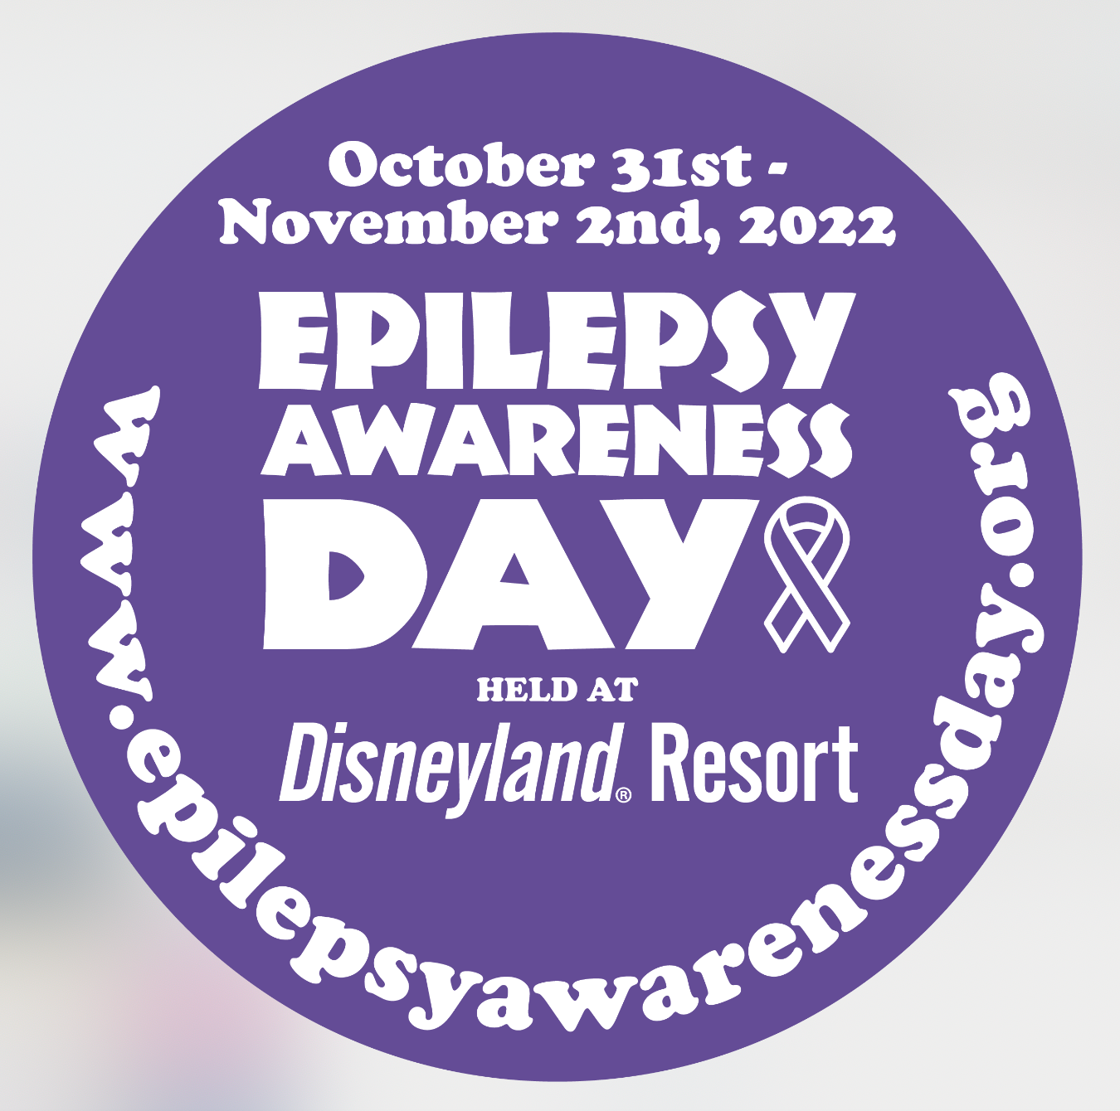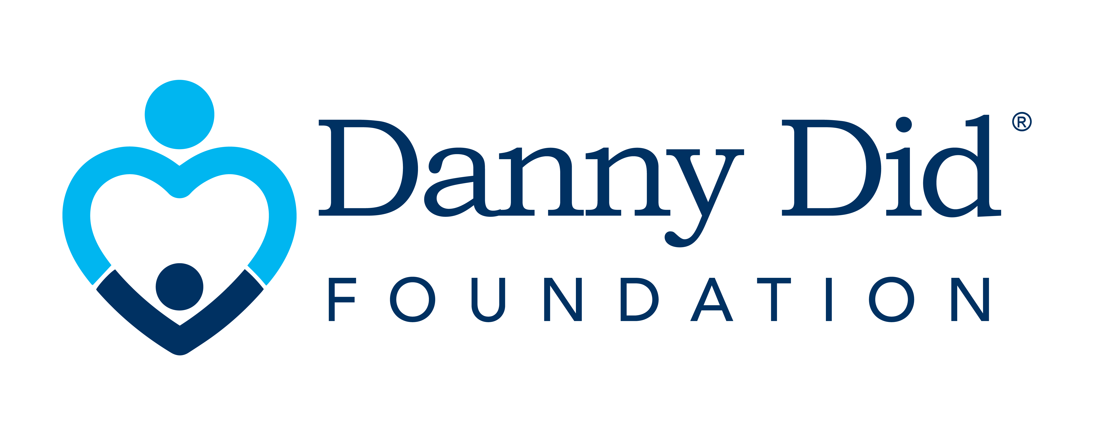

**APPLICATION FOR EADDL TRAVEL FINANCIAL ASSISTANCE**

**Epilepsy Education Expo and Epilepsy Awareness Day at Disneyland (EADDL)**

This event is for people of all ages with epilepsy, their families and friends, and those interested in raising awareness for epilepsy. The free EXPO will feature non-profit support groups, several epilepsy centers, drug and treatment related product manufacturers, seizure dogs and their trainers, and epilepsy professionals from around the world.

FREE Epilepsy Awareness and Education Expo will be held on October 31, 2022 and November 1, 2022 at Disneyland Hotel's Exhibit Hall.

Epilepsy Awareness Day at Disneyland will be held on November 2, 2022 10:00 a.m. - closing

If your family would like to attend EADDL and you require financial assistance, please complete this application and return it to enjoylife@dannydid.org to be considered.

Grants will be awarded to help cover travel related expenses, including your Disneyland Ticket(s). Reimbursable travel expenses include airfare, hotel, car rental, gas and parking only. Food expenses are not reimbursable. For expenses to be reimbursed, they must be substantiated. All submitted receipts must be related to your EADDL travel and must be dated. ***PLEASE NOTE***: You will make all of your own travel arrangements. Priority will be given to those who have not received a Danny Did travel grant in the past. Funding will not be disbursed by the Danny Did Foundation until after EADDL when receipts are provided. Hotel stay reimbursement may include the nights of 10/30-11/2/2022 only. If you extend your trip you will need to cover your expenses.

For reimbursement, all labeled receipts must be provided to Mary Duffy by **December 1, 2022** using this mailing address (no emails):

**Mary Duffy**

**Danny Did Foundation**

**ATTN: EADDL Grant**

**3008 Central St, Suite 203**

**Evanston, IL 60201**

**EADDL WEBSITE**: To learn more about the 2022 EADDL Expo and Day at Disneyland, visit [epilepsyawarenessday.org](http://www.epilepsyawarenessday.org/)

**Please complete and return the application on the next page.**



**Directions**: Please complete this application by typing on this form, then print it out and provide your **signature in pen.** Please then scan/return the application to enjoylife@dannydid.org or mail to:



I am applying for:

I live near Anaheim and need Disneyland Tickets reimbursement only. Maximum 5 tickets.

Travel costs & Disneyland Tickets (airfare, hotel, car rental, gas and/or Disneyland tickets). I understand our travel related expenses will only be reimbursed up to $1500 and I am responsible for all other expenses.

**Parent/Caregiver Name:** Click or tap here to enter text.

**Address:** Click or tap here to enter text.

**Email:** Click or tap here to enter text.

**Phone Number:** Click or tap here to enter text.

**Please explain your connection to Epilepsy including the name and the age of the person who has epilepsy in your family:** Click or tap here to enter text.

**Please describe your expected travel expenses required to attend EADDL:** Click or tap here to enter text.

**Annual Household Income:**Click or tap here to enter text.

**Please provide background on the basis for your financial need:** Click or tap here to enter text.

**Have you attended EADDL in the past? Yes No  If yes, did you receive help from DDF or another nonprofit for that trip? YesNo Name of Organization that helped you.**Click or tap here to enter text.

**Have you received funds from Danny Did before? Yes NoIf so, how were those funds used?**Click or tap here to enter text.

**Who will attend the EADDL with you?:** Click or tap here to enter text.

**I understand that if I receive funds from another charity organization for my trip to EADDL, I will forfeit my Danny Did reimbursement grant.**

**Signature:** ____________________________________________

**Date:** Click or tap here to enter text.