USGS Home
Contact USGS
Search USGS
Oregon Water Science Center
Home Data Studies Publications/Media Information

McKenzie River, Oregon, Source Water Quality Protection

Study Description

Summary
Drinking water for the City of Eugene, Oregon, is drawn from the McKenzie River, a high-quality source that is nonetheless threatened by urban, agricultural, and forestry land uses upstream as well as by structural changes in water management in the watershed. The Eugene Water and Electric Board (EWEB) developed a Drinking Water Source Protection plan for the McKenzie River Watershed that includes comprehensive monitoring and evaluation of potential threats to drinking water sources.
In 2002, the USGS’ Oregon Water Science Center began working with EWEB to monitor dissolved pesticides in the McKenzie River at the EWEB drinking water intake and upstream, and in tributaries draining to the McKenzie. In 2007, the USGS and EWEB entered into a 5-year agreement to continued to assist EWEB in their efforts to assess and monitor many of these upstream threats, and to further understand the relative risks posed by these threats in relation to potential management actions.
The primary objective of this study is to establish a long term relationship between USGS and EWEB, centered around technical studies of threats to drinking water quality and watershed health in the McKenzie River Basin, that will provide EWEB with information necessary to manage and protect its drinking water sources. Specific work elements or studies may be modified from year to year as agreed upon in discussions between EWEB and USGS. The studies currently identified are organized into Tasks, with individual Task objectives as outlined below.
Specific study tasks include:
Task 1: Ongoing semiannual storm runoff pesticide data collection
Task 2: Investigation of sources of natural organic matter and disinfection by-product precursors
Task 3. Reconnaissance sampling for pesticides and organic wastewater compounds using passive samplers
Task 4: (Potential) Investigation of pharmaceuticals and sewage/septics in well water in shallow aquifer systems
Task 5: Model support and development to help EWEB address a variety of management alternatives for McKenzie River water quality

Relevance and Benefits
Pressures on drinking water resources in western Oregon are increasing. Populations within the Eugene-Springfield area are expected to continue to increase, climate change could alter the historically large quantities of clean groundwater supporting summer streamflows in the McKenzie River, river management for endangered species has caused changes in reservoir regulation and downstream thermal regimes, and the recent voter-approved Measure 37 is expected to result in increased rural development. The McKenzie River has been a highly reliable source of outstanding-quality water for drinking, and in recent years EWEB has put additional emphasis on source-water protection efforts. This proposal and the study elements described herein support the Environment and Natural Resources Goal of the USGS Strategic Plan by providing long-term datasets and interpretive water-quality products that will deliver information to provide decision makers (EWEB and others) with a better understanding of current and future water quality conditions, threats to drinking water resources, and options for responding to these conditions. In addition this program, in conjunction with other ongoing work on drinking water resources by the USGS and others in Oregon, will extend our knowledge of overall threats to drinking water resources in the face of increasing pressures from development, resource extraction, and climate change and the roles that scientific investigations can play in understanding and mitigating the risks these threats cause for drinking water.
The overall program enhances the long-term partnership between EWEB and USGS with the goal of understanding the potential threats to water resources in the McKenzie River Basin and providing information on the likely outcome of different options for managing these threats. With support from USGS Federal Matching Funds and the Oregon Water Science Center, EWEB will gain access to unique, relevant USGS resources and expertise in Oregon and elsewhere that will help it achieve its management goals; likewise the USGS will gain an opportunity to refine methods such as passive organic samplers and laboratory analysis of PCPPs for their application in large, generally dilute rivers such as the McKenzie, and will be be able to grow its programs that contribute to drinking water resources in the United States.

Problem
The McKenzie River (Figure 1) is the sole source of drinking water for over 200,000 people in the Eugene area of Oregon. To protect this critical resource, EWEB developed a Drinking Water Source Protection plan in October 2000 and began implementation of this plan in April 2001. The overall goal of the source protection program is to “measure the balance between watershed health and human use over time and implement actions that maintain a healthy balance for production of exceptional water quality.” One component necessary to achieve this goal is understanding the river’s capacity to accommodate constituent loadings and the management actions needed to maintain a healthy watershed with good to excellent water quality. The following elements were identified as part of the source protection strategy:
- Comprehensive monitoring
- Disaster response
- Education and research assistance
- Point-source evaluation and mitigation
- Nonpoint-source evaluation and mitigation
- Land Acquisition
- Public outreach and information sharing
- Watershed land use tracking and management

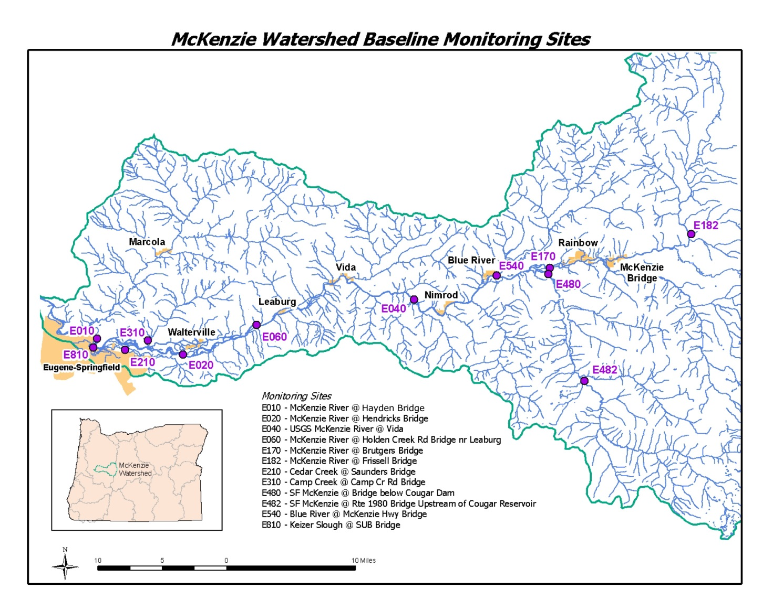
Figure 1. Map of McKenzie River Basin, Oregon

While many of these activities are beyond the scope of U.S. Geological Survey (USGS) investigations, it is within the USGS mission to assist EWEB with monitoring and research, including understanding the effects of watershed land use on water quality, and providing scientifically based guidance for drinking water source protection efforts. Since Fiscal Year (FY) 2002, pesticide samples have been collected during at least one runoff event in almost every spring and fall, through October 2007. Ongoing pesticide data collection during spring and fall is anticipated for the foreseable future; however, the accumulated data since 2002 warrant an interpretive analysis in order to understand the potential threats facing EWEB’s water supply, and optimize future data collection.
In addition to pesticides in the McKenzie River Watershed, potential threats to the drinking water supply exist from a variety of other sources. For instance, in 2005 and 2006 EWEB experienced increased treatment costs due to elevated counts of coliform bacteria, and increased formation of disinfection by-products (DBPs). Initially EWEB traced the elevated coliform bacteria to Cougar Reservoir, a large flood-control reservoir located on the South Fork of the McKenzie River, approximately 50 miles upstream, which was drawn down to historically low levels from 2002-2004 for modifications to the withdrawal structure. Presumably the coliform bacteria were associated with the decay of accumulated organic material (i.e. vegetation growth) along the exposed bed of the reservoir during the draw down; when the reservoir was refilled in 2005, the bacteria decayed organic material and entered the water column. It is also possible that disinfection by-product formation was enhanced by this increase in organic material, or that thermal warming of the outlet from Cougar Reservoir (a desired result of the construction project) changed the nature of ecological processes in the South Fork or main stem McKenzie. These changes may have been enough to change the metabolic processing of nutrients and organic carbon in the river such that DBP formation increased. They may have also altered the survival of bacteria, partially accounting for the increased counts at the treatment plant downstream.
This proposal outlines a series of studies and reports during the period 2007-2012 that will evaluate potential threats to EWEB’s drinking water supplies in the McKenzie River Basin. Data collected and findings from these studies will inform EWEB’s management of the resource by increasing their overall understanding of contaminant sources and transport, ecological processes, and the results of land management actions in the basin. Some study tasks as outlined below may also be partly funded from other sources beyond EWEB and USGS, particularly in future years, and these aspects are indicated herein.

Task 1: Ongoing semiannual storm runoff pesticide data collection
The objective of this Task is to provide continuing support for pesticide data collection on a long term basis. As part of its drinking water source protection program, EWEB began implementation of a stormwater and urban runoff monitoring program in the winter of 2001/2002 for the lower McKenzie River watershed. Accordingly, pesticide data during Spring and Fall storms have been collected by EWEB in cooperation with USGS since Fall 2002 (Fiscal Year 2003). Quality Assurance (QA) has been a relatively large component of the sampling program – over 30% of samples collected between 2002 and 2006. Following transmittal from the NWQL, both the environmental and QA data have routinely been reviewed, and corrected if appropriate, and subsequently transmitted to EWEB for inclusion in their databases. The approved environmental data have also been made available on NWISWeb according to standard USGS guidelines.
In 2004, EWEB began implementation of a nonpoint source pollution program to evaluate pollution runoff from agricultural activities, commercial forest management activities, septic systems, and construction activities. EWEB uses geographic information system (GIS) analysis of nonpoint source data to identify high priority areas to target for water quality monitoring. Included among the GIS layers available are “pesticide notification” data from private forestry companies, which are annual estimates (most likely overestimates) of pesticides to be applied in the subsequent year. On the basis of these GIS analyses watersheds were identified that are managed primarily for commercial forestry and that have significant applications of pesticides. Since 2004 pesticide monitoring in water has also included samplings of the forestry-intensive watersheds, while remaining primarily focused on urban runoff. Agricultural land is also significant in the middle portions of the watershed, and streams draining these lands will be sampled after EWEB’s outreach efforts have successfully established productive and collaborative relations with local landowners.

Task 2: Investigation of sources of NOM and disinfection by-product precursors
Since 2005, EWEB has experienced increased summertime treatment costs due to increases in the formation of disinfection by-products (DPBs) in treated water (HDR Engineering, 2007). DBP formation is problematic because of increased consumer health concerns when DPB-regulatory thresholds are reached that require additional treatment strategies. DBPs are produced during water treatment when natural organic matter (NOM) reacts to form by-products such as trihalomethanes (THMs) and haloacetic acids (HAAs). Because the propensity of NOM to form DBPs depends on its molecular structure, it is important not only to understand the quantity of NOM contributed by different sources, but also to understand the composition of the NOM and how likely it is to form DBPs.
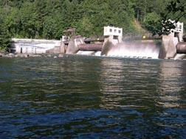
Leaburg Dam on the McKenzie River
There are a number of sources of NOM to the McKenzie River. These include upstream reservoirs and bed material within them, algal production both within and downstream of reservoirs, runoff from disturbed soils in urban, agricultural and timber-management areas, and possibly wetlands or riparian areas along the river. Although the potential causes of increasing DBP formation are many, the timing of the measured increases in DBP formation coincided with the refilling of Cougar Reservoir following 3 years of drawdown for construction. Initial investigations by EWEB traced high coliform bacterial counts to the outlet of Cougar Reservoir in the South Fork McKenzie River, suggesting the reservoir is a potential source of higher NOM and DBP precursor loads (HDR Engineering, 2007). Additional contributing factors could include changes in nutrient, algal, and organic carbon sources in the basin, many of which also could have been significantly affected by changes in the management regime of Cougar Reservoir. By installing a multilevel withdrawal structure at Cougar Reservoir, the Corps of Engineers now manages the reservoir during summer to better mimic natural water temperatures by withdrawing more water from the surface, resulting in warmer summer temperatures in the South Fork and downstream. These changes may also have affected nutrient and trophic status both within the reservoir and downstream, and any downstream changes, combined with warmer water temperatures, could induce shifts in the algal ecology of the South Fork or main stem McKenzie Rivers.
The primary objective of this Task will be to evaluate potential sources of DBP precursors and the mechanisms/processes which control their production in the McKenzie River. A secondary objective will be to specifically determine if recent changes in management of Cougar Reservoir may have contributed to changes in trophic status, including nutrient cycling and algal communities, in downstream reaches that might therefore cause water treatment costs to increase.
Recent data on NOM concentration and DBP formation in treated water from EWEB’s treatment plant will be used to help determine the critical times and possible mechanisms affecting DBP formation. USGS researchers who are proficient with organic matter processing and impacts on drinking water also will be consulted in this study. Upon initial evaluation of reconnaissance data, additional surveys will be planned for FY08, with an interpretive report to be initiated in FY08 and completed in FY09. If appropriate, additional studies may be proposed at that time.

Task 3: Passive sampling for pesticides and organic wastewater compounds.
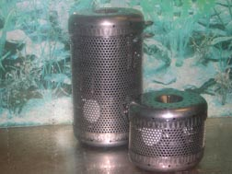
POCIS sampler
Organic contaminants, both hydrophilic and hydrophobic, can be very difficult to assess in dilute mountain rivers such as the McKenzie River because of their episodic nature and low concentrations. Previous sampling in the watershed has shown that a number of different pesticides are detected in urban streams that discharge to the McKenzie River upstream of EWEB’s drinking water intake location; however, there have been very few detections in the McKenzie River itself at the intake. Such compounds may have significant consequences even at concentrations that are orders of magnitude below the detection limits associated with conventional water-sampling techniques. Additionally, there are upstream communities that are entirely dependent on on-site (septic) systems for sewage disposal, which could be sources of pharmaceuticals or other personal care products to the river.
Passive samplers such as polar organic chemical integrative samplers (POCIS) and semipermeable membrane devices (SPMDs) are particularly well suited to overcoming the challenges of both low analyte concentrations and episodic loading. EWEB is interested in using POCIS and SPMDs to evaluate the status of organic contaminants in the McKenzie River at the EWEB intake, and possibly in selected other locations, in order to better understand threats to the integrity of the drinking water source. In addition, several other possibilities exist in western Oregon for passive sampling to examine sources of contaminants or to evaluate threats to other drinking water supplies, and to the extent possible the Oregon Water Science Center would like to increase the spatial coverage of POCIS and SPMD sampling by coordination of these otherwise disparate efforts.
The primary objective of this Task will be to evaluate exposure of the EWEB drinking water intake on the McKenzie River to a broad range of organic contaminants and to determine the overall sources for these compounds. A secondary objective is to use this POCIS/SPMD sampling as an opportunity to leverage additional passive sampling efforts such as near drinking water intakes on the WillametteRiver for Corvallis and Wilsonville and on the Clackamas River, or in the Columbia River as part of the lower Columbia River Estuary Partnership. Funding for any additional sampling efforts would come from other sources (under separate proposals), but the combined information gleaned from these deployments would help provide perspective and contaminant exposure information to create a regional investigation with broad application for several critical water supplies in western Oregon. Efficiencies in passive sampler deployment, retrieval, and analyses are also likely to be gained by combining such efforts, which may result in decreased costs. Data collection under this task will begin during FY07. Continued data collection efforts will depend on the outcomes of the initial deployment, however the initial intent is to incorporate the use of passive sampling strategies into the long-term monitoring program for contaminants in EWEB’s source waters. We anticipate that a preliminary report assessing the methods, results, and applicability to future monitoring will be initiated in FY09 and completed during FY10. Coordination efforts with other programs will begin during FY07 and FY08.

Task 4: Pharmaceuticals and sewage/septics in well water in shallow aquifer systems
Among the groups of contaminants that are potentially entering drinking water supplies at EWEB’s intake are Pharmaceuticals and Personal Care Products (PPCPs). These compounds may be originating from shallow septic systems in the alluvial aquifers along the edges of the McKenzie River, particularly in the region between Springfield and Leaburg Dam, including the communities of Walterville and Leaburg. Information from EWEB’s GIS libraries indicates locally-high densities of septic systems in these reaches, in some cases reaching levels that could cumulatively overwhelm the abilities of the soil microbial communities to degrade compounds before they migrate to the river. Preliminary calculations indicate that these risks are relatively small, and this was generally confirmed with reconnaissance sampling for human tracers during 2006. However, a few samples with moderately elevated nitrate (~0.2 mg/L) and detections of caffeine indicated that there may be locations or time periods when some PPCPs do make their way into the river or its tributaries. Given that the number of on-site disposal systems along the McKenzie River is expected to increase, partly as a result of Measure 37 building claims (see http://www.oregon.gov/LCD/MEASURE37/index.shtml for more information on Oregon’s Measure 37), EWEB is concerned that these few positive indications of potential impacts could grow in future years.
The objective of this Task will be to provide an initial estimate of the magnitude of the problem of PCPPs or other indicators of human waste entering EWEBs drinking water supplies or threatening groundwater resources in the basin. If significant detections occur in shallow groundwater, additional studies will be designed to document the degradation rates of these compounds and/or their risk of migrating to the McKenzie River.

Task 5: Model support and development
Ultimately, the tools to effectively manage watersheds as complex as the McKenzie River watershed will require sophisticated models that allow users to investigate the likely results of changes in uses of land, water, and other resources. EWEB and other resource management agencies in the basin have a need for models that can elucidate:
- Time of travel and contaminant transport
- Water temperature as controlled by discharge, upstream inputs, solar radiation, shading, stream geometry and geology, and point source inputs
- Organic carbon, nutrient dynamics and/or stream trophic status as influenced by point and non-point sources, physical stream parameters, upstream sources including reservoir operations, and resulting effects on formation of disinfection byproducts.
The USGS will work with EWEB to ultimately develop a modeling framework that can utilize existing information together with incremental additions for individual components (e.g. streamflow, temperature, water quality, nutrient and organic material processing), such that over time the model(s) will allow comprehensive evaluations of management alternatives for their effects on water quality. A version of CE-QUAL-W2 has already been constructed for the McKenzie River from the mouth up to the South Fork McKenzie, for computation of streamflow and temperature. Similarly, a MikeBasins Model and Mike-11 Model from Danish Hydraulics Insitute. (DHI) are currently in construction for the lower reaches of the river that will be used for water allocation and rainfall-runoff modeling.
The long-term objective of this Task is to identify and build the model framework that will help answer short term questions about the effects of water management on streamflow, temperature, organic carbon, or spill-response, and that can be modified in the future to accommodate stream ecology and nutrient cycling, and to the extent possible other modeling goals as stated above. In the short term, the objective will be to assist EWEB in understanding the strengths and limitations of existing models for the basin. We will also identify those aspects that may require an alternate modeling approach, and identify steps by which to achieve these capabilities as prioritized by EWEB. Future modeling may require data collection, although much may already be available (particularly after Task 3 has been completed). Downstream effects of reservoir operations are an important component to consider in management of the basin, so the scope of the modeling will at least include the main stem McKenzie up to the South Fork McKenzie as well as Cougar and Blue River Reservoirs. The Corps of Engineers, which operates Cougar and Blue River Reservoirs, also is a potential partner in this effort. A modeling effort by USGS would likely begin in FY09, with an initial report scheduled for FY10.
Accessibility FOIA Privacy Policies and Notices
U.S. Department of the Interior | U.S. Geological Survey
URL: https://or.water.usgs.gov/proj/EWEB/description.html
Page Contact Information: Oregon Webteam
Page Last Modified: Monday, 19-Dec-2016 19:51:18 EST

