**McKenzie River**

**Algae & Aquatic Invasive Plant Identification**

1. Filamentous Algae

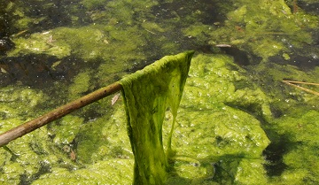

1. Hydrilla

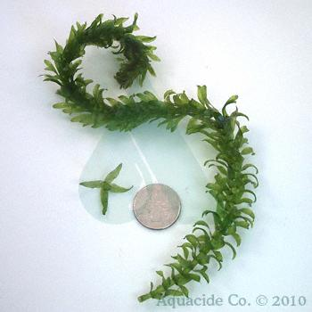

1. Elodea

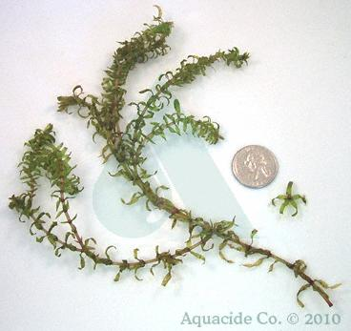

1. Milfoil

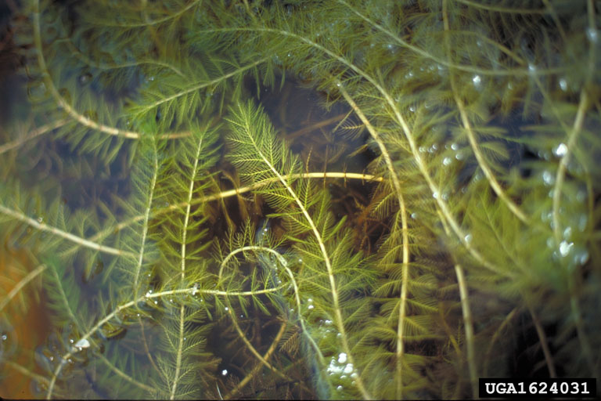

1. Didymo or "Rock Snot" 