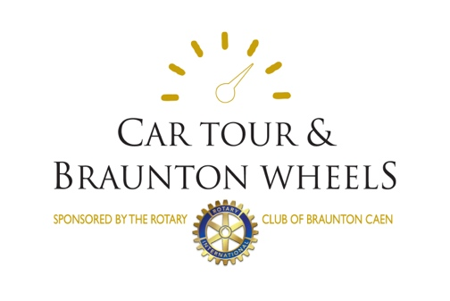

Rotary Club of Braunton Caen

Charity Car Tour

Booking Form

**Sunday 28th April 2019**

**DRIVER DETAILS**

First Name..........................................................Surname...................................

Address.........................................................................................................................................

Post Code...............................Tel..........................Mobile..................................

Email................................................................................................................................................................

Please tick if you are happy to have further details sent by email

**NAVIGATOR**

First Name.........................................................Surname......................................

**CAR DETAILS**

Make..................................................Model..........................................................

Year...................Registration No.............................Colour...................................

I have read the Regulations for the Tour and agree to abide by them.

Signed........................................................................Date.....................................

Rotary Club (if applicable)....................................................................................

To assist with catering please confirm your refreshment requirements

Please reserve.............coffee and bacon roll(s) at start. Please reserve.............cream teas at finish.

**Please return this form, with a cheque for £45.00 made payable to ‘The Rotary Club of Braunton Caen’ to: Jan Lewis, Hedgemoor, 5 Observer Close, South Molton EX36 3FE .**

**Or return by email and send payment by BACs to**

**Rotary Club of Braunton Caen Sort Code 30-90-49 A/c No 34016968 using the first 3 digits of your registration number as a reference.**

**Receipts will not be posted, but an acknowledgement can be sent by email.**