PUPIL EQUALITY STATEMENT

Context
The Ashington Learning Partnership (ALP) consists of two schools:
- Both are above average sized primary schools;
- Both are three/four form entry and based on two sites;
- Central has a school deprivation indicator in the bottom 5% nationally and Bothal in the bottom 40%;
- Central has a proportion of free school meals significantly above that seen nationally and Bothal has a proportion of free school meals broadly in line with that seen nationally.

The work of the ALP schools is reinforced by:

Core Values
Responsible We are accountable for our words and actions
Excellence We try our best in everything we do
Safe We protect ourselves from harm
Prepared We are ready to learn
Equality We treat everybody fairly
Courage We face our challenges and do our best to overcome them
Teamwork We participate together to be successful

Guiding Principles
Partnership – Achieving Success Together
Responsibility – Acting With Integrity & Respect
Excellence – Being the Best That We Can Be
Opportunity – Building Pathways to Progress

- Equal Opportunities
It is the aim of the governing body of the Ashington Learning Partnership to provide a learning culture in which due regard is given to equality of opportunity.

We declare ourselves to be firmly committed to equality of opportunity for all our pupils regardless of gender, ethnicity or disability. We will seek to build a reputation for equality of which the ALP can be proud.

We aim to ensure that no pupil, parents, job applicant or employee receives less favourable treatment than another on grounds of sex, race, colour, ethnic origin, marital status, sexual orientation, disability, age (within the context of the normal retirement age) or any other factors unrelated to the requirements of the job and which are not restricted by legislation.

This should be demonstrated as follows:
For pupils:
- to have a learning environment matched to needs and abilities;
- to have the opportunity to develop as spiritual, social, physical and intellectual beings;
- to work in an atmosphere of tolerance, security and care;
- to have the right to make choices and decisions about their learning;
- to have reasonable access to materials and support matched to their needs;
- to be supported by skilled and caring staff;
- to be valued irrespective of ability, race, gender, age or achievement.
For parents:
- to have the right to make critical comment about the education of their children;
- to ensure that the schools meet their statutory obligation to provide an education for their children in keeping with national legislation;
- to contribute to the development of Ashington Learning Partnership;
- to be valued irrespective of ability, race, gender or age.

The ALP is committed to providing equal opportunities for all. Careful consideration is given to equality to eliminate any discrimination in experiences offered across the Trust in order to ensure equity and fairness in both access and engagement.

2. Enrichment Opportunities Consistency
When making decisions regarding the Trust opportunities the following should be taken into
consideration:
- Safeguarding;
- the needs of each school in their own right;
- the collective needs of learners within the ALP;
- Budget and access to funding both at school and Trust level;
- Restrictions and benefits of the physical site; in being able to host an event, for example
- locally identified needs;
- national priorities.

Should consideration of the above result in a difference of experience/event across the Trust, this will be discussed by the leadership team with the Executive Principal making the final decision.

The Friends Groups
When agreeing planned events, the Executive Principal will be represented and ensure that such events are planned according to:
- Safeguarding;
- Budget/access to funding;
- Restrictions and benefits of the physical site;
- Capacity and manpower of the team to deliver such events/celebrations.

Liaison between individual school based groups will take place where possible.

3. Transgender
Gender is often an important part of an individual's identity and developing a positive sense of gender identity is part of growing up. However, gender identity is often complex and there is a spectrum of gender which is wider than just boy/man or girl/woman.

Support for transgender pupils is inherent within policies and curriculum and builds on best practice already in place to eliminate discrimination, advance equality of opportunity and foster good relations. This procedure seeks to provide a broad overview of the needs of transgender pupils and their families.

Principles
In developing practice to support transgender pupils, we will try to follow these principles:
- Listen to the pupil and their parents. Wherever possible follow their lead and preferences.

- No pupil should be made to feel that they are the ones who are causing problems or that they owe anything to their school in return for being treated with the equality they deserve and are legally entitled to.
- Avoid seeing the pupil as a problem and instead see an opportunity to enrich the school community and to challenge gender stereotypes and norms on a wider scale.
- Avoid, where possible, gender segregated activities and where this cannot be avoided, allow the pupil to access the activity that corresponds to their gender identity.
- Challenge bullying and discrimination.
- Promote positive attitudes to gender diversity by including transgender issues within activities relating to discrimination, hate crime, diversity, inclusion, SRE and PSHE.

Early Help Process
It is important that any support offered to a transgender pupil starts with identifying their individual needs. It must be understood that some transgender pupils may not want any special treatment. Some may choose to be known by a different name or to wear different clothes. However, most transgender pupils (and their families) will need some expert/ specialist support as they grow up and develop.

A transgender pupil may benefit from an Early Help Assessment to identify any additional needs arising from transgender issues. We would (with agreement and in consultation with the pupil and parent) complete an Early Help Assessment to identify specific information that the pupil would like to be shared with those working with them to avoid them having to repeat themselves. When completing the assessment particular attention should be paid to the sections on emotional health and wellbeing, family and social relationships, and behaviour and an action plan put in place to address these issues and ensure the pupil has a robust support plan. The allocated Lead Professional should always be someone who knows and gets on well with the pupil.

Terminology and Language
The correct terminology and language should be used and in order to do this there may need to be some education in lessons around sexual orientation and gender so that staff and pupils have a clear understanding that sexual orientation and gender identity are two completely different things. For the matter of fairness and inclusion it is extremely important that the correct gender, name and pronouns are used correctly to address transgender pupils.

Names and Pronoun Change
Respecting a pupil request to change name and pronoun is crucial in supporting and validating that pupil’s identity. Some transgender pupils and young people may wish to change their name to make it in line with their gender identity. Although they may not have changed their name legally, individuals have the right to choose the name by which they are known to by staff and fellow pupils. More information on changing names on birth certificates can be found at www.deedpoll.org.uk/CanABirthCertificateBeChanged.html

School Attendance
We will make reasonable adjustments to accommodate absence requests for any treatment or appointments with external sources in line with our attendance policy. Sensitive care will be taken when recording the reason for absence.

School Photos
Transgender pupils may feel fine with having their photograph taken at school but steps must be taken to ensure that these images do not reveal any confidential information. We will always seek parental permission to publish photos in line with the use of pupil images policy.

Transphobia and Bullying
We have a robust anti-bullying policy in place. In line with this procedure, transphobia incidents will be recorded and dealt with in the same manner as other incidents that are motivated by prejudice, e.g. racist or homophobic incidents.

Physical Education
Sports and Physical Education is a key aspect of the national curriculum and the physical and mental well-being of young people. Physical Education develops pupil’s competence and confidence to take part in a range of physical activities that become a central part of their lives, both in and out of school.

A transgender pupil has the same right to Physical Education as any other pupil. With regard to transgender pupils at school, there should be reasonably few, if any, issues regarding participation within the sports of their true gender.

There may be sports where, if puberty develops whilst in primary school, male to female (M2F) transgender pupils may have a physical advantage over other girls but this should not present a problem within a carefully and sensitively managed lesson context. The issue of physical risk within certain sports will also be managed properly within the lesson context rather than preventing a transgender pupil from participating, which would be discriminatory.

If a pupil is binding their chest, they should be monitored carefully during particularly physical activities and in hot weather. There is a chance that the binding could cause discomfort or even impair breathing. Short breaks from activity could be offered discreetly.

Changing Room Facilities
The use of changing room facilities will be carefully considered. Facilities for transgender pupils will be sensitive to their needs and also recognise the needs and sensitivities of other pupils. When competing at another school or outside venue, school staff will ensure there is appropriate sensitive provision available. We will take a view on prior to the delivery of those lessons, in discussion with parents.

Swimming Lessons
The transgender pupil should be given the choice as to whether they wish to partake in swimming lessons or not. Parents will be made aware of the statutory responsibility for all children to be able to swim 25 metres by the end of Key Stage 2. If the transgender pupil wishes to partake in swimming lessons, then a risk assessment of the changing facilities should be completed. There must be careful consideration, in consultation with the pupil and parents/cares and in line with the health and safety policy of the leisure centre or swimming pools health and safety procedures. For example, it may be against health and safety regulations to wear a t-shirt in the swimming pool and therefore would be more appropriate for a F2M pupil to wear an all in one wetsuit or similar.

Residential Visits
Careful consideration and preparation will be needed where a transgender pupil is taking part in a residential visit – transgender pupils will not be excluded from the visit. The sleeping arrangements will need to be thought about carefully before the visit takes place. Risk assessments should be carried out prior to the residential visit so that reasonable adjustments can be made to allow the pupil to participate fully.

Vaccinations
We will allow any gender specific vaccinations to be carried out at the GP’s surgery in order to eliminate any embarrassment.

4. Other
Toilet Facilities
There is provision in school for unisex toilets and disabled. If they wish to, pupils will be able to use these facilities which will be labelled sensitively and appropriately. Otherwise transgender pupils may use the toilets that are appropriate to their gender identity.

School Uniform
All pupils will be expected to follow the School Uniform Policy, which covers uniform and hairstyles. There is a broad range of uniform available for both genders. Make up and jewellery are not permitted for any pupil.

Confidentiality
Information about a person’s status in terms of protected characteristics is considered ‘sensitive personal data’ and is subject to tighter controls than other personal data. Explicit consent is required before it can be processed. The following suggested suitable response for staff to offer should they be asked questions in relation to trans issues:

"We value all our pupils whatever their personal circumstances. Our job is to give them a good education in a happy school environment. That is what we are focusing on, and we would ask everyone to respect the privacy of all our pupils."

Created Reviewed
Signed: | Name: Nikki Lumley
Role: Schools Business Manager | Date: December 2018
Adopted
Signed: | Name: Andy Roberts
Role: Executive Principal | Date: March 2019

Appendix 1
Glossary of Terms - Transgender

Asexual (or ace) - someone who does not experience sexual attraction.

Bi – refers to an emotional and/or sexual orientation towards more than one gender.

Biphobia – the fear of dislike of someone who identifies as bi.

Cisgender or Cis – someone whose gender identity is the same as the sex they were assigned at birth. Non-trans is also used by some people.

Coming out – when a person first tells someone/others about their identity as lesbian, gay, bi or trans.

Gay – refers to a man who has an emotional, romantic and/or sexual orientation towards men. Also a generic term for lesbian and gay sexuality – some women define themselves as gay rather than lesbian.

Gender – often expressed in terms of masculinity and femininity, gender is largely culturally determined and is assumed from the sex assigned at birth.

Gender dysphoria – used to describe when a person experiences discomfort or distress because there is a mismatch between their sex assigned at birth and their gender identity. This is also the clinical diagnosis for someone who doesn’t feel comfortable with the gender they were assigned at birth.

Gender expression – how a person chooses to outwardly express their gender, within the context of societal expectations of gender. A person who does not confirm to societal expectations of gender may not, however, identify as trans.

Gender identity – a person’s innate sense of their own gender, whether male, female or something else (see non-binary below), which may or may not correspond to the sex assigned at birth.

Gender reassignment – another way of describing a person’s transition. To undergo gender reassignment usually means to undergo some sort of medical intervention, but it can also mean changing names, pronouns, dressing differently and living in their self-identified gender. Gender reassignment is a characteristic that is protected by the Equality Act 2010, and it is further interpreted in the Equality Act 2010 approved code of practice.

Gender Recognition Certificate (GRC) – this enables trans people to be legally recognized in their affirmed gender and to be issued with a new birth certificate. Not all trans people will apply for a GRC and you currently have to be over 18 to apply. You do not need a GRC to change your gender markers at work or to legally change your gender on other documents such as your passport.

Heterosexual / straight – refers to a person who has an emotional, romantic and/or sexual orientation towards people of the opposite gender.

Homosexual – this might be considered a more medical term used to describe someone who has an emotional romantic and/or sexual orientation towards someone of the same gender. The term ‘gay’ is now more generally used.

Homophobia – the fear or dislike of someone who identifies as lesbian or gay.

Intersex – a term used to describe a person who may have the biological attributes of both sexes or whose biological attributes do not fit with societal assumptions about what constitutes male or female. Intersex people may identify as male, female or non-binary.

LGBT – the acronym for lesbian, gay, bi and trans.

Lesbian – refers to a woman who has an emotional, romantic and/or sexual orientation towards women.

Neurodiverse – a concept where neurological differences are recognized and respected in the same way as any other human difference.

Non-binary – an umbrella term for a person who does not identify as only male or only female, or who may identify as both.

Outed – when a lesbian, gay, bi or trans person’s sexual orientation or gender identity is disclosed to someone else without their consent.

Person with a trans history – someone who identifies as male or female or a man or women, but was assigned differently at birth. This is increasingly used by people to acknowledge a trans past.

Pansexual – refers to a person whose emotional, romantic and/or sexual attraction towards others is not limited by biological sex, gender or gender identity.

Questioning – the process of exploring your own sexual orientation and/or gender identity/

Sex – assigned to a person on the basis of primary sex characteristics (genitalia) and reproductive functions. Sometimes the terms ‘sex’ and ‘gender’ are interchanged to mean ‘male’ or ‘female’.

Sexual orientation – a person’s emotional, romantic and/or sexual attraction to another person.

Trans – an umbrella term to describe people whose gender is not the same as, or does not sit comfortably with, the sex they were assigned at birth. Trans people may describe themselves using one or more of a wide variety of terms, including (but not limited to) Transgender, Transsexual, Gender-queer (GQ), Gender-fluid, Non-binary, Gender-variant, Crossdresser, Genderless, Agender, Non-gender, Third gender, Two-spirit, Bi-gender, Transman, Transwomen, Trans masculine, Trans feminine and Neutrois.

Transgender man – a term used to describe someone who is assigned female at birth but identifies and lives as a man. This may be shortened to trans man, or FTM, an abbreviation for female-to-male.

Transgender woman – a term used to describe someone who is assigned male at birth but identifies and lives as a woman. This may be shortened to trans woman, or MTF, an abbreviation for male-to-female.

Transitioning – the steps a trans person may take to live in the gender with which they identify. Each person’s transition will involve different things. For some this involves medical intervention, such as hormone therapy and surgeries, but not all trans people want or able to have this. Transitioning also might involve things such as telling friends and family, dressing differently and changing official documents.

Transphobia – the fear or dislike of someone based on the fact they are trans, including the denial/refusal to accept their gender identity.

Transsexual – this was used in the past as a more medical term (similarly to homosexual) to refer to someone who transitioned to live in the ‘opposite’ gender to the one assigned at birth. This term is still used by some although many people prefer the term trans or transgender.

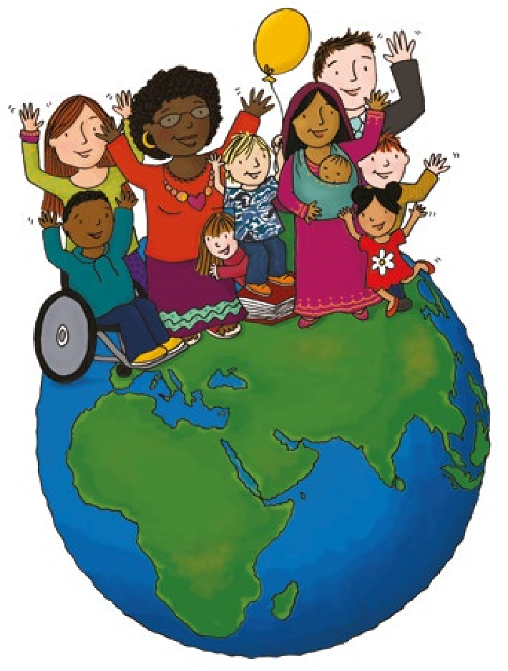
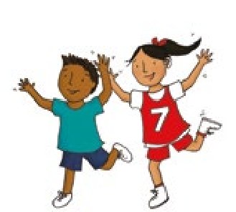
In 1989, governments across the world promised all children the same rights by adopting the UN Convention on the Rights of the Child. The Convention says what countries must do so that all children grow as healthy as possible, can learn at school, are protected, have their views listened to, and are treated fairly.
Appendix 2
Our

Rights
These are our rights.

Article 1
Everyone under the age of 18 has all the rights in the Convention.

Article 2
The Convention applies to everyone: whatever their race, religion or abilities, whatever they think or say, whatever type of family they come from.

Article 3
The best interests of the child must be a top priority in all things that affect children.

Article 4
Governments must do all they can to make sure every child can enjoy their rights.

Article 5
Governments must respect the rights and responsibilities of parents and carers to direct and guide their children as they grow up, so that they can enjoy their rights properly.

Article 6
Every child has the right to life. Governments must do all they can to make sure that children survive and develop to their full potential.

Article 7
Every child has the right to a legal name and nationality, as well as the right to know and, as far as possible, to be cared for by their parents.

Article 8
Governments must respect every child’s right to a name, a nationality and family ties.

Article 9
Children must not be separated from their parents unless it is in their best interests (for example, if a parent is hurting a child). Children whose parents have separated have the right to stay in contact with both parents, unless this might hurt the child.

Article 10
Governments must act quickly and sympathetically if a child or their parents want to live together in the same country. If a child’s parents live apart in different countries, the child has the right to visit both of them.

Article 11
Governments must do everything they can to stop children being taken out of their own country illegally or being prevented from returning.

Article 12
Every child has the right to have a say in all matters affecting them, and to have their views taken seriously.

Article 13
Every child must be free to say what they think and to seek and receive all kinds of information, as long as it is within the law.

Article 14
Every child has the right to think and believe what they want and to practise their religion, as long as they are not stopping other people from enjoying their rights. Governments must respect the rights of parents to give their children information about this right.

Article 15
Every child has the right to meet with other children and to join groups and organisations, as long as this does not stop other people from enjoying their rights.
Article 16
Every child has the right to privacy. The law should protect the child’s private, family and home life.
Article 17
Every child has the right to reliable information from the media. This should be information that children can understand. Governments must help protect children from materials that could harm them.
Article 18
Both parents share responsibility for bringing up their child and should always consider what is best for the child. Governments must support parents by giving them the help they need, especially if the child’s parents work.
Article 19
Governments must do all they can to ensure that children are protected from all forms of violence, abuse, neglect and bad treatment by their parents or anyone else who looks after them.
Article 20
If a child cannot be looked after by their family, governments must make sure that they are looked after properly by people who respect the child’s religion, culture and language.
Article 21
If a child is adopted, the first concern must be what is best for the child. All children must be protected and kept safe, whether they are adopted in the country where they were born or in another country.
Article 22
If a child is a refugee or is seeking refuge, governments must make sure that they have the same rights as any other child. Governments must help in trying to reunite child refugees with their parents.
Article 23
A child with a disability has the right to live a full and decent life with dignity and independence, and to play an active part in the community. Governments must do all they can to provide support to disabled children.
Article 24
Every child has the right to the best possible health. Governments must work to provide good quality health care, clean water, nutritious food and a clean environment so that children can stay healthy. Richer countries must help poorer countries achieve this.
Article 25
If a child lives away from home (in care, hospital or in prison, for example), they have the right to a regular check of their treatment and the way they are cared for.
Article 26
Governments must provide extra money for the children of families in need.
Article 27
Every child has the right to a standard of living that is good enough to meet their physical, social and mental needs. Governments must help families who cannot afford to provide this.
Article 28
Every child has the right to an education. Primary education must be free. Secondary education must be available for every child. Discipline in schools must respect children’s dignity. Richer countries must help poorer countries achieve this.
Article 29
Education must develop every child’s personality, talents and abilities to the full. It must encourage the child’s respect for human rights, as well as respect for their parents, their own and other cultures, and the environment.
Article 30
Every child has the right to learn and use the language, customs and religion of their family, regardless of whether these are shared by the majority of the people in the country where they live.
Article 31
Every child has the right to relax, play and take part in a wide range of cultural and artistic activities.
Article 32
Governments must protect children from work that is dangerous or might harm their health or education.
Article 33
Governments must protect children from the use of illegal drugs.
Article 34
Governments must protect children from sexual abuse and exploitation.
Article 35
Governments must ensure that children are not abducted or sold.
Article 36
Governments must protect children from all other forms of bad treatment.
Article 37
No child shall be tortured or suffer other cruel treatment or punishment. A child should be arrested or put in prison only as a last resort and then for the shortest possible time. Children must not be in a prison with adults. Children who are locked up must be able to keep in contact with their family.
Article 38
Governments must do everything they can to protect and care for children affected by war. Governments must not allow children under the age of 15 to take part in war or join the armed forces.
Article 39
Children neglected, abused, exploited, tortured or who are victims of war must receive special help to help them recover their health, dignity and self-respect.
Article 40
A child accused or guilty of breaking the law must be treated with dignity and respect. They have the right to help from a lawyer and a fair trial that takes account of their age or situation. The child’s privacy must be respected at all times.
Article 41
If the laws of a particular country protect children better than the articles of the Convention, then those laws must stay in place.
Article 42
Governments should make the Convention known to children and adults.

The Convention has 54 articles in total. Articles 43–54 are about how adults and governments work together to make sure that all children get all their rights.

