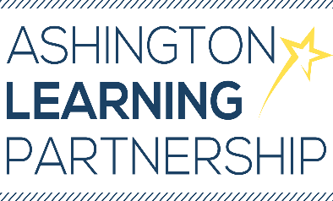

13 March 2020

Dear Parents/Carers

Coronavirus (COVID-19) update

A quick note as we understand that you may well be concerned about the potential risk of coronavirus to your child(ren). We have always put the safety and wellbeing of your child(ren) first and would like to reassure you that we are reviewing the situation on an ongoing basis. We are complying with all regular updates from the Department for Education (DfE), National Health Service (NHS) and Public Health England (PHE) as part of our ongoing risk assessment process.

The DfE have advised that no school should close in response to a suspected or confirmed COVID-19 case unless advised to do by Public Health England. The NHS today advise:

- if you have a new cough (described as persistent) or high temperature you should stay at home for 7 days. You should stay at least three steps away from other people in your home if possible. If symptoms get worse or are no better after seven days, seek medical advice.
- go online to 111.nhs.uk (do not go to a GP, pharmacy or hospital).

As of today, the official advice to schools remains unchanged, so it’s “business as usual”.

We can all continue to help by ensuring that we all use good hygiene methods, particularly with regard to regular handwashing. We continue to remind our pupils of this in an age appropriate way and have posted guidance on the website and social media pages.

If the situation changes regarding Central Primary and Bothal Primary schools we will update you accordingly, but please be assured that we are monitoring the situation closely and have contingency plans should a need arise.

Yours faithfully,

Andy Roberts
Executive Principal

