Bothal Primary School
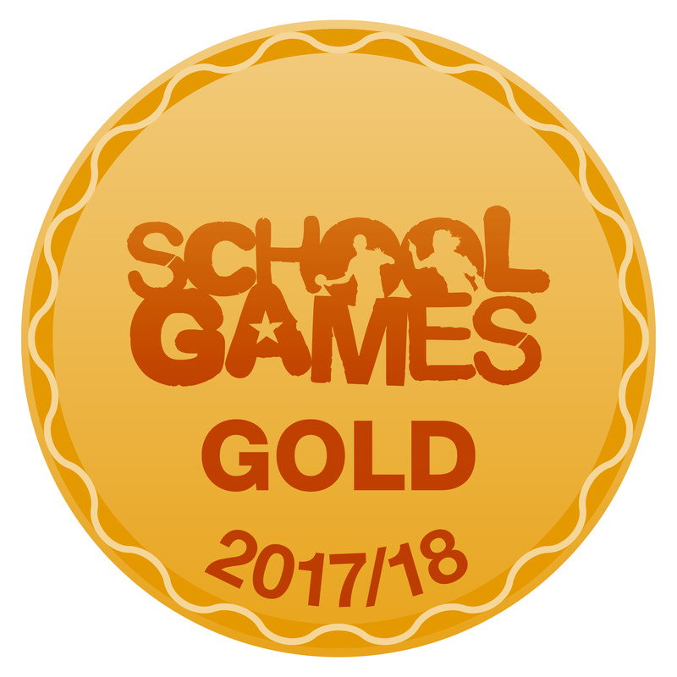

Sport Premium Information 2018-19

The Primary PE and Sport Premium is awarded to every school with primary aged pupils and must be used to fund additional and sustainable improvements to the provision of PE and sport, to encourage the development of healthy, active lifestyles. Schools should publish the amount of premium received; a full breakdown of how it has been spent (or will be spent); what impact the school has seen on pupils’ PE and sport participation and attainment and how the improvements will be sustainable in the future. Schools should also consider how their use of the premium is giving pupils the opportunity to develop a healthy, active lifestyle. In 2018 – 2019 we will receive £20900 of funding. Below is a summary of how we will use it to benefit our pupils.

There are 5 key areas for the premium to be spent on:
1. the engagement of all pupils in regular physical activity – kick-starting healthy active lifestyles
2. the profile of PE and sport being raised across the school as a tool for whole school improvement
3. increased confidence, knowledge and skills of all staff in teaching PE and sport
4. broader experience of a range of sports and activities offered to all pupils
5. increased participation in competitive sport
Sports Premium Expenditure and Impact in 2018-2019

Expenditure | Amount (£)
Joining the Ashington and Coquet School Sport Partnership including Primary membership of Youth Sport Trust | 2900
Employment of a PE and Sports Teaching Assistant | 8000
Specialist Competition entry/ judges fees (trampolining) | 234.50
Primary PE Passport | 400
Purchasing PE equipment (Summer 19) | 2865.50
Purchasing equipment for active lunchtimes/ extra-curricular (summer 19) | 5150
Healthy Lifestyles programme | 800
Provision of staff CPD – PE conference (supply costs) | 150
TOTAL | 20900

PE and Sport Premium Key Outcome Indicator | School Focus | Actions to achieve | Planned Impact | The Impact on Pupils  (to be reviewed July 2019) | Sustainability / Next Steps  (to be reviewed July 2019)
The engagement of all pupils in regular physical activity – kick starting healthy active lifestyles | To provide the opportunity for 30 minutes of physical activity in school time for each pupil | Provide activity opportunities within and beyond curriculum  Provide sample pupils with activity trackers – baseline levels then set personal targets (avtivity tackers now linked to PE passport – awaiting further instructions from designers)  Parent workshop – activity levels (tbc)  Assemebly – PE star of the week | More children being active for longer within the school day (in lessons and at break, lunchtimes and after school)  Parents more knowledgeable about how active their child should be | KS1 – 30.8% attendance (increase of 30.8%)  KS2 – 90.8% attendance (increase of 0.5%) “I loved winning PE star of the week. I tried really hard to be fit and healthy all week to try to win it”  Activity trackers – 100% of pupils improved their activity levels over a period of time  “The school provides a lot of opportunities for my children to be active. The extra-curricular offer is outstanding.” Parent  SSG mark - GOLD | Further engagement of families to support delivery of 30 active minutes outside of school time.  Continue with extra-curricular offer in school – all staff delivering a club  Purchase Summer 19 new equipment for Sept 19 – equipment rota on a termly basis
 | To provide access to a range of non-competitive festivals | Attend School Sport Partnership festivals:  Year 1 – Hula Hooping  Year 2 – Gymnastics  Year 3 – Tag Rugby, Personal Best, Cricket  Year 4 – Orienteering, Multi-sports  Year 5 – Skipping  Year 6 – Hula hooping | All children will have a positive experience of taking part in a sports festival and will be able to explain the benefits of being physically active. | Year 1 – 100% participation  Year 2 – 100% participation  Year 3 – 100% participation in TR and cricket  12 pupils attended the PB festival  “I loved the personal best festival, I’ve really used my resilience to achieve better scores”  Year 4 – 100% participation  “I feel my teamwork skills have been improved as I had to communicate much better in order for my team to succeed”  12 pupils attended the multi-sports festival  “It was fantastic seeing other pupils working together to help each other. Watching them congratulate each other for the performance of others was wonderful to see.”  Year 5 – 100% participation  “I can’t wait to do skipping back at school so I can practise my new skills”  Year 6 - 100% participation  “It was great fun and a hard work out at the same time. I’ll definitely do it on a lunch time as I fell much more confident with my ability” | Continue using the sport partnership to access non-competitive festivals
 | To increase extra-curricular sport provision | To provide a minimum of one club for each year group each term | More children will attend extra-curricular clubs on our school site. | Currently 20 extra-curricular (after school) sports clubs  2 x KS1 after school sports clubs;  18 x KS2 after school sports clubs  Minimum of 5 x KS2 lunch clubs every week  KS1 – 30.8% attendance (increase of 30.8%)  KS2 – 90.8% attendance (increase of 0.5%)  SSG mark - GOLD | Continue philosophy of all staff running a club
 | To support the running of a physical activity intervention club.  To support a healthy lifestyles project | Identify children who would benefit from being part of a physical activity intervention club  Club to run on a lunchtime.  Workshop on healthy lifestyles | Increased activity levels in our least active children.  Increased knowledge on healthy lifestyle/ Improved scores on fitness equipment | 2 x waveboarding clubs for identified pupils  “I loved the healthy lifestyles workshop. I learned a lot of new things about how to stay fit and healthy. I will definitely join a club at school.”  All pupils involved in the workshop now participate (more) in extra-curricular clubs  SSG mark - GOLD | Continue with lunchtime intervention clubs  Purchase Summer 19 new equipment for Sept 19 – equipment rota on a termly basis
The profile of PE and sport being raised across the school as a tool for whole school improvement | To develop leadership skills in our pupils. | Health/ Sports Leaders to be established  Sports Leader training to be delivered to Year 6 pupils  SSOC to canvas student voice and plan activities | School Sport Organising Crew to be involved with planning and delivering sports opportunities across school year. | 3 x year 6 classes –completed playmaker award  Leaders used on a lunchtime to deliver activities  SSG mark – GOLD | Continue with pathways model in school timetable (year 5 for leadership?)
 | To provide focussed physical intervention programmes | Identify children who have less developed motor skills  Deliver individual programmes for these pupils | Physical intervention programme supporting children who require additional support with physical skills.  Improved physical skills in these children. | 2 x waveboarding clubs for identified pupils  “waveboarding is hard work. I didn’t realise that I could have fun and work hard”  SSG mark – GOLD | Continue with lunchtime intervention clubs  Purchase Summer 19 new equipment for Sept 19 – equipment rota on a termly basis
 | To use PE to consolidate / support learning in other curriculum areas. | One member of staff to attend ‘PE and maths’ CPD and feed back to staff at staff meeting.  Staff briefed in active classroom activities  Assemebly – PE star of the week | Children’s activity levels increased in lessons/ registration. | “I love active lessons. I feel more alert and I think that I learn better during them”  Pupils have been observed repeating the gonoodle activities during breaktimes  “pupils are more engaged when the learning is active”  “I loved winning PE star of the week. I also love seeing which staff member is going to win the belt” | Embed into registration routines  Staff/ pupil voice on active lessons
Increased confidence, knowledge and skills of all staff teaching PE and sport | To improve the confidence of staff in using core tasks to deliver the primary PE National Curriculum. | Develop the use of planning and assessment app to support teaching and learning. | Teachers are more confident when using core tasks in their PE planning | 100% of pupils access a broad, balanced curriculum which is focussed on developing physical literacy | Continual process of staff development based on audit of teachers’ needs will be continued in future years.
 | To develop staff confidence and subject knowledge through provision of CPD | Feedback to be provided to all staff in staff meeting.  CPD to 4 staff on delivering active stories (trial delivery Summer 2 with year 3 group) | Teachers more confident when teaching gymnastics  Teacher assessment will be accurate  More active literacy lessons – improved behaviour and data | Data of pupils is accurate – moderation event Jan 19 with 7 schools attending | Teachers will continue to have an impact on future cohorts of children.
 | To support class teachers with planning and delivering high quality lessons and schemes of work. | Purchase Primary PE passport so all teachers have access to quality lesson planning | Teachers more confident to deliver a range of sports.  Children make good or better progress in PE. | Staff more confident to deliver P.E. to all year groups – staff voice summer 19  Attainment and progress data – available upon request | Teachers will continue to have an impact on future cohorts of children.  Purchase specific EYFS add on  Train all EYFS on how to use app for P.E. assessement
Broader experience of a range of sports and activities offered to all pupils | To provide safe, varied and innovative equipment to support all children’s learning in a wide range of activities. | All staff involved in selecting additional equipment to purchase | Children engaged in learning in PE as a result of new and varied equipment | 100% of pupils access a broad, balanced curriculum which is focussed on developing physical literacy  Extra-curricular offer includes a wide range of activities from dance, games, individual sports, health based activities and inclusive sports | Pupil voice – focus on what activities to deliver within lessons and extra-curricular – Summer 19  Purchase Summer 19 new equipment for Sept 19 – equipment rota on a termly basis
 | To deploy leaders to run a range of lunchtime activities for other children | Deliver playground leaders’ training  Support leaders in their role by regular observations | Children more active at lunchtimes due to increased opportunities |  | Trained leaders work with children in younger years to ensure continuity of leaders within the school – start training in year 5?  Purchase Summer 19 new equipment for Sept 19 – equipment rota on a termly basis
Increased participation in competitive sport | To develop intra-school competition | One intra-school competition to be held each half term  Match reports featured in newsletters / website | More children taking part in intra-school competitions. | 100% of children taking part in intra-school competition | Continue with competition within lessons/ lunch times  Purchase Summer 19 new equipment for Sept 19 – equipment rota on a termly basis
 | To provide extra-curricular coaching | At least one club for each age group to be run each half term. | More children taking part in extra-curricular sporting activities. | Currently 20 extra-curricular (after school) sports clubs  2 x KS1 after school sports clubs;  18 x KS2 after school sports clubs  Minimum of 5 x KS2 lunch clubs every week  KS1 – 30.8% attendance (increase of 30.8%)  KS2 – 90.8% attendance (increase of 0.5%)  SSG mark - GOLD | Continue philosophy of all staff running a club  Source external companies to deliver specialist coaching
 | To enable pupils to compete against other schools | Attend School Sport Partnership and School Games competitions  Record which children are participating so each pupil has the opportunity to compete. | More children taking part in inter-school competitions. | KS2 – 46.3% of pupils have competed against other schools (Increase of 5.5%)  SSG mark - GOLD | Continue using the sport partnership to access competitive competitions  Continue with competition schedule separate to sports partnership e.g. East North School Football

Swimming data 2018/19

Percentage of pupils who can swim 25 metres competently, confidently and proficiently – 20.5%
Percentage of pupils who can use a range of strokes e.g. front crawl, breast stroke etc – 20.5%
Percentage of pupils who can perform safe self-rescue in different water based situations – 20.5%
Schools can choose to use the Primary PE and Sport Premium to provide additional provision for swimming but this must be for activity over and above the national curriculum requirements. Have you used it in this way? No. This was due to suitable pool availability.
Please note that data must be taken from the last time they swam in school lessons. Bothal Primary School swam in Year 3.

