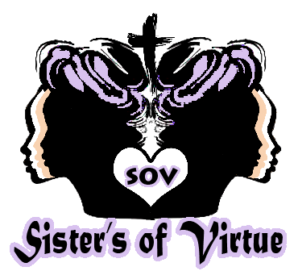
SOV-Sisters of Virtue, Inc. 501©3
P.O. Box 444
Dearborn Heights, Michigan, 48127
Phone: (313) 815-3509
Email: Director@sistersofvirtue.org

Hello!! Welcome to SOV-Sisters of Virtue, a 501©3 Organization. Send us your story for our website. Photos are always welcomed. We are here to help…Reach out and touch us!

We cannot promise to upload all posts and we promise not to use your name(s), if you do not want us to. Please fill out any information or circumstance you wish us to post in the space below: You can email us handwritten or typed to director@sistersofvirtue.org or fax form to 248-562-3104. We will be sure to contact you. Please include your contact information.

