CEEL C # 3 March 9, 2021 Jo Ann workshop Polls
Your ACE score poll
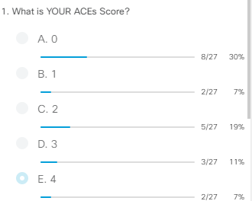
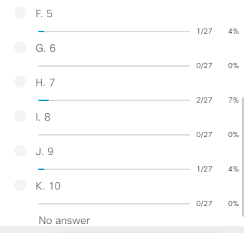

ACE scale score Activity 2 (A child you know)
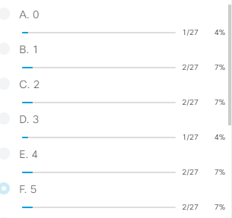
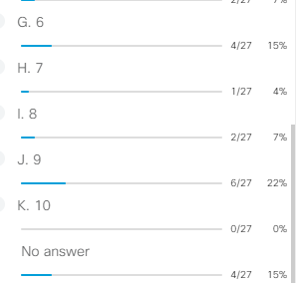

School Connectedness Factors Poll
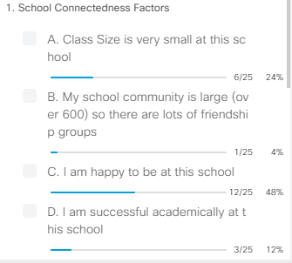
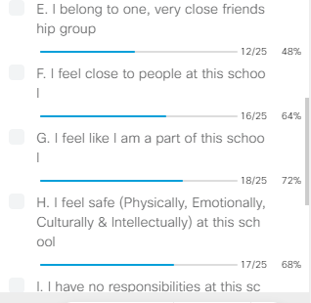

School shooting Factors Poll
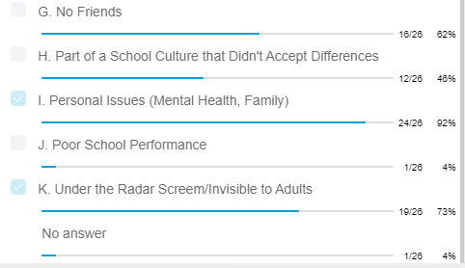
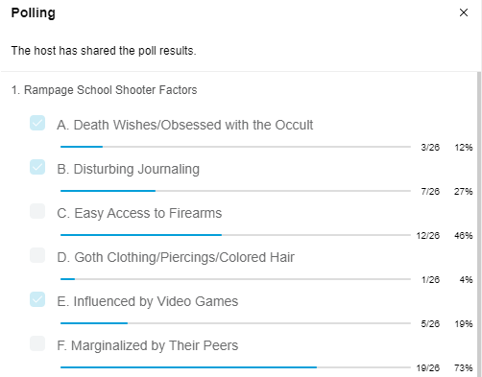

Poll-Principles of Restorative Practices
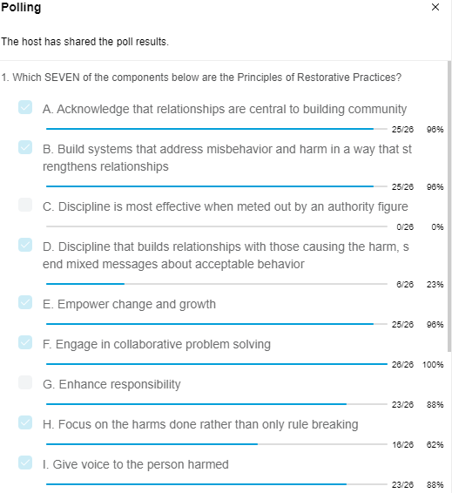

- Website for CEEL C # 3 fellows for JoAnn’s presentation
https://schoolclimateconsultants.com/ceel-2021

