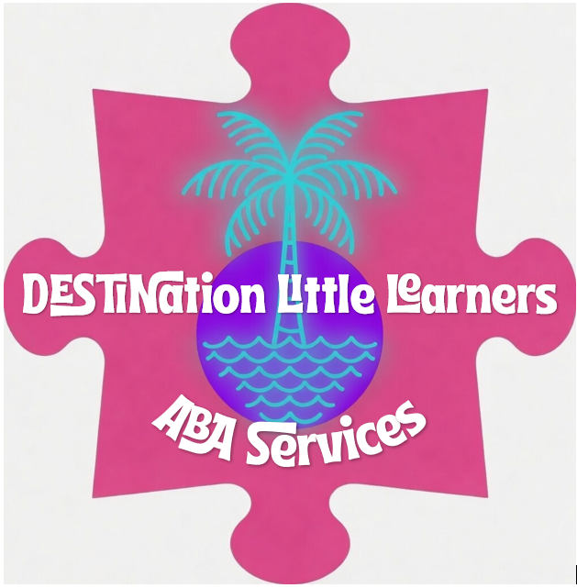
ASD Testing in-Person:

Masino Mental Health Services, LLC
507 John Sims Pkwy E
Niceville, FL 32578
(850) 424-5210
Masinomentalhealth.com

Center for Neuro-psychological Testing
1804 Lewis Turner Blvd
Fort Walton Beach, FL 32547
850.499.0759
Drsantana.com

Bay Area Psychological Consultants
1417 Partin Dr N UNIT 1
Niceville, FL 32578
(850) 729-0303
https://bayareapsychconsult.com

Virtual Testing:
As You Are
Asyouare.com

