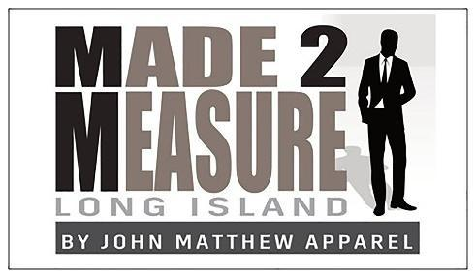

Thank you for your business!
A deposit is requested prior to placing your order:
Orders under $100 will be $50
Orders under $500 will be $250
Orders over $500 will be 50%
Cash and checks are welcome. Balance due on delivery
Payment Options:
1) JMA uses Intuit Payments to assist with payment options. Options include your American Express, Visa, Mastercard, Discover, Electronic Check (Bank Transfer) and Apple Pay. If your preference is Apple Pay then please open your invoice inside an Apple device and that option will be presented. Customers do not incur an additional charge when using their credit card nor any of the payment options. JMA never sees your credit card information while offering a safe and secure method of payment.
2) Check: Make payable to: John Matthew Apparel
Mail to:
John Matthew Apparel
23 Mary Pitkin Path
Shoreham, NY 11786
Call, email or text if you have any billing questions.

Thank you,
Gerard Kneisel
m2mli by John Matthew Apparel
516.268.4555

