
E-Safety Policy
Designated Safeguarding Lead: Toni Aston
Deputy Designated Safeguarding Leads: Will Scott & Jason Barratt
Headteacher: Daniel Laughton
Overview
This policy should be read with the following policies and guidance;
- PREVENT Strategy – HM Government (Appendix I)
- Keeping Children Safe in Education – DFE September 2023.
This policy applies to all adults, including volunteers and external agencies, working in or on behalf of the school. We understand that all our associates are an important part of the wider safeguarding system for our pupils and this system is described in statutory guidance ‘Working Together to Safeguard Children’ (2023 – Appendix A). Everyone working in or for our school service shares an objective to help keep children and young people safe.
Holton Sleaford Independent School is committed to safeguarding and promoting the well-being of all its pupils. Each pupil’s welfare is of paramount importance. We recognise that some children may be especially vulnerable to online abuse. We will always take a considered and sensitive approach in order that we can support all our pupils.

The Headteacher and Designated Safeguarding Lead will oversee the safe use of technology when students are in the care of Holton Sleaford Independent School and act immediately if they are concerned about online bullying, radicalisation, or online grooming.
They are responsible for ensuring the safety (including online and the prevention of being drawn into terrorism) of all members of the school community.
They have concerns about the school's online reputation.
Teachers will work with the Headteacher/ Designated Safeguarding Lead (DSL) to have an overview of the serious child protection issues that arise from the sharing of personal data, access to illegal or inappropriate materials (including extremism and radicalisation, inappropriate online contact with adults, potential or actual incidents of grooming and cyber-bullying.

Education of pupils
‘Children are taught about safeguarding, including online, through teaching and learning opportunities, as part of providing a broad and balanced curriculum.’ Keeping Children Safe 2024

A progressive planned Online Safety education program occurs through discrete lessons across the curriculum for students in all years and is regularly revisited.
Within this:
• Key Online Safety messages are reinforced through tutor times, PGW lessons and SMSC - Including Safer Internet Week (February), and anti-bullying week (November)
• Pupils are taught to keep themselves safe online and to be responsible in their use of different technologies
• Pupils are guided to use age-appropriate search engines for research activities. Staff are vigilant in monitoring the content of the websites visited and encourage pupils to use specific search terms to reduce the likelihood of coming across unsuitable material.
• In lessons where internet use is pre-planned and where it is reasonable, pupils are guided to sites checked as suitable for their use and processes are in place for dealing with any unsuitable material that is found in internet searches
• Pupils are taught to be critically aware of the content they access online, including recognition of bias and extreme or commercial content. They are guided to validate the accuracy and reliability of information.
• Pupils are taught to acknowledge the source of information used and to respect copyright when using material accessed on the internet
• Pupils are provided with opportunities to influence the online safety curriculum through student council meetings.
• Pupils are educated to recognise and respond appropriately to ‘different forms of bullying, including cyber-bullying’ and given opportunities to support each other.

Training of Staff
There is a planned programme of Online Safety training for all staff and governors to ensure they understand their responsibilities, as outlined in this. This includes:
• all staff knowing the Designated Safeguarding Lead
• an annual audit of the Online Safety training needs of all staff
• all new staff and governors receiving Online Safety training as part of their induction programme
• providing information to supply and student teachers on the school’s Online Safety procedures
• this Online Safety Policy and its updates being shared and discussed in staff meetings and in Governor meetings
• Providing training within safeguarding training and as specific online safety updates and reviews
• DSL providing guidance as required to individuals and seeking external support on issues
• staff and governors are made aware of the Professionals Online Safety Helpline (POSH) 0344 381 4772

Objectives
For our school to offer the highest level of E-safety we can, it is essential that we abide by these objectives:

- All staff must receive appropriate safeguarding and E-Safety training, which is regularly updated and tracked by the Designated Safeguarding Lead.

Roles and Responsibilities
The Governing Body
Safeguarding Governor – Stephen White
Our governing boy and proprietors will ensure that there are appropriate policies and procedures in place for appropriate action to be taken in a timely manner to safeguard and promote children’s welfare:
- All governors must read part 2 of ‘Keeping Children Safe in Education’ (2024 – see Appendix B).
- The governing body will ensure that Holton Sleaford Independent School abides by the Recruitment Policy and School Visitors Policy.
- The governing body will ensure that all staff follow the Staff Code of Conduct and Behaviour Policy – staff will be direct to both documents during their induction.
- The governing body will ensure that all staff and pupils abide by the E-Safety Policy and any training that is required has been carried out regularly.
- The governing body will ensure that a reliable member of the Senior Leadership Team is appointed as Designated Safeguarding Lead (DSL).
- The governing body will ensure that a Deputy Designated Safeguarding Lead (DDSL) is appointed.
- The governing body will ensure that the children are educated about E-Safety and about safeguarding (PGW curriculum) within tutor times as referenced in the school’s SMSC Policy.
- The governing body will ensure that all staff are undertaking appropriate E-safety training regularly.
- The governing body is responsible for remedying any weaknesses in child protection arrangements.
- .
- The governing body will review policies and procedures annually.
Designated Safeguarding Lead – Toni Aston

Online Bullying.
Online bullying: Online bullying (along with all other forms of bullying) of any member of the school community will not be tolerated. Full details are set out in the school’s behaviour policy. The school will follow procedures in place to support anyone in the school community affected by online bullying. Pupils and staff are made aware of a range of ways of reporting concerns about online bullying.
This may be by
telling a trusted adult,
Childline App and phone number 0800 1111.
Pupils, staff parents and carers are informed of their responsibilities to report any incidents of online bullying and advised to keep electronic evidence.
All incidents of online bullying reported to the school will be recorded by the school. Holton Sleaford Independent School will follow procedures to investigate incidents or allegations of online bullying. The school will take steps, where possible and appropriate, to identify the bully. This may include examining school system logs, identifying and interviewing potential witnesses, and contacting the service provider and the police. Pupils, staff, parents, and carers must work with the school to support its approach to online bullying and its online safety ethos. Sanctions for those involved in online bullying will follow those for other bullying incidents as indicated in the school Behaviour Policy and may include:
• the bully being asked to remove any material deemed to be inappropriate or the service provider being contacted to remove content if the bully refuses or is unable to delete content
• internet access being suspended at the school for a period of time. • The parents and carers of pupils are being informed.
• The police are being contacted if a criminal offence is suspected.

Sexting
Youth Produced Sexual Imagery
Staff understand that when an incident involving youth produced sexual imagery comes to their attention:
- The incident will be referred to the DSL as soon as possible.
- The DSL will hold an initial review meeting with appropriate school staff.
- There should be subsequent interviews with the young people involved (if appropriate).
- Parents should be informed at an early stage and involved in the process unless there is a good reason to believe that involving parents would put the young person at risk of harm.
The school will provide appropriate support for sexting incidents which take place in and out of school. Within school, any device that has an illegal image of a child under 18 or is suspected of having such an image will be secured and switched off. This will then be reported to the Designated Safeguarding Lead (DSL). An individual staff member will not investigate, delete or pass on the image. The Designated Safeguarding Lead (DSL) will record any incident of sexting and the actions taken in line with advice from Lincolnshire's Safeguarding Board.
Prevent
Holton Sleaford Independent School works to ensure children are safe from terrorist and extremist material when accessing the internet on the premises. Appropriate levels of filtering are in place through a managed filtering service, which includes terms related to terrorism. Appropriate monitoring of internet use will identify attempts to access such material. Children are educated to evaluate information accessed with a reporting procedure that identifies inappropriate sites so that action, including blocking, can be put into place.
Work with others
- The DSL will liaise with the Head of School to inform them of issues especially ongoing enquiries under section 47 of the Children Act (1989) and police investigations.
- The DSL will liaise with the case manager (as referenced in KCSIE 2024 – Appendix B) and the Local Authority Designated Officer (LADO) for child protection concerns that concern a staff member or volunteer.
- The DSL will liaise with staff on matters of safety and safeguarding and when deciding whether to make a referral by liaising with relevant agencies. They will act as a source of support, advice, and expertise for staff.
- The DSL will promote the educational outcomes of looked-after children and children with social workers.
Supporting the child and partnership with parents
- The DSL will make every effort to maintain a healthy working relationship with parents/carers and together we will provide a secure, caring, supportive, and protective relationship for the child.
- Children will be given a proper explanation that is appropriate to their age and understanding as to what actions have been taken on their behalf and why.
- We will endeavour always to preserve the privacy, dignity and right to confidentiality of the child and parents. The DSL will determine which members of staff need to know personal information and what they need to know for the purpose of supporting and protecting the child.

Undertake training
- The DSL and DDSL will undergo training to provide them with the knowledge and skills required to carry out the role. This training will be updated at least every two years.
- The DSL will attend LCC DSL Safeguarding Briefings throughout the academic year to refresh their knowledge and skills on a regular basis.
- The DSL will keep detailed, accurate, secure written records of concerns and referrals.
- The DSL must understand and support the school with regards to the requirements of the Prevent duty and are able to provide advice and support to staff on protecting children from the risk of radicalisation.
- The DSL will encourage a culture of listening to children and taking account of their wishes and feelings, among all staff, in any measures the school may put in place to protect them.
Raise Awareness
- The DSL will ensure the school’s Safeguarding and Child Protection Policy are known, understood, and implemented appropriately.
- The DSL will ensure that the school’s Safeguarding and Child Protection Policy is reviewed annually to suit the most recent government support and guidance.
- The DSL will ensure that the school’s Safeguarding and Child Protection Policy is publicly accessible on the school website.
- The DSL will ensure that staff are aware of training opportunities and the latest local policies of safeguarding through the Lincolnshire Safeguarding Children Partnership.
- Works with Teaching Staff, SENCO and Head of School to review each LAC pupil’s progress and development and decide on any changes to provision.

In the absence of the DSL, staff can refer any issues to the DDSL, who has partaken in the same level of training as the DSL.
Deputy Designated Safeguarding Lead – Nadine Oldman
All staff, governors, proprietors, and volunteers
- All staff, governors, proprietors and volunteers must read and sign to say that they understand and will fully comply with the school’s policies and procedures.
All staff responding to disclosure
In the event of the DSL receiving elicit enough information, the DSL must make an informed decision of what to do next. To allow to DSL to make an informed decision, it is essential that all staff will:
- Listen to and take seriously any disclosure or information that a child may be at risk of harm.
- Try to ensure that the person disclosing does not have to speak to another member of school staff.
- Clarify the information.
- Try to keep questions to a minimum and of an open nature e.g. using TED technique – ‘tell me, explain to me, describe to me’.
- Try not to show signs of shock, horror, or surprise.
- Not express feelings of judgements regarding any person alleged to have harmed any child.
- Explain sensitively to the person that they have a responsibility to refer the information to the DSL, children need to know that staff may not be able to uphold confidentiality where there are concerns about their safety or someone else’s.
- Reassure and support the person as far as possible.
- Explain that only those who need to know will be told.
- Explain what will happen next and who will be involved.
- Record details including date, what they child has said, in the child’s words on a ‘Record of Concern/Cause for Concern’ form and pass to DSL or on an electronic system and record any visible signs, injuries or bruises on a Body Map.
- Record the context and content of their involvement, and will distinguish between fact, opinion, and hearsay.
Actions by the DSL or DDSL
Following any information raising concern, the DSL will consider:
- Any urgent medical needs of the child.
- Whether the child is subject to a child protection plan.
- Discussing the matter with other agencies involved with the family.
- Consulting with the appropriate persons e.g. duty and advice team.
- The child’s wishes.
Then decide:
- To talk to parents, unless to do so may place the child at risk of significant harm, impede any police investigation and/or place the member of staff or others at risk.
- Whether to make a child protection referral to Children’s Social Care-Duty and Advice Team because a child is suffering or is likely to suffer significant harm and if this needs to be undertaken immediately.
OR
- Not to make a referral at this stage.
- If further monitoring is necessary.
- If it would be appropriate to undertake an assessment (e.g. Early Help Assessment) and/or make a referral to Children’s Social Care.
All actions and decisions made must be fully documented and the process depicted in Appendix C.
Recording and monitoring
At Holton Sleaford Independent School, we will ensure that accurate records will be made as soon as possible and will clearly distinguish between observation, fact, opinion, and hypothesis. All records will state who is providing the information, the date and time, information will be recorded in the child’s words where possible and a note made of the location and description of any injuries seen. This information will be stored on the Hub and an example of how this is done can be found in Appendix D. It is essential that no photographs of injuries are taken.
The DSL will ensure that the method for other members of staff or volunteers passing on concerns or information is always adhered to as consistency is paramount in ensuring that nothing gets missed. All records of concern are followed up and clearly show what action is being taken because of the concern and the outcomes of this action.
All documents will be securely stored on the SchoolPod, separate from the child’s school file. This will only be accessible by the DSL, DDSL, SENCo and other trained members of staff. The information will be secured with appropriate levels of limited access and will be password protected.

Safeguarding Issues
- See Appendix B – Keeping Children Safe in Education (2024)
- See Appendix E – Lincolnshire Prevent Referral Pathway

Contents Covered in Appendix
- Children abduction and community safety incidents
- Children and the court system
- Children missing from education
- Children with family members in prison
- Child Criminal Exploitation (CCE)
- Child Sexual Exploitation (CSE)
- County lines
- Modern Slavery and National Referral Mechanism
- Cybercrime
- Domestic abuse
- Homelessness
- ‘Honour-based’ abuse (Female Genital Mutilation)
- Forced Marriage
- Preventing radicalisation
- The Prevent duty
- Channel
- Child-on-child abuse
- Sexual violence and sexual harassment between children in schools
- Upskirting
- Initiation/Hazing
- At any point in the process if there is a concern a young person has been harmed or is at risk of harm a referral should be made to children’s social care and/or the police immediately.
- Staff will also refer to Appendix F – The DfE guidance (2021) on Searching Screening and Confiscation Advice for Schools.
Contextual Safeguarding
Holton Sleaford Independent School recognises that safeguarding incidents and/or behaviours can be associated with factors outside the school and/or can occur between children outside the school. All staff, but especially the DSL will consider the context within which such incidents and/or behaviours occur. This will then determine whether there are environment factors that are present in a child’s life that are a threat to their safety and/or welfare. The DSL will provide as much information as possible to children’s social care as part of any referral undertaken.
Children who may require Early Help
At Holton Sleaford Independent School, we are aware that safeguarding is not just about protecting children from deliberate harm, neglect, and failure to act. It relates to broader aspects of care and education, including:
- Children’s health and safety and well-being, including their mental health.
- Meeting the needs of children who have special educational needs and/or disabilities.
- The use of reasonable force.
- Meeting the needs of children with medical conditions.
- Providing first aid.
- Educational visits.
- Intimate care and emotional well-being.
- Online safety and associated issues.
- Appropriate arrangements to ensure children’s security considering the local context.
- Young carers.
- Privately fostered children.
- Children who have returned home to their family from care.
- Children showing signs of engaging in anti-social or criminal behaviour.
- Family circumstances presenting challenges for the child, such as substance abuse, adult mental health, and domestic violence.
- Early signs of abuse and/or neglect.
- Signs of displaying behaviour or views that are extreme.
- Children misusing drugs or alcohol themselves.
- Not attending school or are at risk of exclusion from school.
- Frequently going missing/goes missing from care or from home.
- Is at risk of modern slavery, trafficking, exploitation, radicalised.
- Not in education, training, or employment after the age of 16.
As these children are more vulnerable, we will identify who our vulnerable children are, ensure all staff and volunteers know the processes to secure advice, help and support where needed.
When reasonable force is used, it is essential it is in line with national guidelines and considers individual pupil needs and risk management/care plans and regarding SEND.
Children with Special Educational Needs and/or Disabilities
At Holton Sleaford Independent School, we give special consideration to safeguarding and protecting children who may have additional vulnerabilities:
- Additional barriers can exist to the recognition of abuse and neglect which can include assumptions that indicators of abuse such as behaviour, mood and injury relate to the child’s disability without further exploration.
- Vulnerable children can disproportionately be impacted by things like bullying and abuse, without outwardly showing any signs.
- Communication barriers and difficulties in overcoming these barriers.
- Seeing a disability first and abuse second.
- These additional challenges are addressed through a high level of pastoral care and our communication and interaction with our young people.
Looked After Children
All staff recognise that Looked After Children and care leavers are more vulnerable than other children, often having poorer educational outcomes, therefore, ensuring their well-being, safety and welfare, helping them to reach their potential which includes the Looked After Child who is moving on. Holton Sleaford Independent School will also ensure that care leavers are supported with pathways including liaison with Local Authority where a personal advisor will be appointed and a full working relationship is maintained with Lincolnshire Virtual School (virtualschool@lincolnshire.gov.uk).
Risk Assessments
At Holton Sleaford Independent School, all staff will abide by the school’s Risk Assessment Policy to promote safety. All risk assessments will be stored on the school’s online ‘SharePoint’, which is only accessible with an account and password.
There will be individual risk assessments in place to support when deciding a response to a child demonstrating potentially harmful behaviour such as sexually harmful behaviour or when identifying whether a child who may be particularly vulnerable, such as a child at risk of Child Sexual Exploitation.
Safeguarding Information for Pupils
All pupils in our school regularly reminded that they could approach any member of staff. The school is committed to ensuring that pupils are aware of behaviour towards them that is not acceptable and how they can keep themselves safe. All pupils know that we have a senior member of staff who is the DSL with responsibility for child protection and safeguarding and know who this is. We inform pupils of whom they might talk to, both in and out of school, their right to be listened to and heard and what steps can be taken to protect them from harm. PGW lessons will cover this content and the students’ families will receive an induction pack that will make them aware of Lincolnshire safeguarding procedures.

Written by… | Toni Aston | 1/11/24
Approved by… | Daniel Laughton | 1/11/24
Signed…
Date sent to Governors |  | Due for Review
Date approved by Governors |  | 1/11/25

Appendix A – Working Together to Safeguard Children (2018)
https://assets.publishing.service.gov.uk/government/uploads/system/uploads/attachment_data/file/779401/Working_Together_to_Safeguard-Children.pdf
Appendix B – Keeping Children Safe in Education (2024)
Keeping children safe in education 2022 (publishing.service.gov.uk)
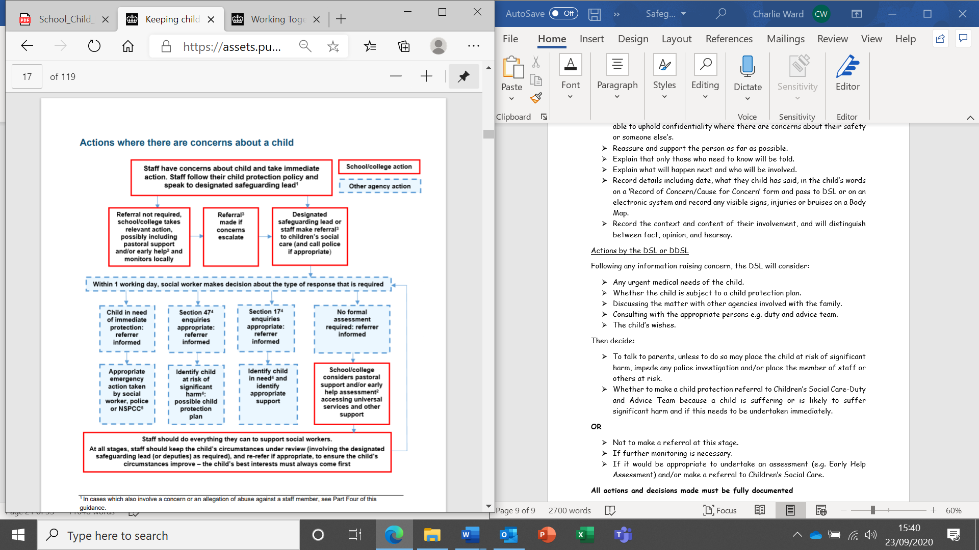
Appendix C – Keeping Children Safe in Education.

Appendix D – Lincolnshire Prevent Referral Pathway
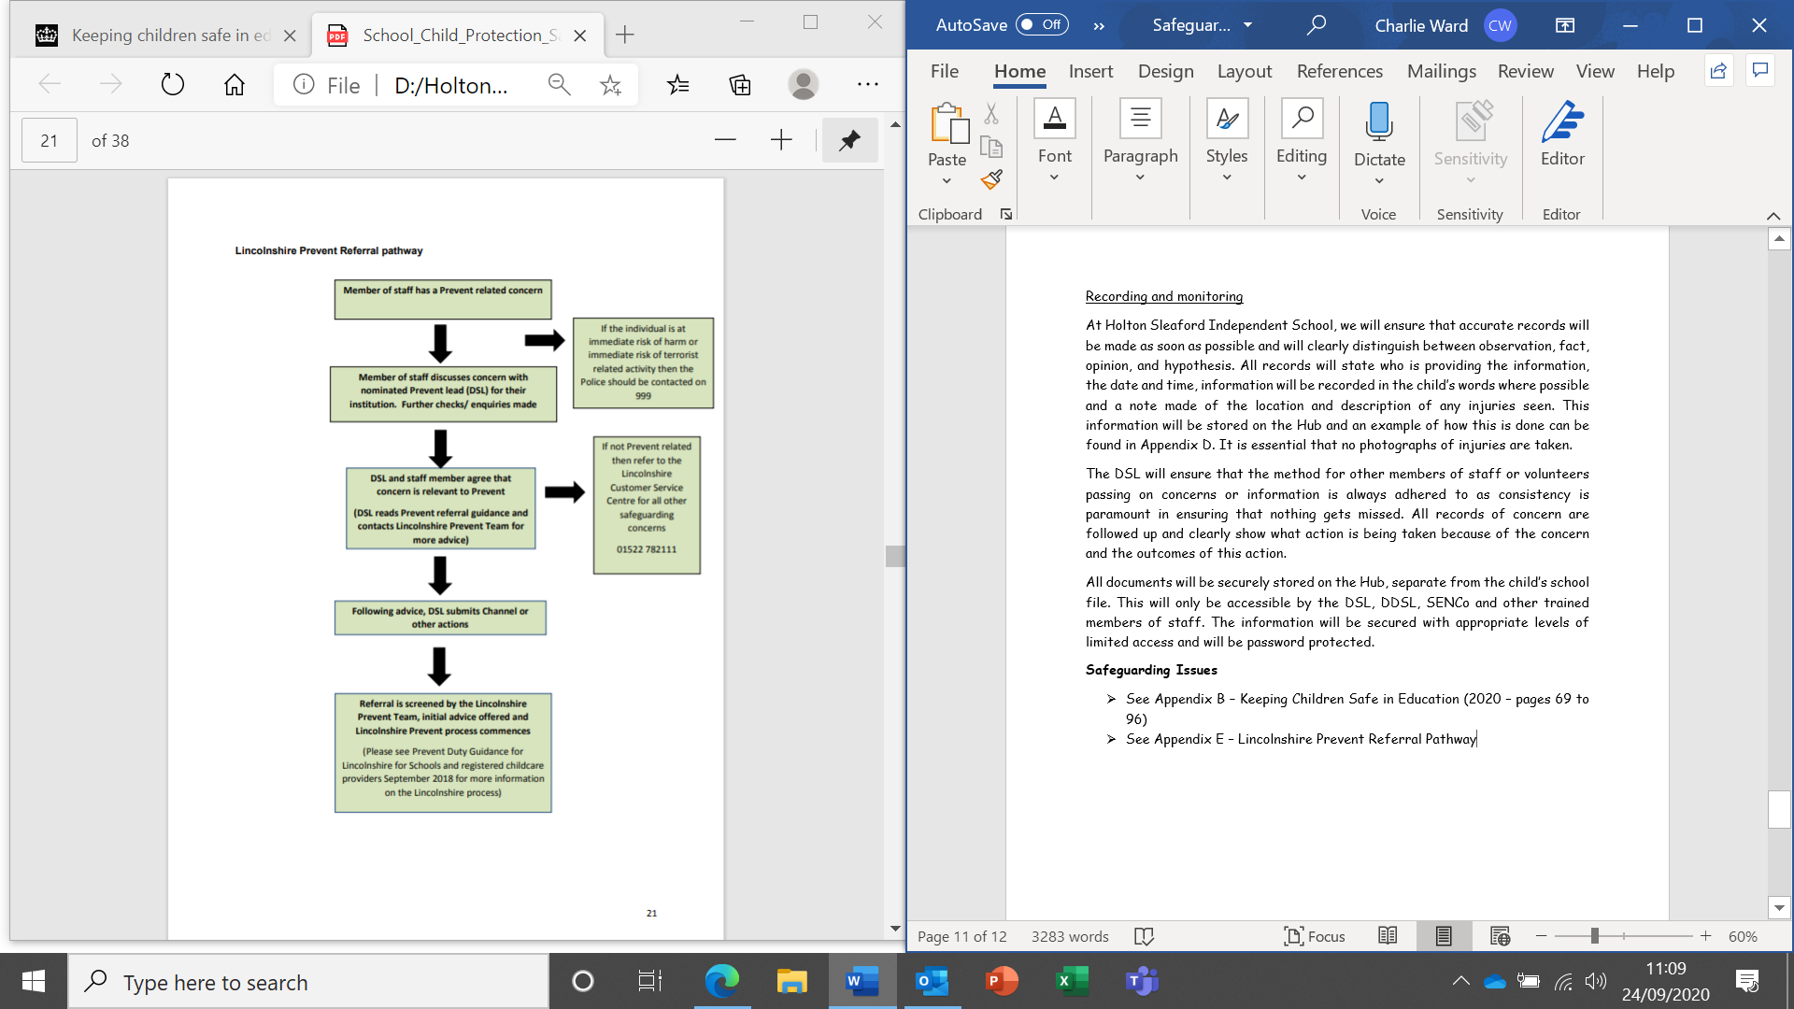

Appendix E – Teaching Online Safety in School (2019)
https://assets.publishing.service.gov.uk/government/uploads/system/uploads/attachment_data/file/811796/Teaching_online_safety_in_school.pdf
Appendix F – Education for a Connected World (2020)
https://assets.publishing.service.gov.uk/government/uploads/system/uploads/attachment_data/file/896323/UKCIS_Education_for_a_Connected_World_.pdf
Appendix G – Prevent Strategy (2021)
Revised Prevent duty guidance: for England and Wales - GOV.UK (www.gov.uk)

