**Curriculum Policy and Plan**

Holton Sleaford Independent School (HSIS) is confident that our curriculum offer is an effective route to ensuring that pupils are well prepared for work or further study at the conclusion of their education.

At all key stages, our offer is specifically designed to focus on the essential elements of a pupil’s personal progress, where Physical Education (Sport Science at KS4 and 5), Outdoor Education and PGW target social and physical development, while Maths and English take care of pupils essential academic needs to access further opportunities at Holton or another provider. We offer Humanities, Science and Art (KS3) to ensure the students are offered a broader range of subject knowledge to allow them to potentially transition back to mainstream education.

Alongside all of this, sits the Duke of Edinburgh qualifications, which will provide pupils with the wider social experiences essential to personal development.

While in KS5 our Core Aim is the new Sport and Outdoor Activities BTEC National, allowing pupils to build on their experiences from KS4 and to have the opportunity to access the Duke of Edinburgh Silver Award. In order to ensure that our pupils are as employable as possible and to encourage a clear vision of where they want to be post-education, Holton will employ a carefully managed work experience programme for our pupils where targeted placements of up to 2 days per week over the duration of their course will give them a solid grounding in the world of work.

**KS2 and 3 Timetable**

This base timetable fully meets the DfE requirement that pupils in KS2 and 3 are able to experience opportunities in the following areas;

* **Maths & English**
* **Physical Education**
* **Outdoor Education**
* **Science**
* **ICT** through the pupils’ use of their own Holton laptops in classroom-based lessons
* **Human & Social** through Humanities and Personal Growth and Wellbeing
* **Aesthetic & Creative** through Art

Furthermore, during tutor periods at the start of each day, pupils will benefit from SMSC and British Values based tasks, along with appropriate Careers guidance. Further information on purpose and content is available in the HSIS SMSC Policy and the HSIS Careers Policy. They will also be introduced to ‘Duolingo’ for the opportunity to promote learning an alternative language.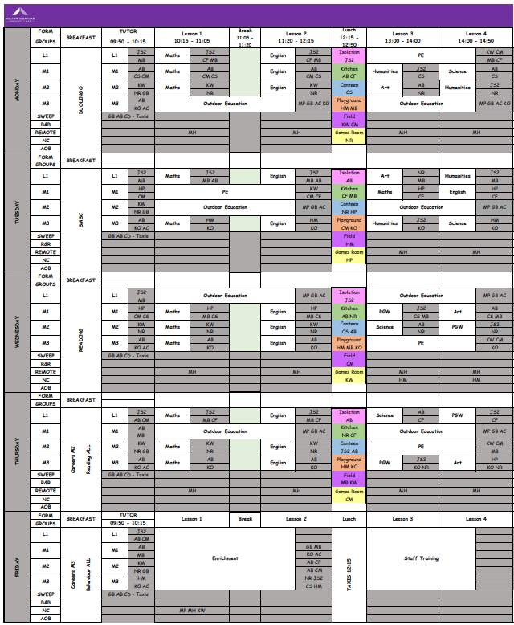

**KS4 and 5 Timetable**

This base timetable fully meets the DfE requirement that pupils in KS4 are able to experience opportunities in the following areas;

* **Maths & English** via Functional Skills Level 1&2 delivery
* **Physical Education** through BTEC First Award Level 2 in Sport
* **Outdoor Education** through the Duke of Edinburgh Award scheme and additional residentials
* **Science** via Sports Science, Outdoor Education and Maths
* **ICT** through the pupils use of their own HSIS laptops in classroom-based lessons
* **Human & Social** through BTEC L2 in Personal Growth and Wellbeing and Outdoor Education where geography and history form key components during walks and expeditions
* **Aesthetic & Creative** enabled through experiences during Outdoor Education and residential visits recorded using multiple medias

Furthermore, during tutor periods at the start of each day, pupils will benefit from SMSC and British Values based tasks, along with appropriate Careers guidance. Further information on purpose and content is available in the HSIS SMSC Policy and the HSIS Careers Policy.

The post-16 programme is dependent on existing qualifications, those without either or both Maths and English at Level 2 will be required to retake. Where this is the case these subject(s) will replace a whole or half days work experience in the timetable below. Post-16 will also continue to benefit from our Interventions Programme on a Friday morning.

**Curriculum Accreditations**

From 13-19 pupils at HSIS will have the opportunity to achieve the following accreditations by accessing our unique curriculum offer.

|  |  |  |  |
| --- | --- | --- | --- |
| Topic | KS4 | | KS5 |
| Outdoor Education | Duke of Edinburgh Bronze Award | Duke of Edinburgh Silver Award | Pearson/Edexcel BTEC Nationals L3 in Sport and Outdoor Activities |
| Physical Education | BTEC First Award in Sport Level 2 | | Work Experience placements and Functional Skills L2 retakes if required |
| PSHE | BTEC L2 Personal Growth and Wellbeing | |
| Maths | Pearson/Edexcel Functional Skills Mathematics EL3 and L1 | Pearson/Edexcel Functional Skills Mathematics L2 |
| English | Person/Edexcel  Functional Skills English EL3 and L1 | Pearson/Edexcel Functional Skills English L2 |

|  |  |  |
| --- | --- | --- |
| **Written by…** | **Charlie Ward** | **6/11/24** |
| **Approved by…** | **Mike Whatton** | **6/11/24** |
| **Signed…** |  | |
| **Date sent to Governors** |  | **Due for Review** |
| **Date approved by Governors** |  | **6/11/25** |