

Easter Newsletter

Maths
All our year groups have been working really hard on their different topics this term. Our U1 class has started to look at shapes, calculating angles and lines of symmetry, even pushing themselves to start looking at perimeter and area. Our U2’s have been looking at data collection and presentation, particularly enjoying creating averages from some friendly competition in the form of golf and presenting their data in scatter graphs to show whether the staff or student team performed better. U3 and Sixth Form classes have been using this term to re-cap some previously covered topics in preparation for their level 1 & 2 functional skills exams. Some of these topics include:
- Area, Surface Area and Volume
- Scale Drawings
- Averages
- Fractions, Decimals and Percentages.
All our year groups have made excellent progress this term! I look forward to helping this progress continue into the next term.

English
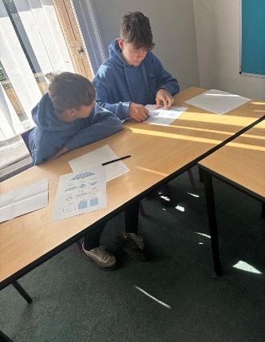
U1 have been learning about the novel Animal Farm, as part of their curriculum. We looked at structure and format of a letter, then used the skills they have learnt to write a letter to Farmer Jones, complaining about the state of the farm. We then researched the 7 Commandments that were established by the pigs Napolean and Snowball, to create an informative poster to display subject knowledge.
U2 have been looking at the structure and format of articles. We looked at the features of an article and where we would find articles. We looked and compared different newspapers, magazines and articles on the internet. With the knowledge we had learnt and the information we gathered, we then wrote our own article.
U3 have been working hard on looking at different writing formats and how they all differ. We have looked at the different features that an article, letter, email and review have. This then enabled them to complete their writing exam. We are awaiting their results.

Personal Growth and Wellbeing
Within PGW students have been finishing up their work for Unit 1. As we move onto Unit 2 we will look at ways in which students can maintain emotional wellbeing. In doing this we will look at our own emotions and others, the benefits of healthy emotional wellbeing and ways in which we can protect our own mental health. Students will also touch on the consequences of unhealthy emotional wellbeing looking at depression, anxiety and panic attacks.

Sport Science
This term sports science students have been engaged in a variety of practical and theoretical activities. In unit 1 we focussed on badminton, developing their skills and technical aspects of the sport. For unit 2 we worked on assessments that involved analysing and evaluating two sports of their choice, diving deep into specific roles, techniques and fitness requirements. In unit 3 the students shifted focus to personal development, creating and assessing their own personal training programs where they applied the knowledge gained throughout their course to design effective fitness plans tailored to individual needs and goals. These tasks have helped them to gain and comprehend understanding of both sports, specific skills and the broader principles of physical fitness.
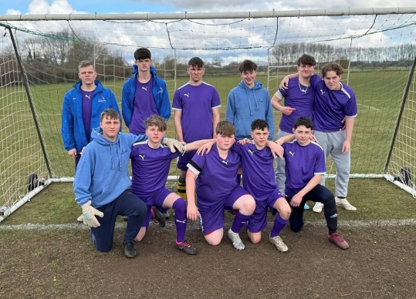
Welcoming in the new year of 2025, came a new sport for each of our classes. For L1, M1 and M3 students the sport was football! Students developed week by week with different themes of Passing, Dribbling and Shooting and we worked on their team skills in game situations, with lots of goals scored and fun had by all. M2’s new sport was Badminton! Students found it tricky and challenging at the start but showed their perseverance and determination to get better, and are now looking like solid badminton players, with some great rally’s and matches on show.
The start of Term 4 meant a fresh sport for the classes, and a sport not many of our students had ever played before! M1 moved onto Badminton, where there were some great battles between students and even staff, but overall, a high level of development. For L1, M2 and M3, Volleyball was introduced! With little to no knowledge of the sport, students developed week by week through the different skills and techniques needed, first using balloons, then softer volleyballs, then onto the regulation Volleyballs! We also had lots of fun practicing our skills with a beach ball week to week! Overall, students should be very proud of their achievements and development in each of the sports!

Outdoor Education
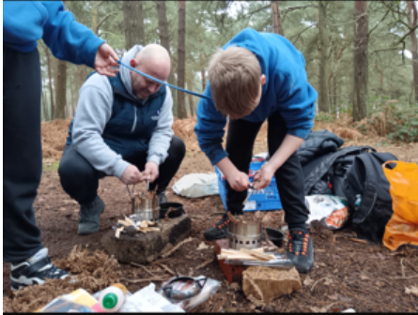
Since Christmas the U1 group have been covering a variety of activities during OE including climbing, volunteering, snooker, trampolining, ice skating, 10 pin bowling, walking and map skills. This has all been in preparation to begin the Duke of Edinburgh award during the next stage of Outdoor Education in years U2 and U3. All the students have worked well learning some new skills and improving on skill already learned. Since Christmas the U2 group have been covering a variety of activities during OE including water sports (paddleboarding, canoeing, raft building), snooker, ice skating, 10 pin, walking and map skills. This has all been as a part of the skills, physical and volunteering sections of the Duke of Edinburgh Bronze award. All the students have worked well learning some new skills and improving on skill already learned.
U3 have continued to work towards their Duke of Edinburgh Bronze Award and have been focusing on their physical section and have been learning the basics of ice skating. Over the course of three weeks they made clear progression from skating with an aid and being able to skate freely. During these sessions they have been pushing themselves to improve their skillset and be able to build up speed skating and being able to stop safely and feel more confident on the ice.
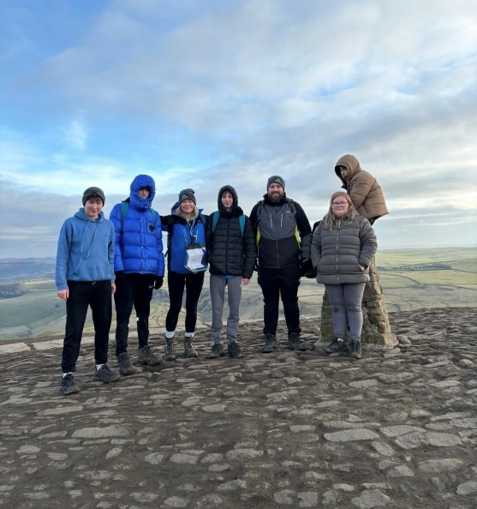
During half day outdoor education, they have been working on the skills section towards the Bronze Award, where they have been refining their map/reading skills and confidence in using a compass to measure distance and how long it takes to travel. This has allowed them to plan their own routes and put this into practice and begin doing the walks independently preparing them for their expedition in the summer term. Alongside this they have been doing campcraft skills, pitching tents and making sure they are all safe to use for the expedition as well as using the gas stoves to challenge their cooking skills. They particularly enjoyed making homemade pancakes in the sunshine!
During this term sixth form have been challenging their skillset at ice skating whilst working towards their Duke of Edinburgh Bronze award. Each pupil has made clear progression over the course of three weeks. Some pupils even took the time to watch short YouTube videos to teach themselves to skate backwards and were having competition amongst themselves to see who could skate backwards, they even started to add spins and stops into their skating and have thoroughly enjoyed the sessions and improving their overall skillset and become competent skaters.
During the skills section, this term the Foundation group have been taking part in campcraft sessions, where they have been checking the tents to make sure they are in full working order and are ready for the expedition in the summer term. They have worked well as a team to check that these all work and have the correct equipment. They also had a lesson in the woodland areas where they created a den out of natural resources and worked extremely well together to create this.

Trips/Residentials
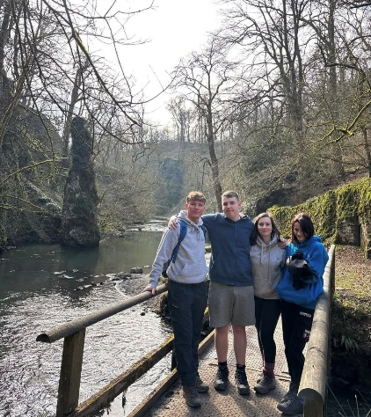
On Monday the 3rd of February 2025, The U3 class travelled to Castleton for a one-night/two day stay in the Peak District. During their stay pupils took part in a full day walk starting from the picturesque village of Castleton through to Hollins Cross all the way up to the top of Mam Tor known as the “shivering mountain”. Whilst at the top pupils got a glimpse of the great views of the surrounding peaks and valleys. Pupils worked together using skills learnt from their previous outdoor education lesson to safely navigate the route. The next day the group then took part in an underground guided tour of Speedwell Cavern inside a boat. During the tour the guide educated the group on how the tunnels were previously used for mining as well as the various rock formations that have built up over time. Overall, another successful residential for the U3 group with new pupils at Holton having a first taste of the residential experience in preparation for their week-long residential in Cornwall for May.
On Wednesday the 19th of March 2025 the U1 group travelled to the Peak District for a one-night stay at Hartington Hall in Derbyshire. Upon arrival to the Peak District pupils completed a 3-hour walk starting from the village of Hartington through the Beresford Dale along the River Dove and into the Wolfscote Dale along the high rocky cliffs and finally finishing back at the youth hostel. During the walk pupils witnessed the spectacular scenery across the dale from the rocky limestone cliffs and even explored the small caves along the walk. The following day the group then went to the Peak Zoo whereby they encountered various animals whereby and were able to enter the enclosures to feed wallabies and come face to face with lemurs. Overall, the trip was another great experience for pupils to come away from their home comforts and complete a full day walk testing their fitness and using map reading skills learnt ready for future expeditions.

Fishing
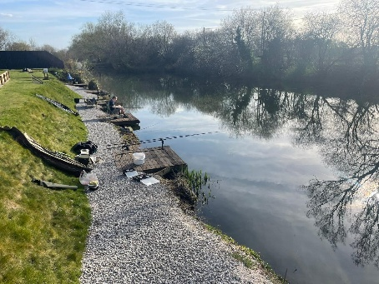
Enrichment Fishing - The New Year saw us change venues with the Friday morning fishing moving from lakes to rivers, with a change of tactics from general course angling to hunting for the rivers apex predator; Esox Lucius or more commonly called the Pike. Winter Pike fishing takes one of two forms, lure fishing or dead baiting and the students wanted to do both. Luckily one of the staff who lead on the school’s piscatorial adventures had experience of pike fishing. We used legered dead baits [mackerel, smelts and lamprey] on alarms and quivertip rods as well as various types of lures that the students could cast and retrieve as they walked the river back. I must mention at this point the generosity of a number of fellow anglers that have donated equipment to the school enabling us to do different sorts of fishing. We had a number of takes and good runs on the dead baits but unfortunately did not land a fish.
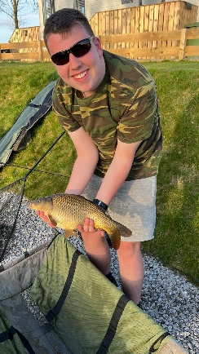
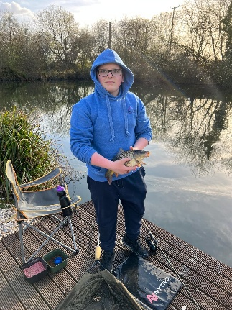
After half term as the weather warmed up [a little bit] we returned to local lakes Haverholme Park Lake and White House Farm Fishery, both venues very generously let the students fish for free on Friday mornings, and again a change of target species [roach, rudd, bream, perch and carp] and therefore tactics and tackle. We are trying to give the students as full a range of fishing experience as we can so that they can decide which aspect of the piscatorial arts they would like to do as a hobby. Again, the generosity of the angling fraternity has been amazing with float rods, quivertip rods and reels being donated to school along with various terminal tackle. We have had some really good sessions float fishing with maggots/worms/sweetcorn and pellets which have enabled us to teach the students lots to different rigs and tactics to use in various conditions. Most recently we have been focusing on feeder fishing using quivertip rods with either a free running cage/maggot feeder or inline feeder. The techniques learnt have enabled the students to target bream and carp successfully.
Finally school has had its first fishing residential, three days/two nights at Sapphire Lakes at Cromwell just north of Newark. Three students were able to fish for a variety of course species right outside their accommodation, from early morning into the dark, a really special experience. Everyone caught fish, enjoyed themselves and grew in confidence over the time there. This is something we are planning to repeat as it was such a success. Just to reassure everyone no fish have been killed during the making of this outdoor adventure [except the dead baits but that’s their role, the clues in the name] and all fish caught have been safely returned to the water: ‘And Away’.

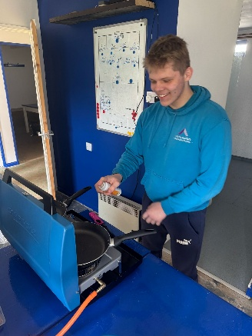
Work Experience
This term, there has been a remarkable improvement in the engagement of our 6th form students with work experience opportunities. Almost all students now have an active placement, with only a few awaiting final approvals from Safety Measures. This surge in participation highlights the growing commitment to gaining real-world experience and understanding of the workplace environment. The benefits of work experience are invaluable, providing students with hands-on skills, boosting their employability, and offering insights into potential career paths. We would like to extend our sincere thanks to both students and parents/guardians for their continued support and dedication in pushing forward this essential part of the student’s development. Your involvement has been instrumental in making this terms success possible.
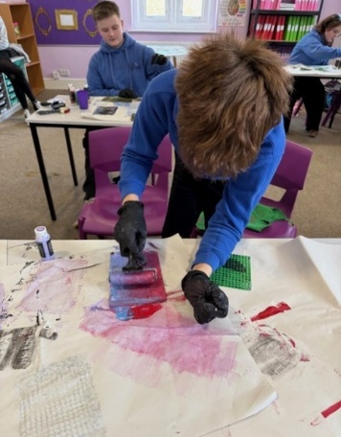
Pottery
Another fantastic term in pottery. The students have really pushed themselves to create some difficult pieces. It hasn’t always been easy but they have practiced staying calm and thinking differently to overcome the challenges they faced. Students have seen the process from mud to glazed pot and have remembered lots of technical language. One of the students told staff ‘In pottery, I learnt patience and made my mum a vase’.

Headteacher Comment- Daniel Laughton
It is always lovely to see and read about all the great work both staff and pupils are achieving at Holton. I am very proud of how the pupils access our curriculum and the effort they put into all challenges that they face. I hope everyone has a well-deserved break over the easter holidays and I look forward to seeing what the summer term has in store for all.

