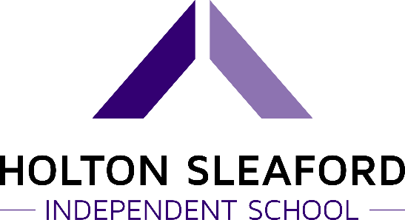
British Values Statement
Overview
Through our curriculum, extra-curricular activities, teaching and learning, Holton Sleaford Independent School will promote British values. We will ensure that all learners understand the values that have built the foundations of British society. Through developing our students’ understanding of these values, they will develop a feeling of empathy and pride towards our school and community. We aspire to prepare our students to be functioning members of British society, so it is essential that understand and are open to engaging with different cultural backgrounds, origins, and beliefs. We have several objectives for all associated with Holton Sleaford Independent School to adhere to:
Objectives
- To understand the role of democracy in British society.
- To possess a mutual respect and tolerance of those with different faiths and beliefs.
- To learn to uphold the rule of law and support freedom, justice, and equality.
- To value the positions of citizens from different cultures, religions, and backgrounds and what they bring to British society.
- To value the differences of others’ and respect them.
- To show tolerance to communities that are different to your own.
- To value democracy and stand up for right against wrong.
- To understand the need to support others when they require assistance.
- To be a loyal and proud citizen of the United Kingdom.
We have an array of strategies to support these objectives:
Strategies
- The school will promote British values through its teaching, learning across the subjects of the curriculum.
- The school will engage in conversations with the students, where they will openly discuss parliamentary democracy and its role in British society.
- The school will teach the students about the duties of UK citizens and contributions required to support life in the United Kingdom.
- The school will hold discussions about both local and national issues to promote understanding and pride in the students’ roles within local communities and society.
- The school will promote the importance of duty, loyalty, individual liberty, and patriotism through the curriculum.
Outcomes
These strategies will allow all associated with Holton Sleaford Independent School to gain a good understanding of the values that underpin the privileges, rights, responsibilities, and duties of a British citizen. Our students will develop into functioning members of their local communities and British society, who will respect democracy, rule of law, individual liberty. The students will hold a mutual respect and tolerance to those of different beliefs and faiths.

Written by… | Charlie Ward | 4/11/21
Approved by… | Mike Whatton | 4/11/21
Signed…
Date sent to Governors |  | Due for Review
Date approved by Governors |  | 4/11/22

