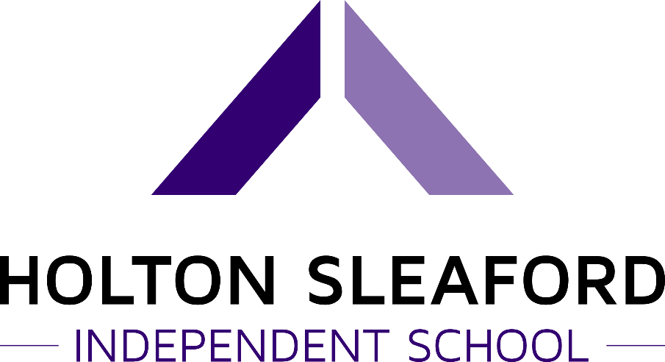

English as an Additional Language (EAL) Policy

The term EAL is used when referring to pupils where the mother language at home is not English. Where pupils are classified as EAL, in their household another language is spoken at times. This does not mean that the child necessarily speaks another language, but it does mean that the child may not always be hearing standard English at home. This policy sets out the school’s aims, objectives and strategies with regards to meeting the needs of EAL pupils.

Aims and Objectives
- To meet the full range of needs for EAL pupils as far as is reasonably practicable
- To welcome and value the cultural, linguistic and educational experiences that pupils with EAL bring to the school.
- To help EAL pupils to become confident and fluent in speaking and listening, reading and writing in English.
- To encourage and enable parental support in improving children’s attainment.

Strategies
- Classrooms need to be socially and intellectually inclusive, valuing cultural differences and fostering a range of individual identities.
- Identify the pupil’s strengths and encouraging them to transfer their knowledge, skills and understanding of one language to another.
- Recognise that pupils with English as an additional language may need more time to process and answer both orally and in written format.
- Provide additional verbal support eg repetition, alternative phrasing, peer support.
- Offering additional visual support eg: posters, objects, pictures.

At Holton Sleaford Independent School (HSIS) we value parental involvement and their help and support with activities at home. HSIS will support parents/carers access to information by providing translations where necessary. We believe in supporting all our parents/carers so they feel confident about approaching the school with any concerns or queries they may have.

Written by… | Mike Whatton | 4/11/21
Approved by… | Charlie Ward | 4/11/21
Signed…
Date sent to Governors |  | Due for Review
Date approved by Governors |  | 4/11/22

