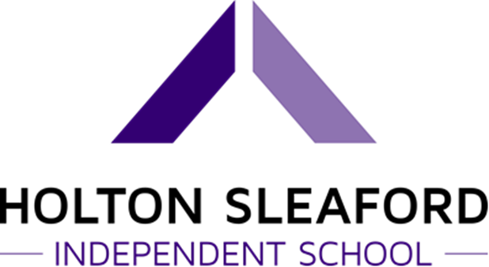

Sex and Relationships Education Policy

Values and Ethos
This policy covers our school approach to Relationships and Sex Education.
We define 'relationships and sex education' as learning about the emotional, social, and physical aspects of growing up, relationships, sex, human sexuality, sexual health and gaining awareness of the diversity of relationships in today’s society. We believe relationships and sex education is important for our school because it helps combat ignorance and increase understanding by providing information about physical, emotional and social aspects of human sexual development, including the nature of love, personal relationships and family life.
The intended outcomes of our programme are that pupils will address the issues of:

- Self esteem
- Human growth and development
- Knowledge of body
- Relationships
- Personal and social education skills
- Safety
- Family and responsibility
- Rights
- Responsibilities
- Risks
- Respect

Roles and Responsibilities
The SRE programme will be led by Tom Ward. The Head of School, Daniel Laughton, is responsible for ensuring the below requirements are met.
The SRE lead is responsible for ensuring the planning and delivery of the subject is in line with teaching standards and meets the statutory requirements.

Legislation

- Documents that inform the school's RSE policy include:
  - Education Act (1996)
  - Learning and Skills Act (2000)
  - Education and Inspections Act (2006)
  - Equality Act (2010)
  - Supplementary Guidance SRE for the 21st Century (2014)
  - Keeping Children Safe in Education – Statutory safeguarding guidance (2016)
  - Children and Social Work Act (2017)
  - Relationships Education, Relationships and Sex Education (RSE) and Health Education, Draft statutory guidance for governing bodies, Company Director, Head of School and senior leadership teams (February 2019)

Curriculum Design
Our SRE programme is an integral part of our whole school provision and for information on when these different topics are covered see Curriculum folders.

The curriculum will meet the needs, or be adapted for, those children with protected characteristics by staff having an awareness of all pupils’ individual needs and EHCPs.

We ensure that SRE fosters gender equality and LGBT + equality by Promoting inclusion and reducing discrimination are part of RSE throughout the school and reflect our equality policy. When teaching about relationships and families we include same sex relationships and specific understanding of different types of relationships, including lesbian, gay and bisexual relationships. Homophobic, biphobic and transphobic references, language and bullying are not tolerated in school and are challenged and dealt with as part of our commitment to promoting inclusion, gender equality and preventing bullying.

Our SRE programme will be planned and delivered through timetabled lessons.

Our SRE programme will be taught through a range of teaching methods and interactive activities including; Role-play, discussion, outside agencies, quizzes, pair and small group work, using case studies and stories to help de-personalise discussions so pupils gain confidence to talk and listen to each other.

Learning about relationships and sex education will complement learning in all other subjects, as pupils will be able to develop better relationships and tolerances for one another and apply their knowledge of how some relationships work to literature, science, and specific related topics.

Safe Practice
We will ensure a safe learning environment by coming to agreed classroom rules and expectations. Teachers and pupils will establish a group agreement by discussion and agreement from all pupils. Distancing techniques such as role play are used because it de-personalises the issues discussed. Teachers will deliver the SRE curriculum in a way that allows pupils to explore varying viewpoints by ensuring that information is unbiased and impartial.

Potentially sensitive questions from pupils within lessons will be answered by taking into account the nature of the question and if it can be sensitively answered within the group or this needs to be addressed outside the classroom.

Pupils will be able to ask questions anonymously by leaving written questions in designated place.

Safeguarding
Although SRE is not about personal disclosures and personal issues, it is possible that a pupil may disclose personal information. Staff understand that they cannot promise pupils absolute confidentiality, and pupils know this too. Although teachers cannot offer unconditional confidentiality, pupils are reassured that their best interests will be maintained. They will be reminded that if confidentiality has to be broken, they will be informed first, if possible, and then supported as appropriate. They are encouraged to talk to their parents or carers and are provided with support to do so If teachers are concerned in any way that a pupil is at risk of sexual or any other kind of abuse, they will talk to the Designated Safeguarding Lead and follow the school’s procedures. This school upholds the right of any health professional to work within their professional code of conduct. However, when professionals are delivering aspects of SRE in the classroom they are bound by the school’s SRE policy.

If external agencies are used to help deliver any topics, they will need to follow school policy and procedure before entering the school site.

Parents and Carers
We place the utmost importance on sharing responsibility with parents and carers for their children’s education. We will take every opportunity to inform and involve parents and carers by;

- Making the policy available on the school’s website
- Discussing individual concerns and helping parents and carers support the needs of their children.

Parents/carers are made aware of procedures to follow if they wish to withdraw their children from SRE. Students may not be removed from lessons that cover the statutory national curriculum. Even when a child has been withdrawn from SRE lessons, if the child should ask questions at other times, these questions would be answered honestly by staff.

Resources
High quality resources will support our SRE provision and will be regularly reviewed as part of the yearly planning and reviewing process. This will also include delivery of BTEC L2 Personal Growth and Wellbeing, which covers all aspects of nationalised SRE requirements.

Selected resources, such as books, film clips, will be used which support and promote understanding within a values context and underpin the learning and knowledge acquisition throughout the SRE programme.
The resources reflect diversity by ensuring they come from a wide range of source and promote equality and caring selected for non-bias.

Assessment and reporting
Assessment will be via the completion of units in the aforementioned BTEC qualification. This will then be recorded on School Pod for use in reporting and progress tracking.

Teachers will critically reflect on their work in delivering SRE through self-evaluation, standardisation, and school quality assurance processes. Pupils will have opportunities to review and reflect on their learning through self-evaluation forms and time within lessons to review lesson outcomes.

Pupil voice will be influential in adapting and amending planned learning activities through pupil’s questionnaires. Parents will be notified of progress through end of year reports, parents evening and key worker calls. Teachers will ensure that the learning objectives have been met by using a variety of assessment-based activities.

Written by… | Daniel Laughton | 3/11/21
Approved by… | Luke Hollingworth | 3/11/22
Signed…
Date sent to Governors |  | Due for Review
Date approved by Governors |  | 3/11/22

