Safeguarding and Child Protection Policy
Designated Safeguarding Lead: Toni Aston
Deputy Designated Safeguarding Lead: Nadine Oldman
SENCo: Michael Whatton
Additional DSL Trained Staff: Daniel Laughton
Overview
This policy should be read with the following policies and guidance;
- PREVENT Strategy – HM Government (Appendix I)
- Keeping Children Safe in Education – DFE September 2023.
This policy applies to all adults, including volunteers and external agencies, working in or on behalf of the school. We understand that all our associates are an important part of the wider safeguarding system for our pupils and this system is described in statutory guidance ‘Working Together to Safeguard Children’ (2018 – Appendix A). Everyone working in or for our school service shares an objective to help keep children and young people safe by contributing to:
- Providing a safe environment for children and young people to learn and develop in our school setting.
- Identifying children and young people who are suffering or likely to suffer significant harm and taking appropriate action with the aim of making sure they are kept safe both at home and at Holton Sleaford Independent School.
Holton Sleaford Independent School is committed to safeguarding and promoting the well-being of all its pupils. Each pupil’s welfare is of paramount importance. We recognise that some children may be especially vulnerable to abuse. We recognise that children who are abused or neglected may find it difficult to develop a sense of self-worth and to view the world in a positive way. Whilst at school, behaviour may be challenging. We recognise that they may exhibit concerning behaviours and at times this may impact on other children either directly or indirectly. We will always take a considered and sensitive approach in order that we can support all our pupils.
At Holton Sleaford Independent School, we acknowledge that safeguarding covers a broad variety of roles and responsibilities, including:
- Child Protection
- Staff Conduct; inside and outside of school.
- Curriculum
- Managing allegations against staff
- Building design
- Safe recruitment and selection
- Whistle blowing
- Transport to and from School
- Health and safety
- Behaviour Management
- Attendance
- Online Safety
- Anti-bullying policies
Taking into consideration ‘Keeping Children Safe in Education’ (2023), the roles of our school staff are outlined as:
- School staff are particularly important as they can identify concerns early, provide help for children, and prevent concerns from escalating.
- The Teachers’ Standards 2012 state that teachers (which includes members of the senior leadership team) should safeguard children’s well-being and maintain public trust in the teaching profession as part of their professional duties. At Holton Sleaford Independent School, we extend this standard and expectation to all our associates.
- All staff should be prepared to identify children who may benefit from the early help process, as stated in the statutory guidance ‘Working Together to Safeguard Children’ (2018 – Appendix A).
- Supply staff are included in, for the sake of this policy, ‘all staff’.
Objectives
For our school to offer the highest level of safeguarding we can, it is essential that we abide by these objectives:
- To clarify roles and responsibilities of everyone within our school in relation to child protection and safeguarding.
- To have clear strategies in place that are followed when a child is identified as needing more support.
- The term ‘child’ or ‘children’ refers to anyone under the age of 18 years.
- To understand that safeguarding includes preventing impairment of children’s mental and physical health or development.
Strategies
To allow us to achieve our objectives, it is essential that the following strategies are carried out by all associates of Holton Sleaford Independent School:
- The Staff Induction Pack will direct all staff towards:
  - Safeguarding and Child Protection Policy
  - Behaviour Policy
  - Staff Code of Conduct
  - Safeguarding response to children who go missing from education
  - The roles of the Designated Safeguarding Lead
- All staff must receive appropriate safeguarding and child protection training, which is regularly updated and tracked by the Designated Safeguarding Lead.
- All staff should be aware of their local early help process and understand their role within it as referenced in ‘Working Together to Safeguard Children’ (2018 – Appendix A).
- All staff should be aware of the school’s referral protocol (see Outcomes).
- As stated within ‘Working Together to Safeguard Children’ (2018 – Appendix A), all staff should be particularly alert to the potential need for early help for a child who:
  - has special additional or education needs
  - is a young carer
  - is showing signs of being drawn into anti-social or criminal behaviour
  - is frequently missing/goes missing from care or from home
  - is at risk of modern slavery, trafficking, or exploitation
  - is in a family circumstance presenting challenges for the child, such as drug and alcohol misuse, adult mental health issues and domestic abuse
- All staff need to read Part 1 of ‘Keeping Children Safe in Education’ (2023 – Appendix B), which contains important information about specific forms of abuse and safeguarding issues. The issues referred to are:
  - Child abduction and community safety incidents
  - Children and the court system
  - Children missing from education
  - Children with family members in prison
  - Child Criminal Exploitation (CCE)
  - Child Sexual Exploitation (CSE)
  - County lines
  - Modern Slavery and National Referral Mechanism
  - Cybercrime
  - Domestic abuse
  - Homelessness
  - ‘Honour-based’ abuse (Female Genital Mutilation/Coercion)
  - Forced Marriage
  - Preventing radicalisation
  - The Prevent Duty
  - Channel
  - Child-on-child abuse
  - Sexual violence and sexual harassment between children in schools
  - Upskirting
  - Initiation/Hazing
Roles and Responsibilities
The Governing Body
Safeguarding Governor – Stephen White
Our governing boy and proprietors will ensure that there are appropriate policies and procedures in place for appropriate action to be taken in a timely manner to safeguard and promote children’s welfare:
- All governors must read part 2 of ‘Keeping Children Safe in Education’ (2023 – see Appendix B).
- The governing body will ensure that Holton Sleaford Independent School abides by the Recruitment Policy and School Visitors Policy.
- The governing body will ensure that all staff follow the Staff Code of Conduct and Behaviour Policy – staff will be direct to both documents during their induction.
- The governing body will ensure that all allegations against associates of Holton Sleaford Independent School will follow the protocol outlined in the Complaints Policy.
- The governing body will ensure that all staff and pupils abide by the E-Safety Policy and any training that is required has been carried out regularly.
- The governing body will ensure that a reliable member of the Senior Leadership Team is appointed as Designated Safeguarding Lead (DSL).
- The governing body will ensure that a Deputy Designated Safeguarding Lead (DDSL) is appointed.
- The governing body will ensure that the children are educated about E-Safety and about safeguarding (PGW curriculum) within tutor times as referenced in the school’s SMSC Policy.
- The governing body will ensure that all staff are undertaking appropriate safeguarding training regularly.
- The governing body is responsible for remedying any weaknesses in child protection arrangements.
- The Safeguarding Governor will ensure that the DSL/DDSL has liaised all allegations appropriately with the Local Authority.
- The governing body will review policies and procedures annually.
Designated Safeguarding Lead – Toni Aston
Managing Referrals
- The DSL will ensure that cases of suspected abuse are reported to the Local Authority children’s social care.
- The DSL will seek advice from the Prevent Team regarding radicalisation concerns and refer cases to the Channel programme when necessary.
- The DSL will support staff who make referrals to the Channel programme when advised by Prevent team.
- The DSL will support the Head of School to refer cases where a person is dismissed or left due to risk/harm to a child to the Disclosure and Barring Service as required.
- The DSL will refer cases to the Police where a crime may have been committed.
Work with others
- The DSL will liaise with the Head of School to inform them of issues especially ongoing enquiries under section 47 of the Children Act (1989) and police investigations.
- The DSL will liaise with the case manager (as referenced in KCSIE 2023 – Appendix B) and the Local Authority Designated Officer (LADO) for child protection concerns that concern a staff member or volunteer.
- The DSL will liaise with staff on matters of safety and safeguarding and when deciding whether to make a referral by liaising with relevant agencies. They will act as a source of support, advice, and expertise for staff.
- The DSL will promote the educational outcomes of looked-after children and children with social workers.
Supporting the child and partnership with parents
- The DSL will make every effort to maintain a healthy working relationship with parents/carers and together we will provide a secure, caring, supportive, and protective relationship for the child.
- Children will be given a proper explanation that is appropriate to their age and understanding as to what actions have been taken on their behalf and why.
- We will endeavour always to preserve the privacy, dignity and right to confidentiality of the child and parents. The DSL will determine which members of staff need to know personal information and what they need to know for the purpose of supporting and protecting the child.
Undertake training
- The DSL and DDSL will undergo training to provide them with the knowledge and skills required to carry out the role. This training will be updated at least every two years.
- The DSL will attend LCC DSL Safeguarding Briefings throughout the academic year to refresh their knowledge and skills on a regular basis.
- The DSL will understand the assessment process for providing early help and intervention.
- The DSL will have a working knowledge of how local authorities conduct a child protection case conference and a child protection review conference and be able to attend and contribute to these effectively when required to do so.
- The DSL will ensure that each member of staff has access to and understands the Safeguarding and Child Protection Policy.
- The DSL must be alert the specific needs of children in need, those with special educational needs and young carers.
- The DSL will keep detailed, accurate, secure written records of concerns and referrals.
- The DSL must understand and support the school with regards to the requirements of the Prevent duty and are able to provide advice and support to staff on protecting children from the risk of radicalisation.
- The DSL will encourage a culture of listening to children and taking account of their wishes and feelings, among all staff, in any measures the school may put in place to protect them.
Raise Awareness
- The DSL will ensure the school’s Safeguarding and Child Protection Policy are known, understood, and implemented appropriately.
- The DSL will ensure that the school’s Safeguarding and Child Protection Policy is reviewed annually to suit the most recent government support and guidance.
- The DSL will ensure that the school’s Safeguarding and Child Protection Policy is publicly accessible on the school website.
- The DSL will ensure that staff are aware of training opportunities and the latest local policies of safeguarding through the Lincolnshire Safeguarding Children Partnership.
Availability
- The DSL, during term time and school hours, must always be available for staff in the school to discuss any safeguarding concerns.
- It is the responsibility of the DSL to arrange adequate and appropriate cover arrangements for any out of hours/out of term activities.
LAC Designated Staff Members – Michael Whatton/Toni Aston/Nadine Oldman
- Attends all LAC meetings with relevant stakeholders.
- Responsible for the provision and progress of LAC pupils
- Works with Teaching Staff, SENCO and Head of School to review each LAC pupil’s progress and development and decide on any changes to provision.

In the absence of the DSL, staff can refer any issues to the DDSL, who has partaken in the same level of training as the DSL.
Deputy Designated Safeguarding Lead – Nadine Oldman
- The DDSL will ensure that all policies and procedures are implemented and followed by all staff.
- The DDSL will ensure that all staff are allowed time to be discharged from their responsibilities to contribute to the assessment of children.
- The DDSL will ensure that an environment is created where all staff and volunteers feel comfortable raising concerns about poor or unsafe practice regarding safeguarding and child protection.
- The DDSL will ensure that the Recruitment Policy and School Visitors Policy are implemented and followed with all appointments.
All staff, governors, proprietors, and volunteers
- All staff, governors, proprietors and volunteers must read and sign to say that they understand and will fully comply with the school’s policies and procedures.
- All staff, governors, proprietors and volunteers must read and sign to say that they understand parts 1 and 5 of ‘Keeping Children Safe in Education’ (2023).
  - This includes Child on Child Sexual Violence and Sexual Harassment.
- All staff, governors, proprietors and volunteers will identify concerns as early as possible and provide help, to prevent concerns from escalating and identify children who may be in need of extra help or who are suffering or are likely to suffer significant harm.
- All staff, governors, proprietors and volunteers will attend training outlined by the DSL.
- All staff, governors, proprietors and volunteers will provide a safe environment in which children can learn.
- All staff, governors, proprietors and volunteers will be aware that they may be asked to support a Social Worker to take decisions about individual children.
- All staff, governors, proprietors and volunteers will inform the DSL of any concerns about a child immediately.
- All staff, governors, proprietors and volunteers will inform the Head of School of any concerns regarding an adult within school at the earliest opportunity.
- All staff, governors, proprietors and volunteers will inform the Chair of Governors of any concerns regarding the head at the earliest opportunity.
- All staff, governors, proprietors and volunteers will act on the concern and make the referral themselves if they feel the concern is not being taken seriously.

Child Protection Procedures
Definitions
- See Appendix B – Keeping Children Safe in Education (2023)
Concerns that staff must act on immediately and report
- Any suspicion that a child is injured, marked, or bruised in a way which is not readily attributable to the normal knocks or scrapes received in play.
- Any explanation given which appears inconsistent or suspicious.
- Any behaviours which give rise to suspicions that a child may have suffered harm (e.g. worrying drawings or play).
- Any concerns that a child may be suffering from inadequate care, ill treatment, or emotional maltreatment.
- Any concerns that a child is presenting signs or symptoms of abuse or neglect.
- Any significant changes in a child’s presentation, including non-attendance.
- Any hint or disclosure of abuse from any person.
- Any concerns regarding person(s) who may pose a risk to children (e.g. living in a household with children present).
- Any potential indicators of Child Exploitation.
- Any potential indicators of FGM.
- Any potential indicators of Radicalisation.
- Any potential indicators of living in a household with Domestic Abuse.
All staff responding to disclosure
In the event of the DSL receiving elicit enough information, the DSL must make an informed decision of what to do next. To allow to DSL to make an informed decision, it is essential that all staff will:
- Listen to and take seriously any disclosure or information that a child may be at risk of harm.
- Try to ensure that the person disclosing does not have to speak to another member of school staff.
- Clarify the information.
- Try to keep questions to a minimum and of an open nature e.g. using TED technique – ‘tell me, explain to me, describe to me’.
- Try not to show signs of shock, horror, or surprise.
- Not express feelings of judgements regarding any person alleged to have harmed any child.
- Explain sensitively to the person that they have a responsibility to refer the information to the DSL, children need to know that staff may not be able to uphold confidentiality where there are concerns about their safety or someone else’s.
- Reassure and support the person as far as possible.
- Explain that only those who need to know will be told.
- Explain what will happen next and who will be involved.
- Record details including date, what they child has said, in the child’s words on a ‘Record of Concern/Cause for Concern’ form and pass to DSL or on an electronic system and record any visible signs, injuries or bruises on a Body Map.
- Record the context and content of their involvement, and will distinguish between fact, opinion, and hearsay.
Actions by the DSL or DDSL
Following any information raising concern, the DSL will consider:
- Any urgent medical needs of the child.
- Whether the child is subject to a child protection plan.
- Discussing the matter with other agencies involved with the family.
- Consulting with the appropriate persons e.g. duty and advice team.
- The child’s wishes.
Then decide:
- To talk to parents, unless to do so may place the child at risk of significant harm, impede any police investigation and/or place the member of staff or others at risk.
- Whether to make a child protection referral to Children’s Social Care-Duty and Advice Team because a child is suffering or is likely to suffer significant harm and if this needs to be undertaken immediately.
OR
- Not to make a referral at this stage.
- If further monitoring is necessary.
- If it would be appropriate to undertake an assessment (e.g. Early Help Assessment) and/or make a referral to Children’s Social Care.
All actions and decisions made must be fully documented and the process depicted in Appendix C.

Action following a child protection referral
The DSL or other appropriate member of staff will:
- Make regular contact with the social worker involved to stay informed.
- Wherever possible, contribute to the strategy discussion.
- Provide a report for, attend, and contribute to any subsequent child protection conference.
- If the child or children are made the subject of a child protection plan, contribute to the child protection plan, and attend core group meetings and review conferences.
- Where possible, share all reports with parents prior to meetings.
- Where in disagreement with a decision and concerns remain with the child firstly:
  - Talk in the first instance to the DSL.
  - Check the referral included all the relevant information and clearly documented the concerns about the child.
  - Finally follow the professional resolution and escalation protocol shown on the LCSB website.
- Where a child subject to a child protection plan moves from the school or goes missing, immediately inform Children’s Social Care Customer Service Centre.
Recording and monitoring
At Holton Sleaford Independent School, we will ensure that accurate records will be made as soon as possible and will clearly distinguish between observation, fact, opinion, and hypothesis. All records will state who is providing the information, the date and time, information will be recorded in the child’s words where possible and a note made of the location and description of any injuries seen. This information will be stored on the Hub and an example of how this is done can be found in Appendix D. It is essential that no photographs of injuries are taken.
The DSL will ensure that the method for other members of staff or volunteers passing on concerns or information is always adhered to as consistency is paramount in ensuring that nothing gets missed. All records of concern are followed up and clearly show what action is being taken because of the concern and the outcomes of this action.
All documents will be securely stored on the SchoolPod, separate from the child’s school file. This will only be accessible by the DSL, DDSL, SENCo and other trained members of staff. The information will be secured with appropriate levels of limited access and will be password protected.
Safeguarding Issues
- See Appendix B – Keeping Children Safe in Education (2023)
- See Appendix E – Lincolnshire Prevent Referral Pathway
Contents Covered in Appendix
- Children abduction and community safety incidents
- Children and the court system
- Children missing from education
- Children with family members in prison
- Child Criminal Exploitation (CCE)
- Child Sexual Exploitation (CSE)
- County lines
- Modern Slavery and National Referral Mechanism
- Cybercrime
- Domestic abuse
- Homelessness
- ‘Honour-based’ abuse (Female Genital Mutilation)
- Forced Marriage
- Preventing radicalisation
- The Prevent duty
- Channel
- Child-on-child abuse
- Sexual violence and sexual harassment between children in schools
- Upskirting
- Initiation/Hazing
Youth Produced Sexual Imagery
Staff understand that when an incident involving youth produced sexual imagery comes to their attention:
- The incident will be referred to the DSL as soon as possible.
- The DSL will hold an initial review meeting with appropriate school staff.
- There should be subsequent interviews with the young people involved (if appropriate).
- Parents should be informed at an early stage and involved in the process unless there is a good reason to believe that involving parents would put the young person at risk of harm.
- At any point in the process if there is a concern a young person has been harmed or is at risk of harm a referral should be made to children’s social care and/or the police immediately.
- Staff will also refer to Appendix F – The DfE guidance (2018) on Searching Screening and Confiscation Advice for Schools.
Contextual Safeguarding
Holton Sleaford Independent School recognises that safeguarding incidents and/or behaviours can be associated with factors outside the school and/or can occur between children outside the school. All staff, but especially the DSL will consider the context within which such incidents and/or behaviours occur. This will then determine whether there are environment factors that are present in a child’s life that are a threat to their safety and/or welfare. The DSL will provide as much information as possible to children’s social care as part of any referral undertaken.
Children who may require Early Help
At Holton Sleaford Independent School, we are aware that safeguarding is not just about protecting children from deliberate harm, neglect, and failure to act. It relates to broader aspects of care and education, including:
- Children’s health and safety and well-being, including their mental health.
- Meeting the needs of children who have special educational needs and/or disabilities.
- The use of reasonable force.
- Meeting the needs of children with medical conditions.
- Providing first aid.
- Educational visits.
- Intimate care and emotional well-being.
- Online safety and associated issues.
- Appropriate arrangements to ensure children’s security considering the local context.
- Young carers.
- Privately fostered children.
- Children who have returned home to their family from care.
- Children showing signs of engaging in anti-social or criminal behaviour.
- Family circumstances presenting challenges for the child, such as substance abuse, adult mental health, and domestic violence.
- Early signs of abuse and/or neglect.
- Signs of displaying behaviour or views that are extreme.
- Children misusing drugs or alcohol themselves.
- Not attending school or are at risk of exclusion from school.
- Frequently going missing/goes missing from care or from home.
- Is at risk of modern slavery, trafficking, exploitation, radicalised.
- Not in education, training, or employment after the age of 16.
As these children are more vulnerable, we will identify who our vulnerable children are, ensure all staff and volunteers know the processes to secure advice, help and support where needed.
When reasonable force is used, it is essential it is in line with national guidelines and considers individual pupil needs and risk management/care plans and regarding SEND.
Children with Special Educational Needs and/or Disabilities
At Holton Sleaford Independent School, we give special consideration to safeguarding and protecting children who may have additional vulnerabilities:
- Additional barriers can exist to the recognition of abuse and neglect which can include assumptions that indicators of abuse such as behaviour, mood and injury relate to the child’s disability without further exploration.
- Vulnerable children can disproportionately be impacted by things like bullying and abuse, without outwardly showing any signs.
- Communication barriers and difficulties in overcoming these barriers.
- Seeing a disability first and abuse second.
- These additional challenges are addressed through a high level of pastoral care and our communication and interaction with our young people.
Looked After Children
All staff recognise that Looked After Children and care leavers are more vulnerable than other children, often having poorer educational outcomes, therefore, ensuring their well-being, safety and welfare, helping them to reach their potential which includes the Looked After Child who is moving on. Holton Sleaford Independent School will also ensure that care leavers are supported with pathways including liaison with Local Authority where a personal advisor will be appointed and a full working relationship is maintained with Lincolnshire Virtual School (virtualschool@lincolnshire.gov.uk).
Online Safety
At Holton Sleaford Independent School, our staff will be aware of and follow the DfE guidance, shown in Appendix G (Teaching Online Safety in School – 2019), to ensure our students understand how to stay safe and behave online as part of existing curriculum requirements. Staff will also follow UK Council for Children Internet Safety’s (UKCCIS) guidance ‘Education for a Connected World’ (2020 – Appendix H).
Risk Assessments
At Holton Sleaford Independent School, all staff will abide by the school’s Risk Assessment Policy to promote safety. All risk assessments will be stored on the school’s online ‘SharePoint’, which is only accessible with an account and password.
There will be individual risk assessments in place to support when deciding a response to a child demonstrating potentially harmful behaviour such as sexually harmful behaviour or when identifying whether a child who may be particularly vulnerable, such as a child at risk of Child Sexual Exploitation.
Safeguarding Information for Pupils
All pupils in our school regularly reminded that they could approach any member of staff. The school is committed to ensuring that pupils are aware of behaviour towards them that is not acceptable and how they can keep themselves safe. All pupils know that we have a senior member of staff who is the DSL with responsibility for child protection and safeguarding and know who this is. We inform pupils of whom they might talk to, both in and out of school, their right to be listened to and heard and what steps can be taken to protect them from harm. PSHE lessons will cover this content and the students’ families will receive an induction pack that will make them aware of Lincolnshire safeguarding procedures.
Allegations regarding Person(s) Working in or on behalf of School (including Volunteers)
When an allegation is made against any person working in or on behalf of the school that he or she has:
- Behaved in a way that has harmed a child or may have harmed a child.
- Possibly committed a criminal offence against or related to a child.
- Behaved towards a child or children in a way that indicates he or she would pose a risk of harm to children.
Whilst we acknowledge such allegations, as all others, may be false, malicious, or misplaced, we also acknowledge they may be founded. It is, therefore, essential that all allegations are investigated properly and in line with agreed procedures.
Initial actions to be taken:
- The person who has received an allegation or witnessed an event will immediately inform the Head of School and make a record.
- If an allegation is made against the Head of School, the matter will be reported to the Safeguarding Governor who will proceed as the ‘Head of School’.
- The Head of School will take steps, where necessary, to secure the immediate safety of children and any urgent medical needs.
- The member of staff will not be approached at this stage unless it is necessary to address the immediate safety of children.
- The Head of School may need to clarify any information regarding the allegation; however, no person will be interviewed at this stage.
- The Head of School will consult with the LADO immediately, to determine if it is appropriate for the allegation to be dealt with by school or whether there needs to be a multi-agency response to the matter.
- The needs of the child or children will remain at the centre of all action taken. Any referral to the LADO should also be accompanied by consultation with Lincolnshire Customer Service Centre when appropriate. This is to establish from the outset whether the concerns identified meet the threshold for a Section 47 child protection investigation and/or the police in respect of any criminal investigation.
- Consideration will be given throughout to the support and information needs of pupils, parents, staff, and the employee the subject of the allegation.
- The Head of School will inform the Safeguarding Governor of any allegation against a member of school staff.
If consideration needs to be given to the individual’s employment and immediate management of risk, advice will be sought from the HR advisor employed by Holton Sleaford Independent School.

Written by… | Toni Aston | 1/11/23
Approved by… | Daniel Laughton | 1/11/23
Signed…
Date sent to Governors |  | Due for Review
Date approved by Governors |  | 1/11/24

Appendix A – Working Together to Safeguard Children (2018)
https://assets.publishing.service.gov.uk/government/uploads/system/uploads/attachment_data/file/779401/Working_Together_to_Safeguard-Children.pdf
Appendix B – Keeping Children Safe in Education (2022)
Keeping children safe in education 2022 (publishing.service.gov.uk)
Appendix C – Keeping Children Safe in Education.

Appendix D – Safeguarding Data Retention on the Hub
Internal Notifications
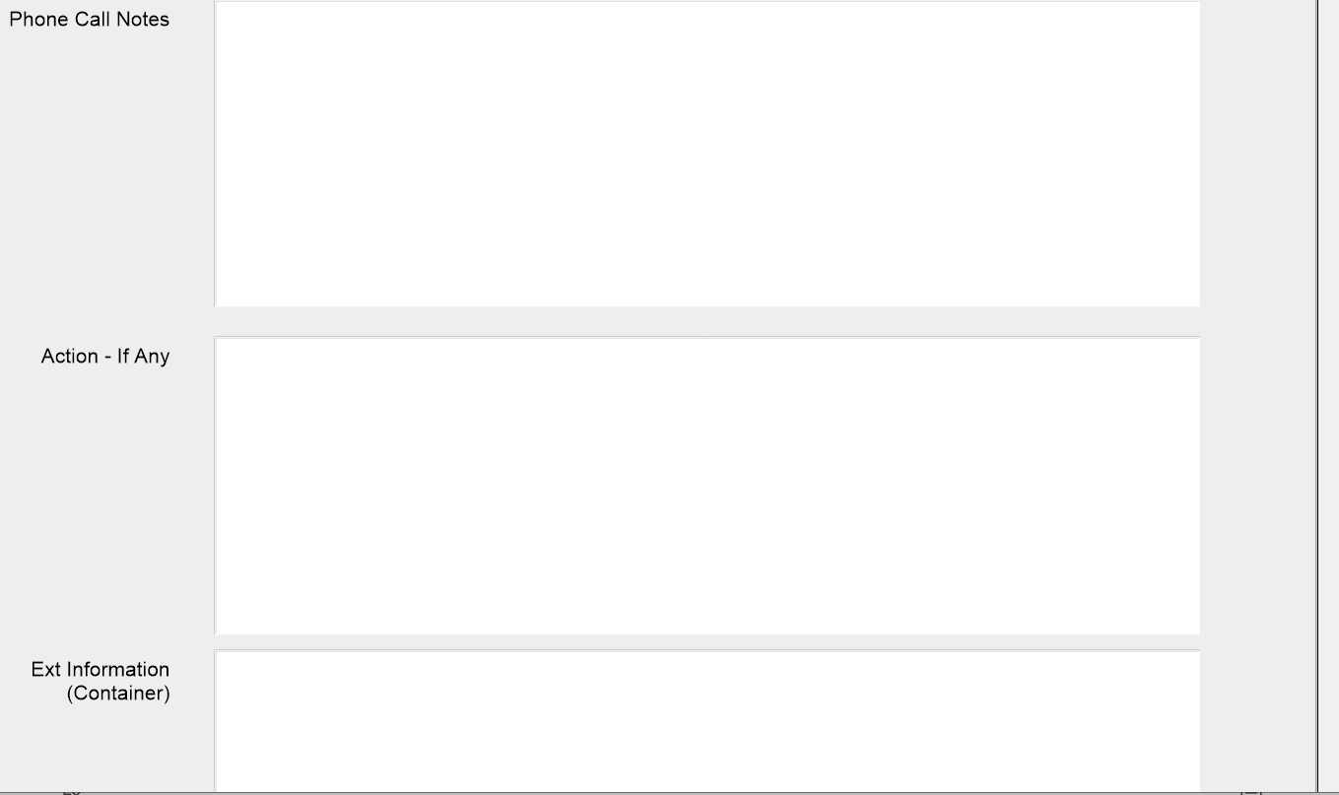
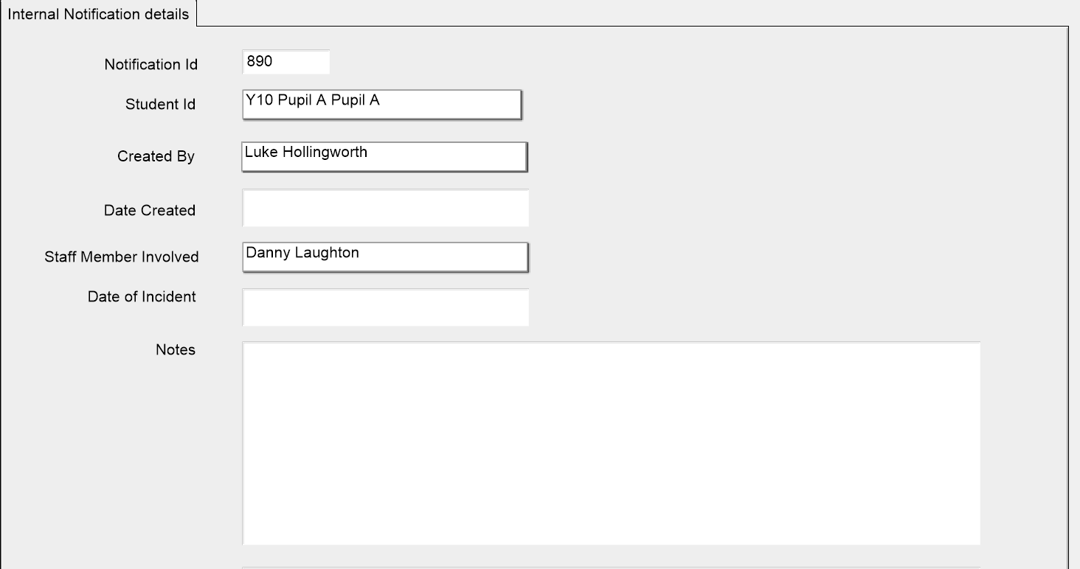

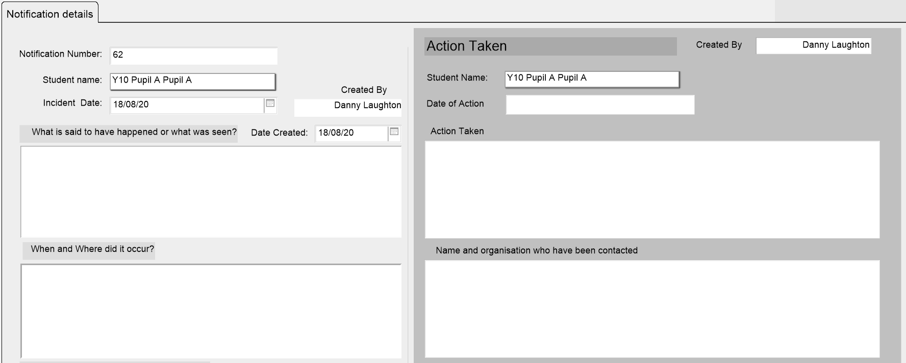
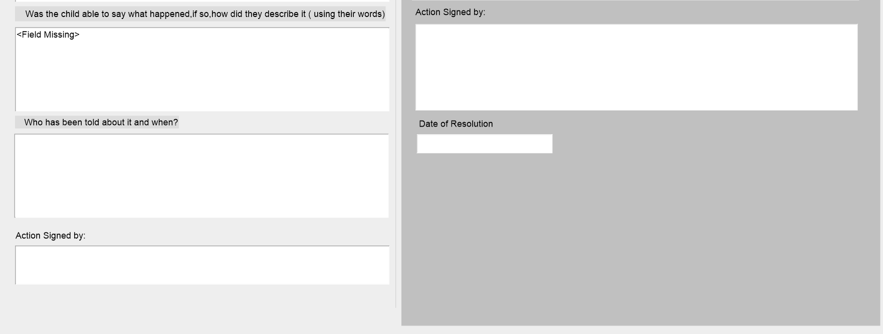
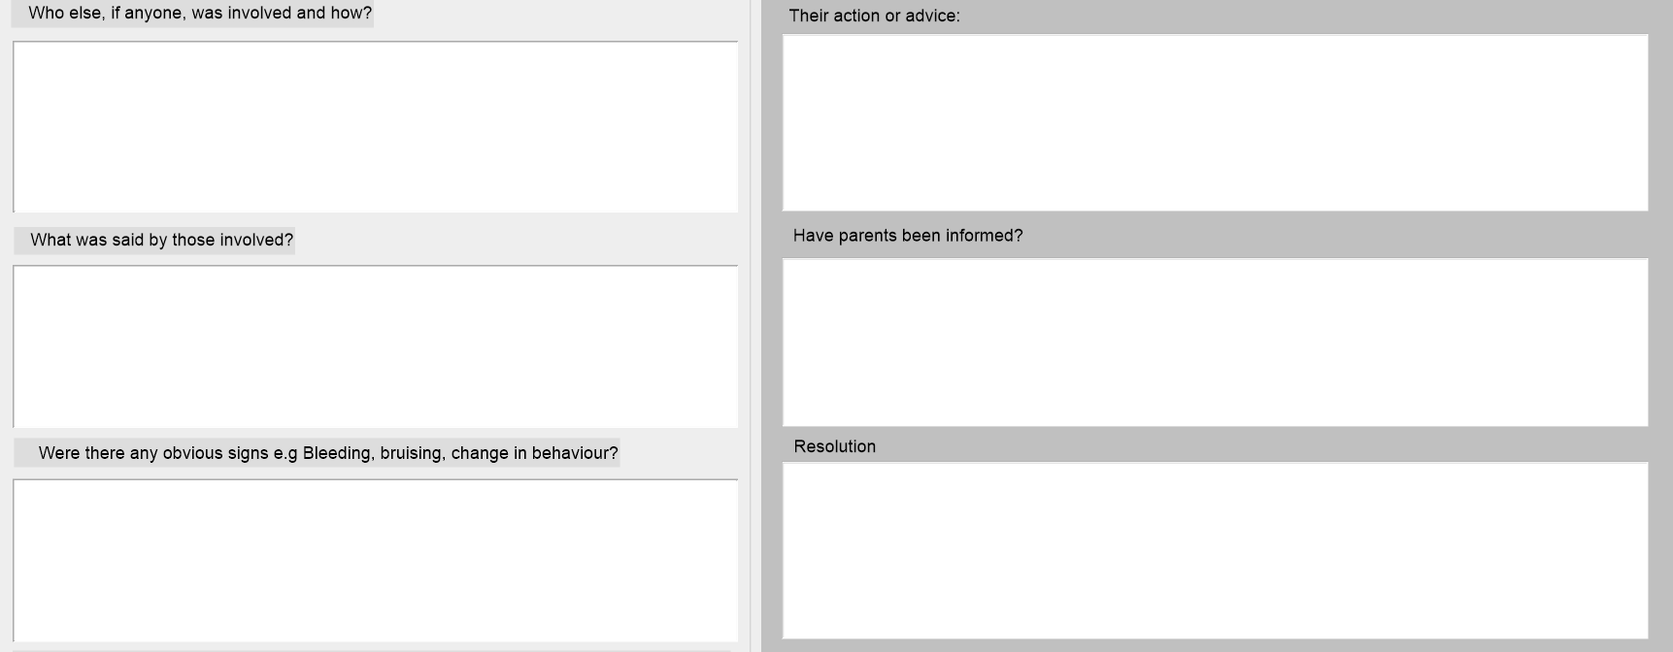
Safeguarding Notifications for Reporting to External Agencies.

Appendix E – Lincolnshire Prevent Referral Pathway

Appendix F – The DfE guidance (2018) on Searching, Screening and Confiscation Advice for Schools
https://assets.publishing.service.gov.uk/government/uploads/system/uploads/attachment_data/file/674416/Searching_screening_and_confiscation.pdf
Appendix G – Teaching Online Safety in School (2019)
https://assets.publishing.service.gov.uk/government/uploads/system/uploads/attachment_data/file/811796/Teaching_online_safety_in_school.pdf
Appendix H – Education for a Connected World (2020)
https://assets.publishing.service.gov.uk/government/uploads/system/uploads/attachment_data/file/896323/UKCIS_Education_for_a_Connected_World_.pdf
Appendix I – Prevent Strategy (2021)
Revised Prevent duty guidance: for England and Wales - GOV.UK (www.gov.uk)

