Year Group: | Pathway Section:
Year 9 | - Interests profile to identify and understand key interests.  - Start to record activities.  - Careers Library introduces employability skills and sectors.
Year 10 | - Careers Library and Competencies tool link skills used in school with careers.  - Activities to further develop skills.  - Careers Library builds LMI awareness.
Year 11 | - Revisit Interests and discover how passion links to pathways.  - Subjects and Careers Libraries for informed educational choices.  - Competencies for skillset self-awareness and to prepare for mock interviews.
Year 12 | - Understand Personality Profile and preferred Work environments.  - CV and Writing tools draft application materials.  - Placements tool to complete and reflect on WEX.
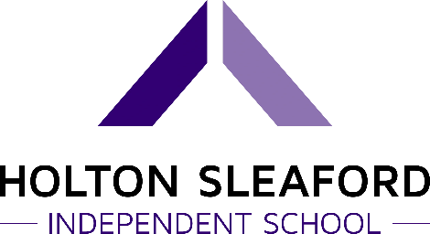

THE UNIFROG LEARNING JOURNEY:
We know how important it is to map out your provision and demonstrate the student learning journey. This helps everyone to visualise the main areas of focus for each year group. Alongside the student roadmap, we also focus on Staff Engagement:
- Annual staff training, strategy call and review meeting.
- Attend regional CPD events and webinars.
- Record interactions.
- Create scheme of work.

