

**Holton Summer Newsletter July 2025**

**Message from Executive Headteacher:**

**Ofsted Inspection- 10th-12th June 2025**

The school had a visit from Ofsted in June and two inspectors visited both the Osbournby and Sleaford site. After the 2 ½ days inspection, the school was judged to be **‘GOOD’** in all areas. This is a fantastic achievement and recognition for all the hard work by staff, pupils and parents/ carers. The school continues to strive to provide the best education and pastoral support for all of our pupils.

A copy of the full report can be found on the school’s website in the **‘latest news’** area.

I would like to wish everyone a safe and well-deserved summer holiday and look forward to the next academic year that **will start for pupils on Wednesday 3rd September 2025.**

**Dan Laughton- Executive Headteacher**

**Maths**

M3 Maths - M3 have been working incredibly hard this term looking at statistics, problem solving and position and direction. All pupils have made a conscious effort to try their absolute best and this has been clear to see with the amazing work they have produced. Pupils have in particular enjoyed creating their own line graphs and bar charts as we some very creative students.

All our year groups have been working really hard on their different topics this term. Our U1 class has recently started to look at some topics in preparation for the next academic year including calculations with large numbers as well as basic operations with fractions.

Our U2’s have also been looking ahead to next year, starting to look at some of the second-year topics including ordering mixed number fractions and following the order of operations.

U3 and Sixth Form classes have been using this term to re-cap some previously covered topics in preparation for their level 1 & 2 functional skills exams. Some of these topics include:

· Area, Surface Area and Volume.

· Scale Drawings.

· Averages.

· Fractions, Decimals and Percentages.

All our year groups have made excellent progress this academic year. I look forward to this continuing next year.

**English**

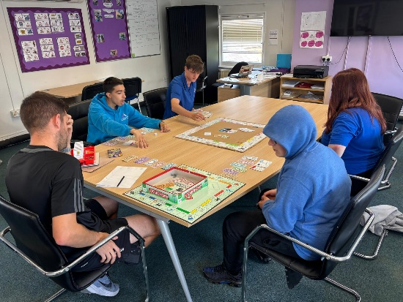This term U1s have been recapping the structure and format of writing a newspaper article. Students researched about VE day and then based their article writing around this. We have been looking at the structure and format of writing a report where students were able to choose a topic of their choice. We have latterly been looking at a leaflet layout where students were then able to design their own. Throughout their English lessons, students have been concentrating on Spelling, Punctuation and Grammar Skills as we continue to embed this into their everyday learning

This term the 6th form group have worked really hard revising topics ready to take their exams. They have also worked hard on their presentation and debating skills in order to complete the Speaking and Listening part of their English Qualification.

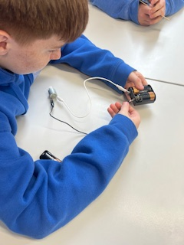**Science**

M3 Science - We have been looking at two topics over this term, 'Electricity and constructing circuits' and 'How we see light'. All pupils have loved the hands-on approach we try to implement in science. We have constructed multiple experiments which have been extremely successful.

**PE**

During PE this term, our U1’s to U3’s have been improving their knowledge and understanding of how to play cricket. Plenty of practice has gone into learning the different techniques for batting, bowling and fielding. This has led us to be able to mix groups together over the course of the term to compete in friendly cricket matches between forms. The progress made due to the application put into the constant practice and repetitions of the key skills needed for a full match is something that every student should be incredibly proud of themselves for. Furthermore, plenty of progress has been made by our U2’s and U3’s towards completing their coursework. By working together in the classroom, each student has managed to build and demonstrate a full gym program incorporating the FITT principles needed to show growth and improvement of performance in the gym.

**Outdoor Education**

Our U2’s have been completing a range of activities to work towards their Duke of Edinburgh award this term. We started off with 2 weeks of archery at Wild Pines in Market Rasen. This was followed by climbing for the rest of the term at Tallington Lakes and the YMCA in Lincoln. These are both activities which some of the students had never attempted before so it was great to see everybody giving each activity their best shot. Plenty of students have battled through their fear of heights during the climbing which they should be incredibly proud of themselves for. The encouragement and support shown by other students should also be commended for creating a fantastic atmosphere for our outdoor education lessons. Well done guys!

This term has seen our U1 group master their mountain biking skills between Sherwood Pines and Willingham Woods. Over the first 4 weeks of lessons, the basic skills were recapped so that a baseline level could be worked out for each student. Each student was allocated a specific route to complete a time trial around Sherwood Pines which was determined by the level of their mountain biking skills throughout their baseline testing. Once this was completed, the class moved onto Willingham Woods for the final weeks of the term. Here, there are a wide variety of linear routes over the course of 200m of woodland area. This is where the pupils really managed to put their skills to the test, racing over jumps, drops and round steep bends. A fantastic work ethic was shown in healthy competition 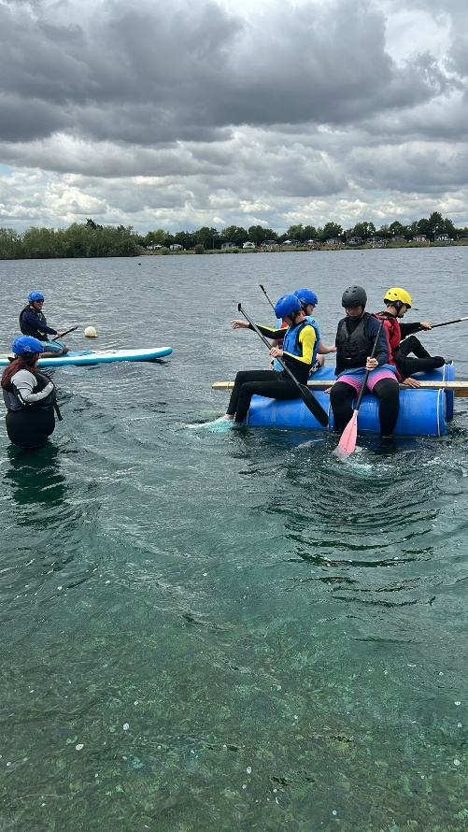throughout the term which was great to see.

During the summer term Sixth form and U3 have been going to Tallington Lakes and refining their skills at Kayaking and paddle boarding. At the end of the term students were eager to get on the water which was met with enthusiasm and pupils were challenging themselves to races and trying to see who could stand up the longest without falling in.

As the term has progressed, they have faced certain challenges from the staff at Tallington Lakes, from swapping boards and boats without falling in the water. Pupils are looking forward to getting the monster paddleboard out towards the end of term where they can refine them team-work skills paddling around the lake.

This year has been packed with all sorts of activities to help the students grow, work together, and enjoy the great outdoors.

Our mountain biking has been a big hit. Pupils learned how to handle their bikes on trails, and explore Sherwood Pines going through the green and blue routes. In swimming, everyone improved their skills and became more confident in the water as well as playing some games in the pool. Plus, our outdoor education lessons taught pupils how to read maps, set up camp, and even go climbing! But the most fun was watersports at Tallington lakes, which was a great way for pupils to challenge themselves on kayaks/paddle boards, enjoying the water thoroughly.

The students have also been on trips from PGL to Castleton in the Peaks, doing all sorts of activities like Zip lining, exploring Blue Johns Cavern and other outdoorsy activities.

We're super proud of how much our students have gotten involved and how hard they've worked. These activities teach them important skills, help them stay healthy, and create memories. We can't wait to keep offering these fantastic experiences in the years to come, with some exciting new activities to be added.

**Art**

In Art, this term, our pupils have been creating their own textiles. We have learnt how to use different types of stitches when sewing, tie-dyed t-shirts and learnt how to weave our own fabric using a loom.

All pupils have been exploring textiles to create their own cushion or wall hanging.

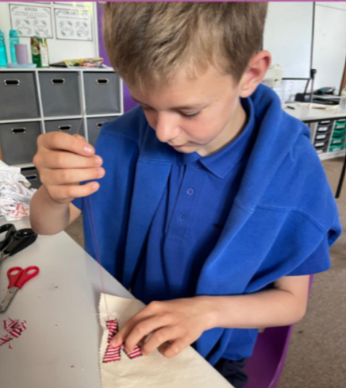**, Picture**

**Humanities**

This term our students have been diving into one of the most impactful events of the 20th century: **World War II**. Our focus has been on understanding what life was like on the Home Front, particularly for ordinary people living through extraordinary times.

Below is a summary of the key themes we’ve been studying in class:

The Blitz

We explored how families sought shelter during air raids, often spending nights in underground stations or Anderson shelters.

Discussions focused on how communities coped with fear, destruction, and loss - highlighting the resilience and solidarity of the British people.

The students enjoyed recreating a model of an Anderson shelter.

Evacuees

Over 3 million children were sent from urban areas to the countryside to escape the dangers of bombing.

Students have imagined what it would feel like to leave their families behind and spoke about what essentials and personal items they would take in their suitcases.

Rationing

Students have learned about ration books, limited food supplies and how families made the most of what they had.

The students thoroughly enjoyed recreating their own ration books, using tea bags to give them the aged effect.

Women’s Roles During the War

 From working in munitions factories to serving in the armed forces, women proved essential to Britain’s war effort.

Students were surprised and impressed by how quickly gender roles shifted during this period and enjoyed designing their own propaganda posters encouraging women to join the war effort.

**Enrichment – Self and Social**

Over the course of this year, students have been offered a variety of opportunities tailored to their individual needs and self-co targets. Staff have actively involved students in the planning process, using their input to shape activities that are both meaningful and supportive. These experiences have included mindfulness walks, community engagement projects, and developing social confidence in public settings such as restaurants and cafés—where students have practiced respectful behaviour and taken the initiative to make and place their own orders. Looking ahead, students will be visiting a local farm on 4th July, where they’ll assist in caring for the animals as part of their continued personal development.

**Duke of Edinburgh**

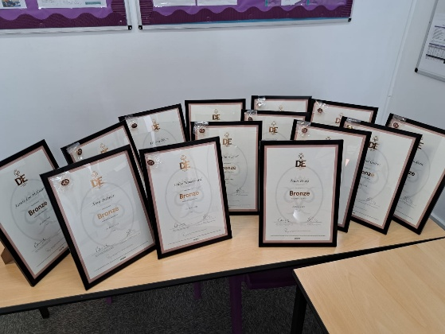This term most groups have been taking part in their Duke of Edinburgh Bronze Award expeditions to achieve the full qualification. All groups walked independently from Horncastle to Woodhall Spa along the Spa trail using their map reading skills learnt from their outdoor education lessons. Using teamwork and sheer determination, the groups walked for approximately 6 hours across both days meeting staff at various checkpoints along the 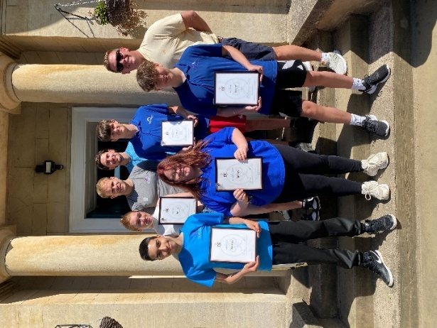route. Most pupils have therefore successfully achieved the qualification and will now be working towards the silver award. Overall, it has been great to see pupils working together towards a common end goal and helping push each other on when others were struggling due to the heat and physical demands of the qualification, and they should be proud of their efforts.

**Cornwall Trip**

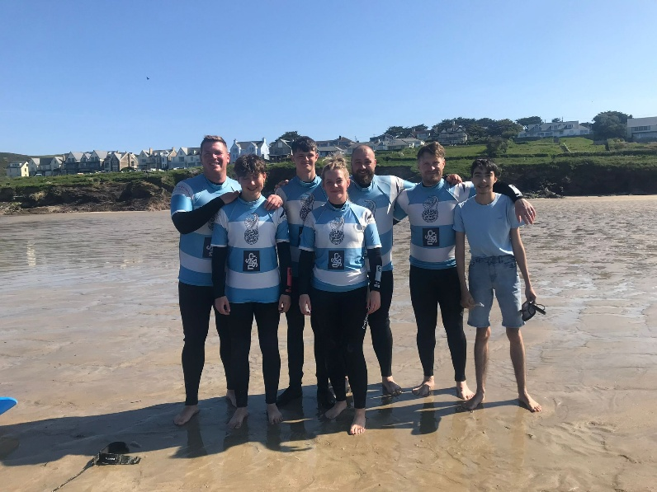On Sunday 11th May five students made the long-awaited trip down to Polzeath for the U3's attending their first weeklong residential here at Holton. Throughout the duration of the week in Cornwall students took part in two-hour surfing lessons each day, pushing themselves to improve on their skills in each session. Two of the students opted to partake in a further 2 hours of surfing each day to push and improve their skills. Whilst we were there, students and staff enjoyed time on the beach after surfing playing cricket and forming positive relationships and enjoying the element of competition throughout the week. Towards the end of the week staff and students took an afternoon visiting Padstow via the local ferryboat. The students were keen to explore and worked together on the port crabbing, helping each other and working together part of a team. Overall, a very successful trip down to Cornwall with each student pushing themselves out of their comfort zone, with surfing and learning a new skill. Students took the lead on meals out and ordering their own meals and drinks, helping massively with their social skills. We are very proud of how the students conducted themselves during the week, building their resilience and how they represented the school for the duration of the trip.

**Paris Trip**

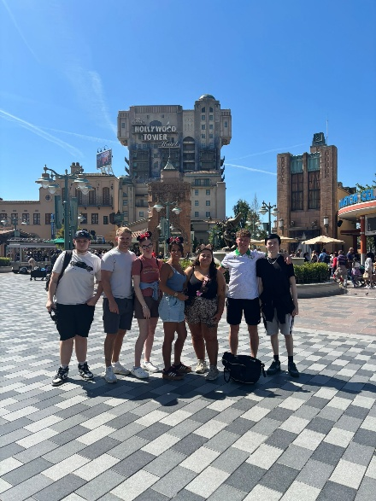On Monday the 19th of May 2025 some of our sixth form students travelled to Paris for Holton Schools second abroad residential. The first two days were spent at Disneyland Park and Walt Disney Studios where students got to experience the magic of Disney by witnessing the character parade, going on all the thrill rides, and being able to watch some of the shows. The Tower of Terror was a real highlight for the group! However the most memorable moment for all of us was the Disney Tales of Magic Night Show, which combined pyrotechnics, fountains and fireworks to create a truly unique visual experience and a special memory for them to share. The penultimate day was spent at the Eiffel Tower seeing some pupils conquering their fear of heights by getting a lift to the second floor. Later that day we returned to the Tower to watch its famous after dark sparkle before going on a river cruise along the River Siene. Most pupils on the trip attended Barcelona the previous year, all but one, who for that pupil this trip was their first experience going abroad and they’ve told us this trip was ‘incredible’. It was a great experience for all involved by combining the fun experience of Disney with time to take in the French culture when visiting Paris city centre, and we are proud to have been able to make these memories that will hopefully stay with our pupils throughout their life.

**London Trip**

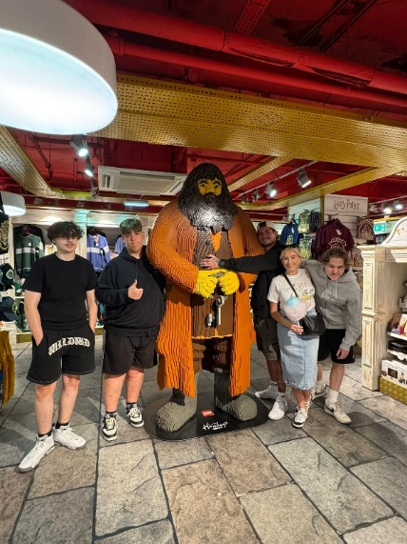The day had come for our sixth form students to have their trip to London; the long-awaited trip was finally here! The trip started with smiles on staff and students faces, the question was, were those smiles going to stay on all faces by the end of it. The activities started with a bang, with a trip to Harry Potter World in our sights. Followed by a trip to Top Golf in Watford in the evening. (This was a fan favourite for students and staff). With the students hitting every flag possible at the driving range, it was a very impressive start to the trip. The second day had arrived, and it was packed with activities. The morning started with a trip to London Zoo. Followed by a lot of walking around Camden Market, Oxford Street, Regent Street, Piccadilly Street and many more. The evening didn’t disappoint either, with the famous Hard Rock Café for tea, followed by a live performance watching Come Alive.

The third and final day was again full of activities with visiting Westminster Abbey, Big Ben and the Palace of Westminster. Again, the afternoon didn’t disappoint. Up first was visiting the London Dungeon. The students loved this, but the question was. Who jumped more, the staff or students? I’ll let you have a guess. Up next was the London Eye, with a look all over London, the question was, who could spot Wembley first. To finish off the afternoon was a river cruise across the River Thames, focussing on all the historic buildings. And lastly, the choice of what to do in the evening was all down to the students. The choice was: the cinema or shopping on oxford street. To the surprise of all staff, the students picked shopping to finish off the trip.

The plan was to be up bright and early on Friday morning to travel back to school, and surprising, the students got up and ready just in time ready to leave. The question was, was the smiles still on faces by the end of the trip, and to answer the question, they certainly were.