www.learnliveuk.com/paving-the-way-virtual-careers-festival

PREPARE IN ADVANCE
You have an opportunity here to find out heaps of information about a range of jobs and careers.

Take a bit of time to look through the resources available and plan how to get the most out of the virtual festival.

TAKE PLENTY OF BREAKS
The Festival is designed to be spread over 4 days with between 1 - 3 hours focused time a day.

Give yourself lots of short breaks and don't sit on your computer for more than an hour at a time.

TIME MANAGEMENT
Day 1 starts at 11am, following that, the days begin at 10am.

Check in, say hi and find out what challenges & opportunities you have in store each day!

QUIZ & CHALLENGES
Throughout the Festival there will be quizzes and challenges to take part in. You could even WIN Work Experience

Of course, prizes will be available so you need to be in it, to win it!

KEEP CHATTING
Many of the festival activities involve communicating through the Learn Live chat room.

Keep asking questions and if they are not answered live then we will reply at the end of the festival

MOTIVATION & RESILIENCE
You will have shown great motivation & resilience during lockdown by developing new ways of learning - Well done!

Keep that going by being motivated to find out more and ask lots of questions

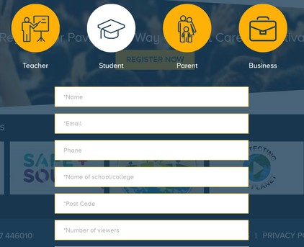L E AR N L I V E

Learn Live are our Festival partners and we are delighted to be using their platform to bring you over 80 broadcasts from employers, colleges, universities and apprenticeship providers from across Cheshire & Warrington.

H O W T O R E G I S T E R
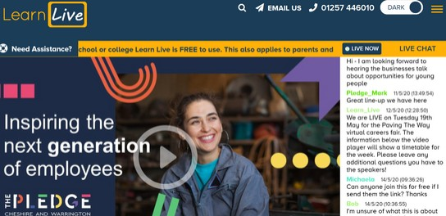Before Tuesday, please visit www.learnliveuk.com/paving-the-way-virtual-careers-festival/
AB O U T L E AR N L I V E
Learn Live seeks to inspire the next generation through engaging and interactive live broadcasts direct into the classroom. They have worked successfully with companies like The BBC, Balfour Beatty, Gatwick Airport, National Apprenticeship Service, Lancashire LEP, Network Rail, IBM, Health Education England and The NHS since 2015 to deliver careers advice, recruitment opportunities and health awareness broadcasts into schools and colleges across the UK.

The Learn Live technology is free to schools and colleges and doesn’t require any additional equipment to be purchased or procured to interact with the live broadcasts. All broadcasts can be viewed via interactive whiteboards or projectors using IE or Google Chrome browsers on existing laptops, PCs or via an app on tablet devices.

Since 2015, Learn Live have delivered over 350 live broadcasts and reached over 400,000 young people in schools, colleges and other educational institutions including Job Centre Plus. Over 2,000 schools and colleges have also engaged with the on demand video content with live interactive chat.

DAY IN THE LIFE

In this section you will find descriptions, photos and logos of each of the business owners or employers that you meet on Learn Live. They are in sector order so you may like to print a few of the pages that are
of interest to you and make some extra notes.

TIP
Over days 1 & 2 of the festival, different industry sector videos will be broadcast each hour.

Most of the Day in the Life videos are less than FIVE minutes long and you are asked to watch between 6 - 8 of them today and the same tomorrow.
Watch the video's carefully, there may
be some quiz questions about them
during the Festival!

TUESDAY
11am Construction & Engineering 12pm Health & Social Care
1pm Creative & Media
2pm Agriculture & Food Production

WEDNESDAY
10am Manufacturing & Logistics 11am Digital & Technology 12pm Finance & Law
1pm Science
2pm Self-Employment
3pm Uniformed Services & Third Sector

END OF DAY ONE (TUESDAY)

Industry sectors, companies or people that interest me

END OF DAY TWO (WEDNESDAY)

Industry sectors, companies or people that interest me

END OF DAY THREE (THURSDAY)

Industry sectors, companies or people that interest me

END OF DAY FOUR (FRIDAY)

Industry sectors, companies or people that interest me

DAY 3 (THURSDAY)

Today you will be exploring the next stages of education that are open to you.
We have videos from most of the colleges, universities and apprenticeship providers in the region here to take your questions. Please choose at least three of the activities.

MORE TBC

DAY 4 (FRIDAY)
Friday morning is very hands-on. The activities will help you plan for your future job. You can learn about all the different elements of making a CV, searching for jobs, applying and even being interviewed. You will be asked to choose at least three of the activities.

AFTERNOON
MORNING

