**Avoiding Online Dangers**

**What is the danger shown by this image?**

**List as many ways as you can think to avoid this danger**:

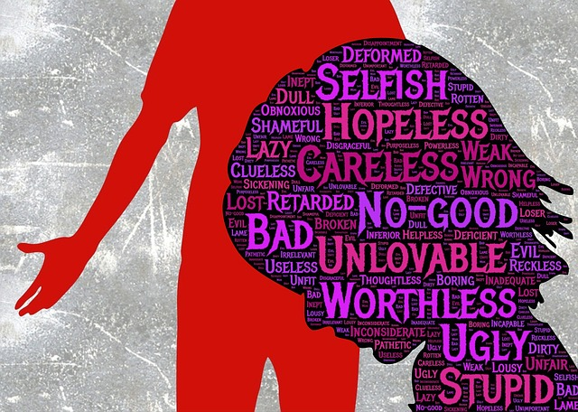

**What is the danger shown by this image?**

**List as many ways as you can think to avoid this danger**:



**What is the danger shown by this image?**

**List as many ways as you can think to avoid this danger**:

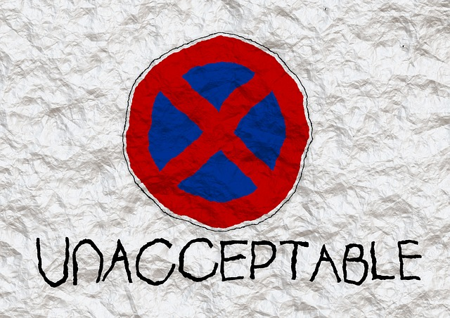

**What is the danger shown by this image?**

**List as many ways as you can think to avoid this danger**:



**What is the danger shown by this image?**

**List as many ways as you can think to avoid this danger**: