Understanding materials and contact surfaces are essential to understanding what will provide protection and what will not.

This document is meant to help provide a greater understanding of the material world around you, including your apparel, permeation of particles through materials, barriers, cleaning and performance.

Contact: Odessa Ingarfield

Bachelor of Human Ecology- textile science and clothing design

[Odessa1909@gmail.com](mailto:Odessa1909@gmail.com)

+1 403 589 5729

<https://dessius.com/>

<https://www.linkedin.com/in/odessa-ingarfield-97840755/>

**CONTENTS:**

Materials and Contact surfaces p. 2- 3

Various materials p. 3- 5

Woven

Knit

Non-woven

Continuous sheet

Moulded

Coatings, resins, films and laminates

What does this all mean p. 5- 6

Basic porosity

Transportation on materials p. 6- 7

Surfaces

Keeping it clean and reducing the spread p. 7- 8

When you come home

Soap

Laundry

Rags and Cleaning material

If you go to the hospital

**MATERIALS AND CONTACT SURFACES**

Why is it important to understand materials and contact surfaces? A basic understanding helps to know if what you are doing is helpful or harmful in terms of particle and particulate movements.

There are spaces in materials that we can’t see with the naked eye, the same way we cannot see a virus with the naked eye. Materials are also made of smaller components called yarns and fibres. Some materials do not have yarns or fibres but are created as a film or a continuous sheet.

Clothing, jackets, shoes, bags, purses, scarves, socks, gloves and hats can transport particles and particulates without us being aware. When products become visibly dirty, we see the particles attached to the material. Mud, plant oil, ink, paint, body oil, grease, spores/fungus, other fibres, dyes, etc. can all attach to a material and we will see it, but viruses and bacteria can be transported and attached without being visible.

How we take on and off our material items, move around with them and launder them can reduce the transportation of viruses and bacteria.

Our awareness can help us understand if our clothing, accessories, footwear, scarves, masks, paper, etc. are protecting us from water, wind, chemicals, bacteria, and viruses or are simply keeping us warm, covered or restricting impact or sharp object penetration.

The import of this is to understand if we are carrying unseen and unwanted particulates with us into our home, work, kitchens, offices or transferring them from our clothing to our faces, noses, mouths, or eyes.

There are three raw material compositions:

Natural - cotton, hemp, wool, silk, linen, jute, rubber

Synthetic - nylon, polyester, elastane, olefin, acrylic, polyurethane

Regenerated cellulose - viscose rayon, bamboo rayon, cuprammonium rayon (cupro), lyocell

There are five basic material formats:

Woven

Knit

Non-woven

Continuous sheet

Moulded

There are three types of applications to materials, yarns or fibres to alter their performance:

Resins and coatings

Films and laminates

Bonded

Natural raw materials did not require chemical processing to create the raw material. They were either grown, raised, or cultivated.

Synthetic raw materials are carbon based and generally are derived from petroleum processing or from the degradation of natural products where the carbon is captured and converted into a plastic.

Regenerated cellulose come from plants or plant bases and require chemical manipulation to produce.

Properties of materials, yarns and fibres that affect how they perform in relation to particulates or particles are:

Fibre or raw material shape, material construction, and additional coatings, films or resins.

Smooth fibres and material surfaces will keep particles and particulates on the surface as there are no crevices, spaces, irregularities or twists for the tiny particles or particulates to fall into or shift between.

The only smooth fibres are silk, cuprammonium rayon (cupro) and then the plastics or synthetics such as polyester, nylon, elastane (spandex), and olefins. Natural fibres excluding silk and cupro all have surface texture or irregularities such as striations, scales, nodes or twists. These surface irregularities enable particles or particulates to become trapped or shift away from the surface of a material.

    

Smooth Striations Scales Nodes Twists

**VARIOUS MATERIALS**

There are 4 basic materials that you might encounter:

Woven, knit, non-woven, sheet and moulded

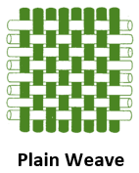**Woven materials** such as this plain weave can have a multitude of attributes and properties. You would find this type of fabric on pants, shirts, jackets, bags, hats, and woven scarves.

If you look there are yarns running vertically (the warp direction) and horizontally (the weft direction). In between these yarns are small spaces called interstices. It is through these small spaces that particles and particulates can pass through.

The size of the space or interstices is what determines the size of a particle or particulate that can pass through.

These voids can be smaller in tightly woven materials or very big in loosely woven materials. A virus ranges from 0.1- 0.005 microns on average. The spaces between the vertical and horizontal yarns are generally 50 microns and larger. Microfibres and nanofibers can reduce the size of the voids between fibres but it is safe to say that the majority of textiles produced for consumer goods have spaces of 50 microns or larger between yarns or filaments.

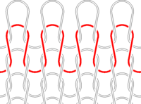**Knit materials** have yarns are formed into loops instead of straight yarns intersecting each other at right angles. As you can see there is a lot of opportunity for space between the yarns. These spaces are again, generally 50 microns and larger.

Knit materials also move significantly more than woven materials because of the loop structure. This means that the spaces between knits can increase more than that of wovens when pulled or stretched.

Knits are used in sweaters, t-shirts, pants, leggings, fleece sweaters, scarves, gloves, sportswear, to name a few items.

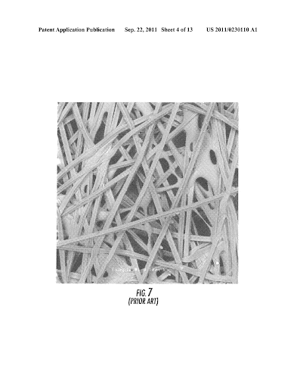**Non-woven materials** come in a variety of textures, thicknesses and with numerous means to produce them.

Non-wovens do not generally have fibres that sit at 90 degree angles to each other. They can random, overlap, have irregularities or can be consistent in their alignment.  
The spaces, voids or pores of non-wovens enable particles and particulates to pass through.

Non-wovens can have larger spaces between the fibres or very, very small spaces. The size of the voids can range from 0.001 microns and larger. These materials use microfibres, standard fibres, nanofibers but can also include glues or adhesives which again fill the voids between fibres. These materials can be used to contain powders and are able to restrict small particles and particulates from passing through before a coating is even applied.

Non-wovens are used in masks, bags, filters, felts, toilet paper, paper towels, wipes, and layers in between clothing.

Toilet paper and paper towels have larger voids and are absorptive, that is why they are used for cleaning spills or wiping away bodily fluids or waste. Paper towels and toilet paper are not barriers however and they allow bacteria and viruses to pass through them. These should not be used as any form of protection and should solely be used to absorb liquids or waste.

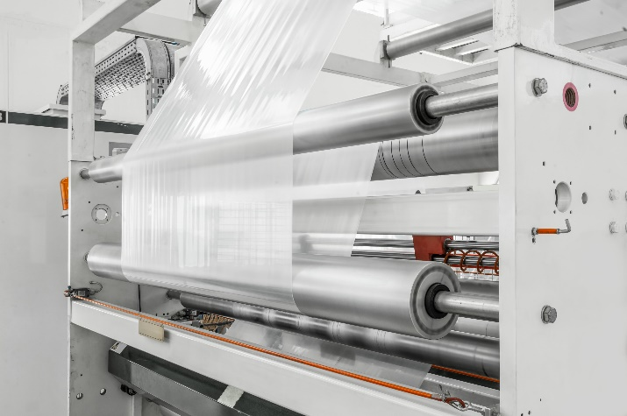**Continuous sheets** can have a vast range of properties and permeation degrees (ability for particles and particulates to pass through). They can be made porous to enable water or dirt to pass through them or they can be solid without voids to be waterproof, windproof and particulate barriers. They can prevent air from passing through and dependent upon the chemical, can be barriers to chemicals.

These materials are used in bags, as liners, for protective sheeting, as covers and in agriculture.

Their porosity will determine what is able to pass through if anything. Their thickness also contributes to their durability and their base materials will determine what can degrade it or damage it. Their surfaces can be smooth or textured.

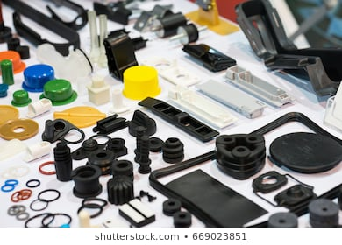**Moulds** can be used to create a vast array of products in metals, plastics, and rubbers.

These products that can come out of moulds vary in performance based on their raw materials used, how they are poured, cooled and if there are coatings applied after their construction.

Moulded items can be porous, have very large spaces made with air or gas that allow particles to pass through or they can be impermeable. They can have smooth surfaces or textured. If they are coated, they can be resistant to a variety of chemicals, particulates and particles. They can naturally be resistant against some forms of corrosion or permeation. They can also allow particles and particulates to sit on their surface or fall inside pores or textured dips or grooves.

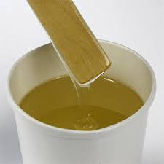**Coatings, resins, laminates, films and bonding adhesives** can all play an important role in how a material performs.

Coatings and resins can be applied to fibres and yarns, they can also be applied to materials and finished products. Coatings and resins are in a liquid or paste. They can be applied at any stage of a products cycle. They can be activated further with heat, chemicals or pressure.

Films and laminates are in a sheet form or two materials that have an adhesive (glue) that can bond together. Films can only be applied to materials before final conversion to a finished good. Laminates must be created before goods are assembled. The laminated materials can then be cut, sewn, bonded or joined. Films that are near liquid state can be applied to finished products, but this requires skill and special equipment to ensure that the film does not detach after application and is smooth.

These additional components can fill in the voids, spaces, pores, and interstices of materials. They can reduce the size of the space/void or fill it completely. These coatings can be chemical, liquid, microbial, viral, or gaseous/vaporous barriers. Their performance depends on their application process and the raw materials used.

Coatings, resins and films can also denature or degrade the outer layer or skin of viruses and bacteria killing them. They need testing and also need to verify WHICH viruses and bacteria they act against.

They can render a material resistant or proof against a wide range of particles and particulates.

They can be washable or begin to degrade with only one cleaning. It is possible to determine their expected life through testing.

**WHAT DOES THIS ALL MEAN?**

Different materials provide different degrees of protection against the weather, sharp objects, viruses, bacteria, dust, liquids, air borne particles, and chemicals.

They can keep us warm, cool us down, prevent us from getting wet and allow us to stay safe.

Understanding which materials provide which characteristics is important. Understanding how they can trap particles or transport them is also important. Lastly how we clean them can keep us healthy or simply appear to be safe.

**Some basic porosity details:**

Virus size: 0.1- 0.001 microns

Bacteria size: 10- 0.1 microns

Red blood cells: 1-10 microns

Toilet paper and paper towels: are not barriers for viruses or bacteria. Their voids are about 20 microns and larger.

Knit or woven gloves: are not barriers for viruses or bacteria. They can simply trap the virus or bacteria in the material and transport them to your face or another contact surface.

Medical gloves: are barriers for viruses and bacteria but please check their rating to see what they are barriers to.

Standard woven and knit materials: void size of 50 microns and larger.

Tightly woven uncoated materials: void size of 10 microns and larger.

Non-woven materials uncoated: void size can vary dependent upon formation and materials used. Void sizes generally from 1 micron and larger.

Microfibre woven and non-woven materials: these can vary dependent upon their raw materials and construction. Their fibre size will determine their ability to create smaller voids.

Nanofibre woven and non-woven materials: these are not as readily available on the market but can be an answer for future antimicrobial and antiviral solutions that are more environmentally friendly.

Coatings, resins, laminates and films: these applications can reduce void size to create products that restrict permeation of liquids, gases, particles and particulates. They can create void sizes smaller than 0.005 microns. They can also restrict the ability of a user to breath or for vapour to escape from a person. They can limit comfort and even performance for the user. You need to understand the end use before you apply it. They can also have limited life expectancy and restrict the cleaning of a product.

**TRANSPORTATION ON MATERIALS**

Smooth surfaces: These materials will allow particles, viruses, bacteria or liquid to sit on the surface without falling into crevices, folds or pores. Smooth surfaces can be wiped easier but also allow for transfer from their surface to another object easier (as particles simply sit on top).

Absorbent surfaces: Can absorb liquids and draw them into a fibre, yarn or material. They move liquids and can remove them from a surface. Very absorbent materials are generally poor barriers and require another layer or coating on one side to act as a barrier.

Porous surfaces: These have spaces or voids for particles to pass through or sit inside. Particles do not sit on top of a product but will sit inside spaces and on the flat areas.

Textured surfaces: Textures allow particles to sit in the various surface areas. It can move them from the top to a lower area.

**KEEPING IT CLEAN AND REDUCING SPREAD**

Now that you see how materials are created and their various properties here are some key details to help reduce the movement and spread of particles, viruses, liquids and bacteria.

1. Understand that viruses require help to move around. They need a means to transport them.
2. Your hands, arms, face and skin are easier to clean than a shirt, scarf, gloves or sleeves.
3. DO NOT pull your shirt or jacket down over your hands to touch a contact surface. ROLL UP your sleeves and use your hands. Then thoroughly wash your hands after.
4. GLOVES are not going to protect you unless they are medical gloves. Medical gloves are useful if you have open cuts, wounds or abrasions on your hands. Medical gloves can also limit spread if they are properly disposed of after use when dealing with multiple potentially infected individuals.

Washing your hands and arms are great to remove particles, viruses and bacteria from your skin. If you have cuts on your hands then medical gloves are important otherwise your skin is a REMARKABLE barrier.

1. Waterproof fabrics and coated or laminated fabrics are better barricades than uncoated however they can restrict the ability to breath. You need to understand how they perform. If you don’t understand how they perform, assume they are not providing a barrier to viruses or bacteria.

Because clothing, shoes, accessories, bags, hats, etc. can transport particles and particulates be aware when you are entering and leaving establishments. Be aware of what you touch and how you touch it.

**WHEN YOU COME HOME:**

Remove your shoes and place them in a safe and isolated area, inside a box or in an area on a shelf or aside from where people walk and interact.

If you may have come into contact with potential virus or bacteria of concern remove your clothing as soon as you get home and place them directly into a washing machine or laundry basket.

Go to your washroom and have a shower or bath using soap. It does not need to be hot water but warm water and soap.

Clean any surfaces you touched prior to your shower or bath.

This will reduce the spread or introduction to viruses and bacteria throughout your home.

**SOAP:**

Is a surfactant. It gets in between a contact surface and a particle. It loosens the attraction between two objects. Soap works by relaxing the attraction between particles, bacteria, viruses and your skin, clothes, shoes, handles, counter tops.

Soap can also contain antiseptic. They can dry out viruses and bacteria as well.

**LAUNDRY:**

Do not overload your washing machine. Fill it to a comfortable level so that clothing can move around, and water can penetrate. Use appropriate amount of suggested laundry detergent. The detergent releases the attraction between your clothes and particles. You do not need to use hot water. Warm water is best.

**RAGS AND CLEANING MATERIALS:**

After you clean an area with soap and water or cleaning agent, thoroughly rinse out the rag or sponge. Wash rags and sponges frequently and rinse them out well.

**IF YOU GO TO THE HOSPITAL:**

Remove your clothes and shoes when you get home. Wash your clothes and avoid touching surfaces until you have showered or bathed with soap and shampoo. Rinse yourself thoroughly after. Wash your shoes with soap and water on top and on the soles. Wash all contact surfaces. Wash your hands again.

You are the best defense against sickness.