Visit to the DUMP… death or resurrection
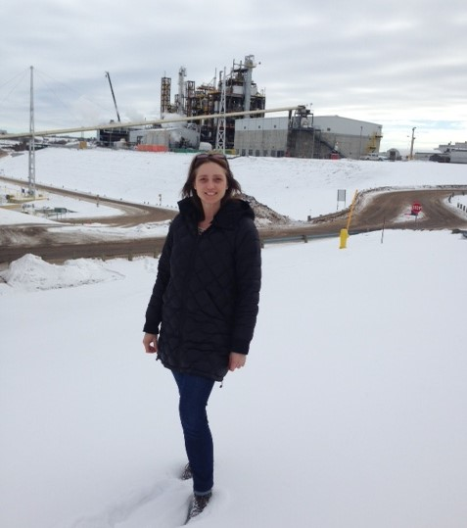
Following along with the research on product end-of-life I took a tour of the Edmonton Waste Management Centre. This facility, located in Edmonton, Alberta offered some great information on constraints, limitations and potentials. Is the death march needed or can products rise once again to become another consumer good or packaging; these were the questions I walked through the facility contemplating.
The EWMC (Edmonton waste management centre) was an opportunity to see into what numerous facilities experience and represents an insight for consumer product design, government and private sector collaboration and potential changes to product labelling, design and testing.
Some of the loudest potential opportunities that shouted in my ears were:
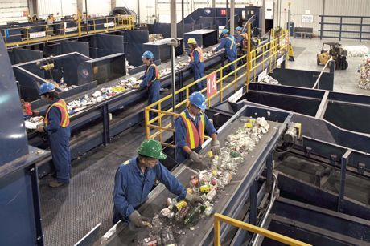
- Globally unified recycling identification that is clear and easy
- Labelling standards akin to garment labelling on all consumer goods/finished goods: which makes it easier for facilities to understand materials used and how they can be reprocessed
- National recycling, composting and waste management standards and not municipally based: uniformity in system equipment, sorting capacity and (re)processing
- Consumer goods end-of-life testing: to determine if consumer goods produced can be recycled and how easily
- Ability to sell sorted and recycled materials
After speaking with waste processing facilities in British Columbia and Alberta in both the private and public domains, these seem to be general issues that represent constraints but also great potential.
Other points of interest were the potential to convert waste materials of various compositions into biofuels for conversion into methanol and ethanol. As well as the fact that although there are a multitude of thermoplastics that come through the facility, it is demand that determines what will be recycled versus what will be converted into a biofuel. Composting in Alberta and British Columbia also faces challenges in relation to food waste, compostable packaging, natural materials and compostable utensils. Composting is often done outside and using little energy aside from what is produced during natural decomposition. The limitations with outdoor natural composting consist of requirements for full decomposition between 60 days and 1 year. Many compostable packaging and utensil products do not meet this. Standardization nationally at compost facilities as well as national requirements for compostable products need to be created to prevent user confusion, manufacturing strain and ease of production and disposal. International standards would further facilitate composting ease.

Steps to move forward:
- Create global recycling identification that is clear and easy. Many products are shipped internationally and therefore a unified approach is essential. The confusion in symbols, numerical values, acronyms and wording is difficult when manual sorting is necessitated.

- Labelling on all consumer goods would help with recycling and reprocessing in the same fashion it helps consumers understand how to care for their products or what they can expect during use, this would enable easier end-of-life processing.

- National consistency is a great start!! Localized waste, recycling and composting capacities, equipment and processes make it incredibly hard for manufacturers to produce in an efficient, responsible and standardized fashion. The goal however would be to work together internationally and create international standards in waste processing, recycling and composting since most products do not necessarily arrive at one singular destination. The world is a global marketplace and therefor the optimum solution would be to have global uniformity in waste management!

- Reprocessing test methods that help determine a finished goods ease of recycling would be a great incentive for designers, developers and innovators to determine if their product is a hindrance to convert or can be easily converted at end-of-life. Reprocessing test methods could evaluate combination of materials used, finishes and treatments as well as assembly of products. Today there are test methods for elasticity, seam slippage, tensile strength, permeability, abrasion resistance, impact resistance and plastic recycling, etc. but limitations for international standards on finished goods recycling or disposal. The Association of Plastics Recyclers has a great website and offers services to help innovators and manufacturers produce responsibly. https://www.plasticsrecycling.org/apr-design-guide/training-program
ASTM and EN have various methods for different materials but there is nothing in place for finished goods in relation to natural and synthetic as well as treatments and finishes.
There are books available: https://books.google.ca/books?id=TBrOGJqvgcMC&pg=PA277&lpg=PA277&dq=test+methods+for+recycling&source=bl&ots=7FUDlIpH-8&sig=ACfU3U0SDZBxPRNLW5YAVAn7DGV20IFfXg&hl=en&sa=X&ved=2ahUKEwi5qZecvYDhAhUI74MKHTZlA30Q6AEwDnoECAAQAQ#v=onepage&q=test%20methods%20for%20recycling&f=false
https://books.google.ca/books?id=9WrWBHqTnoEC&pg=PA252&lpg=PA252&dq=recycling+test+methods&source=bl&ots=jmC27qpozG&sig=ACfU3U0BBr0Npg_EC4zR0TGIwfz8RdJ95A&hl=en&sa=X&ved=2ahUKEwjDmLS2voDhAhUl5oMKHYzVCJ84ChDoATANegQICBAB#v=onepage&q=recycling%20test%20methods&f=false
and we need to have a unified front as a multitude of natural materials receive coatings that significantly alter how that material will degrade or can be processed. There are blends for synthetics and multi-material components in one product as well.

- The last component of resale for recycled materials in essential. There are costs that arise from recycling materials, sorting and processing. Facilities needs consumers or processors for recycled materials otherwise they will simply sit and require disposal. It is important for industry to understand the import of local recycleable materials conversion otherwise if there is no market and consumption of the products then they will not be reused. Local market usage, factories and facilities will render the reuse of recycled material potential greater. This is possible through improved local production capacities.
There are a multitude of organizations, governments, private-sector companies and individuals working towards global sustainability and betterment. This is wonderful. The greater the collaboration and unified approach; the more uniform the attack and the more synergetic the efforts, the easier it will be for all industries, users and processors to work together for responsible and sustainable existence.
Best
Odessa Ingarfield

