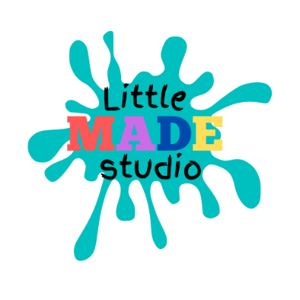
Child Protection Policy
November 2020
Introduction: Everyone who participates in Little MADE Studio classes, whether online or in person, is entitled to do so in an enjoyable and safe environment.
Little MADE Studio is committed to devising and implementing policies so that everyone taking part in our sessions accepts their responsibilities to safeguard children from harm and abuse.
This means to follow procedures to protect children and report any concerns about their welfare to appropriate authorities. The aim of the policy is to promote good practice, providing children with appropriate safety/ protection whilst in our sessions and to allow our teachers to make informed and confident responses to specific child protection issues.
Policy Statement Little MADE Studio is committed to the following:
• the welfare of the child is paramount
• all adults and children, whatever their culture, ability, gender, language, racial origin, religious belief and/or sexual identity should be able to participate in our sessions in a fun and safe environment • taking all reasonable steps to protect children from harm
• all suspicions and allegations of poor practice or abuse will be taken seriously and responded to swiftly and appropriately
• all Little MADE Studio employees and contractors will be recruited with regard to their suitability for that responsibility, and will be provided with guidance in good practice and child protection procedures
• working in partnership with parents is essential for the protection of children. The implementation of procedures should be regularly monitored and reviewed. The policy should be reviewed every 3 years or whenever there is a major change in the organisation or in relevant legislation.
Promoting Good Practice Child abuse is any form of physical, emotional or sexual mistreatment or lack of care that leads to injury or harm. It is not the responsibility of employees or participants in Little MADE Studio sessions to make judgements about whether or not abuse is taking place. It is however their responsibility to identify possible abuse and act if they have concerns about the welfare of the child. Indicators of Abuse Most people are not experts in such recognition, but indications that a child is being abused may include one or more of the following:
• unexplained or suspicious injuries such as bruising, cuts or burns, particularly if situated on a part of the body not normally prone to such injuries
• an injury for which an explanation seems inconsistent
• engaging in sexually explicit behaviour
• becoming increasingly dirty or unkempt
• neglect occurs when an adult fails to meet a child’s basic physical and/or psychological needs, to an extent that is likely to result in serious impairment of the child’s health or development.
For example, failing to provide adequate food, shelter and clothing, failing to protect from physical harm or danger, or failing to ensure access to appropriate medical care or treatment. Refusal to give love, affection and attention can also be a form of neglect. •
safety of the child is paramount. If the child needs urgent medical attention call an ambulance, inform the doctors of the concern and ensure they are made aware that this is a child protection issue
• record all information
• report the incident to the Little MADE Studio practitioner. It is not the responsibility of anyone working for That Kid Life to decide whether or not child abuse has taken place.
However, there is a responsibility to act on any concerns through contact with the appropriate authorities so that they can then make inquiries and take necessary action to protect the child. Recording Information To ensure that information is as helpful as possible, a detailed record should always be made at the time of the disclosure/concern. Information should include the following:
• the child’s name, age and date of birth
• the child’s home address and telephone number
• whether or not the person making the report is expressing their concern or someone else’s • the nature of the allegation, including dates, times and any other relevant information
• a description of any visible bruising or injury, location, size etc. Also, any indirect signs, such as behavioural changes
• details of witnesses to the incidents
• have the parents been contacted? If so, what has been said?
• has anyone else been consulted? If so, record details •
has anyone been alleged to be the abuser? Record detail Reporting the Concern All suspicions and allegations MUST be reported appropriately. Little MADE Studio expects its members and staff to discuss any concerns they may have about the welfare of a child immediately with the person in charge and subsequently to check that appropriate action has been taken. He/she should take responsibility and seek advice from the NSPCC helpline, the duty officer at the local social services department or the police. Telephone numbers can be found in your local directory. NB: If there is any doubt, you must report the incident: it may be just one of a series of other incidences which together cause concern Confidentiality Every effort should be made to ensure that confidentiality is maintained for all concerned. Information should be handled and disseminated on a need to know basis only. All information should be stored in a secure place with limited access to designated people, in line with data protection laws. Use of Photographic/Filming Equipment Parents will be asked permission if a camera is to be used in class for any reason. No identifiable photographs or moving images will be published by Little MADE studio without written permission from the parents of the children concerned.
Declaration On behalf of Little MADE Studio I, the undersigned, will oversee the implementation of the Child Protection Policy and take all necessary steps to ensure it is adhered to. Amanda Abrey 22 November 2020

