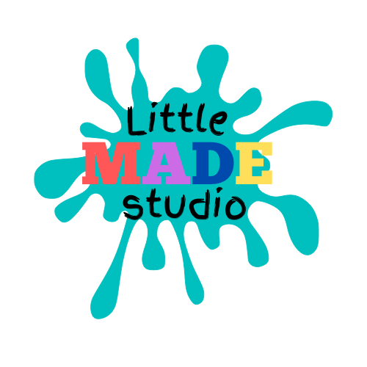

Kids Crafting Club

Medical Form
Child’s name: | Date of birth:
Doctor:
Doctor’s address:

Doctor’s telephone:
Does your child or the child in your care have any known medical problems or additional needs?
(Please list)

Please detail any medical needs your child has/medication taken: (please provide full details, if medication is needed an additional medication consent form will need to be completed)

Does your child have any known allergies? (an Allergy Management Plan will be put in place where required)

Does your child have any dietary requirements?

Any other information relevant to your child’s health

Parent/Carer emergency contact telephone numbers:

In the event that my child is involved in a serious accident I expect to be contacted immediately on the above telephone numbers.

In the event that my child requires immediate medical treatment before I can get to the hospital I hereby authorise the staff member present to consent to any emergency medical treatment necessary to ensure the health and safety of my child on my behalf.

Signed: Date:

_____________________________________________ _____________________

