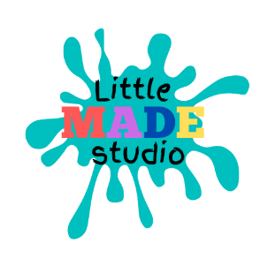
Payments, Refunds and Transfers Policy
This policy aims to outline all procedures related to payments, refunds and transfers for workshops and classes provided by Little MADE Studio.
Payments
• Full payment must be received prior to the session via bookwhen.com/littlemadestudio.
• Payments are accepted via Stripe (for card payments) and Paypal.
• Your child’s place is not secure until full payment has been made, meaning their place may become available for others.
• We can, on occasion, accommodate ‘on the door’ bookings but you may be turned away if we are at full capacity.
Refunds
• We are unable to offer refunds for cancellations, unless in exceptional circumstances, as determined by Amanda Abrey.
• If for any reason a class or workshop is cancelled, you will be informed via email and issued a refund within 3 working days.

Transfers
• Bookings may be transferred to a different sessions, subject to availability, up to 48 hours before the class or workshop. Please email amandaellenabrey@gmail.com to arrange this.
• Classes that have already passed cannot be transferred to future dates.

This policy was adopted by: Little MADE Studio Date: 01/01/2022
To be reviewed: 01/01/2023

