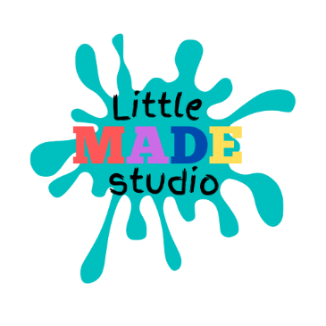
Safeguarding Policy
Little MADE Studio
November 2020
Policy Statement:
As a self employed individual and the sole person of the organisation I, Amanda Abrey of Little MADE Studio, am committed to practices that protect children from harm. I recognise and accept my responsibility to develop the awareness of issues that may cause children harm.
Definition: For the purposes of these policies and procedure children are any person under the age of 18 years, or those that are considered vulnerable.
I will endeavour to safeguard children by:
• Adopting child protection policies and guidelines through a code of behaviour.
• Sharing information about any concerns with agencies who need to know, and involving parents and children appropriately.
• Ensuring that I am in possession of an enhanced disclosure from the Criminal Record Bureau, in accordance with their guidelines.
• Making any new staff aware of these child protection procedures and policies.
• I am also committed to reviewing this policy and good practice at regular intervals.
CODE OF BEHAVIOUR I MUST NOT:-
1. Spend excessive amounts of time with children alone, away from others. Meetings with individual children should be avoided or take place within sight of others. If privacy is needed, the door should remain open and others should be aware of the meeting.
2. Make unnecessary physical contact with children. Always check and gain consent with a parent or guardian for before doing so.
3. Meet children outside the organised activities, unless it is with the knowledge and consent of the parents and the person in charge of the event.
4. Start an investigation or question anyone after an allegation or concern has been raised. This is the job of the authorities. I will make an accurate record of the facts and report these to the designated person.
5. Show favouritism to any one child, nor issue or threaten any form of physical punishment.
6. Never (even in fun)- • Initiate or engage in sexually provocative conversations or activity.
• Allow the use of inappropriate language to go unchallenged.
• Do things of a personal nature for children that they can do themselves.
• Allow any allegations made by a child go without being reported and addressed or either trivialise or exaggerate child abuse issues.
• Make promises to keep any disclosure confidential from relevant authorities.
I MUST:-
7. Respect children’s rights to privacy and encourage children and adults to feel comfortable enough to report attitudes or behaviour they do not like.
8. Act with discretion with regards to personal relationships and ensure personal relationships do not affect my leadership role within the organisation. All pre-existing relationships between staff and/or participants of any event must be declared.
9. Refrain from consuming alcohol for a period of at least 12 hours prior to interacting with any child or children.
10.Remain aware of the procedures for reporting concerns.
11. If I become the subject of inappropriate affection or attention from a child ensure that others present are aware of this.
12. If I have any concerns relating to the welfare of a child in their care, be it concerns about actions/behaviours of another adult or concerns based on any conversation with the child, particularly where the child has made an allegation, they should report this to the designated person.
Identity Checks: • My photo identification is available to be checked and verified by any client. Vetting Checks
• As an individual who comes into contact with children, I must hold an enhanced Disclosure and Barring Service (DBS) check. All class leaders will also be in receipt of an enhanced DBS check - to be renewed every two years.
Overseas Checks If a member of staff has lived outside the UK for six months of more in the past five years must have an overseas CRB check. Company Procedures I should carry photo identification and ensure that it is available to be checked and verified by any client. I will also sign in and out of any venue as required.
Annual Review This policy is reviewed and reissued on an annual basis. If concern for the welfare of a child is raised, a report will be disclosed to the NSPCC: 0845 608 5454
Amanda Abrey Founder of Little MADE Studio 07702 969 856

