We would like to extend a big

‘Thank You’

to all our 2026 sponsors!

All West Glass | Lakes District Arts Council
AMC Village Insurance | Lakes District Cattlemen
Andy’s Machining & Repair | Lakes District Maintenance
Artemis, Blackwater Gold | Lakes District News
Bandstra Transportation Systems Ltd. | LDFC Printing & Stationery
BC Livestock Producers Co-Op Assoc. | Lino’s Sales
Frank Bergen | LMR Holdings
Blu Jay Sports | Marmon Financial Management Co. Ltd.
Bulkley Valley Credit Union | Nadina Truck
Bulkley Valley (Castle) Home Centre | Napa Auto Parts/Polar Park
Bulkley Valley Insurance Services | Nechako Kitimaat Development Fund
Burns Lake Auto Supply | Office Pub & Grill
Burns Lake Community Forest | Options Program
Burns Lake & District Comm. Foundation | P&B Feeds ‘N’ Needs
Burns Lake Hardware & Garage Ltd. | Pine Ridge Holdings Ltd.
Burns Lake Solar | Pine Ridge Modular
Burns Lake Veterinary Clinic | Pro-Tech Forest Resources Ltd.
Cattle Industry Development Society | Province of BC
Cheslatta Carrier Nation | Radley Contracting
Chinook Community Forest | Regional District of Bulkley-Nechako
Coastal Gas Link pipeline | Rio Tinto
Corey’s Uptown Automotive Ltd. | Royal Bank of Canada
Corey’s Uptown Auto Wrecking | Save-On-Foods
Corridor: 16 | Shinedown Enterprises
Courtyard by Marriott, Prince George | Starland Timber Mart
Brent Craddock | Strimbold Law
Craddock Trucking | Subway
Cross Creek Logging Ltd. | Sullivan Motor Products
Decker Lake Forest Products | Summit Integrated Services
Flintstone Mining Division Ltd. | Tahtsa Timber Ltd.
Four Rivers Co-Operative | Tatalrose Corner Store & Custom Meats
Free Growing Forestry Ltd. | Tech North Solutions
Hampton Lumber/Babine Forest Products | Tricon Truss & Millwork
Huber Farm Equipment | Village of Burns Lake
Industrial Transformers | Waste Management
Intata Logging Ltd. | Westline Ford Ltd.
Kal Tire | Woods ‘N” Water Sports & Recreation
Key-oh Lodge

And, all our wonderful Fall Fair Volunteers
“We Couldn’t Do It Without You!!”
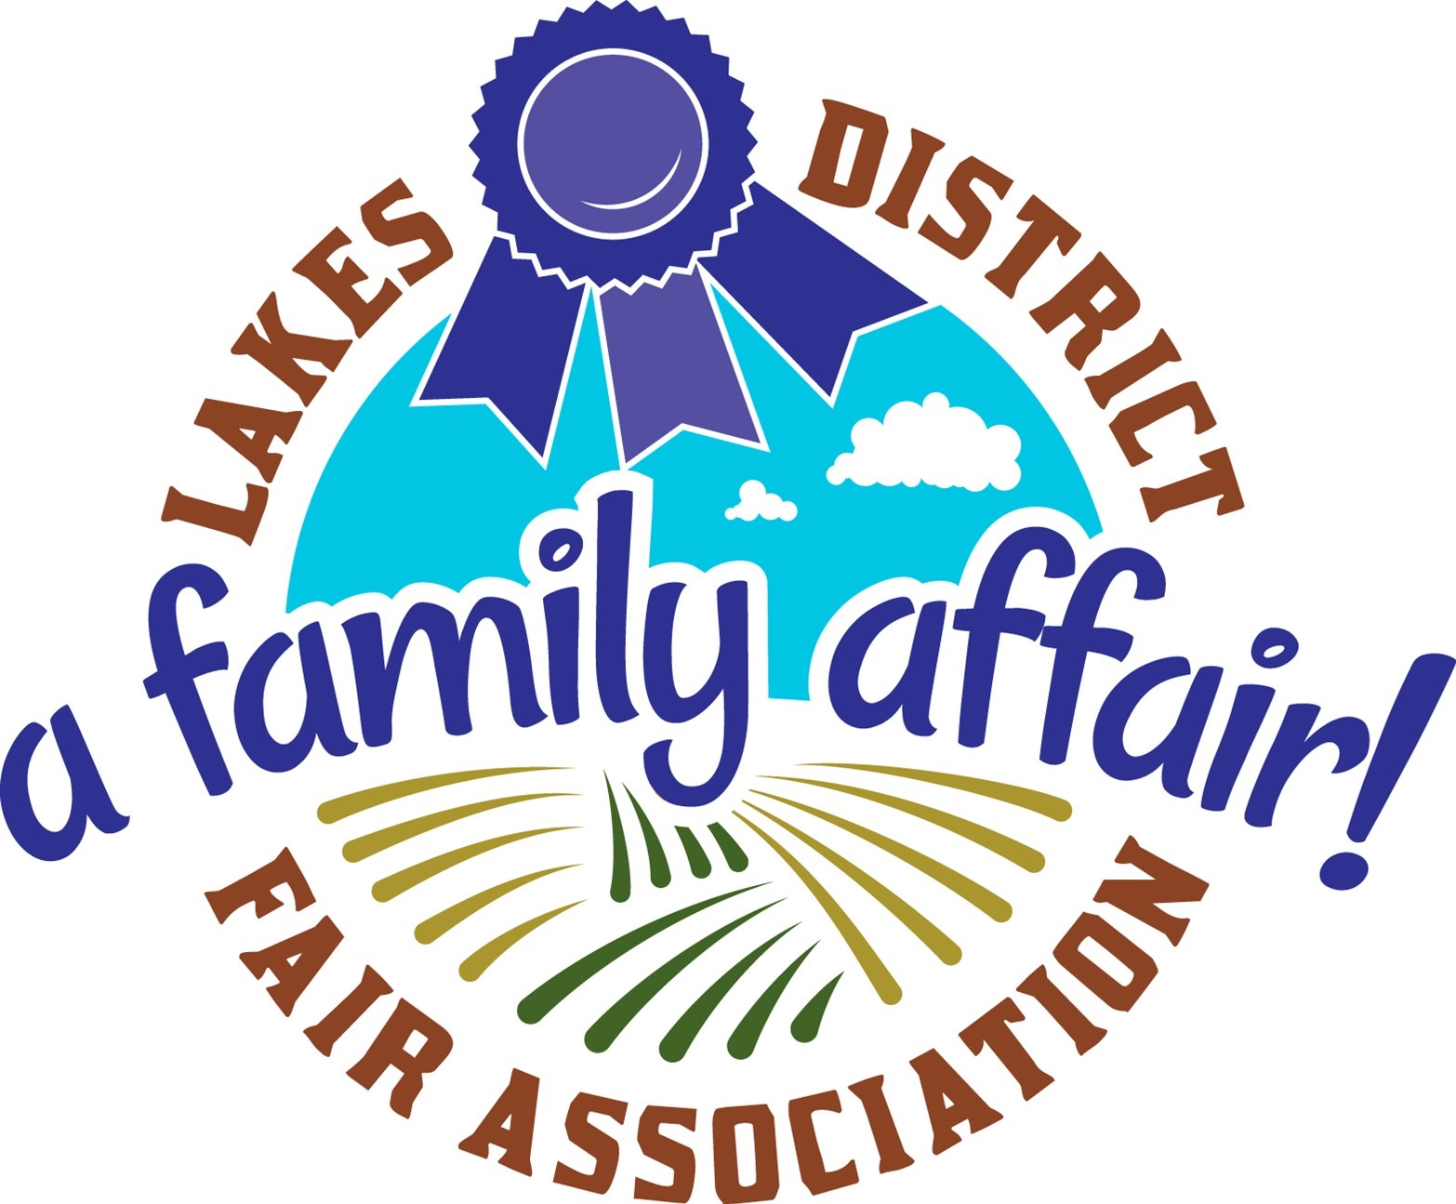 | 80th Annual  Lakes District Fall Fair  Children’s and Music Festival  September 11th, 12th, and 13th 2026

Celebrating 80 Years of Community and Agriculture

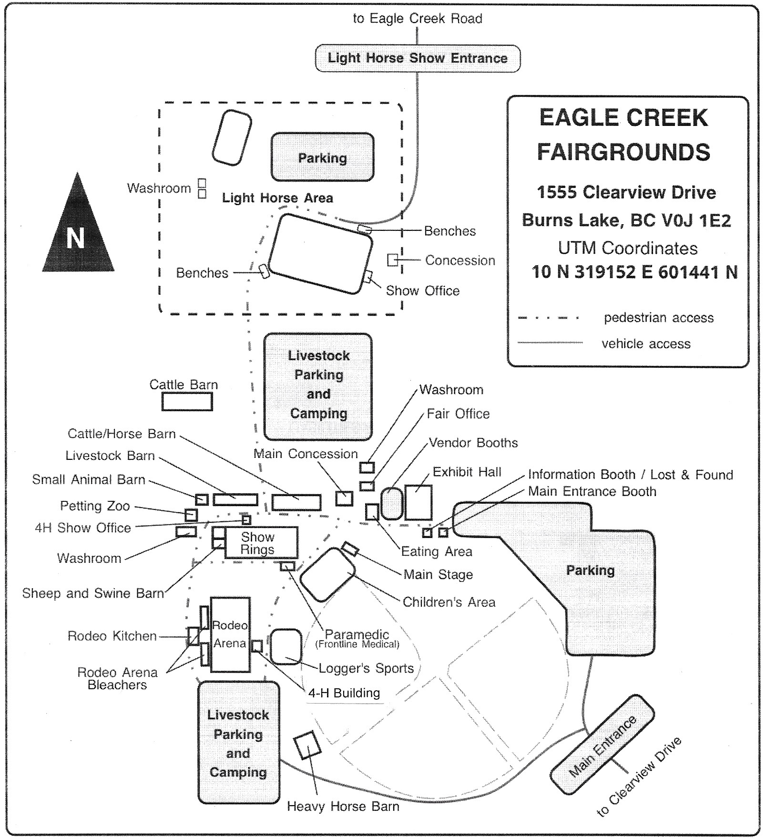

Use the map to locate Fall Fair exhibits, concessions and activities.
The Information Booth and ‘Lost and Found’ are just inside the Main Gate.
The Frontline Medical truck will be parked across the road from the Children’s Festival.
Bike riders: Please walk your bike in designated (posted) areas.

Friday, September 11th

8:30 am to 11:30 am | All entries to be in the Exhibit Hall
1:00 pm to 7:00 pm | Health checks for small animals
5:00 pm | Gates open and Exhibit Hall opens  Children’s Festival: Bumper Balls (weather depending).
6:00 pm | Super Dogs in the field behind the Information Booth
6:30 pm | 80th Anniversary Vintage Games – tasty prizes
7:00 pm | Exhibit Hall closes  All cattle to be on the Fairgrounds
7:30 pm to 9:30 pm | Friday Dance – Lights and Music by Thorburn Sound
8:30 pm | Moonlight Games for Adults

Saturday, September 12th

8:00 am | Pancake Breakfast at the Main Concession  All livestock to be on the Fairgrounds  4-H Achievement Day begins
8:30 am | 4-H Beef Judging in the Livestock Show Ring
9:00 am | Music Festival opens on Main Stage  Stock Dog Trials begin in the Rodeo Arena
10:00 am | Exhibit Hall opens  Livestock show  Small animal judging  Burns Lake Saddle Club Extreme Trail event starts in the Lower Arena
10:30 am | Registration table opens at Children’s Festival and Super Host sign-up  Carnival Fun begins at Children’s Festival
11:00 am | Children’s Festival area: Hammer Tent; Strong Start; Duck Races; PG Cottonwood Railway, Bumper Balls and Northern Inflatables (weather depending); Bull Riding.  Artisan demonstration in the Exhibit Hall: Vanessa Allen - How to create a Tree of Life suncatcher  Super Dogs in the field behind the Information Booth
12:00 noon | Opening Ceremonies of the 2026 Fall Fair on Main Stage  Eric the Juggler
12:15 pm | Team Roping in the Rodeo Arena until 4:15 pm
12:30 pm | Children’s Festival Sack Races
1:00 pm | Artisan demonstration in the Exhibit Hall: Jenny Pirie - The Patchwork Initiative - Scrappy Applique Quilt making  Scouts Honour Kids Band on the Children’s Festival Stage  Burns Lake Saddle Club Ranch Hand in the Lower Arena  Super Dogs in the field behind the Information Booth
2:00 pm | Amanda’s Pet Show on the Children’s Festival Stage

We thank you for your cooperation with these rules while on the Fairgrounds:

By entering the Fall Fair grounds, each individual agrees to observe the rules of the Lakes District Fair Association and behave safely. For example: no climbing on structures; no smoking except in private vehicles or in the campground areas; all dogs must be on a leash at all times on the Fairgrounds, or in a camper or kennel or pen in the camping areas; no riding of bikes in the Fairgrounds proper; no alcohol or cannabis use except in the campground areas by persons 19 years of age or older.

Saturday, September 12th (continued)

3:00 pm | Tug-of-War: on the road in front of the Children’s Festival stage:  7-10 year olds; 11-15 year olds; then … Adult Teams  Super Dogs in the field behind the Information Booth
3:30 pm | Children’s Festival: 80th Anniversary Races (parents encouraged to participate)
4:00 pm | Open Mic at Children’s Festival Stage
4:30 pm | Children’s Festival: Veggie Faces
5:00 pm | Jackpot Barrel Race in the Rodeo Arena  Children’s Festival closes for the day  2026 4-H Auction begins
6:00 pm | Tweedsmuir Fiddlers lead the Family Dance on the Main Stage
7:00 pm | Exhibit Hall closes
7:30 pm | Music Festival closes for the day

Sunday, September 13th

8:00 am | Pancake Breakfast at the Main Concession
10:00 am | Exhibit Hall opens  Ranchers’ Choice in the Livestock Show Ring  Stock Dog Trials begin in the Rodeo Arena  Bulkley Nechako Carriage Club driving demonstration in Lower Arena
10:30 am | Music Festival opens on Main Stage  Registration table opens at Children’s Festival; Children’s Festival is open  Registration opens for Logger Sports events  Heavy Horse Pull weigh-in at the scales
11:00 am | Logger Sports events; Children’s Festival events continue  Stock Dog Trials begin in the Rodeo Arena  Artisan demonstration in the Exhibit Hall: Mandolyn Nicholas - Beginner’s Knitting Workshop  Super Dogs in the field behind the Information Booth
12:00 noon | Eric the Juggler
12:30 pm | Open Mic at Children’s Festival Stage
1:00 pm | Karen Ritchey’s Drill Team in the Rodeo Arena  Lakes District Pony Club demonstration in the Rodeo Arena  Artisan demonstration in the Exhibit Hall: Lynda Peebles - the 3-D method of drawing  Scouts Honour Kids Band on the Children’s Festival Stage  Super Dogs in the field behind the Information Booth  Barrel Races in the Lower Arena
1:30 pm | Heavy Horse Pull begins in the Rodeo Arena
2:00 pm | 80th Anniversary Races in Children’s Festival area
3:00 pm | Exhibit Hall closes and exhibitors to claim entries  Children’s Festival and Music Festival close  Super Dogs in the field behind the Information Booth

In an emergency:
Cell service is available in most locations on the Fairgrounds.
Frontline Medical truck is parked across the road from the Children’s Festival.
In an emergency, call the Medic at (250) 251-4220

