Midway Saddle Club
2019 Cancer Benefit Horse Show
(In memory of Clayton Ragsdale)
November, 2 2019
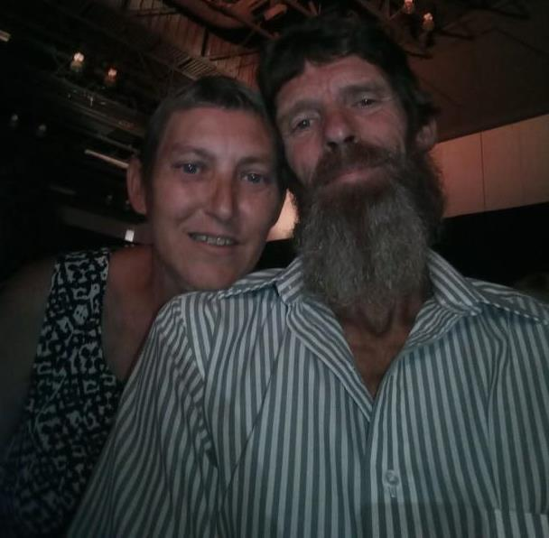
Our show is November 2nd, even though October is cancer awareness month. Midway Saddle Club is honored to host this show and silent auction. This year’s recipient is Mary Norrell, who is the aunt of one of our members.
Mary is a 52 year old wife, mother and grandmother. She and her husband have 3 children and 6 grandchildren, 3 living in Florida and 3 here in Georgia. Mary and her husband Daniel just celebrated their 34th wedding anniversary. They are also helping their son raise his 12 year old son.
In 2017, Mary and her husband went out to dinner then afterwards she became ill. She was taken to the ER and after undergoing numerous tests they diagnosed Mary with stage 3 rectal cancer. Soon she underwent surgery and was given a colostomy bag. After undergoing 18 rounds of radiation and chemotherapy treatment. She was able to have another surgery to reverse the colostomy.
In late 2018, the cancer returned in the form of Breast Cancer. Thankfully it was caught and diagnosed early. Mary has finished radiation and chemotherapy again, but will be taking a preventative drug for the next 5 years. She also goes every three weeks for preventative infusions.
Now today, Mary and her family are concerned once again because as she started having some unusual pain in her back and side. She just had a PET scan at the end of August and found out the cancer has returned in her lymph nodes.
Mary had previously worked for the same employer for 18 years, but due to her health she is unable to work right now. Her husband is still working trying to support their family.
WE at Midway Saddle Club are trying to help this family during this difficult time. We all know that insurance doesn’t cover everything. This is so much more…copays, co-insurances, gas to the doctor’s visits, treatments, meals, parking and the list goes on!
We will be hosting an open horse show, silent auction and a cake auction on November 2nd, 2019 at 1pm in Mary’s honor. All of the proceeds from the silent auction, bake sale, donation jar, gate fee, and the club’s portion of the 50/50 raffle go directly to Mary Norrell.
Please come out and help us honor Mary!

