Date: __________________

Dear Parent / Carer,

Our Physical Education uniform is as follows:

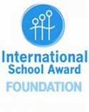

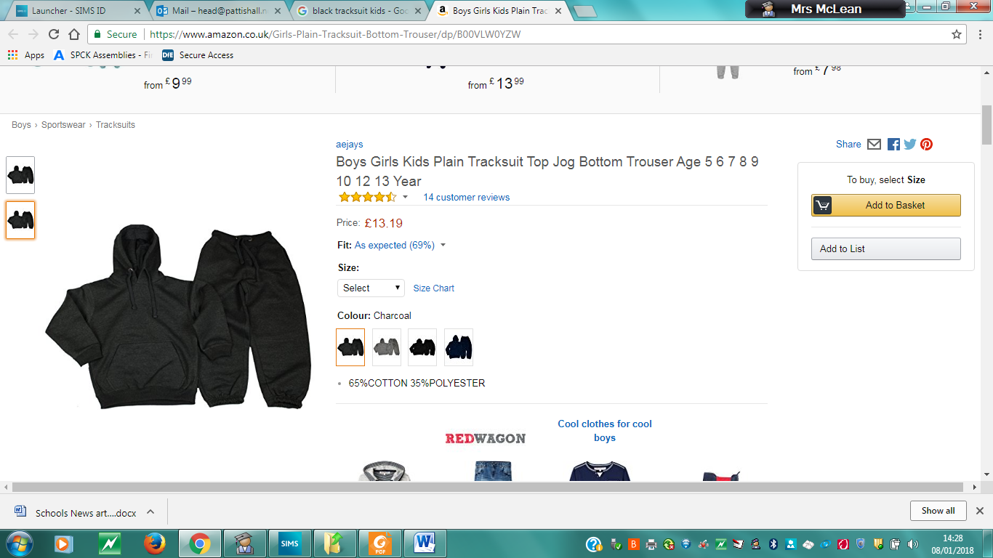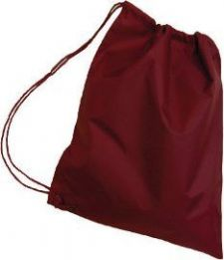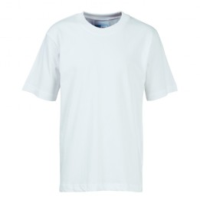

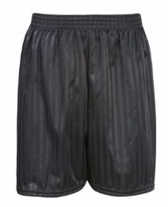

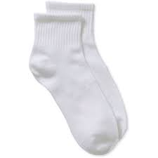

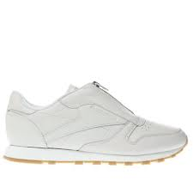

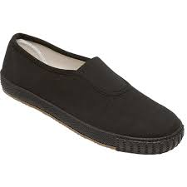

Our branded uniform is available from School Trends: <https://www.schooltrends.co.uk/uniform/PattishallCEPrimarySchoolNN128NE>

Please do make sure that your child has the appropriate uniform and that they assist you in keeping themselves clean and smart, including polishing their own shoes. Taking pride in one’s appearance promotes confidence, self-esteem and a sense of pride and belonging.

Please also make sure that every item is clearly labelled.

If you require any assistance with providing your children with uniform, please do not hesitate to ask for help.

With every good wish,

Mrs E McLean

Head Teacher