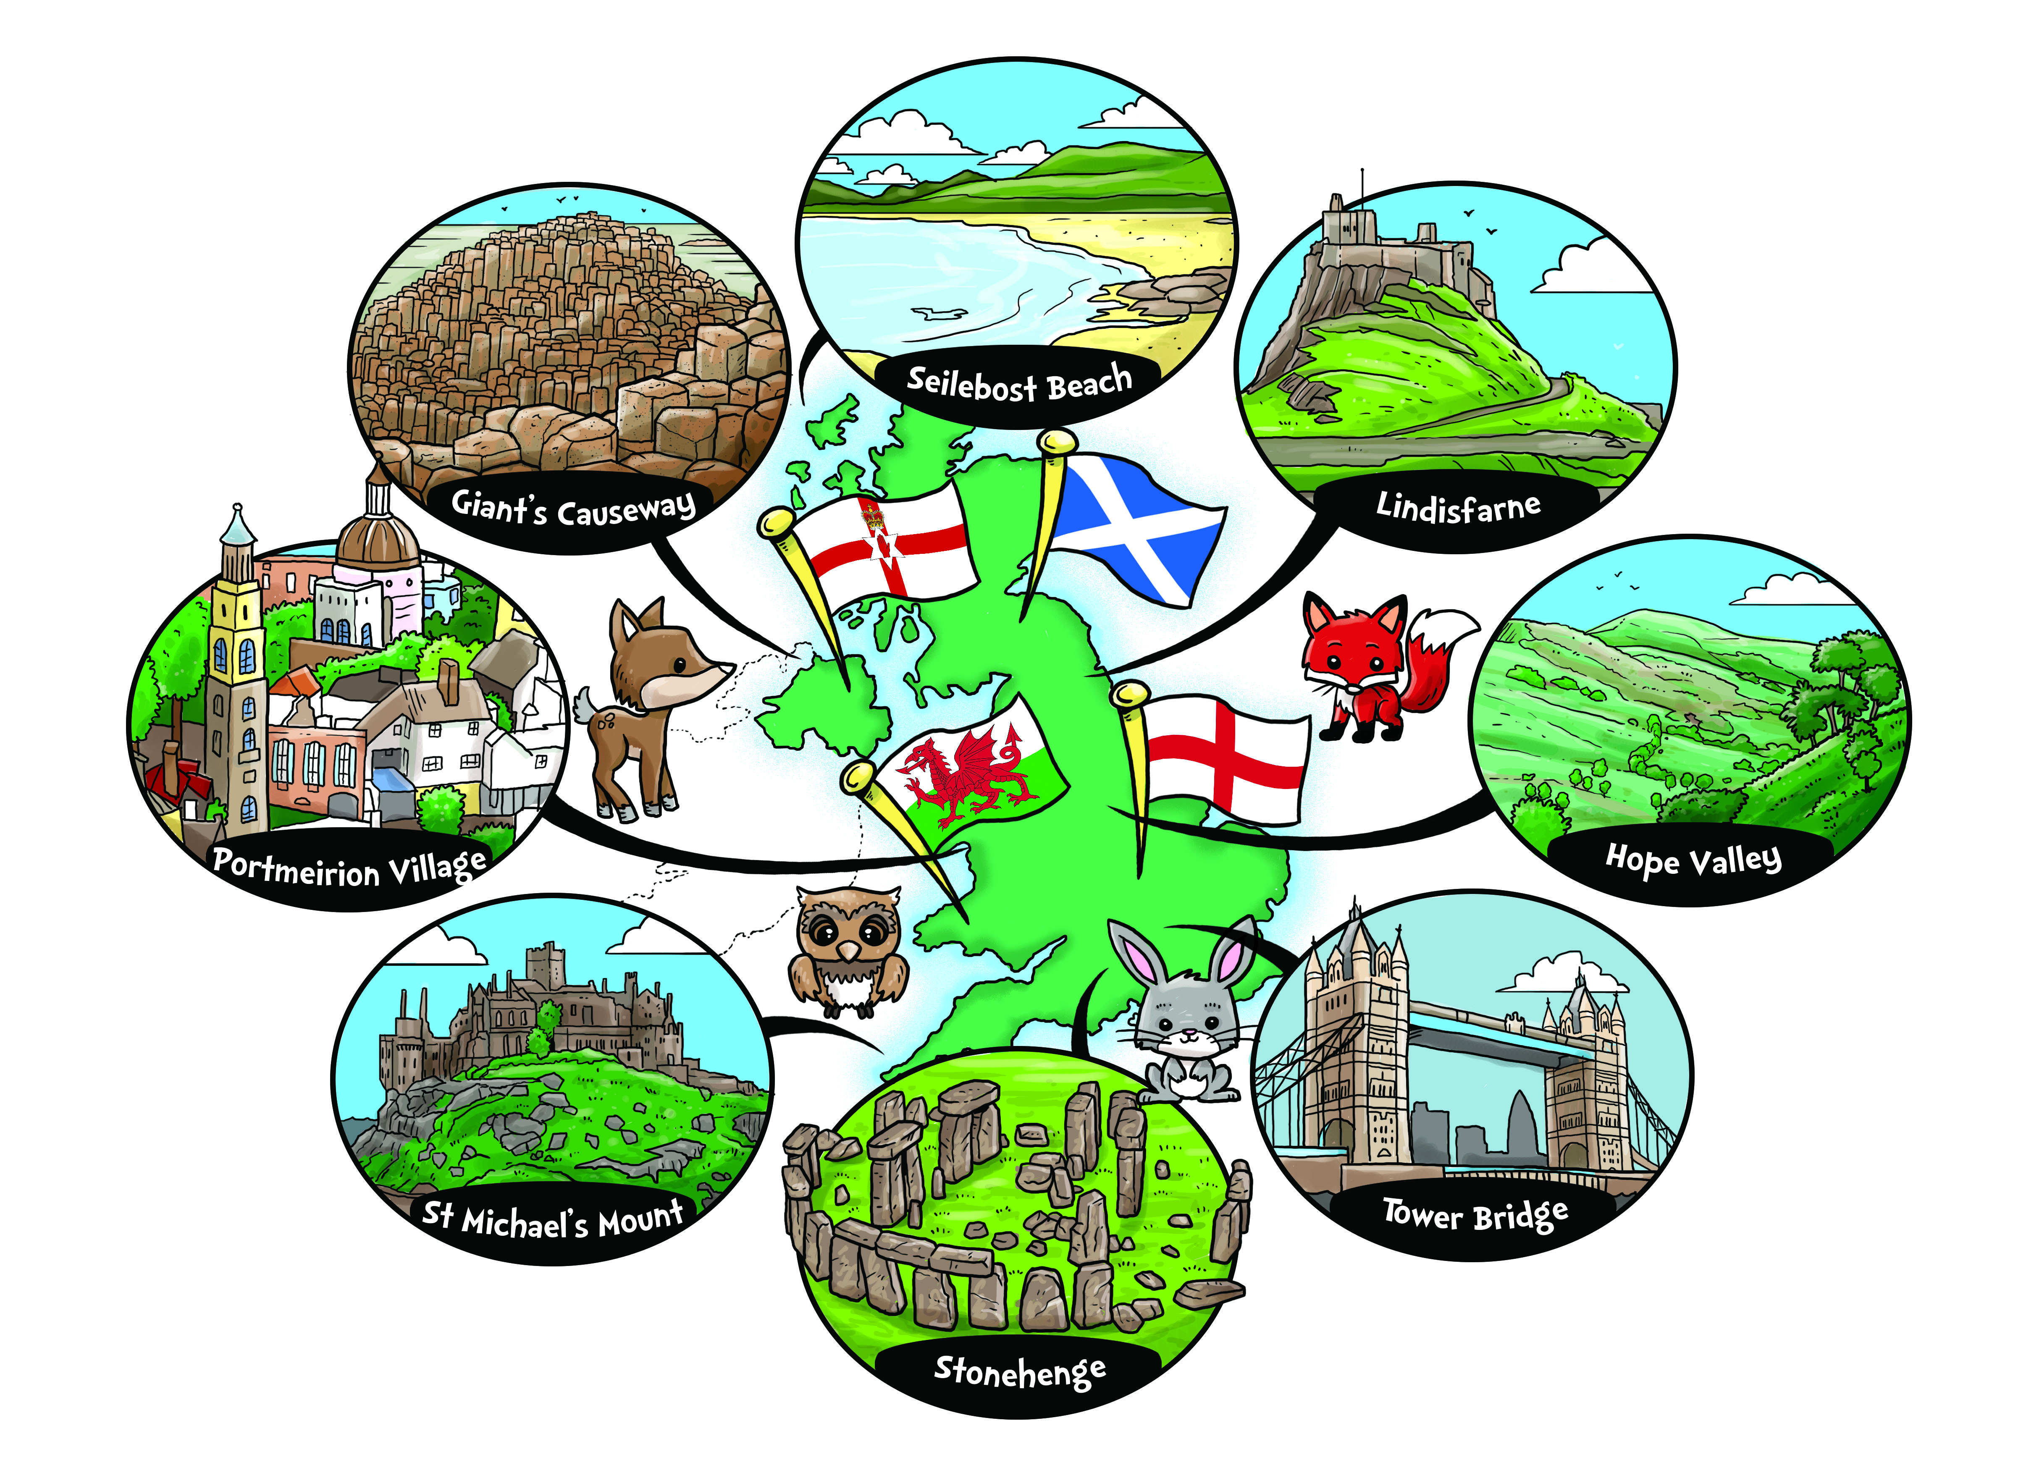

**MATHS**

* 3D and 2D shape and pattern.
* Comparing and measuring length and height.
* Numbers to 40
* Addition and subtraction word problems
* Multiplication and Division

**This Term’s Topic:**

Amazing Places and Spaces in the UK

**MUSIC**

Unit: “I wanna play in a band”

* Singing
* Rhythms
* Composition using instruments

**PSHE**

Growth Mindset

School rules and values

**RE**

What do Christians Lean from the Bible?

**SCIENCE**

* Observe seasonal changes.
* Study the habitats of British Wildlife
* Study the main features of plants and trees
* Examine the food chains in the British countryside.

**ENGLISH**

* Daily RWI reading sessions focussing on phonic and comprehension skills.
* Write correctly punctuated sentences.
* Using an increasing range of vocabulary to make our writing exciting and interesting.
* Writing for different purposes – both real and fictional
* Find the answers to questions about a text.
* Answering questions about what they have read in written form.

**PE**

* Superhero dance
* Counter-balance

**ART & DT**

Drawings and paintings of some of the amazing locations we study.

Create sculptures inspired by those we study in the UK.

**GEOGRAPHY**

* Learn about the countries and capitals of the UK (and their locations)
* Discover some of the physical and human features of the UK.
* Carry out an in-depth study of our local area.
* Learn about some of the UKs most amazing landmarks.

**HISTORY**

* Learn about the National days of each country in the UK (and celebrate some!)

**COMPUTING**

Giving instructions to Beebot.

Using copy and paste to collect and sort pictures of animals.