PSHE

Protective behaviours – safe places, network hand.

Saying No! – Taking risks, smoking, drugs, alcohol.

PE

Static balances.

Dynamic balances.

Team Games – Dodgeball; Benchball.

ART & DT

3D models – famous buildings.

Watercolour landscapes.

Highland cattle.

Castles

MATHS

* Numbers to 1000.
* Simple addition and subtraction.
* Column addition and subtraction with renaming.
* Multiplication and division x3 and x4.

SCIENCE

* Rocks: Compare and group different kinds of rocks; how fossils are formed; recognising that soils are made from rocks and organic matter.
* Plants: What plants need to grow healthy and well.

ENGLISH

* Main texts: Swallows and Amazons; Famous Five – Five on a Treasure Island.
* Writing and SPAG: Stories, reports, diary, poems, fact-files, prefixes, suffixes, apostrophes, dictionary skills.

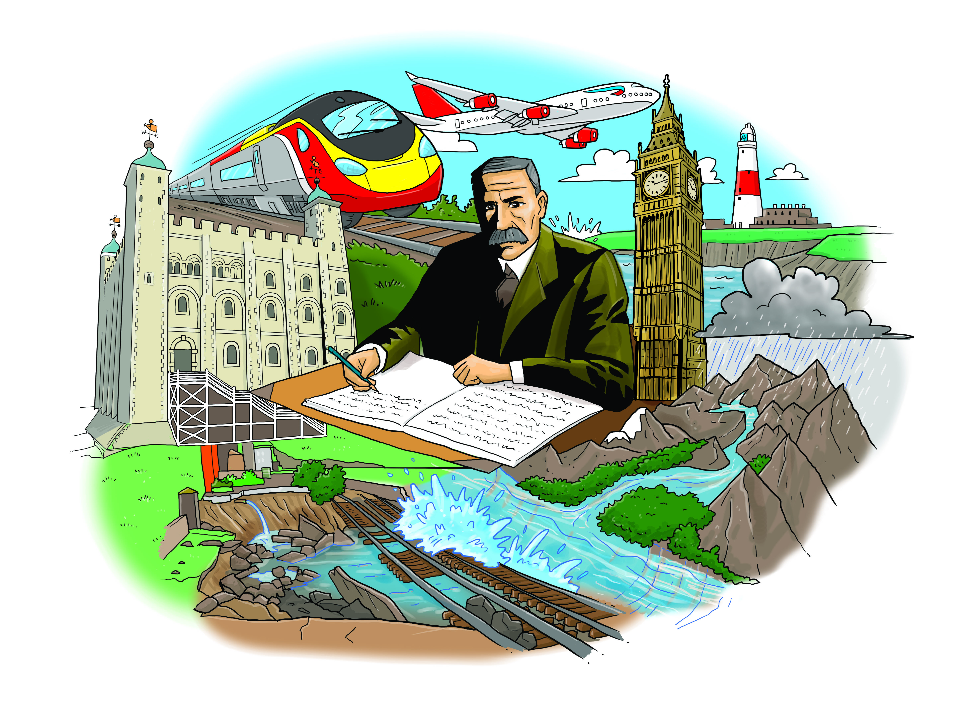

GEOGRAPHY

* Atlas and map skills.
* UK mountains, lakes and rivers.
* Road, rail and transport links.
* Famous landmarks.
* Weather – Storms , wind, floods.

HISTORY

* Castles around UK.
* The Monarchy.
* How places have changed – coalmining areas; mills and factories.

MFL (FRENCH)

General greetings.

Colours.

Songs and Stories.

RE

Values – What matters most toHumanists and Christians. Personal viiews on how we behave.

COMPUTING

We are programmers – Short, scripted, animation cartoon.

MUSIC