HISTORY

* Development of language from Stone Age to Modern times.
* Different forms of communication – signals, gestures, words.
* Early writing implements, alphabets, picture books.

MATHS

* Dividing by 3, 4 and 8.
* Word problems using multiplication and division.
* Multiplying and dividing 2 digit numbers.
* Measuring: Length, Mass (Weight).

ENGLISH

* Greek Myths; Traditional Tales and Legends. Adventure Stories based on historical events and characters.
* Non-chronological reports.
* Reading comprehension.
* Verbs; commas; speech marks; sentence structure.

SCIENCE

* Characteristics of materials.
* Investigate materials and test their fitness for purpose.
* Magnets and Springs.
* Magnetic forces.
* Magnetic materials

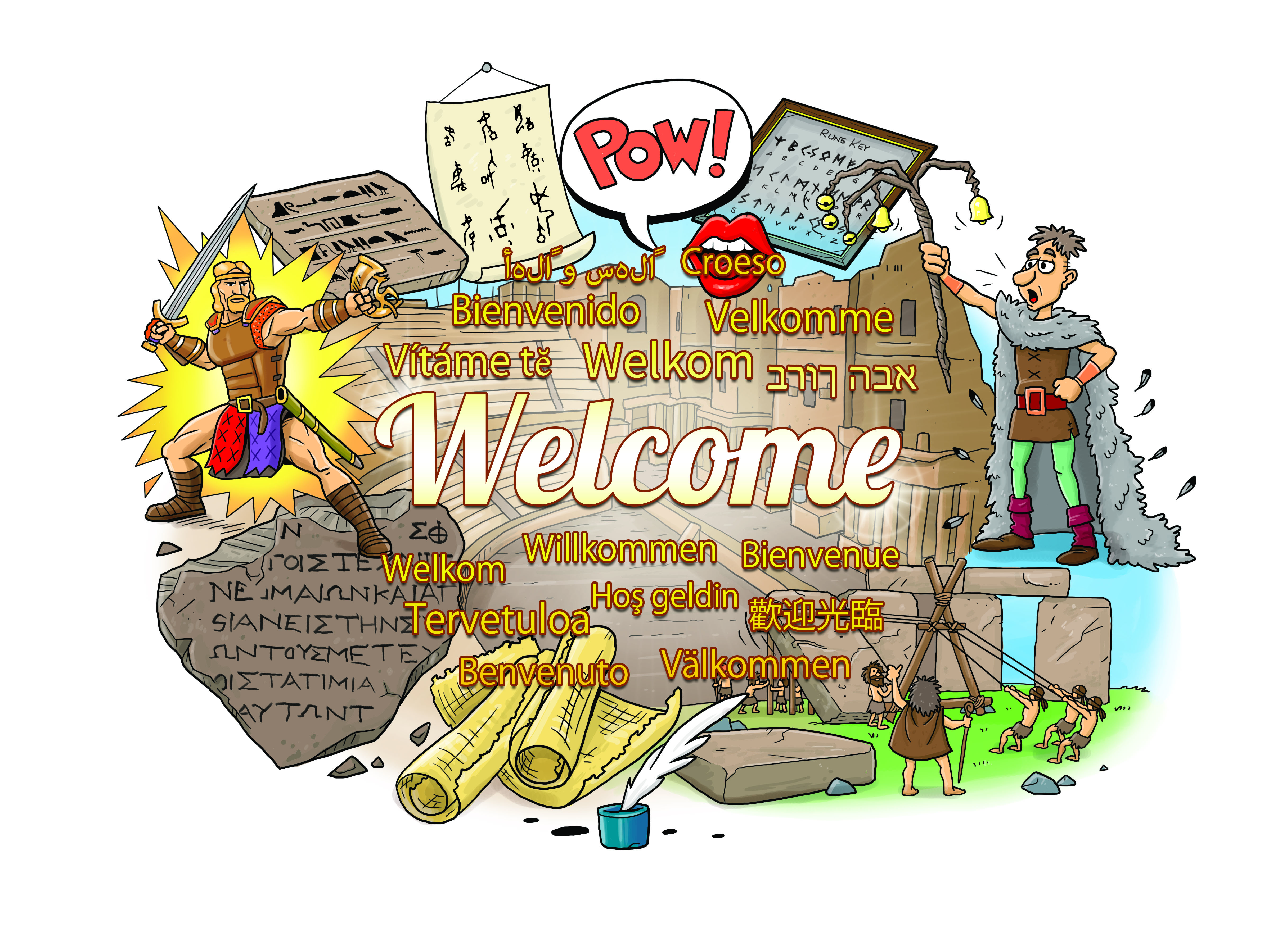

GEOGRAPHY

* Locate ancient civilizations on World Map.
* Locate home countries of the Romans, Saxons and Vikings on a map.

MFL (French)

Finger rhymes. Traditional songs and dance. Art of Renoir. Asking and answering questions.

Spelling

RE

Christianity in action.Story of the Good Samaritan. Easter- festival of sacrifice or new life?.

Easter

ART & DT

Draw and paint images of picture and script based languages.

COMPUTING

Debug simple programs.

PE

Gymnastics

Ball skills

Team games

PSHE

Money Matters: Cost of Living; Budgeting; Charity Work.

Chocolate: Fairtrade: Real cost; Advertising.

MUSIC

Let your spirit fly.

Listening and appraising songs. Learning to sing and play instruments.